CMPU 2007 – Databases 1

Continuous Assessment – Part 2

Burger Shack Database

Group Members:
David Corcoran – D22126022
Kai Reid – C21745961

Domain Types
Outline here the domain types you created, their names, definition, the reason you included them and an example how you used them e.g.
Domain Type Name | Type Definition | Reason Introduced | Example
Description | VARCHAR(50) | For attributes which are character based descriptions | type_desc in entity X
Amount | NUMBER(7,2) | For attributes which represent monetary amounts | x_amt in entity X
Time | TIMESTAMP WITH LOCAL ZONE | Date and time attributes which require a very clearly defined time element | date_occur in entity X

Major Decisions
Have a section per decision. This can include decisions such as where to place particular attributes, whether to have an entity, what type of relationship to use. Anything you had to discuss should be included in this section.

Non-key constraints
Outline here the non-key constraints added to your database and explain the reason why you have added those. Check the table below with some examples:
Constraint type | Name given | Reason for introducing it
NOT NULL | Name_not_null | The names of the competitors could not be null on the table competitors.
UNIQUE | Address_unique | The address must be unique in the table competitors.

ERD

Logical Model
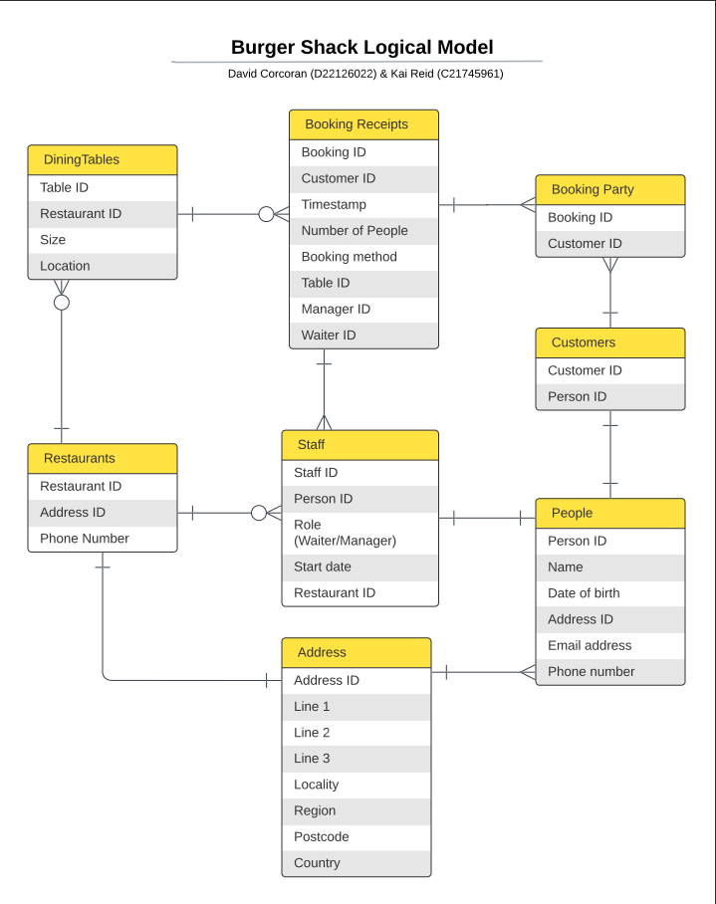
Screenshot of Physical Model

