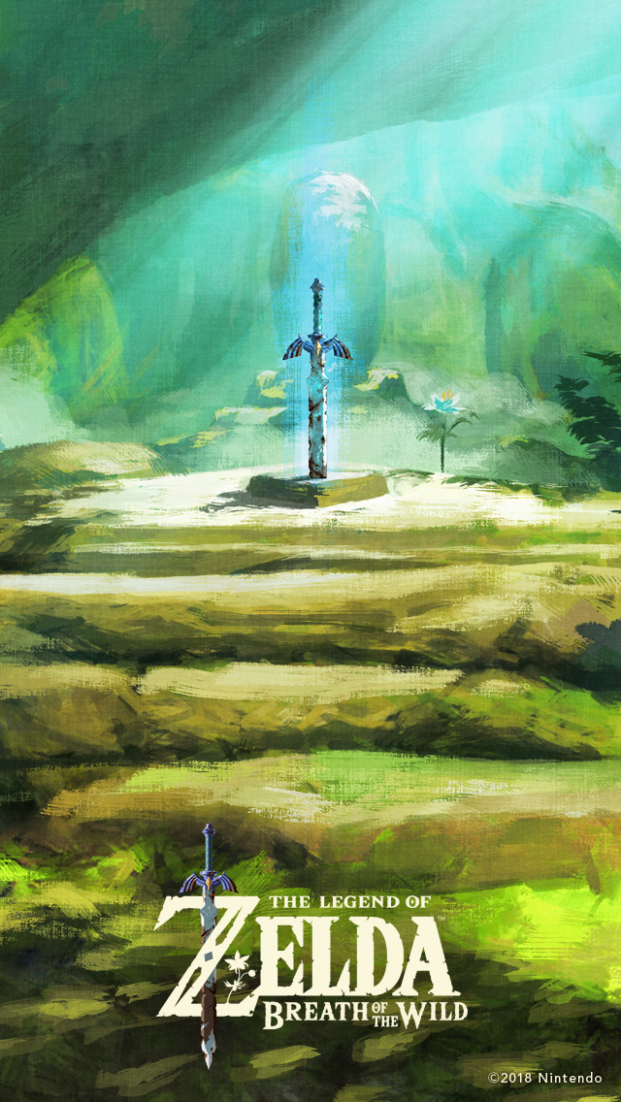

**Happy Birthday!!!!!**

Happy birthday, Rebecca !!!!!!