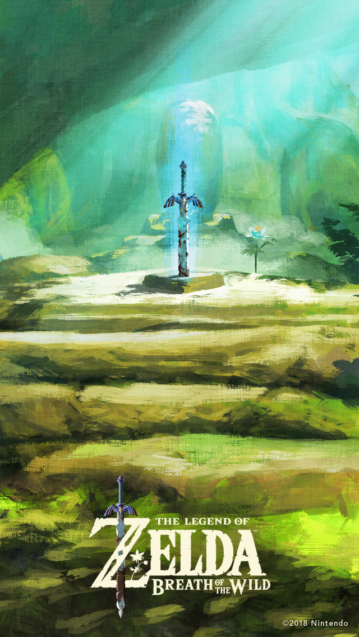

**Happy Birthday!!!!!**

Happy birthday, Camila !!!!!!