**JQUERY**

**Capture MODAL WINDOW CLOSE event in JQUERY(Page 6)**

On the modal window: resizable:true, draggable:true, close:function(){apex.event.trigger(document,'RefreshReports')}

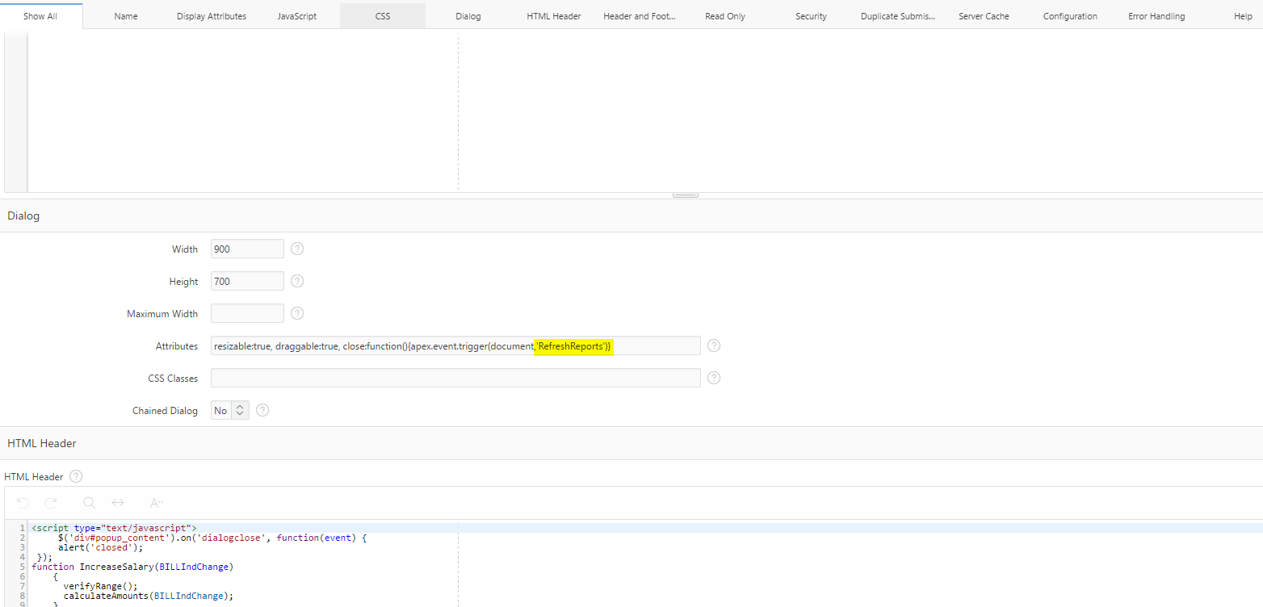

On the parent Page: Use DA to capture close event that occurred in another page(Page 4)

