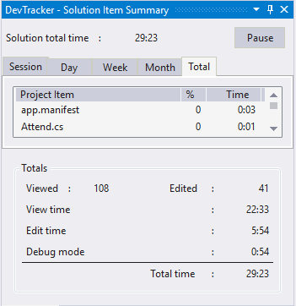

Sachiko-san,

This image includes the hours worked on the BJ Student software from my home computer. It does not include any work from any other device, including the PC from work.

Here is a brief explanation of the time:

View Time – UI management, design, structuring of the program and code

Edit Time – Coding time

Debug Mode – Testing and debugging

Currently development in progress includes the weekly summary system. Suggested features are networking to share information between computers at work and an iPad application. These are possible but would be very large projects, so I will only begin working on these if you request it.

The price point we discussed was $25/hr (the average software programmer’s payrate), which would total to 82,561 yen (112 yen/$). Whatever price is decided, please calculate a 20% discount as this is a generous opportunity and experience.

Please let me know if you have any questions.

Terry