A Comprehensive Research about Multi-Robot Control Models
Boqiang Yang¹, Shuyan Zhang², Ziyang Zheng³*, Shizhe Zu³
¹Alibaba Cloud Big Data Application College, Zhuhai College of Science and Technology, Zhuhai, 519000, China
² School of Computer Science, Beijing Institute of Technology, Beijing, 100081, China
³ School of leeds, Southwest Jiaotong University, Chengdu, 611756, China
*Corresponding author：Sc213zz@leeds.ac.uk
Abstract. Multi-agent systems (MAS) are composed of multiple agents that have the ability to learn and make decisions autonomously, while interacting with each other and a shared environment. The collaboration of multiple robots within complex spaces inevitably gives rise to potential conflicts, making the development of models to coordinate the entire system a prominent aspect in this field. Despite the growing scholarly attention towards MAS in recent years, the research in this area has remained complex and obscure, lacking a clear and concise summary of the concepts and pertinent details. Therefore, the purpose of this paper is to introduce two distinct models of MAS and review several previous studies. Specifically, the paper describes the centralized model and decentralized model of MAS, presenting both the traditional framework and recent innovative advancements. A thorough analysis of these models will be conducted, evaluating their respective advantages and disadvantages. Furthermore, a conclusive summary will be provided, along with a prospect for future research in the field of MAS.
Keywords: Multi-Robot Control; centralized model; decentralized model
- Introduction
Multi-agent systems (MAS) consist of multiple agents, which learn and take decisions autonomously, interacting with each other and a shared environment [1]. It aims to convert a large and complex system into small, manageable systems that communicate and coordinate with each other. In recent years, due to the cross-penetration and development of biology, computer science, artificial intelligence, control science, sociology and other disciplines, multi-agent systems have attracted more and more attention from many scholars, and have become a research hotspot in the field of control science and artificial intelligence In the area of MAS, a series of technical problems are spanned, concluding the knowledge, goals, skills, planning of the agent and methods to enable agents to take coordinated action to solve the problem. Benefiting from the implementation of automation and new technologies in various fields, MAS has shown significant performance as well as potential in collaborative patrol, forest inspection, etc. [2-4].
Whilst multiple robots work together within a closed space inevitably suggests possible conflicts, which may lead to potential danger in practical use. Therefore, models to coordinate the entire system have acted as one of the highlights in the field. Although MAS has attracted worldwide attention in recent years, research in this area is always complicated and obscure, lacking clear and understanding summary of the notion and relevant details. The paper describes centralized model and decentralized model of MAS, introducing the traditional framework and novel improvement in recent years. The corresponding analysis will be discussed, evaluating several advantages and disadvantages of centralized model and decentralized model. Then a conclusion of the paper will be given and prospect for future research about MAS will be raised.
- Centralised model
In a centralised model, the cluster generally selects individual robots to exercise control over the rest to coordinate the entire system. The central controller usually receives and processes information from each robot in the system so as to make global decision for the system or individuals in some occasions. In the paper addressing modeling multi-robot formation control presented by Desai et al, the problem is decomposed into operating a lead robot along with manipulating other follower robots in the system [5]. A traditional architecture of centralised multi-robot control system is shown in Fig. 1. Individual robot with sensors could receive information such as position of obstacles and relative position in the formation. Then it passes information through certain standards to the controller and receives order from it. The most significant feature of this type of approach may be demonstrated by the fact that it allows individuals to have access to additional information from the entire multi-robot system when deciding the following action.
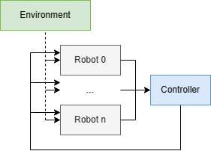
Fig. 1. Traditional Centralised Multi-Robot Control Model (Original)
One of the representative traditional approaches in this model is the centralised formation control of mobile robots proposed by Cruz et al [6]. The paper is based on a linearized dynamic model of a unicycle-like mobile robot, where the relative positions of the robots, the formation heading, etc. are used as formation parameters for the formation state vector. The movement and changes of the target formation are tracked by a central controller based on the control law. In experiments, good tracking of desired formations was demonstrated. The solution does not involve additional phases such as the training process and is easy to use at application level. One of the further developments of this approach could be semi-centralised control proposed by Wan et al, which focused on minimize the cost when the formation changes [7]. In this approach, the problem of arranging the robots in a formation is transformed into a task distribution problem, where the actions of the robots are coordinated by means of a leader-follower method [8]. A central agent in the system is responsible for sending commands to each robot, which detects possible collisions and avoids them on its own.
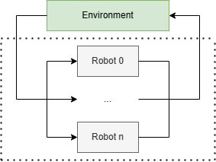
Fig. 2. Full-Centralised Reinforcement Learning Multi-Robot Control Model (Original)
Some approaches, which differ from traditional mathemtic methods, introduce reinforcement learning - a system in which robots optimise their behaviour by accumulating experience and responding to the rewards from environment. In a centralised model, information is exchanged mutually between robots and participates in their policy updates, suggesting that the data transfer among robots is bidirectional. In addition, decisions could be made either as joint actions given by a central control unit like Fig. 2 or by each robot individually. The major advantage of the former process is its capacity to train multiple robots by directly applying single-robot training methods, however, at the corresponding expense of space occupied in central unit caused by the rise in the number of robots. Although such complete centralised model represents little competitiveness in performance, it could be used as performance baseline to conduct comparisons with other reinforcement training models [9]. In contrast, decentralised execution shown in Fig. 3, is more widely adopted. Jiang et al. propose a centralized training framework on the basis of supervised learning (a DNN directly mapping the observation of robots to decide actions) to control policy learning, which is deployed afterwards in a decentralised way on each robot [10]. This method manages to minimise the need of inter-robot communication by deploying trained model on individual robot and let each make decision based on local observation. Nevertheless, merely limited number of robots are considered during the experiment phase, suggesting that no evidence could ensure the performance of training process under larger scale.
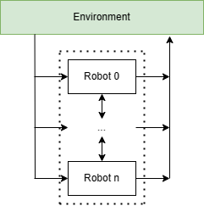
Fig. 3. Semi-Centralised Reinforcement Learning Multi-Robot Control Model (Original)
Overall, centralised model represents a general method to utilise comparatively more feedback from the environment than distributed methods - Robots could share computational facilities or communicate with each other in order to exchange information. By sharing mutual information, the training process can be eased and the learning speed can become superior when matched against independently trained agents [11]. Whilst the scheme requires an ideal condition where the central unit has enough global information of the environment as well as that of each robot it commands. Therefore, this system often relies on the quality of inter-robot communication or could even be limited by it.
- Decentralized model
In a decentralized model, a cluster typically achieves control and collaboration among robots by assigning tasks and coordinating policies. In a decentralized model, each robot has some degree of autonomy and decision-making ability. They can coordinate their actions by communicating and sharing information with other robots. This decentralized structure makes the system more flexible and adaptable, as each robot can make independent decisions based on the information it receives. The decentralized model also has better fault tolerance and robustness. Since each robot has its own decision-making ability, when one robot in the system fails, the other robots can continue to perform tasks and maintain the operation of the entire system. This decentralized architecture lowers the possibility of a single point of failure and increases system dependability.
In the realm of robot systems, distributed multi-robot formation control is a prominent area of study. However, when operating in dynamic environments, such as those with moving obstacles, the challenges faced by formation control are amplified. The presence of these dynamic elements introduces complexities that must be addressed for effective formation control. A classical approach to solve the collision problem in a dynamic environment is based on the consensus algorithm with displacement-based strategy [12]. However, consensus algorithm has the dependency on formation center knowledge. If the formation center is dynamic or changes frequently, maintaining accurate knowledge of the formation center can become challenging. In contrast, Jiawei et al proposed a new approach based on the artificial potential field (APF) and distributed consensus under dynamic obstacle interference [13]. To achieve formation control of multi-robot systems and maintain formation shape in the presence of dynamic barriers, this method suggests a distributed control strategy.
A distributed control algorithm is created to accomplish the formation control of several robots by specifying robot states, forming requirements, and dynamic obstacle modeling. Robots exchange state and obstacle information with each other through the network and perform corresponding motion control according to the received control instructions to achieve shape formation and avoid collision with dynamic obstacles. The method's comprehensive flowchart can be found in Fig. 4. Compared with traditional obstacle avoidance, dynamic obstacle avoidance method is more effective. The formation movement under numerous dynamic barriers interference is depicted in Fig. 5 using the conventional approach and Fig. 6 shows formation movement by reference [13]. The trajectory of the robot formation in Fig. 6 is more compact. The simulation result shows more advantageous than traditional consensus algorithm was.
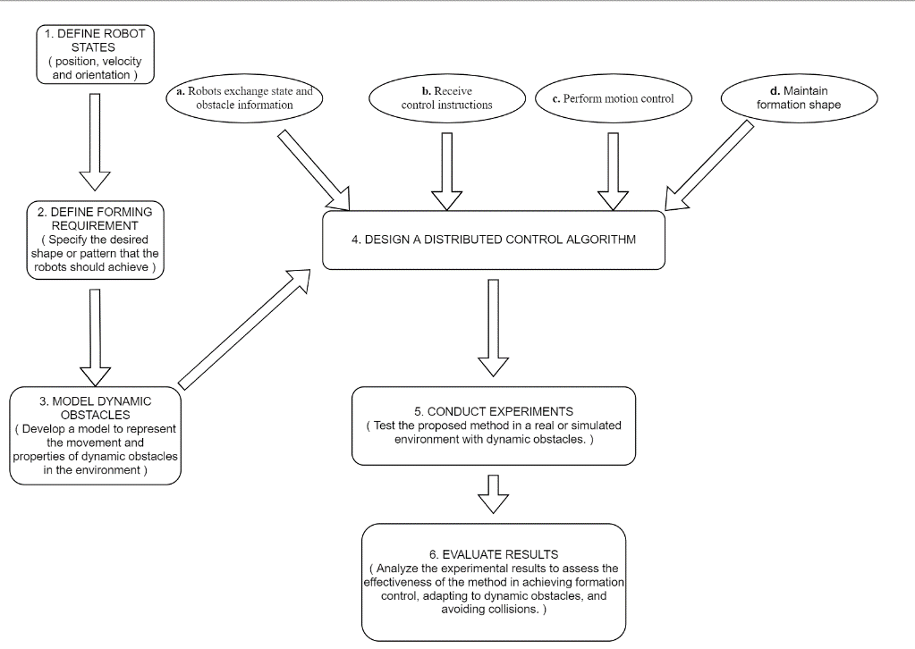
Fig. 4. Distributed Multi-Robot Control Procedure (Original)
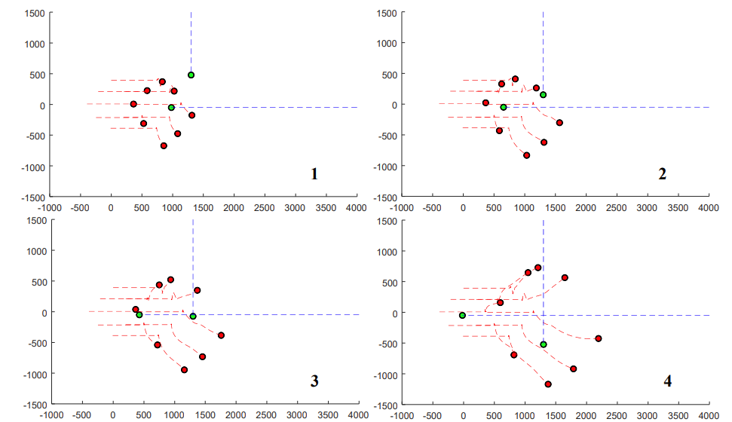
Fig. 5. formation movement by traditional method [13]
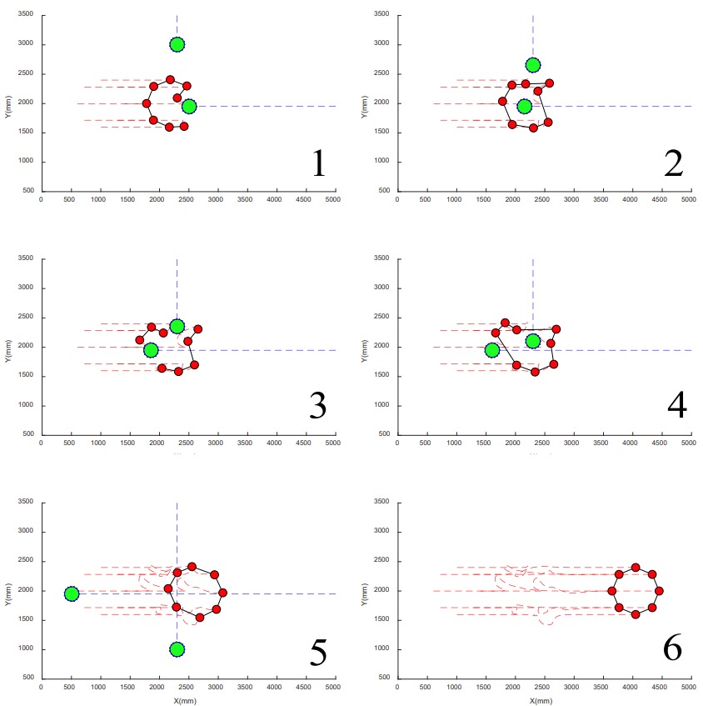
Fig. 6. formation movement by dynamic obstacle avoidance method [13]
In addition to the impact of obstacles, the impact of communication is usually considered. One of the key study areas in the underwater vehicle field is formation control of multi-autonomous underwater vehicle systems. But in the underwater environment with limited communication, the realization of formation control of underwater vehicles is faced with challenges. One representative approach pertains to the proposed solution put forth by Zaiyi et al for addressing communication barriers, specifically those encountered in underwater settings [14]. This paper describes a technique for achieving formation control of several autonomous underwater vehicle systems with limited connectivity.
Reference [14] addresses the challenge of formation control in multi-autonomous underwater vehicle (AUV) systems. The study proposes a comprehensive methodology that encompasses the modeling of the AUV system, formulation of the desired formation shape, identification of communication constraints, and development of a distributed control algorithm to facilitate coordinated motion. It is verified through numerical simulations, demonstrating its effectiveness in achieving formation control with limited communication resources. Fig. 7 displays a full flow diagram of this approach.
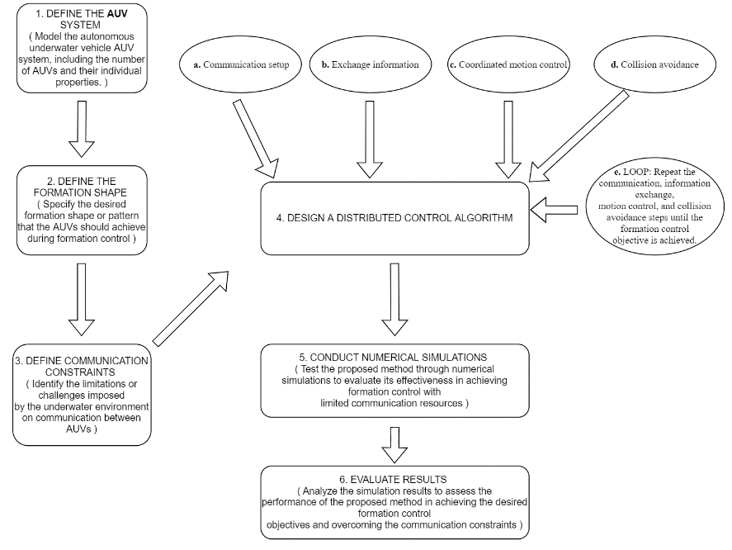
Fig. 7. Distributed Formation Control of Multiple AUV Systems (Original)
In addition to the aforementioned proposed methodologies, resolving the issue of robot freezing caused by the interaction of repulsion and attraction forces in scenarios that require the collaborative efforts of multiple robots, such as missions of search and rescue, monitoring activities, and security applications, remains a prominent challenge. One representative approach is the distributed multi-robot cooperative hunting algorithm based on limit cycles proposed by Ming et al [15]. This method aims to facilitate collaborative hunting tasks among multiple robots, allowing them to effectively track and capture targets. By leveraging the principles of limit cycle theory, the algorithm harnesses the stability of limit cycles to achieve coordination and synchronization behaviors among the robots.
Overall, the decentralized model provides greater flexibility, adaptability, and fault tolerance by allowing two-way data transfer and decision-making autonomy between robots. It enables robots to collaborate better, share information, and make more accurate decisions, improving the performance.
- Comparison between centralized model and decentralized model
After a mass of research and analysis in this area, some consensus has been reached about the performance comparison between centralized model and decentralized model, for instance, in contrast to fully centralized control approaches, fully decentralized approaches are expected to have higher stability and scalability due to their features, containing redundancy and parallelization. But these features may bring the loss of speed and efficiency to the system. Jamshidpey, A. et al. proposes a coverage control task for independent ground robots [4]. They use four control approaches, which conclude fully centralized approach and decentralized approach, and compare corresponding performance indicators. Their summary and a line chart of high difficulty task are listed in the Fig. 8.

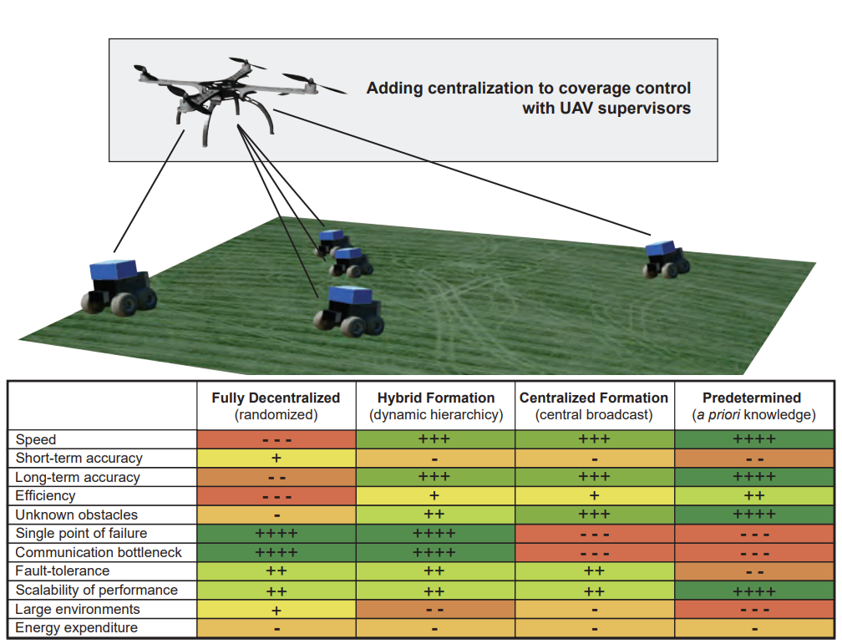
Fig. 8. Summary of the key findings in the task [4]
For the fig. 8, the minus sign (-) and plus sign (+) indicates the performance of control approaches in different aspects. The more minus sign the approach gets, the lower its indicator is in this aspect. Instead, the plus sign is related to a relatively better indicator. It can be concluded that in this task centralized model is more efficient than decentralized model and more stable in a long-term task while decentralized model is relatively more accurate in a short-term task and performs better in large environments. The most notable difference is that though centralized model serious suffer from single point of failure, decentralized seldom encounter this issue.
For centralized model, all decisions and resource allocations are made at the central agent. This feature enhances the coordination and consistency of the system, also eases design of centralized model [16]. But this may increase the fault scope when faced with the central agent of failure, on which all decisions from the whole system rely. This kind of pattern also limit its scalability. As the number of agents increases, the computing and communication burden concentrated on the central agent will ascend, which may test limitation of the agent. Meanwhile, in large environments, with all decisions passing through the central agent, it may take a long time for the system to response the task, causing the inefficiency of the system.
Compared to centralized model, when one agent malfunctions, fully decentralized model is believed to be more stable due to the operation of other agents, ensuring the accomplishment of tasks [17]. In terms of scalability, because of the decentralize of making decision and responding the task, this model is expected to remain its performance in large environments, which contains the high efficiency of responding tasks. However, coordinating the behavior of multiple agents can become very complex and conflicts may arise because decision-making is decentralized across agents.
Centralized and decentralized models have their own advantages and disadvantages. When choosing models, it is necessary to weigh them against specific application scenarios and requirements. For example, for problems that require global optimization, a centralized model may be more appropriate, while for large-scale, dynamic systems, a decentralized model may be more advantageous.
- Advantages and development trends of MRS
  - The Advantages of MRS
Multi-robot system can realize efficient automated production in the field of manufacturing. Different robots can work together to complete complex tasks, improve production efficiency and quality, and at the same time can work together to provide more comprehensive and efficient services. For example, hotels can use multiple robots to provide services such as room cleaning and baggage handling, increasing customer satisfaction. Multi-robot systems can also play an important role in disaster relief, medical care and other fields. Multiple robots can form a closely coordinated team to complete tasks together. In disaster relief, the multi-robot system can search and rescue trapped people, provide communication and material support. In the field of medical care, multi-robotic systems can help care for patients and provide supplementary medical services. In addition, there are many advantages to multi-robot control:
Flexibility and flexibility: multi-robot system has strong flexibility and flexibility. When the system needs to cope with the changing environment or task requirements, it can realize rapid adjustment and adaptation through the reallocation of robot tasks and resources.
Increased efficiency and productivity: Multi-robotic systems can speed up task execution while reducing error rates. Since multiple robots can work in different locations at the same time, the time required to complete a task can be greatly reduced. This is particularly important for improving the efficiency of manufacturing, logistics, warehousing and other fields.
Safety and personnel reduction: Multi-robot systems can replace manual tasks in some dangerous and harsh environments, reducing the dependence on personnel and risks. For example, in the nuclear radiation environment of nuclear power plants, multi-robot systems can undertake radiation monitoring, equipment maintenance and other work to ensure the safety of workers.
Scalability: The multi-robot system has strong scalability and can be flexibly expanded and adjusted as the demand increases or changes. By adding more robots, more complex tasks and greater workloads can be adapted.
  - The trends of MRS
Multi-robot intelligent control means that multiple intelligent machines cooperate with each other to complete a task or solve a problem. In the future, multi-robot intelligent control is expected to enable a series of advances and innovations.
First, multi-robot intelligent control will improve production efficiency and work efficiency. Through collaboration and intelligent control between machines, automated and intelligent workflows can be achieved, improving the quality and quantity of products on the production line, while reducing errors and failures.
Secondly, multi-robot intelligent control will bring greater flexibility and adaptability. Collaboration between machines makes the entire system more flexible and can be quickly adjusted and adapted to meet different work scenarios and changes in requirements.
Finally, multi-robot intelligent control is expected to achieve a higher level of autonomous decision-making and intelligent operation. Through interaction and information sharing between machines, higher levels of decision making and task allocation can be achieved, eliminating the need for human intervention, improving work efficiency and reducing human errors.
However, it is worth noting that the development of multi-robot intelligent control will also face some challenges and considerations: collaboration between machines requires efficient communication and information exchange, which requires machines to have strong communication capabilities and information processing capabilities. Multi-robot intelligent control needs to establish uniform standards and specifications to ensure compatibility and interoperability between different machines. The development of multi-robot intelligent control also needs to fully consider the issue of security and privacy protection to avoid information leakage and abuse between machines.
Overall, multi-robot intelligent control is expected to achieve a more efficient, flexible and intelligent way of working in the future, but at the same time, it also needs to consider various factors to promote collaboration and development between multiple machines.
- Conclusion
With the development of industrialization, people's demand for automation of production and service is increasing. Multi-robot intelligent control can realize cooperative operation and automatic control of multiple robots, improve production efficiency and service quality. The continuous development and application of artificial intelligence, machine learning, sensor technology, etc., provide technical support for multi-robot intelligent control. The paper describes centralized model and decentralized model of MAS, introducing the traditional framework and novel improvement in recent years. The corresponding analysis will be discussed, evaluating several advantages and disadvantages of centralized model and decentralized model.
In the future, multi-robot intelligent control is expected to enable a series of advances and innovations. Overall, multi-robot intelligent control is expected to achieve a more efficient, flexible and intelligent way of working in the future, but at the same time, it also needs to consider various factors to promote collaboration and development between multiple machines.

Authors Contribution
All the authors contributed equally and their names were listed in alphabetical order.

Reference
- Weiss, G. (Ed.). (1999). Multiagent systems: a modern approach to distributed artificial intelligence. MIT press.
- Macwan, A., Vilela, J., Nejat, G., & Benhabib, B. (2014). A multirobot path-planning strategy for autonomous wilderness search and rescue. IEEE transactions on cybernetics, 45(9), 1784-1797.
- Mnih, V., Badia, A. P., Mirza, M., Graves, A., Lillicrap, T., Harley, T. (2016). Asynchronous methods for deep reinforcement learning. In International conference on machine learning, pp. 1928-1937.
- Jamshidpey, A., Wahby, M., Heinrich, M. K., (2021). Centralization vs. decentralization in multi-robot coverage: Ground robots under uav supervision.
- Desai, J. P., Ostrowski, J. P., & Kumar, V. (2001). Modeling and control of formations of nonholonomic mobile robots. IEEE Transactions on Robotics and Automation, 17(6), 905–908.
- De La Cruz, C., & Carelli, R. (2006). Dynamic modeling and centralized formation control of mobile robots. IECON 2006-32nd Annual Conference on IEEE Industrial Electronics, 3880–3885.
- Wan, S., Lu, J., & Fan, P. (2017). Semi-centralized control for multi robot formation. 2017 2nd International Conference on Robotics and Automation Engineering, 31–36.
- Shao, J., Xie, G., Yu, J., & Wang, L. (2005). Leader-following formation control of multiple mobile robots. 2005 IEEE International Symposium on, Mediterrean Conference on Control and Automation Intelligent Control, 2005., 808–813.
- Dorri, A., Kanhere, S. S., & Jurdak, R. (2018). Multi-agent systems: A survey. Ieee Access, 6, 28573–28593.
- Jiang, C., Chen, Z., & Guo, Y. (2019). Learning decentralized control policies for multi-robot formation. 2019 International Conference on Advanced Intelligent Mechatronics (AIM), 758–765.
- Foerster, J., Farquhar, G., Afouras, T., Nardelli, N., & Whiteson, S. (2018). Counterfactual multi-agent policy gradients. Proceedings of the AAAI Conference on Artificial Intelligence, 32.
- Fuady, S., Ibrahim, A. R., & Bambang, R. T. (2013). Distributed formation control of multi-robot system with obstacle avoidance. In 2013 International Conference on Robotics, Biomimetics, Intelligent Computational Systems, pp. 94-98.
- Hu, J., Sun, J., Zou, Z., Ji, D., & Xiong, Z. (2020). Distributed multi-robot formation control under dynamic obstacle interference. In 2020 International Conference on Advanced Intelligent Mechatronics (AIM) pp. 1435-1440.
- Wang, Z., Zhu, Z., Wei, Z., Huang, X., & Yin, B. (2017). Research on formation control of multiple autonomous underwater vehicle systems with limited communication. In 2017 International Conference on Computer Systems, Electronics and Control (ICCSEC) pp. 343-346.
- Wu, M., Huang, F., Wang, L., & Sun, J. (2009). A distributed multi-robot cooperative hunting algorithm based on limit-cycle. In 2009 International Asia Conference on Informatics in Control, Automation and Robotics (pp. 156-160).
- Bangkok, Thailand.5.Decker, K., & Lesser, V. R. (1995). Designing a family of coordination algorithms. In ICMAS, 95, pp. 73-80.
- Wooldridge, M., & Jennings, N. R. (1995). Intelligent agents: Theory and practice. The knowledge engineering review, 10(2), 115-152.

