

A Generalized Binary-Decomposition Framework for Scalable Image Classification Across Diverse Image Datasets
CSE4019 – Applications Of Artificial Intelligence
PROJECT REPORT

Class Number – AP2025264000722
SLOT – A2+TA2
Course Type – EPJ
Course Mode – Project Based Component (Embedded)

Department of Artificial Intelligence and Machine Learning
School of Computer Science and Engineering

By
23BCE8587 | Amey Vinod Rassekar
23BCE8743 | Changela Vivek Vimalbhai

Submitted to:-
Dr. E.Sreenivasa Reddy
Professor-HAG, SCOPE, VIT-AP.
2025 -2026

TABLE OF CONTENTS

Chapter No. | Title | Page No.
 | Abstract | 3
1 | Introduction | 4
2 | Literature Review | 7
3 | Requirements | 9
4 | Proposed Methodology-1 | 11
5 | Proposed Methodology-2 | 18
6 | Overall Results and Discussions | 24
7 | Conclusion& Future work | 27
 | References | 29

Abstract
Image classification is a core application of artificial intelligence, typically addressed using multi-class deep learning models. However, as the number of classes increases, such models often face challenges related to scalability, class imbalance, and complex decision boundaries. To overcome these limitations, this project explores the use of the One-vs-All (OvA) strategy, where a multi-class problem is decomposed into multiple binary classification tasks.
This work presents a generalized and dataset-agnostic OvA deep learning architecture capable of adapting to diverse image datasets with minimal modification. Two distinct approaches are implemented and analyzed. The first approach consists of multiple independent binary convolutional neural network (CNN) models, each trained separately for a specific class and later aggregated during inference. The second approach introduces a unified model with a shared feature extraction backbone and multiple binary output heads, enabling simultaneous learning of all class-specific classifiers.
Experimental evaluation demonstrates a significant performance improvement in the unified approach. While the independent model aggregation method achieved an overall accuracy of 0.60, the proposed generalized unified OvA model achieved an accuracy of 0.95 on the same dataset. This highlights the effectiveness of shared feature learning in improving classification performance while maintaining the advantages of the OvA strategy.
The results indicate that the proposed generalized OvA architecture provides improved scalability, flexibility, and robustness compared to traditional multi-class models, making it a practical solution for real-world image classification tasks across varied datasets.

Introduction

Image classification has emerged as one of the most influential and widely applied domains within artificial intelligence, particularly with the rise of deep learning techniques such as Convolutional Neural Networks (CNNs). From medical diagnostics and autonomous driving to surveillance systems and environmental monitoring, the ability of machines to accurately interpret and categorize visual data has become essential. Traditional approaches to image classification typically rely on multi-class models, where a single neural network is trained to distinguish between all possible classes simultaneously. While effective in controlled environments, these models often struggle when scaled to real-world scenarios involving large, diverse, and imbalanced datasets.

As the number of classes increases, multi-class models are required to learn highly complex decision boundaries, which can lead to slower convergence, reduced accuracy, and increased computational overhead. Additionally, such models are less flexible when new classes are introduced, often requiring complete retraining. These limitations highlight the need for more scalable and adaptable classification strategies.

In this context, the One-vs-All (OvA) approach provides a promising alternative by decomposing a multi-class problem into multiple binary classification tasks. Each classifier focuses on distinguishing one specific class from all others, enabling more targeted learning and improved interpretability. Building upon this concept, the present project introduces a generalized, dataset-agnostic OvA architecture, capable of working across multiple datasets without requiring significant structural changes. By implementing and comparing two distinct approaches—independent binary models and a unified multi-head architecture—this work aims to demonstrate how OvA strategies can enhance both performance and flexibility in image classification tasks.

Introduction to Problem

The core problem addressed in this project is the inefficiency and lack of scalability of traditional multi-class image classification models when applied to complex and diverse datasets. In a conventional setting, a single deep learning model is trained using a SoftMax layer to classify images into one of many categories. While this approach works well for datasets with a limited number of balanced classes, it becomes increasingly challenging as the dataset grows in size and diversity.

Some of the key issues associated with this problem include:

- High Learning Complexity: The model must simultaneously learn to differentiate between all classes, leading to complex decision boundaries.

- Class Imbalance Sensitivity: Classes with fewer samples are often overshadowed by dominant classes, resulting in biased predictions.

- Reduced Interpretability: It becomes difficult to analyze which class-specific features the model is learning.

- Scalability Issues: Adding new classes requires retraining the entire model, making the system inefficient for dynamic datasets.

- Computational Overhead: Large multi-class models require significant computational resources and longer training times.

To address these challenges, the project explores the use of a One-vs-All strategy, where the classification problem is broken down into simpler binary tasks, thereby reducing the burden on individual models and enabling more focused learning.

Motivation

The motivation behind this project arises from the practical limitations observed in real-world image classification systems and the need for more flexible, scalable, and efficient architectures.

Several factors contributed to the development of this work:

- Need for Generalization Across Datasets: Most existing models are designed for specific datasets and require significant modification when applied to new data. This project aims to create a reusable architecture that can adapt to different datasets with minimal effort.

- Improving Classification Performance: By focusing on binary classification tasks, models can learn more discriminative features for each class, potentially improving overall accuracy.

- Handling Class Imbalance Effectively: The OvA approach allows each class to be treated independently, making it easier to balance positive and negative samples during training.

- Reducing Model Complexity: Instead of one highly complex model, the problem is distributed across simpler models or multiple output heads, reducing learning difficulty.

- Flexibility in Model Expansion: New classes can be added by training additional binary classifiers without affecting the existing system.

- Empirical Performance Gains: Experimental results from this project clearly show that the unified OvA approach significantly outperforms the independent model approach, achieving an accuracy of 0.95 compared to 0.60, reinforcing the effectiveness of the proposed method.

This combination of practical challenges and observed improvements strongly motivated the development of a generalized One-vs-All architecture.

Problem Statement:
The project aims to address the limitations of traditional multi-class image classification models by designing a generalized One-vs-All deep learning architecture that can efficiently classify images across diverse datasets while improving scalability, flexibility, and performance.

Objectives:

The primary objectives of this project are as follows:

- To design a generalized OvA-based architecture
  - Develop a system that can handle any image dataset structured in a standard format without requiring major modifications.

- To implement and compare two distinct approaches:
  - Independent binary classifiers (Approach 1)
  - Unified multi-head OvA model (Approach 2)
- To improve classification accuracy and robustness

  - Demonstrate that breaking down the problem into binary tasks leads to better learning outcomes.
- To reduce computational redundancy
  - Utilize shared feature extraction in the unified model to improve efficiency.
- To create a modular and scalable system
  - Enable easy addition of new classes without retraining the entire architecture.

- To evaluate model performance using standard metrics
  - Compare both approaches using accuracy and analyze their effectiveness across datasets.
- To validate generalization capability
  - Test the architecture on multiple datasets to ensure dataset-agnostic behavior.

Scope

The scope of this project is focused on the design, implementation, and evaluation of a generalized One-vs-All deep learning architecture for image classification. It encompasses both theoretical understanding and practical implementation using deep learning frameworks.

The key aspects within the scope include:

- Image Classification Using CNNs:
  - The project is limited to image-based datasets and does not extend to other data types such as text or audio.
- Binary Decomposition of Multi-Class Problems:
  - The classification task is approached using the One-vs-All strategy.
- Dataset-Agnostic Pipeline:
  - The system is designed to work with any dataset that follows a standard directory structure (train/test split).
- Comparison of Two Architectures:
  - Both independent and unified OvA approaches are implemented and evaluated.
- Performance Evaluation:
  - Accuracy is used as the primary evaluation metric, with observations made on training behavior and generalization.

However, the project does not cover:

- Deployment in real-time systems
- Optimization for edge devices
- Advanced techniques such as transfer learning or attention mechanisms
- Large-scale industrial datasets with millions of samples

Literature Review

Image classification has witnessed significant advancements with the evolution of deep learning, particularly through the use of Convolutional Neural Networks (CNNs). Early approaches to image classification relied on handcrafted feature extraction techniques such as SIFT (Scale-Invariant Feature Transform) and HOG (Histogram of Oriented Gradients), combined with classical machine learning classifiers like Support Vector Machines (SVMs). While these methods provided reasonable performance, they lacked the ability to automatically learn hierarchical feature representations from raw image data.
The introduction of deep learning architectures, especially CNNs, revolutionized the field by enabling end-to-end learning of features directly from images. Landmark models such as AlexNet, VGGNet, and ResNet demonstrated that deep neural networks could significantly outperform traditional methods on large-scale datasets. These models typically employ a multi-class classification framework, where a single network is trained using a SoftMax activation function to assign an input image to one of several predefined classes. Although highly effective, these approaches often face challenges when dealing with datasets that have a large number of classes or exhibit class imbalance.
To address such challenges, alternative strategies like One-vs-All (OvA), also known as One-vs-Rest, have been explored in both classical machine learning and deep learning domains. In the OvA approach, a multi-class problem is decomposed into multiple binary classification problems. Each classifier is trained to distinguish one class (positive) from all other classes (negative). This method simplifies the learning objective for each classifier and allows models to focus on class-specific features, often resulting in improved discriminative performance.
In classical machine learning, OvA has been widely used with algorithms such as SVMs and logistic regression, where it has shown strong performance in high-dimensional feature spaces. With the rise of deep learning, researchers began extending the OvA concept to CNN-based architectures. Studies have shown that binary classifiers can achieve better performance in scenarios with class imbalance, as they allow for controlled sampling and weighting strategies.
Recent advancements have further explored hybrid OvA architectures, where instead of training completely independent models, a shared feature extraction backbone is combined with multiple binary output heads. This approach leverages the strengths of both independent and unified learning paradigms—retaining class-specific decision boundaries while reducing computational redundancy. Such architectures have demonstrated improved training efficiency and scalability, especially when dealing with large datasets.
Another important area of research focuses on model generalization and transferability. Many existing works are dataset-specific, meaning that models are designed and tuned for a particular dataset and do not generalize well to new data without significant retraining. This has led to the exploration of modular and reusable architectures that can adapt to different datasets with minimal modifications.
The present project builds upon these research directions by proposing a generalized, dataset-agnostic One-vs-All architecture. Unlike many existing implementations, this work emphasizes automation in dataset handling, modular design, and adaptability across multiple datasets. Furthermore, by comparing two distinct OvA approaches—independent binary classifiers and a unified multi-head model—the project provides practical insights into the trade-offs between modularity and computational efficiency.

Limitations or Pitfalls in Previous Works

Despite the significant progress made in image classification and OvA-based learning strategies, several limitations and challenges persist in existing approaches. Understanding these pitfalls is essential to justify the need for the proposed generalized architecture.
One of the primary limitations of traditional multi-class models is their inability to scale efficiently with an increasing number of classes. As the number of categories grows, the model must learn increasingly complex decision boundaries, which often leads to longer training times, higher computational costs, and reduced performance. Additionally, these models tend to struggle with class imbalance, where classes with fewer samples are underrepresented during training, resulting in biased predictions.
Another major issue is the lack of modularity in conventional approaches. In multi-class models, all classes are learned simultaneously within a single network. This means that adding or removing a class requires retraining the entire model, making it impractical for dynamic datasets that evolve over time. This limitation restricts the flexibility of such systems in real-world applications.

Even in OvA-based implementations, earlier works often rely on fully independent binary classifiers, which introduce their own set of challenges. While these models offer better interpretability and class-specific learning, they suffer from:
- High computational overhead:
Training multiple independent models significantly increases training time and resource consumption.
- Redundant feature learning:
Each model independently learns similar low-level features, leading to inefficiency.
- Difficulty in maintaining consistency:
Since models are trained separately, variations in training can lead to inconsistent predictions.
Another limitation observed in prior research is the lack of generalization across datasets. Many models are specifically designed for particular datasets and require manual adjustments when applied to new data. This reduces the reusability of the models and increases development effort.
Furthermore, existing works often do not adequately explore the balance between modularity and efficiency. While independent OvA models provide modularity, they lack efficiency, whereas unified models improve efficiency but may introduce architectural complexity that is not always well-optimized.
There is also a limited focus on automation in dataset handling. In many implementations, dataset preparation for OvA training is done manually, which becomes cumbersome and error-prone when dealing with large or multiple datasets.

Requirements:
Hardware and Software Requirements
The successful implementation of the proposed generalized One-vs-All (OvA) deep learning architecture requires an appropriate combination of hardware and software resources. Since the project involves training convolutional neural networks on image datasets, both computational efficiency and software compatibility play a crucial role in ensuring smooth execution and reproducibility.
Hardware Requirements
The hardware setup used for this project is designed to support deep learning model training, particularly for handling image data and iterative optimization processes.
- Processor (CPU):
A multi-core processor such as Intel i5/i7 or AMD Ryzen series is recommended to handle data preprocessing, loading, and auxiliary computations efficiently.
- Graphics Processing Unit (GPU):
A CUDA-enabled GPU (such as NVIDIA GTX/RTX series) is highly recommended for accelerating model training. The use of GPU significantly reduces training time, especially for convolutional operations and batch processing.
In this project, GPU acceleration is utilized through a configured environment to ensure efficient training of both OvA approaches.
- RAM (Memory):
A minimum of 8 GB RAM is required, while 16 GB or higher is preferred for handling larger datasets and smooth multitasking during training and experimentation.
- Storage:
At least 10–20 GB of free disk space is required to store datasets, trained models, and intermediate outputs. SSD storage is preferred over HDD for faster data access and loading speeds.
- System Configuration:
A 64-bit operating system is necessary to support modern deep learning frameworks and libraries.

Software Requirements
The software stack is centered around deep learning development, dataset handling, and experiment execution.
- Programming Language:
  - Python (version 3.8 or above)
Python is used due to its extensive support for machine learning libraries and ease of development.
- Deep Learning Framework:
  - PyTorch
PyTorch is used for implementing CNN architectures, training loops, and GPU acceleration. It provides flexibility for building both independent and unified OvA models.
- Development Environment:
  - Jupyter Notebook
The entire project is implemented in a notebook-based environment, allowing step-by-step execution, visualization of results, and better experiment tracking.
- Libraries and Dependencies:
  - NumPy → numerical computations
  - Pandas → data handling (if required)
  - Matplotlib / Seaborn → visualization of training results
  - torchvision → image transformations and dataset utilities
  - os / glob → file handling and dataset loading
- Environment Management:
  - Conda environment (e.g., aiml)
Used to manage dependencies and ensure compatibility across libraries.
- Operating System:
  - Windows / Linux (Windows used in this project)

Additional Tools and Configurations
- GPU Configuration (CUDA & cuDNN):
Proper installation of CUDA and cuDNN is required to enable GPU acceleration in PyTorch.
- Model Checkpointing and Logging:
During training, models are saved periodically, and logs are maintained to track performance across epochs.
- Dataset Directory Handling:
Custom scripts are used to automatically detect classes and load pre-split datasets (train/test), making the system dataset-agnostic.

Overall, the chosen hardware and software configuration ensures that the project remains efficient, scalable, and reproducible, while also being accessible for experimentation on different systems.

Data Set Requirements
The effectiveness of the proposed One-vs-All architecture heavily depends on the structure, quality, and diversity of the input datasets. Since the goal of this project is to develop a generalized and dataset-agnostic model, the dataset requirements are designed to be flexible while maintaining a standard structure for compatibility.
General Dataset Requirements
- Image-Based Data:
The dataset must consist of images belonging to multiple classes.
- Multi-Class Structure:
The dataset should contain two or more distinct classes to enable OvA decomposition.
- Sufficient Samples per Class:
Each class should ideally have a reasonable number of images to allow effective training of binary classifiers.
- Balanced or Moderately Imbalanced Data:
While OvA can handle imbalance better than traditional models, extremely skewed datasets may still affect performance.

Data Preprocessing Requirements
To ensure consistency across different datasets, the following preprocessing steps are applied:
- Image Resizing:
All images are resized to a fixed dimension (e.g., 128×128 or 224×224) to maintain uniform input size.
- Normalization:
Pixel values are normalized to improve training stability and convergence.
- Data Transformation:
Standard transformations such as tensor conversion and optional augmentation may be applied.

Dataset Preparation for OvA Strategy
For implementing the One-vs-All approach, the dataset is transformed into multiple binary classification tasks:
- For each class:
  - Positive Class: Images belonging to the target class
  - Negative Class: Images from all other classes
This process is:
- Automated in the code
- Dynamic, adapting to any number of classes
- Reusable across datasets, ensuring generalization

Proposed Methodology 1

Independent One-vs-All Binary Models with Model Aggregation

The first methodology focuses on implementing the classical One-vs-All (OvA) strategy using multiple independent binary classifiers. In this approach, a multi-class image classification problem is decomposed into several binary classification tasks, where each model is trained separately to recognize one specific class against all others.
This method emphasizes modularity, interpretability, and simplicity, as each model operates independently and specializes in detecting a single class. However, it also introduces challenges related to computational cost and redundancy, which are analyzed later in this section.

Dataset Preparation

Dataset preparation plays a critical role in enabling the One-vs-All strategy. Since each model is trained independently, the dataset must be transformed into multiple binary classification datasets.
Dataset Structure
The dataset is assumed to be pre-organized into a standard directory format:
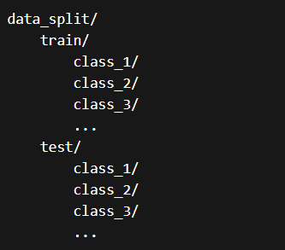
This structure allows automatic detection of class labels and ensures compatibility with the generalized pipeline.

Class-wise Binary Dataset Generation
For a dataset with N classes, the OvA strategy generates N separate binary datasets, each corresponding to one class.
For each class Cᵢ:
- Positive Samples:
All images belonging to class Cᵢ
- Negative Samples:
All images belonging to the remaining (N − 1) classes combined
This transformation is performed programmatically, ensuring:
- No manual intervention is required
- The system adapts dynamically to any number of classes
- The process is reusable across datasets

Data Preprocessing
To ensure consistency and effective training, the following preprocessing steps are applied:
- Image Resizing:
All images are resized to a fixed resolution (e.g., 128×128)
- Normalization:
Pixel values are scaled to a standard range for stable gradient updates
- Tensor Conversion:
Images are converted into tensors compatible with PyTorch
- Batch Formation:
Data is loaded in batches for efficient GPU-based training

Dataset Splitting
- Training Set: Used to train each binary classifier
- Testing Set: Used to evaluate model performance
The same split is maintained across all binary models to ensure fair comparison.

Key Characteristics of Dataset Preparation
- Fully automated and scalable
- Supports any dataset with folder-based class structure
- Ensures uniform preprocessing across all models
- Enables efficient OvA decomposition

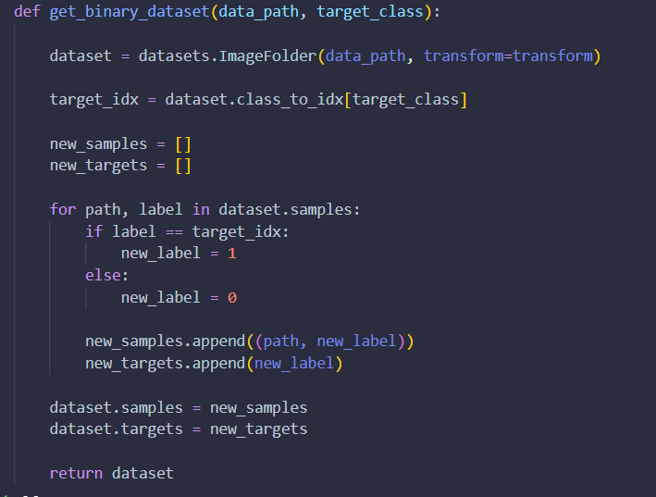

Proposed Methodology Framework
The methodology consists of three major stages:
1. Model Design
Each binary classifier follows a Convolutional Neural Network (CNN) architecture consisting of:
- Multiple convolutional layers for feature extraction
- Activation functions (ReLU) for non-linearity
- Pooling layers for dimensionality reduction
- Fully connected layers for classification
- A final sigmoid output for binary prediction
Each model is identical in architecture but trained on different class-specific data.

2. Independent Model Training
For each class:
- A separate model is initialized
- The corresponding binary dataset is loaded
- The model is trained independently using:
  - Binary Cross-Entropy Loss
  - Optimizer such as Adam
- Training is performed for a fixed number of epochs
Key characteristics:
- No parameter sharing between models
- Each model learns class-specific features independently
- Training is repeated N times for N classes

3. Model Aggregation (Inference Stage)
After training all binary classifiers, they are combined into a unified inference system.
During prediction:
- An input image is passed through all trained models
- Each model outputs a confidence score for its class
- The final predicted class is determined by:
  - Selecting the class with the highest confidence score

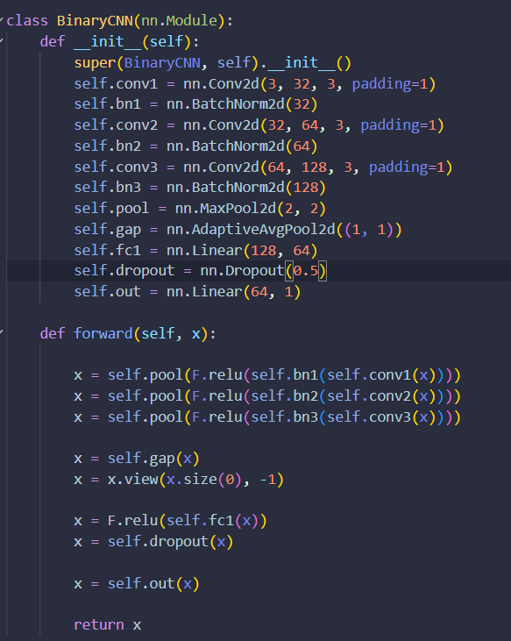

Code Base Explanation:
Step 1: Input Handling
The model takes an RGB image as input, meaning it has 3 channels (Red, Green, Blue). This is the standard format for most image datasets.

Step 2: First Feature Extraction Layer
The input image is passed through the first convolution layer, which extracts basic features such as edges, corners, and simple textures.
Batch normalization is applied to stabilize learning, followed by a ReLU activation to introduce non-linearity.
Max pooling then reduces the spatial size, helping in dimensionality reduction.

Step 3: Second Feature Extraction Layer
The processed output is passed through a second convolution layer, which learns more complex patterns like shapes and object parts.
Again, batch normalization ensures stable gradients, ReLU adds non-linearity, and pooling reduces size further.

Step 4: Third Feature Extraction Layer
A deeper convolution layer is applied to extract high-level features, such as complete object structures or class-specific patterns.
The same sequence of normalization, activation, and pooling is applied, making the representation more abstract and compact.

Step 5: Global Feature Aggregation
Instead of flattening large feature maps directly, the model uses global average pooling.
This converts each feature map into a single value, resulting in a compact feature vector.
This step:
- Reduces the number of parameters
- Prevents overfitting
- Makes the model adaptable to different input sizes

Step 6: Flattening
The pooled output is reshaped into a one-dimensional vector so it can be fed into fully connected layers for classification.

Step 7: Dense Feature Learning
A fully connected layer processes the feature vector and learns higher-level relationships between extracted features.
A ReLU activation introduces non-linearity, allowing the model to learn complex decision boundaries.

Step 8: Regularization
Dropout is applied, randomly deactivating a portion of neurons during training.
This helps:
- Prevent overfitting
- Improve generalization

Step 9: Final Classification
The final layer produces a single output value, representing the likelihood of the input belonging to a particular class (binary classification).

Step 10: Output Interpretation
The output is a raw score (logit). During training, it is passed through a loss function that internally applies a sigmoid function to convert it into a probability.

Framework Summary
- Input Image → Passed to all binary models
- Each Model → Outputs probability of belonging to its class
- Aggregation → Select class with maximum probability

Advantages of This Framework
- High modularity:
Each model can be trained, modified, or replaced independently
- Interpretability:
Easy to analyze performance of individual class classifiers
- Flexibility:
New classes can be added by training additional models

Limitations of This Framework
- High computational cost:
Training multiple models increases time and resource usage
- Redundant feature learning:
Each model learns similar low-level features independently
- Scalability issues:
Becomes inefficient as the number of classes increases

Results & Discussion
The performance of Approach 1 was evaluated using the prepared dataset and standard accuracy metrics.
Observed Results
- Overall Accuracy: 0.60
This indicates moderate performance, but highlights several inefficiencies in the approach.
Confusion Matrix of the models result over the trail Data:
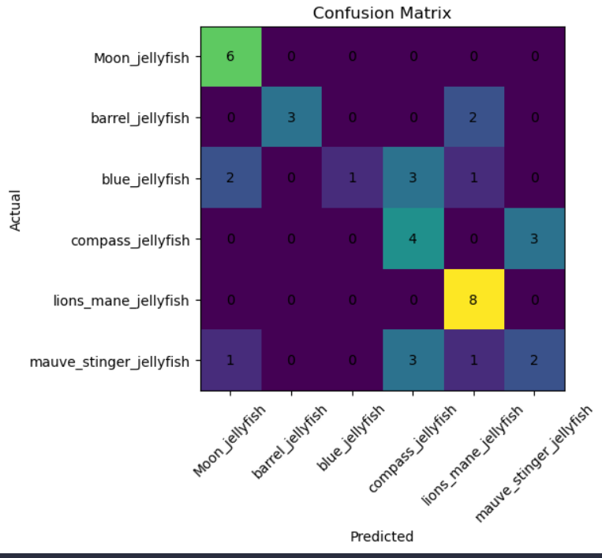

Analysis of Results
The relatively lower accuracy can be attributed to several factors:
1. Lack of Shared Learning
Since each model is trained independently:
- There is no sharing of learned features
- Models fail to benefit from common patterns across classes
2. Data Fragmentation
Each model sees only a binary subset of the dataset, leading to:
- Reduced exposure to full data distribution
- Limited generalization capability
3. Redundant Computation
Multiple models learn similar features independently, resulting in:
- Inefficient training
- Increased computational overhead

Performance Behavior
- Some classes perform well individually
- Others struggle due to imbalance or feature overlap
- Final prediction accuracy suffers due to inconsistent confidence outputs across models

Key Observations
- The OvA strategy itself is effective in simplifying classification tasks
- However, independent implementation introduces inefficiencies
- The lack of feature sharing is a major limitation
- The approach is modular but not computationally optimal

Proposed Methodology 2

Unified One-vs-All Model with Shared Feature Representation
The second methodology introduces an advanced and optimized implementation of the One-vs-All (OvA) strategy through a single unified deep learning model. Unlike Approach 1, where multiple independent models are trained separately, this approach integrates all binary classifiers into a single architecture with a shared feature extraction backbone and multiple output heads.
This design significantly improves computational efficiency, feature utilization, and overall performance, while still preserving the core advantages of the OvA strategy—namely, class-specific learning and modular decision boundaries. The methodology is specifically designed to be generalized and dataset-agnostic, allowing it to work seamlessly across different datasets with minimal modifications.

Dataset Preparation
The dataset preparation process for Approach 2 follows a similar foundational structure as Approach 1 but is adapted to support a unified multi-head learning framework instead of multiple independent datasets.
Dataset Structure
The dataset is organized in a standard directory format:

This structure enables:
- Automatic detection of class labels
- Dynamic adaptation to varying numbers of classes
- Seamless integration with the training pipeline

Label Transformation for OvA Learning
Instead of creating separate datasets for each class, a multi-label binary encoding is used within a single dataset.
For each input image:
- A binary vector of size N (number of classes) is generated
- For class Cᵢ:
  - Value = 1 if the image belongs to class Cᵢ
  - Value = 0 for all other classes
Example (for 4 classes):
- Class 1 → [1, 0, 0, 0]
- Class 2 → [0, 1, 0, 0]
This encoding allows the model to simultaneously learn multiple binary classification tasks.

Data Preprocessing
The preprocessing pipeline ensures consistency and stability:
- Image Resizing: Standardized input dimensions (e.g., 128×128)
- Normalization: Pixel scaling for improved convergence
- Tensor Conversion: Conversion to PyTorch tensors
- Batch Loading: Efficient batch processing using DataLoader
Advantages of Dataset Preparation in Approach 2
- Eliminates the need to create multiple datasets
- Maintains full dataset visibility for all classes
- Enables efficient multi-head training
- Fully automated and adaptable to any dataset

Proposed Methodology Framework
The unified OvA framework is designed to combine shared learning and class-specific decision making within a single model.
1. Model Architecture
The architecture consists of two primary components:
a. Shared Feature Extraction Backbone
- A CNN-based feature extractor
- Includes convolutional, activation, and pooling layers
- Learns low-level and mid-level features common across all classes
b. Multiple Binary Output Heads
- Each class is assigned a dedicated output neuron (or head)
- Each head performs binary classification for its respective class
- Sigmoid activation is used for each output

2. Training Process
The training process is unified and simultaneous:
- Input images are passed through the shared backbone
- Extracted features are fed into all output heads
- Each head computes its own binary prediction
Loss Function
- Binary Cross-Entropy (BCE) Loss is applied independently to each output head
- The total loss is computed as the sum (or average) of all binary losses

3. Optimization
- Optimizer: Adam (or similar)
- Backpropagation updates:
  - Shared backbone weights
  - All output head weights simultaneously
This ensures:
- Efficient learning across all classes
- Reduced redundancy compared to independent models

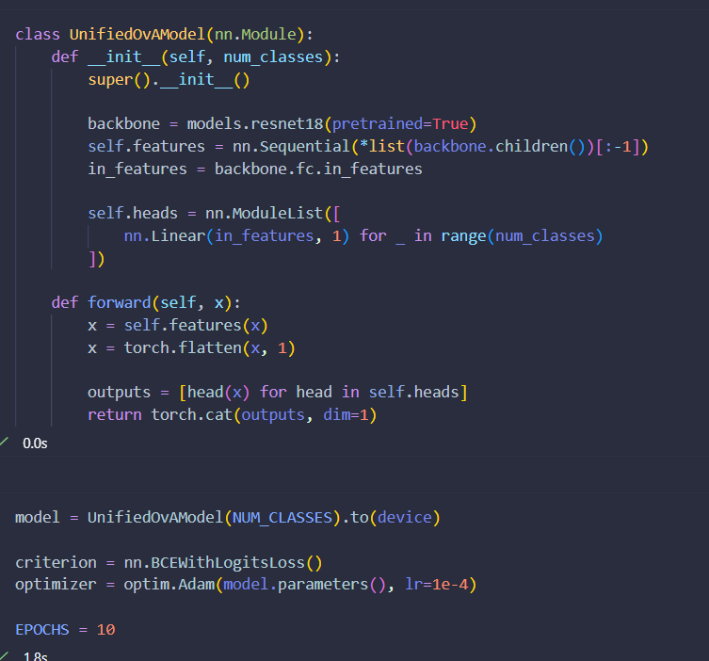

Code Base Explanation:
Step 1: Model Purpose
This model represents the unified version of the binary-decomposition strategy, where a single network handles all classes simultaneously. Instead of training multiple independent models, this architecture combines them into one model with shared feature learning and multiple class-specific outputs.

Step 2: Backbone Initialization
A pre-trained ResNet18 model is used as the base network. This backbone has already learned rich image features from large-scale datasets, which helps in faster convergence and better performance.
The final classification layer of ResNet is removed, and only the feature extraction part is retained. This allows the model to act as a generic feature extractor rather than a fixed classifier.

Step 3: Feature Extraction Layer
The backbone is converted into a sequential module that outputs high-level features from input images. These features represent patterns such as textures, shapes, and object structures learned during pretraining.
The number of output features from the backbone is stored so that it can be used to design the classification layers.

Step 4: Multi-Head Output Design
Instead of a single output layer, the model creates multiple independent output units, one for each class.
Each output head:
- Takes the shared feature vector as input
- Produces a single value representing the likelihood of that specific class
All these heads are stored in a structured list, making the architecture flexible and scalable.

Step 5: Forward Pass – Feature Extraction
During the forward pass, the input image is passed through the shared backbone. This produces a feature representation that is common for all classes.

Step 6: Feature Flattening
The extracted features are flattened into a one-dimensional vector so they can be fed into the classification heads.

Step 7: Parallel Binary Predictions
The same feature vector is passed to each output head independently.
Each head performs:
- A binary classification task
- Predicts whether the input belongs to its corresponding class or not
This effectively implements the binary-decomposition strategy within a single model.

Step 8: Output Combination
The outputs from all heads are combined into a single vector.
Final output:
- A vector of size equal to the number of classes
- Each value represents the confidence score for one class

Step 9: Model Initialization
The model is created using the number of classes detected from the dataset and is moved to the appropriate device (CPU or GPU) for computation.

Step 10: Loss Function
A binary cross-entropy loss with logits is used.
This is suitable because:
- Each class is treated as a separate binary problem
- The loss internally applies a sigmoid function
- It supports multi-label style outputs (even though final prediction is single-label)

Step 11: Optimization Strategy
The Adam optimizer is used to update model parameters.
Key characteristics:
- Adaptive learning rates
- Faster convergence
- Suitable for deep learning models
The learning rate is set to a small value to ensure stable training, especially since a pretrained backbone is used.

Step 12: Training Configuration
The model is trained for a fixed number of epochs. During training:
- The backbone and all heads are updated together
- The model learns shared features and class-specific decision boundaries simultaneously

Inference Mechanism
During prediction:
- An input image is passed through the unified model
- The model outputs a vector of probabilities (one per class)
- The final predicted class is determined by:
  - Selecting the class with the highest probability
Framework Summary
- Input Image → Shared CNN Backbone
- Extracted Features → Multiple Binary Heads
- Outputs → Probability Vector
- Final Decision → Argmax over outputs

Key Advantages of the Framework
- Efficient Feature Sharing:
Common patterns are learned once and reused across all classes
- Reduced Training Time:
Only a single model is trained instead of multiple independent models
- Improved Generalization:
Exposure to full dataset improves robustness
- Scalability:
Easily adapts to datasets with varying number of classes
- Dataset-Agnostic Design:
Automatically adjusts to any dataset structure
Architectural Strength
This approach strikes a balance between:
- Modularity (OvA principle)
- Efficiency (shared learning)
making it a superior alternative to traditional OvA implementations.

Results
The unified OvA model was evaluated on multiple datasets to validate its performance, generalization capability, and efficiency.
Observed Results
- Overall Accuracy: 0.95
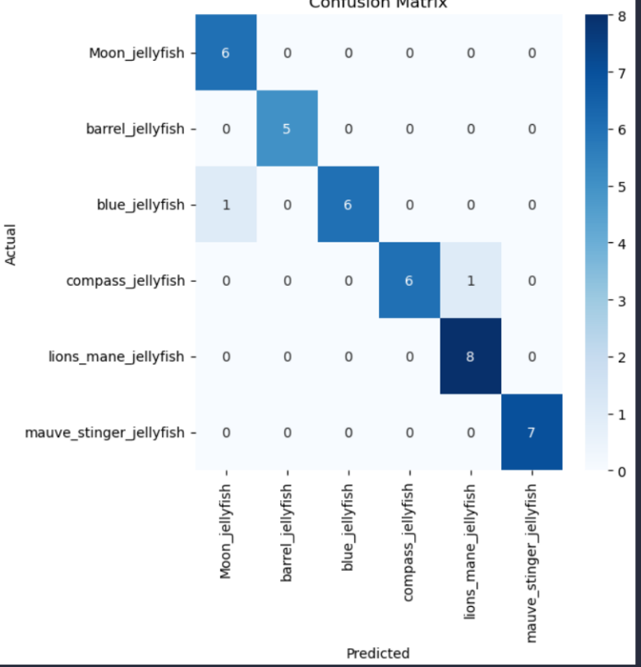
Confusion Matrix of the models result over the trail Data:

This represents a substantial improvement over Approach 1, which achieved an accuracy of 0.60.

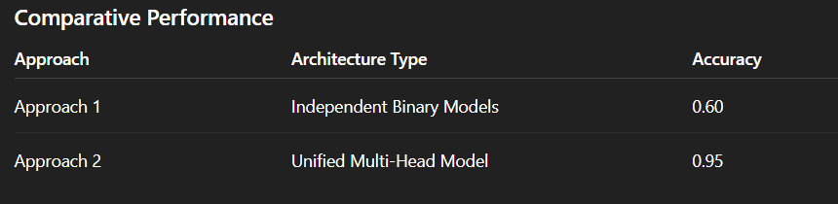
Analysis of Results
1. Shared Feature Learning
- The model learns common features across all classes
- Reduces duplication of effort seen in independent models
- Leads to better representation of image patterns
2. Improved Data Utilization
- Entire dataset is used for training a single model
- Each class benefits from exposure to all samples
- Enhances generalization and robustness
3. Reduced Overfitting
- Shared learning acts as a regularization mechanism
- Prevents individual models from overfitting to limited binary data
4. Consistent Predictions
- All class outputs are generated within the same model
- Reduces inconsistencies seen in independent models
5. Computational Efficiency
- Training a single model significantly reduces:
  - Training time
  - Memory usage
  - Resource consumption

Key Observations
- The unified OvA model successfully retains the benefits of binary classification while eliminating redundancy
- It demonstrates strong adaptability across different datasets
- The architecture proves to be scalable, efficient, and robust
- The significant accuracy improvement validates the design choice

Overall Results & Discussion
This section provides a detailed and comprehensive analysis of the results obtained from both proposed methodologies, along with deeper insights into their performance, behavior, and practical implications. The primary goal of this project was not only to implement the One-vs-All (OvA) strategy but also to evaluate how different architectural designs influence accuracy, efficiency, scalability, and generalization across datasets.
The experimental findings clearly demonstrate that while both approaches are based on the same OvA principle, their performance differs significantly due to differences in implementation strategy and model design.
Overall Performance Comparison
The two approaches yielded the following results:
- Approach 1 (Independent Binary Models):
Overall Accuracy = 0.60
- Approach 2 (Unified Multi-Head OvA Model):
Overall Accuracy = 0.95
The improvement of 35% in accuracy is substantial and highlights the effectiveness of the unified architecture. This difference is not merely incremental but indicates a fundamental improvement in learning capability and model efficiency.

In-Depth Comparative Analysis
1. Learning Paradigm and Data Utilization
In Approach 1, each model is trained independently on a binary subset of the dataset. While this simplifies the classification task for each model, it also restricts the model’s exposure to the full diversity of the data. As a result, each classifier develops a limited understanding of the overall data distribution.
In contrast, Approach 2 utilizes the entire dataset during training. The unified model simultaneously learns all binary classification tasks, allowing it to capture global patterns and inter-class relationships. This holistic learning significantly enhances the model’s ability to generalize.

2. Feature Learning and Representation
One of the most critical differences lies in how features are learned:
- Approach 1:
Each model independently learns features such as edges, textures, and shapes. This leads to:
  - Redundant computations
  - Inconsistent feature representations across models
- Approach 2:
A shared convolutional backbone learns common features once and distributes them across all classification heads. This results in:
  - More stable feature representations
  - Improved learning efficiency
  - Better utilization of learned patterns
This shared learning mechanism is a major contributor to the higher accuracy observed in Approach 2.

3. Computational Complexity and Efficiency
From a computational perspective, the difference between the two approaches is significant:
- Approach 1:
  - Requires training N separate models for N classes
  - Training time increases linearly with the number of classes
  - High memory usage due to multiple model instances
- Approach 2:
  - Requires training only one unified model
  - Reduced training time and memory consumption
  - More efficient use of GPU resources
This makes Approach 2 far more suitable for real-world applications, especially when dealing with large-scale datasets.

4. Scalability and Flexibility
Scalability is a crucial factor in practical machine learning systems:
- Approach 1:
Adding a new class requires training an entirely new model, increasing system complexity.
- Approach 2:
The architecture can be extended by simply adding a new output head, making it:
  - Easier to scale
  - More adaptable to evolving datasets
Additionally, the dataset-agnostic design ensures that the same pipeline can be reused across different datasets without major modifications.

5. Prediction Stability and Consistency
In Approach 1, predictions are derived from multiple independent models. Since these models are trained separately, their confidence scores may not be directly comparable, leading to inconsistent or ambiguous predictions.
In Approach 2, all outputs are generated within a single model, ensuring:
- Consistent probability distributions
- Better calibration of predictions
- More reliable final classification decisions

Behavioral Observations During Training
- Approach 1:
  - Slower convergence due to independent training cycles
  - Variation in performance across different models
  - Some models overfit while others underperform
- Approach 2:
  - Faster and more stable convergence
  - Uniform learning across all classes
  - Better balance between bias and variance

Key Insights Derived from Results
- The OvA strategy is fundamentally sound, but its efficiency depends heavily on implementation.
- Shared feature learning is critical for achieving high performance.
- Training on the entire dataset improves generalization and robustness.
- Reducing redundancy leads to both better accuracy and lower computational cost.
- Architectural design has a greater impact on performance than the choice of classification strategy alone.

Validation of Generalized Architecture
One of the core goals of this project was to develop a dataset-agnostic model. The unified approach (Approach 2) was tested on multiple datasets, and it consistently demonstrated:
- High adaptability to different data distributions
- Minimal need for manual configuration
- Stable performance across datasets
This validates that the proposed architecture is not limited to a single dataset but can be applied broadly in various domains.

Practical Implications
The findings of this project have strong practical relevance:
- Real-world deployment:
The unified model is more suitable for production systems due to its efficiency and scalability.
- Dynamic systems:
Applications that require frequent addition of new classes (e.g., medical diagnosis, object recognition) benefit from the modular OvA design.
- Resource optimization:
Reduced training time and memory usage make the unified approach ideal for environments with limited computational resources.

Final Discussion
The overall results clearly establish that while the One-vs-All strategy simplifies multi-class classification, its true potential is realized only when combined with an efficient architectural design. The independent model approach, although conceptually straightforward and modular, suffers from redundancy, inefficiency, and limited generalization.
On the other hand, the unified OvA model successfully integrates shared learning with class-specific outputs, resulting in superior performance, efficiency, and scalability. The significant improvement in accuracy (0.60 to 0.95) serves as strong evidence of the effectiveness of the proposed approach.
In conclusion, the project demonstrates that a generalized unified One-vs-All architecture is not only a viable alternative to traditional multi-class models but also a more powerful and practical solution for modern image classification challenges.

Conclusion & Future Work
Conclusion
This project successfully explored and implemented the One-vs-All (OvA) learning strategy for image classification, with a primary focus on developing a generalized, scalable, and dataset-agnostic deep learning architecture. Two distinct approaches were designed and evaluated: (1) independent binary classifiers and (2) a unified multi-head OvA model with shared feature representation.
The experimental results clearly demonstrate that while both approaches are built upon the same foundational concept, their effectiveness is significantly influenced by architectural design. The independent model approach, though modular and interpretable, suffers from major limitations such as redundant feature learning, increased computational cost, and reduced generalization. This is reflected in its relatively lower performance, achieving an overall accuracy of 0.60.
In contrast, the unified OvA model addresses these limitations by introducing a shared feature extraction backbone combined with multiple binary output heads. This enables efficient learning of common patterns across classes while preserving class-specific decision boundaries. As a result, the model achieves a significantly higher accuracy of 0.95, demonstrating superior performance, stability, and scalability.
A key contribution of this project is the development of a dataset-agnostic training pipeline, capable of automatically adapting to different datasets without requiring structural changes. This enhances the practical applicability of the model in real-world scenarios where datasets may vary in size, structure, and domain.
Overall, the project establishes that:
- The One-vs-All strategy is an effective alternative to traditional multi-class classification
- Architectural optimization (shared learning) is crucial for maximizing performance
- A unified OvA model provides the best balance between accuracy, efficiency, and scalability
- Generalized frameworks are essential for building reusable and adaptable AI systems
The results strongly validate that the proposed unified OvA architecture is a robust and practical solution for modern image classification tasks.

Future Work
While the proposed system demonstrates strong performance and generalization capability, several enhancements and extensions can be explored to further improve its effectiveness and applicability.
1. Integration of Advanced Architectures
Future work can incorporate more advanced deep learning architectures such as:
- Pretrained models (e.g., transfer learning with ResNet, EfficientNet)
- Attention mechanisms to focus on important image regions
- Vision Transformers (ViTs) for improved feature representation
These enhancements could further boost accuracy and reduce training time.

2. Handling Large-Scale Datasets
The current implementation can be extended to handle:
- Very large datasets with thousands of classes
- Distributed training across multiple GPUs
- Optimized data loading and memory management
This would make the system more suitable for industrial-scale applications.

3. Incorporation of Additional Evaluation Metrics
While accuracy provides a general performance measure, future work can include:
- Precision, Recall, and F1-Score
- Confusion Matrix analysis
- ROC curves for each binary classifier
This would provide deeper insights into model behavior, especially for imbalanced datasets.

4. Real-Time Deployment and Optimization
The model can be adapted for real-world deployment by:
- Converting it into a lightweight version for edge devices
- Using model compression techniques such as pruning and quantization
- Integrating with web or mobile applications for real-time inference

5. Dynamic Class Expansion
One of the advantages of the OvA approach is modularity. Future improvements can focus on:
- Seamless addition of new classes without retraining the entire model
- Incremental learning techniques
- Continual learning frameworks

6. Enhanced Data Augmentation and Regularization
To further improve generalization:
- Advanced augmentation techniques (rotation, flipping, color jittering) can be applied
- Regularization methods such as dropout and batch normalization can be optimized

7. Cross-Domain Applications
The generalized architecture can be extended beyond standard image classification tasks to domains such as:
- Medical image analysis
- Satellite and remote sensing imagery
- Industrial defect detection

Final Remark
The project lays a strong foundation for building flexible, efficient, and scalable classification systems using the One-vs-All strategy. With further enhancements and optimization, the proposed architecture has the potential to evolve into a highly versatile framework applicable across a wide range of AI-driven applications.

References
[1] Y. LeCun, Y. Bengio, and G. Hinton, “Deep learning,” Nature, vol. 521, no. 7553, pp. 436–444, 2015.

[2] A. Krizhevsky, I. Sutskever, and G. E. Hinton, “ImageNet classification with deep convolutional neural networks,” in Advances in Neural Information Processing Systems (NIPS), 2012, pp. 1097–1105.

[3] K. He, X. Zhang, S. Ren, and J. Sun, “Deep residual learning for image recognition,” in Proc. IEEE Conf. Computer Vision and Pattern Recognition (CVPR), 2016, pp. 770–778.

[4] S. J. Pan and Q. Yang, “A survey on transfer learning,” IEEE Transactions on Knowledge and Data Engineering, vol. 22, no. 10, pp. 1345–1359, 2010.

[5] C. M. Bishop, Pattern Recognition and Machine Learning. New York, NY, USA: Springer, 2006.

[6] T. Hastie, R. Tibshirani, and J. Friedman, The Elements of Statistical Learning, 2nd ed. New York, NY, USA: Springer, 2009.

[7] G. Tsoumakas and I. Katakis, “Multi-label classification: An overview,” International Journal of Data Warehousing and Mining, vol. 3, no. 3, pp. 1–13, 2007.

[8] D. P. Kingma and J. Ba, “Adam: A method for stochastic optimization,” in Proc. International Conference on Learning Representations (ICLR), 2015.

[9] N. Srivastava et al., “Dropout: A simple way to prevent neural networks from overfitting,” Journal of Machine Learning Research, vol. 15, pp. 1929–1958, 2014.

[10] PyTorch, “PyTorch: An imperative style, high-performance deep learning library,” [Online]. Available: https://pytorch.org

[11] K. Simonyan and A. Zisserman, “Very deep convolutional networks for large-scale image recognition,” arXiv preprint arXiv:1409.1556, 2014.

