Tab 1
JAVASCRIPT
The map — 11 parts, ~45 videos
Part | What you'll be able to do
1. Foundations | Explain what JS is, where it runs, and set up your machine (videos 1–3)
2. Variables & memory | let/const/var, data types, coercion, stack vs heap (videos 4–10)
3. Built-in types | Strings, numbers/Math, dates (videos 11–13)
4. Arrays & objects | Arrays, objects, destructuring, JSON (videos 14–18)
5. Functions & scope | Params, rest/spread, scope, hoisting, this, IIFE, execution context (videos 19–25)
6. Control flow | if/else, ternary, switch, truthy/falsy (video 26)
7. Loops | for, while, for..of/in, forEach, map/filter/reduce (videos 27–30)
8. The DOM | Select, create, edit, and remove page elements (repo 06_dom)
9. DOM projects | Ship small interactive apps from scratch (repo 07_projects)
10. Events | Listen to clicks/keys, bubbling, delegation (repo 08_events)
11. Async JS | Event loop, setTimeout, Promises, fetch, async/await (repo 09_advance_one)
12. OOP & prototypes | this/new, prototypes, classes, inheritance, getters/setters (repo 10_classes_and_oop)
13. Fun with JS | ES6+ niceties: optional chaining, nullish, short-circuits (repo 11_fun_with_js)

PART 1 · Foundations
🎥 Video 1 — Javascript for beginners | chai aur #javascript
JavaScript is the programming language of the web. It can change and update both HTML & CSS and add interactivity to the webpages.
- Interpreted & dynamically typed. You don't compile it yourself and you don't declare types — a variable can hold a number now and a string later.
- Synchronous. By default JS is synchronous in nature It executes code line by line sequentially. Each operation waits for the last one to complete before executing.
- Single-threaded. It does one thing at a time on one “call stack”.
- Javascript is Case Sensitive and the recommended naming convention is camelCase.
- For Documentation:
  - MDN
  - https://tc39.es/ecma262/
🎥 Video 2 — Setting up environment in local machine for Javascript | chai aur #javascript
- The browser console. Open any page → F12 (or right-click → Inspect) → Console tab. Type JS and press Enter. Fastest way to experiment.
- Node.js. Install from nodejs.org. Now you can run JS files outside the browser: node app.js. This is what backends use.
- Script Tag.
  - Written inside the script tag: <script>...</script>.
  - Written in a separate file which can be linked to HTML:
    - <script src=”hello.js”>...</script>.
    - It separates the HTML and code, easier to read and maintain, cached js files can speed up page loads.
// hello.js → run with: node hello.js
console.log("Hello, Keshav"); // prints to the terminal
// In an HTML file, link it:
// <script src="hello.js"></script>
🎥 Video 3 — Save and work on Github for Javascript | chai aur #javascript
Git tracks changes to your code; GitHub hosts it online — recruiters read your GitHub.
git init # start tracking this folder
git add . # stage all changes
git commit -m "first commit" # save a snapshot
git branch -M main
git remote add origin <repo-url>
git push -u origin main # upload to GitHub
💡 TIP Commit small and often with clear messages. A commit history that reads like a story (“add BMI validation”, “fix clock leading-zero bug”) is itself a signal of professionalism in interviews.
PART 2 · Variables & Memory
🎥 Video 4 — Let, const and var ki kahani | chai aur #javascript
Three ways to declare a variable — but in modern JS you use two of them.
Variable Naming Rules:
- Letters, digits, underscores and $ is allowed.
- Cannot begin with a digit.
- Javascript reserved keywords cannot be used.
Variables which are not initialized are initialized with a value “undefined” by default.
Keyword | Use it?
const | DEFAULT. Can't be reassigned. Block-scoped. Use it for everything you don't reassign.
let | When you WILL reassign (loop counters, accumulators). Block-scoped.
var | Avoid. Function-scoped, hoisted as undefined, allows redeclaration — the source of classic bugs.
const name = "Keshav";
// name = "other"; // ❌ TypeError: Assignment to constant variable
let count = 0;
count = count + 1; // ✅ fine

const user = { age: 22 };
user.age = 23; // ✅ allowed! const locks the BINDING, not the object's contents
⚠️ COMMON MISTAKE const does not mean “immutable”. You can't reassign the variable, but if it holds an object or array you can still change what's inside it. To truly freeze contents, use Object.freeze() (Part 12).
🎯 INTERVIEW “Difference between let, const, var?” Answer with three axes: scope (var = function, let/const = block), reassignment (var/let = yes, const = no), and hoisting/TDZ (var = undefined, let/const = temporal dead zone). Covered fully in Part 5.
Comments: Used for human understanding and are ignored by the compiler.
- // is used to add single line comments.
- /**/ is used for multi-line comments.
🎥 Video 5 — Datatypes and ECMA standards
Every value in JS is one of two families: primitives (simple, immutable values) or objects (collections). There are 7 primitives:
Primitive | Example
String | "hello", `template ${x}`
Number | 42, 3.14, -0, Infinity, NaN
Boolean | true, false
undefined | a variable declared but not assigned
null | intentional “empty” — you set it on purpose
BigInt | 12345678901234567890n (huge integers)
Symbol | Symbol('id') — unique, used as hidden object keys
Everything else — arrays, functions, dates, plain {} objects — is an object (the “non-primitive” / reference type).
typeof "hi" // "string"
typeof 42 // "number"
typeof true // "boolean"
typeof undefined // "undefined"
typeof null // "object" ← famous historical BUG in JS, kept for compatibility
typeof function(){} // "function"
typeof {} // "object"
typeof [] // "object" ← arrays are objects; use Array.isArray([]) to be sure
🎯 INTERVIEW “typeof null?” It returns "object" — a bug from JS's first version that can never be fixed without breaking the web. Interviewers love this one.
🎥 Videos Datatype conversion confusion | chai aur #javascript Why string to number conversion is confusing | chai aur #javascript
JS converts types for you (coercion). Knowing the rules turns “weird” behaviour into predictable behaviour.
Number("42") // 42
Number("42abc") // NaN (Not a Number — a number-typed value meaning “failed”)
Number("") // 0
Number(true) // 1
Number(null) // 0
Number(undefined) // NaN

String(42) // "42"
Boolean(0) // false
Boolean("") // false
Boolean("0") // true ← non-empty string is truthy!
The + operator is special: if either side is a string, it concatenates. Every other math operator (- * / %) forces numbers.
"5" + 2 // "52" (string wins for +)
"5" - 2 // 3 (- forces numbers)
"5" * "2" // 10
10 + "px" // "10px" (handy for CSS)
true + 1 // 2
⚠️ COMMON MISTAKE NaN is “sticky” and NaN !== NaN. Any math with NaN gives NaN. To test for it use Number.isNaN(x), never x === NaN (that's always false).
🎥 Video 8 — Comparison of datatypes in javascript | chai aur #javascript
Two equality operators — and you should use one of them almost always.
- === (strict) — compares value AND type, no conversion. Use this.
- == (loose) — converts types first, then compares. Source of surprises.
5 === 5 // true
5 === "5" // false (number vs string)
5 == "5" // true (== converts "5" to 5)
0 == false // true (both coerce to 0)
null == undefined // true (special rule)
null === undefined // false
"" == 0 // true ← the kind of bug == creates
💡 TIP Rule for life: always use === and !==. The only common exception is x == null, a deliberate shorthand that catches both null and undefined in one check.
Stack and Heap Memory
Where a value lives decides how it copies:
- Primitives live on the stack. Copying a primitive copies the value. The two variables are independent.
- Objects live on the heap; the variable holds a reference (address). Copying an object copies the reference — both names point to the same object.
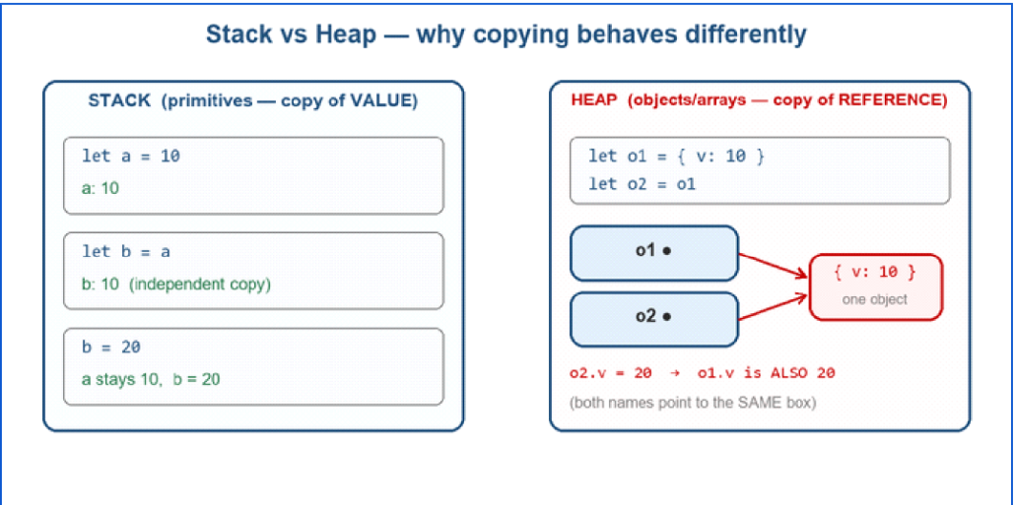
Primitives copy their value (independent). Objects copy their reference (shared) — the #1 source of “why did that other variable change?” bugs.
🎯 INTERVIEW “Pass by value or pass by reference?” JS is always pass-by-value — but for objects, the value being passed IS the reference. So functions can mutate the object you passed in, but reassigning the parameter doesn't affect the caller.

PART 3 · Built-in Types
🎥 Video 11 — Strings in Javascript | chai aur #javascript
Strings are immutable sequences of characters. You never change a string in place — methods return new strings.
const first = "Keshav";
const role = "SDE";
const fullName = new String(“Keshav Khandelwal”);
// template literals (backticks) — the modern way to build strings and preferred way
const line = `${first} is training to be an ${role}`;

first.length // 6
first.toUpperCase() // "KESHAV"
first[0] // "K"
first.charAt(0) // "K"
first.indexOf("s") // 2
first.slice(0, 3) // "Kes" (start, end-exclusive)
" hi ".trim() // "hi"
"a,b,c".split(",") // ["a","b","c"]
"js".includes("j") // true
"abc".replace("a","X") // "Xbc"
💡 TIP Prefer template literals `like ${this}` over "+" concatenation. They read better, handle multi-line strings, and avoid the accidental number+string coercion bugs from Part 2.
🎥 Video 12 — Number and Maths in Javascript | chai aur #javascript
All numbers in JS are 64-bit floating point (there is no separate int type). That has consequences:
0.1 + 0.2 // 0.30000000000000004 ← floating-point rounding
(0.1 + 0.2).toFixed(2) // "0.30" (string, 2 decimals)

const n = 42.7;
Math.round(n) // 43
Math.floor(n) // 42
Math.ceil(n) // 43
Math.trunc(n) // 42 (chops decimals)
Math.max(3, 9, 1) // 9
Math.min(3, 9, 1) // 1
Math.abs(-5) // 5
Math.pow(2, 10) // 1024 (or 2 ** 10)
Math.sqrt(144) // 12

// random integer in [min, max]
const rand = Math.floor(Math.random() * (max - min + 1)) + min;
🎯 INTERVIEW “Why is 0.1 + 0.2 !== 0.3?” Because binary floating point can't represent 0.1 exactly, just like decimal can't write 1/3 exactly. Compare with a tolerance or use toFixed for display.
🎥 Video 13 — Date and time in depth in javascript | chair aur #javascript
const now = new Date(); // current date & time
now.getFullYear() // 2026
now.getMonth() // 0–11 ← January is 0, not 1!
now.getDate() // day of month 1–31
now.getDay() // day of week 0 (Sun) – 6 (Sat)
now.getHours() // 0–23

// build a specific date (month is 0-indexed here too)
const d = new Date(2026, 6, 7); // 7 July 2026

// timestamps (ms since 1 Jan 1970) — great for measuring durations
Date.now() // e.g. 1783372800000
now.toLocaleString("en-IN") // India-formatted string
⚠️ COMMON MISTAKE getMonth() is zero-based (0 = January) but getDate() is one-based. Mixing these up is the most common date bug. Also: getDay() is the weekday, getDate() is the day-of-month — different things.

PART 4 · Arrays & Objects
🎥 Videos 14–15 — Array in Javascript | chai aur #javascript Array part 2 in Javascript Hindi | chai aur #javascript
An array is an ordered, index-from-0 list. It's an object under the hood, so it's a reference type (Part 2 rules apply).
const nums = [10, 20, 30];
nums[0] // random access (10)
nums.length // 3

// add / remove
nums.push(40) // add to END → [10,20,30,40]
nums.pop() // remove from END → returns 40
nums.unshift(5) // add to START → [5,10,20,30]
nums.shift() // remove from START

// the tricky pair
nums.slice(1, 3) // COPY of items 1..2, original untouched
nums.splice(1, 2) // REMOVES 2 items from index 1, MUTATES original

// search & join
nums.includes(20) // true
nums.indexOf(30) // 2
[1,2,3].join("-") // "1-2-3"
[3,1,2].sort() // sorts as STRINGS by default!
⚠️ COMMON MISTAKE slice vs splice: slice() returns a copy and leaves the original alone; splice() mutates the original (removing/inserting). And [3,1,2].sort() gives [1,2,3] but [10,9,100].sort() gives [10,100,9] — it sorts as text unless you pass (a,b) => a-b.
🎥 Videos 16–18 — Objects in depth in javascript in hindi | chai aur #javascript Objects in Javascript part 2 in Hindi | chai aur #javascript Object de-structure and JSON API intro | chai aur #javascript
An object is a collection of key–value pairs (properties). Keys are strings (or Symbols); values are anything.
const user = {
name: "Keshav",
age: 22,
"fav lang": "JavaScript", // multi-word key needs quotes
greet() { return `Hi, ${this.name}`; } // method
};

user.name // "Keshav" (dot notation)
user["fav lang"] // "JavaScript" (bracket notation — needed for spaces/dynamic keys)

const key = "age";
user[key] // 22 ← dynamic key lookup

user.city = "Delhi"; // add
delete user.age; // remove
"name" in user // true
Object.keys(user) // ["name","fav lang","greet","city"]
Object.values(user)
Object.entries(user) // [["name","Keshav"], ...]
🎯 INTERVIEW Dot vs bracket: use dot for known, valid identifier keys; use brackets when the key has spaces/special chars OR when the key is stored in a variable (dynamic access). This shows up constantly in real code.
Destructuring unpacks values out of objects/arrays into variables — you'll see it in every React component.
const user = { name: "Keshav", city: "Alwar", role: "SDE" };

// object destructuring
const { name, city } = user; // name="Keshav", city="Alwar"
const { role: job } = user; // rename → job="SDE"
const { salary = "TBD" } = user; // default if missing

// array destructuring
const [first, second] = [10, 20, 30]; // first=10, second=20
const [head, ...rest] = [1, 2, 3, 4]; // head=1, rest=[2,3,4]

// JSON — the text format APIs speak
const text = JSON.stringify(user); // object → string (to send)
const back = JSON.parse(text); // string → object (when received)
🔑 KEY IDEA JSON looks like a JS object but it's TEXT. APIs send/receive JSON strings; you JSON.parse() what you receive and JSON.stringify() what you send. Keys must be double-quoted in JSON.

PART 5 · Functions, Scope & Execution
🎥 Videos 19–20 — Functions and parameter in javascript | Hindi Functions with objects and array in javascript | chai aur #javascript
Arguments: Values passed to the function while calling.
Parameters should be made a constant to enhance the security of the code.: function function_name (const var, ... ) {}.
// declaration (hoisted — callable before its line)
function add(a, b) { return a + b; }

// expression (NOT hoisted — stored in a variable)
const mul = function (a, b) { return a * b; };

// arrow function (compact; special 'this' — see below)
const sub = (a, b) => a - b;
const square = n => n * n; // one param, one expression

// default parameters
function greet(name = "guest") { return `Hi ${name}`; }

// rest parameter — collect “the rest” into an array
function sum(...nums) { return nums.reduce((t, n) => t + n, 0); }
sum(1, 2, 3, 4); // 10
Spread (...) is the mirror image of rest — it expands an array/object into pieces:
const a = [1, 2], b = [3, 4];
const both = [...a, ...b]; // [1,2,3,4]
const copy = { ...user, city: "Delhi" }; // clone + override
Math.max(...[5, 9, 2]); // spread array into arguments → 9
🎥 Videos 21–22 — Global and local scope in javascript | chai aur #javascript Scope level and mini hoisting in javascript | chai aur #javascript
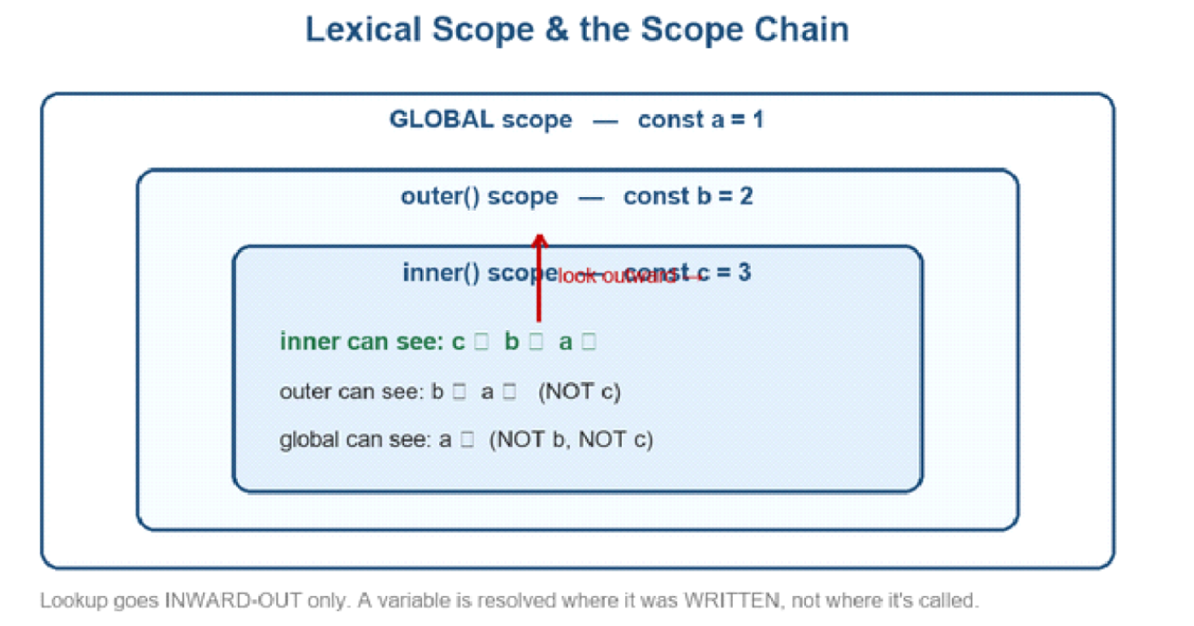
Inner scopes can read outer variables; outer scopes cannot see inner ones. Lookup goes outward only.
Scope = where a variable is visible. JS has global, function, and block ({ }) scope.
const g = "global";
function outer() {
const o = "outer";
function inner() {
const i = "inner";
console.log(g, o, i); // ✅ sees all three (scope chain)
}
inner();
// console.log(i); // ❌ ReferenceError — i is inner-only
}

if (true) {
let blockScoped = 1; // let/const live only in these braces
var functionScoped = 2; // var LEAKS out of the block
}
// console.log(blockScoped) // ❌ not defined
console.log(functionScoped) // 2 ← var ignores block scope
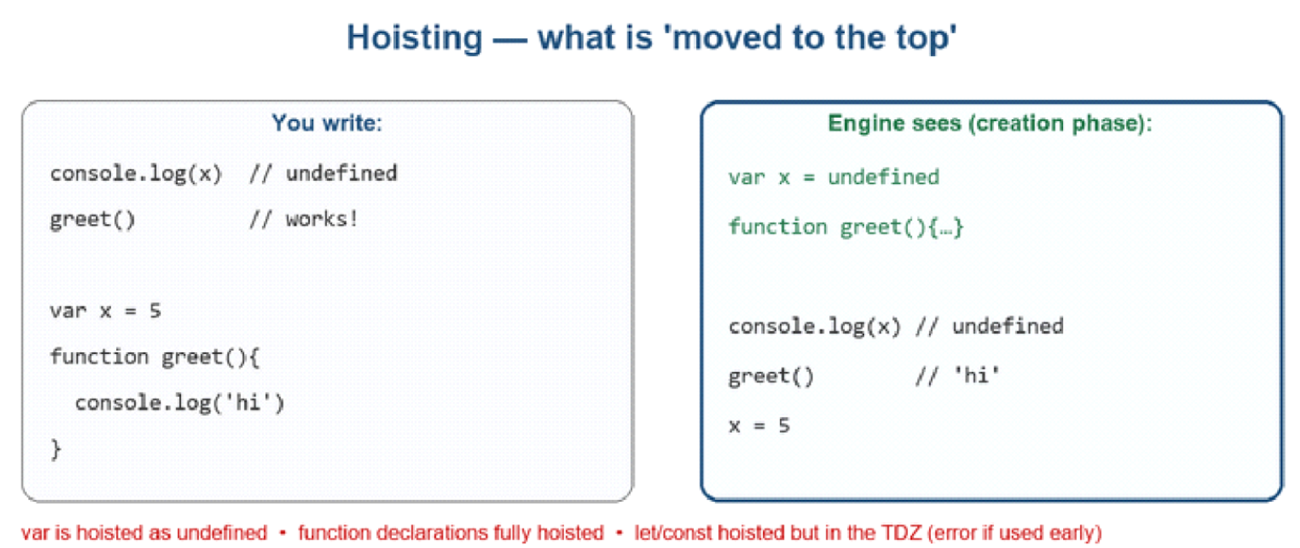
Hoisting: the engine's creation phase registers declarations before any line runs.
Hoisting = during the creation phase, declarations are registered before code runs. But they hoist differently:
- var → hoisted and initialised to undefined (usable early, but empty).
- function declarations → fully hoisted (callable before their line).
- let / const → hoisted but NOT initialised; touching them early throws (the Temporal Dead Zone).
🎯 INTERVIEW “What logs: console.log(x); var x = 5;?” undefined — x is hoisted but not yet assigned. Swap var for let and it throws (TDZ). This exact question is extremely common.
🎥 Video 23 — THIS and arrow function in javascript | chai aur #javascript
this is the object a function is “called on”. Its value depends on HOW the function is called — and arrow functions deliberately break that rule.
const user = {
name: "Keshav",
regular() { return this.name; }, // 'this' = user ✅
arrow: () => this.name, // 'this' = OUTER (not user) ❌
};
user.regular(); // "Keshav"
user.arrow(); // undefined (arrow has no own 'this')

// This is exactly why arrows shine in callbacks:
const timer = {
secs: 0,
start() {
setInterval(() => { this.secs++; }, 1000); // arrow keeps 'this' = timer ✅
}
};
🔑 KEY IDEA Regular functions get their own 'this' from the call site. Arrow functions have NO own 'this' — they borrow it from where they were written. Use regular functions for object methods; use arrows for callbacks where you want to keep the surrounding 'this'.
Arrow functions do not create their own this. They inherit this from the surrounding (lexical) scope.
Regular functions determine this when they are called.
Objects do NOT create a new scope or a new this. The object literal ({}) only creates an object. It does not create a new execution context or a new this.
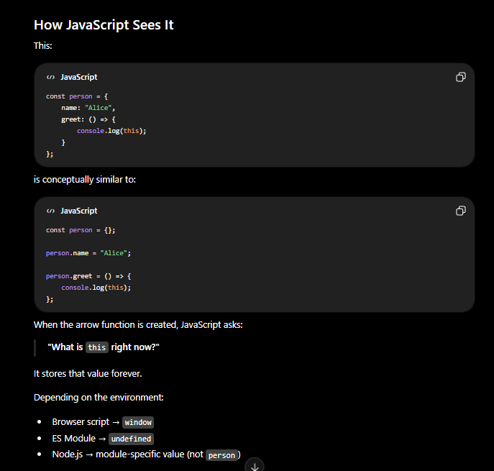
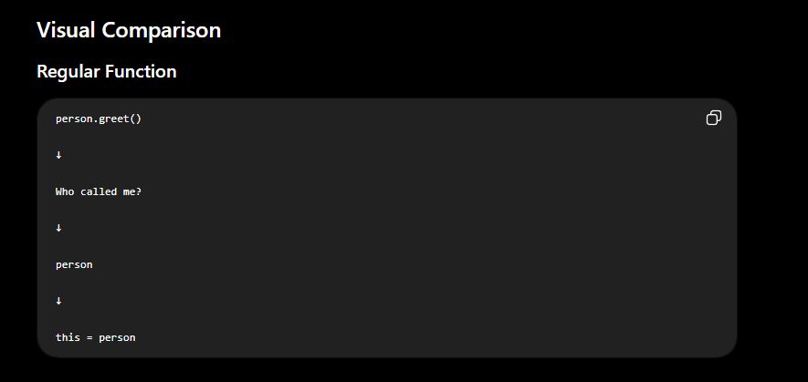
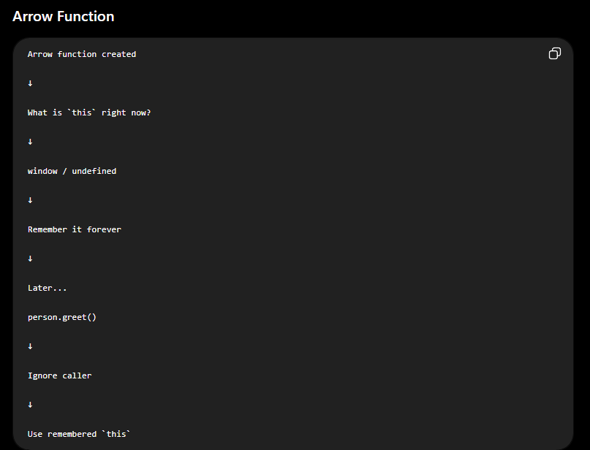
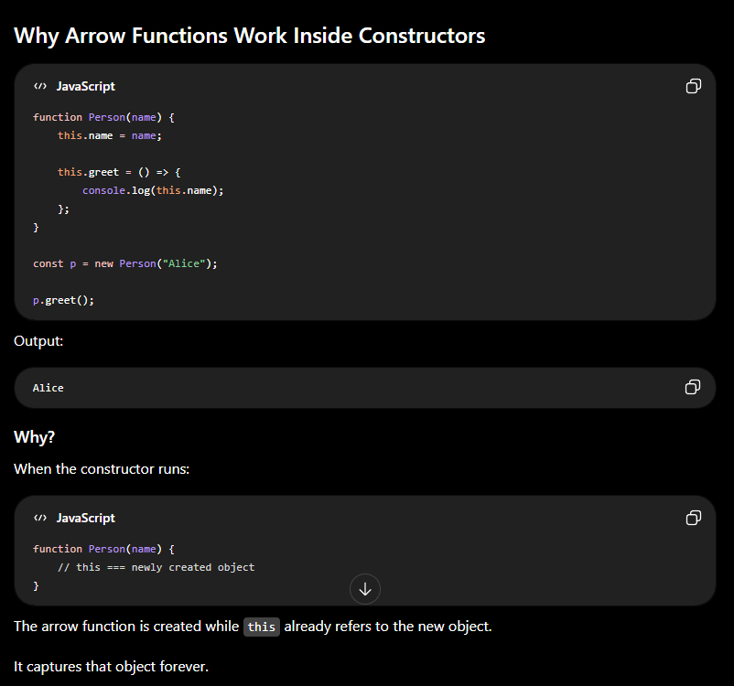
🎥 Video 24 — Immediately Invoked Function Expressions IIFE | chai aur #javascript
(function () {
const secret = "hidden"; // trapped inside — doesn't pollute global scope
console.log("runs immediately");
})();

// arrow IIFE
(() => { console.log("also runs now"); })();
An IIFE runs the moment it's defined. Historically used to create a private scope before let/const/modules existed. You'll still see it in older code and bundlers.
🎥 Video 25 — How does javascript execute code + call stack | chai aur #javascript
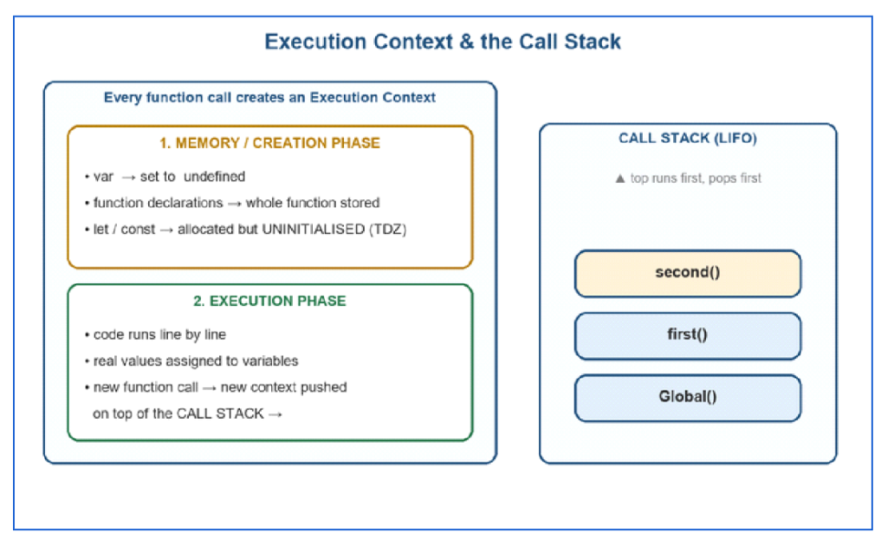
Every call builds an execution context in two phases, and contexts stack up on the call stack (last in, first out).
This ties Part 5 together. When JS runs your file it creates a Global Execution Context, and every function call creates a new one (Function Execution Context).
After execution of every function the function execution context deletes itself.9-
Each context has two phases:
- 1. Memory / creation phase — variables are set up (var → undefined, functions stored whole, let/const in TDZ).
- 2. Execution phase — code runs top to bottom, values get assigned, and each new function call pushes a fresh context onto the call stack.
function first() {
second();
console.log("first done");
}
function second() {
console.log("second done");
}
first();
// Call stack over time:
// [global] → push first() → push second() → log "second done" → pop second() → log "first done" → pop first() → [global]
// Output: second done, first done
🎯 INTERVIEW Be ready to trace the call stack out loud for a nested-function snippet, and to define “stack overflow” — infinite/too-deep recursion filling the call stack. This is the mental model behind the async event loop in Part 11.

PART 6 · Control Flow
🎥 Video 26 — Control flow in javascript in 1 shot | chai aur #javascript
Control flow = deciding which code runs. First, the truthy/falsy rules that power every condition:
🔑 KEY IDEA The 6 falsy values (memorise): false, 0, -0, BigInt 0n, "" (empty string), null, undefined, NaN. EVERYTHING else is truthy — including "0", "false", [], and {}.
// if / else if / else
if (score >= 90) grade = "A";
else if (score >= 60) grade = "B";
else grade = "F";

// ternary — a compact if/else that returns a value
const msg = age >= 18 ? "adult" : "minor";

// switch — clean multi-branch on one value
switch (day) {
case "Sat":
case "Sun":
type = "weekend"; break; // break stops fall-through, no execution after case match
// if break is not written every case after matched case will get executed
default:
type = "weekday";
}

// short-circuit tricks
const port = userPort || 3000; // fallback if userPort is falsy
const name2 = user?.profile?.name; // optional chaining — no crash if missing, undefined if not found (no error)
const seats = count ?? 0; // nullish coalescing: fallback only if null/undefined
⚠️ COMMON MISTAKE || vs ?? : || falls back on ANY falsy value, so 0 || 5 gives 5 (probably not what you want for a real count of 0). ?? only falls back on null/undefined, so 0 ?? 5 gives 0.
💡 TIP Optional chaining + nullish coalescing together are the modern way to read possibly-missing data safely: const n = data?.user?.name ?? "guest";

PART 7 · Loops & Iteration
🎥 Videos 27–28 — For loop with break and continue in javascript | chai aur #javascript While and do while loop in Javascript | chai aur #javascript
for (let i = 0; i < 5; i++) {
if (i === 2) continue; // skip THIS iteration
if (i === 4) break; // exit the loop entirely
console.log(i); // 0, 1, 3
}

let n = 0;
while (n < 3) { console.log(n); n++; } // check, then run

do { console.log("runs once even if..."); }
while (false); // run, then check
🎥 Video 29 — High Order Array loops | chai aur #javascript
const arr = ["a", "b", "c"];

for (const val of arr) { } // VALUES: "a","b","c" ← use for arrays
for (const idx in arr) { } // KEYS/indexes: "0","1","2"
arr.forEach((val, i) => { }); // callback per item (can't break out)

const obj = { x: 1, y: 2 };
for (const key in obj) { } // object keys: "x","y" ← use for objects
⚠️ COMMON MISTAKE for..of = values (arrays). for..in = keys/indexes (objects). Using for..in on an array works but is discouraged: it iterates keys as strings and can pick up inherited properties. Rule: for..of for arrays, for..in for objects.
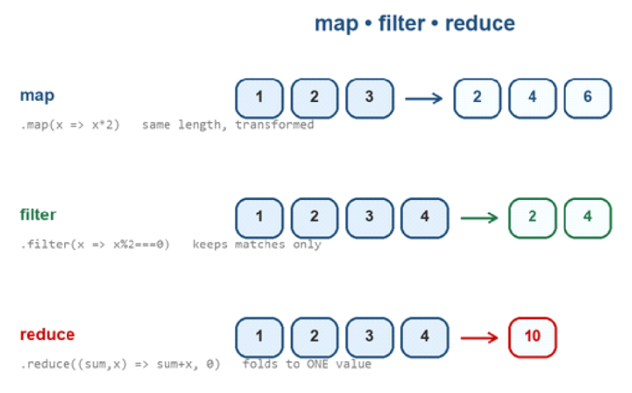
map transforms every item; filter keeps a subset; reduce collapses everything into one value.
🎥 Video 30 — Filter map and reduce in javascript | chai aur #javascript
These three replace most manual loops and are everywhere in React and interviews. All three return a value and do NOT mutate the original array.
const nums = [1, 2, 3, 4, 5];

// map → transform each item, SAME length
const doubled = nums.map(n => n * 2); // [2,4,6,8,10]

// filter → keep items that pass a test
const evens = nums.filter(n => n % 2 === 0); // [2,4]

// reduce → fold everything into ONE result
const total = nums.reduce((acc, n) => acc + n, 0); // 15
// acc = running result (starts at the 2nd arg, 0); n = current item

// they chain beautifully
const sumOfDoubledEvens = nums
.filter(n => n % 2 === 0) // [2,4]
.map(n => n * 2) // [4,8]
.reduce((a, n) => a + n, 0);// 12
🎯 INTERVIEW Expect “implement your own map/filter/reduce” (a polyfill) and “what's the second argument to reduce?” (the initial accumulator value — omit it and reduce uses the first element, which breaks on empty arrays). Know that all three are pure: they return new values, leaving the source array intact.

PART 8 · The DOM
DOM introduction in javascript | chai aur #javascript
Playlist section 06_dom. The DOM (Document Object Model) is the browser's live, tree-shaped representation of your HTML. JavaScript reads and edits this tree, and the page updates instantly.
- document ⇒ root HTML document.
- document.body ⇒ body of the HTML document.
- There are 3 types of nodes:
  - Text Nodes: leaf of the DOM tree.
  - Element Nodes
  - Comment Nodes
- If the JS is written at the top of the body, then the document.body will return a NULL object.
- Child Nodes: Elements that are direct children, For eg: head and body are direct children of html.
- Descendent Nodes: All nested elements, children, their children and so on.
- NodeList and HTML Collection looks like array but they are not an array, they are a collection. So, the array methods does not work on NodeList and HTML Collection
- For Element Nodes:
  - .innerHTML: Get/Set the HTML inside the element (excluding the element itself) as a string.
  - .outerHTML: Get/Set the HTML including the element. (innerHTML + the element itself).
  - .textContent: Get/Set only the text inside the element.
- For other node types:
  - .nodeValue: Get/Set the value of the node (Used for text, comment, etc).
  - .data: Same as nodeValue, can manipulate the text data directly.
- Attribute Methods:
Object Properties | Description
.hasAttribute(‘attribute_name’); | Check for existence of an attribute
.getAttribute(‘attribute_name’); | Get the value of an attribute
.setAttribute(‘attribute_name’, attribute_value’); | Set the value of an attribute.
.removeAttribute(‘attribute_name’); | Remove the attribute from the element.
.attributes | Get all the attributes of the element
.dataset | Contains all the custom attributes created by the programmer. For eg:  the attribute data-one is available as elem.dataset.one

DOM Insertion:
Object Properties | Description
.createElement(‘element_name’); | Creates a new element.
.className = ‘class_name’ | Set Class of the element.
.append(element_object); | Appends the new element at the end.
.prepend(element_object); | Appends the new element at the beginning.
.before(element_object); | Insert before the node.
.after(element_object); | Insert after the node.
.replaceWith(element_object); | Replaces node with the given node.

- .insertAdjacentHTML: Used to insert HTML adjacently, where the first parameter is a code word specifying where to insert.
  - beforebegin: Insert HTML immediately before element
  - afterbegin: Insert HTML immediately after the beginning of the element
  - beforeend: Insert HTML immediately before the end of the element
  - afterend: Insert HTML immediately after element
- Node Removal: .remove()
- Class Operations:
  - Appends class to the classlist: elem.classlist.add('class');
  - Remove class from the classlist: elem.classlist.remove('class');
  - toggle class in and out of the classlist: elem.classlist.toggle('class');
  - Checks if the given class is in classlist or not: elem.classlist.contains('class');
Object Properties | Description
.firstChild | Returns the first child of the object.
.lastChild | Returns the last child of the object.
.firstElementChild | Returns the first child which is an element.
.lastElementChild | Returns the last child which is an element.
.childNodes | Return all the child nodes of the object.
.children | Returns all the child elements of the object.
.hasChildNodes() | Returns boolean true if child nodes exist else returns false.
.parentNode | Returns the parent node of the element object.
.parentElement | Returns the parent element of the element object.
.NextElementSibling | Returns the next sibling which is an element.
.NextSibling | Returns the next sibling.
.previousElementSibling | Returns the previous sibling which is an element.
.previousSibling | Returns the previous sibling.

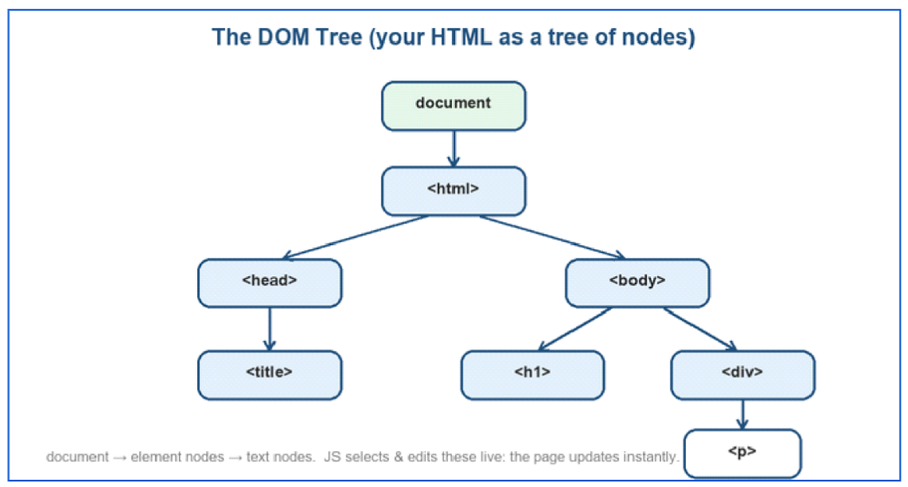
Your HTML becomes a tree of nodes under `document`. JS walks and edits this tree.
🎥 DOM · videos — All DOM selectors NodeList and HTMLCollection | chai aur #javascript
// modern, preferred — CSS-selector based
document.querySelector(".btn"); // first match (or null)
document.querySelectorAll("li"); // ALL matches → NodeList
// older, still common
document.getElementById("title") // by id (no # needed)
document.getElementsByClassName("x") // live HTMLCollection
document.getElementsByTagName("p")
⚠️ COMMON MISTAKE querySelectorAll returns a NodeList, getElementsByClassName returns an HTMLCollection — neither is a real array. To use map/filter, convert first: Array.from(nodeList) or [...nodeList]. NodeList does have forEach; HTMLCollection does not.
🎥 DOM · videos — How to create a new element in DOM | chai aur #javascript Edit and remove elements in DOM | chai aur #javascript
const el = document.querySelector("#title");
el.innerText; // text in the element visible on the page
el.textContent; // text in the element (both visible and hidden) on the page
// read / write content
el.textContent = "Hello"; // text only (safe)
el.innerHTML = "<b>Hi</b>"; // parses HTML (careful: XSS risk with user input)

// attributes & styles & classes
el.setAttribute("id", "main");
el.style.color = "red";
el.classList.add("active");
el.classList.toggle("dark");

// create & insert
const li = document.createElement("li");
li.textContent = "New item";
document.querySelector("ul").append(li);

// remove
li.remove();
💡 TIP Prefer textContent over innerHTML when you're inserting plain text — it's faster and immune to script-injection (XSS). Reserve innerHTML for trusted HTML you control.

PART 9 · DOM Projects
Lets build 4 javascript projects for beginners | chai aur #javascript 2 projects with Async JS | chai aur #javascript
Playlist section 07_projects. Hitesh builds small apps to cement Parts 7–8. Build each yourself without looking, then compare. Here's what each one teaches:
Project | Core concepts it drills
Colour flipper / background changer | querySelector, addEventListener('click'), changing style, random selection
BMI calculator | reading form <input> values, Number() conversion, if/else ranges, template output
Digital clock | new Date(), setInterval, padStart for leading zeros, updating textContent
Guess the number | state in variables, loops/attempts, comparisons, disabling inputs, arrays of guesses
Keyboard event viewer | keydown/keyup events, the event object (e.key, e.code), building elements dynamically
// Digital clock — the pattern behind most of these projects
const clock = document.querySelector("#clock");
setInterval(() => {
const now = new Date();
const hh = String(now.getHours()).padStart(2, "0");
const mm = String(now.getMinutes()).padStart(2, "0");
const ss = String(now.getSeconds()).padStart(2, "0");
clock.textContent = `${hh}:${mm}:${ss}`; // refreshes every second
}, 1000);
💡 TIP These five are perfect “explain your code” interview warm-ups and great first commits on your GitHub. Add one improvement each recruiter won't expect (localStorage to remember state, a keyboard shortcut) — small polish reads as care.

PART 10 · Events
Events in Javascript | chai aur #javascript
Playlist section 08_events. Events are how your code reacts to the user — clicks, key presses, form submits, mouse moves.
addEventListener(type, listener, useCapture = false).
Event Bubbling: When an event occurs on an element, it first runs on the target element and then bubbles up through its ancestors (parent elements) all the way to the root.
If the same event is applied on the element and its parents, then all event handlers will trigger.
It can be prevented by stopping the event propagation.
const func = (e) => {e.stopPropogation();}
const btn = document.querySelector("#save");

btn.addEventListener("click", function (e) {
e.preventDefault(); // stop default (e.g. form submit / link nav)
console.log(e.target); // the element that fired the event
console.log(e.type); // "click"
});

// keyboard
document.addEventListener("keydown", (e) => {
console.log(e.key); // "a", "Enter", "ArrowUp"
});
document.body.addEventListener("click", () => {
console.log("Body");
}, false); // Bubbling (default)

document.body.addEventListener("click", () => {
console.log("Body (capture)");
}, true); // Capturing
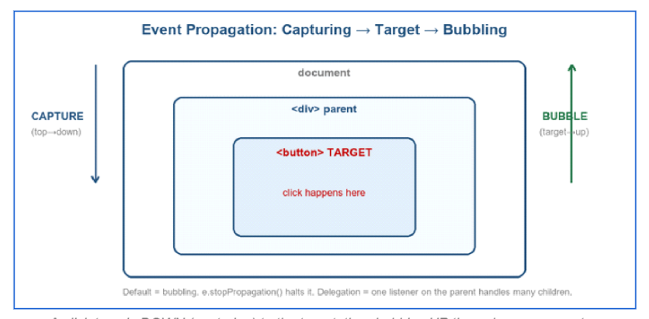
A click travels DOWN (capturing) to the target, then bubbles UP through every ancestor.
Third Parameter (useCapture):
- false (default): Listen during the bubbling phase.
- true: Listen during the capturing phase.
Event propagation: When an event occurs, it goes through three phases:
- Capturing: From the document down to the target.
- Target: The event reaches the target element.
- Bubbling: From the target back up to the document.
When you click a button inside a div inside the body, the event travels in phases: capturing (document → target), then bubbling (target → document). By default your listeners fire in the bubbling phase.
- e.stopPropagation() — stop the event travelling further up/down.
- e.preventDefault() — stop the browser's default action (form submit, link follow).
Properties of Event Object:
- type: Returns the type of event
- timestamp: returns the time (in milliseconds) when the event was created
- defaultPrevented: Tells whether the browser's default action has been prevented. (its not a function, its a value)
- target: The element that actually triggered the event.
- currentTarget: The element on which the event listener is attached. Difference between target and currentTarget is very important for event bubbling:
  - target → where the event started
  - currentTarget → where the listener is running
- relatedTarget: which element the mouse came from or is going to during mouse transition. Mostly used with
  - mouseover
  - mouseout
- clientX: Mouse position relative to the browser window.
- clientY: Vertical mouse position relative to the browser window.
- screenX: Mouse position relative to the user's entire screen.
- screenY: Vertical mouse position relative to the screen.
- altKey: Returns true if Alt key was pressed.
- ctrlKey: Returns true if Ctrl is pressed.
- shiftKey: Returns true if Shift is pressed.
- key: which key the user actually pressed
- code: which physical key on the keyboard was pressed, regardless of the character it produced.
🎯 INTERVIEW Event delegation is the classic question: put ONE listener on a parent and read e.target to handle clicks on any child — even children added later. It's fewer listeners and works for dynamic lists.
// delegation: one listener handles every <li>, present or future
document.querySelector("ul").addEventListener("click", (e) => {
if (e.target.tagName === "LI") {
console.log("clicked:", e.target.textContent);
}
});

PART 11 · Asynchronous JavaScript
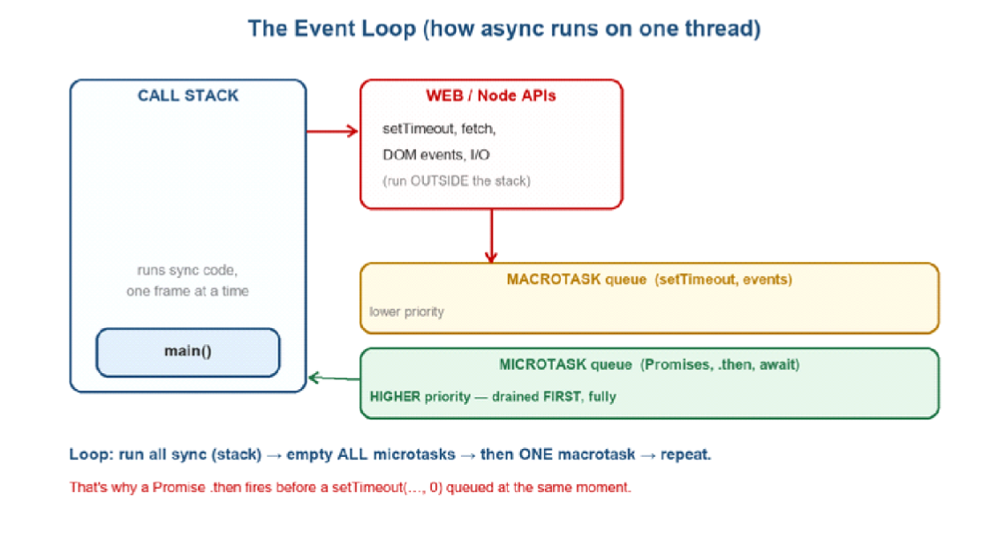Sync code runs on the call stack; async callbacks wait in queues; the event loop feeds them back in — microtasks (Promises) before macrotasks (setTimeout).
🎥 Async · videos — Async Javascript fundamentals | chai aur #javascript
The call stack runs your synchronous code.
- Blocking Code: Blocks the flow of the program (Read file sync)
- Non - Blocking Code: Do not block the execution (Read file async)
Slow things (timers, network, DOM events) are handed to the browser/Node APIs, which run them outside the stack. When they finish, their callbacks wait in a queue. The event loop moves a callback onto the stack only when the stack is empty.
- Microtask queue (Promise .then/.catch, await continuations) — HIGH priority, fully drained first.
- Macrotask queue (setTimeout, setInterval, DOM events) — one is taken only after all microtasks are done.
Callback Functions: Functions that are passed into another function as an argument, which is then invoked inside the outer function to complete an action. For example, the setTimeout function takes a callback function as an argument
console.log("1");
setTimeout(() => console.log("2"), 0); // macrotask
Promise.resolve().then(() => console.log("3")); // microtask
console.log("4");
// Output: 1, 4, 3, 2
// sync (1,4) → microtasks (3) → macrotasks (2), even with 0ms delay
🎯 INTERVIEW That output order (1,4,3,2) is one of the most-asked JS interview questions. The reason: microtasks (Promises) always run before the next macrotask (setTimeout), regardless of a 0 ms delay.
🎥 Async · videos — API request and V8 engine | chai aur #javascript
const id = setTimeout(() => console.log("once, later"), 2000);
clearTimeout(id); // cancel before it fires

const t = setInterval(() => console.log("every 1s"), 1000);
clearInterval(t); // stop the repetition
⚠️ COMMON MISTAKE setTimeout(fn, 1000) does not guarantee 1000 ms — it means “no sooner than 1000 ms, once the call stack is free.” It's a minimum delay, not an exact one.
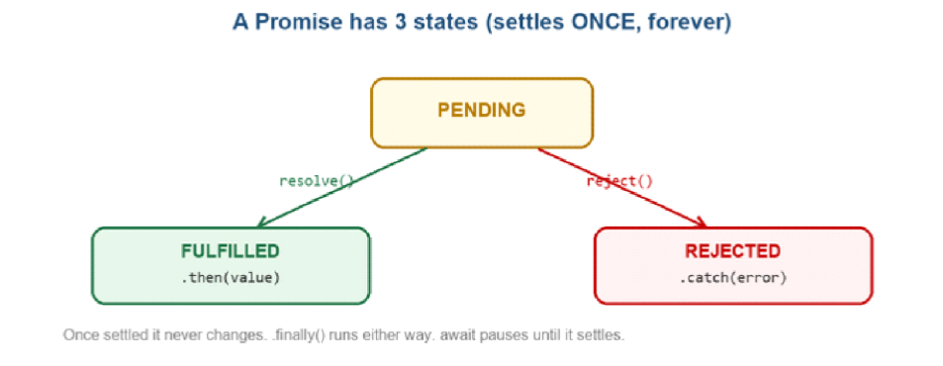
A promise is pending, then settles once — fulfilled or rejected — and never changes again.
🎥 Async · videos — Promise in javascript | chai aur #javascript
- A Promise is an object representing a value that will exist later. It represents the eventual completion (or failure) of an asynchronous operation and its resulting value.
- It's the modern replacement for callback nesting (“callback hell”).
- There are three states of a promise:
  - Pending: Initial State, neither fulfilled nor rejected
  - Fulfilled: Operation completed successfully
  - Rejected: Operation failed.
- Consuming a Promise:
  - .then(): When a promise is completed successfully it returns the resolved output object to the .then().
  - .catch(): When a promise is failed it returns the rejected object to the .catch().
- Promise.all([promise1, promise2, ...]);: used to run multiple promises parallelly at once.
- Promise.allSettled([promise1, promise2, ...]);: Waits for all the promises to settle and returns their results as an array of objects with status and value.
- Promise.race([promise1, promise2, ...]);: waits for the first promise to resolve or reject and its result/error is returned.
- Promise.any([promise1, promise2, ...]);: Waits for the first promise to fulfill and not get rejected and its result is returned. Throws error if all the promises are rejected.
- Async:
  - A function can be made asynchronous by simply using the async keyword. For eg: const func = async () => {}
  - The async function always returns a promise. We can chain this function with .then() and .catch().
- Await:
  - The await keyword makes JS wait until the promise settles or rejects and returns the value. It can only be used inside an async function.
const func = async () => {
const res = await fetch();
}
const p = new Promise((resolve, reject) => {
const ok = true;
if (ok) resolve("data ready");
else reject(new Error("failed"));
}); // new promise is created

p.then(value => console.log(value)) // on fulfilment
.catch(err => console.log(err.message)) // on rejection
.finally(() => console.log("done either way"));

// chaining — each .then passes its return to the next
fetchUser()
.then(user => fetchPosts(user.id))
.then(posts => console.log(posts))
.catch(err => console.log(err));
🎥 Async · videos — Now you know fetch in javascript | chai aur #javascript
A fetch() promise only rejects when a network error is encountered (which is usually when there's a permissions issue or similar). A fetch() promise does not reject on HTTP errors (404, etc.). Instead, a then () handler must check the Response.ok and/or Response.status properties.
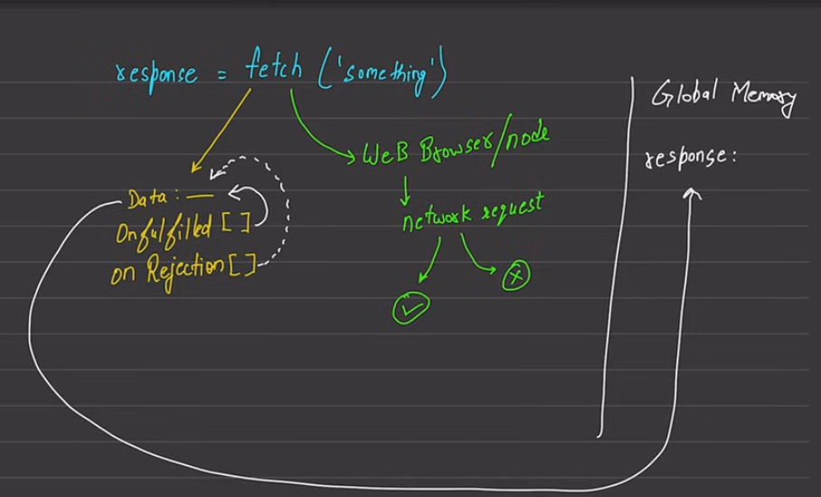
// fetch returns a promise; note the TWO awaits (response, then body)
fetch("https://api.example.com/users")
.then(res => res.json()) // parse JSON body (also a promise)
.then(data => console.log(data))
.catch(err => console.log("network error", err));
🎥 Async · videos — async / await
async/await is syntax sugar over promises — it lets you write asynchronous code that reads like synchronous code. An async function always returns a promise; await pauses until a promise settles.
async function loadUsers() {
try {
const res = await fetch("https://api.example.com/users");
if (!res.ok) throw new Error(`HTTP ${res.status}`);
const data = await res.json();
return data;
} catch (err) {
console.log("failed:", err.message); // handles both network & thrown errors
}
}

// run promises in PARALLEL, wait for all
const [a, b] = await Promise.all([fetch(urlA), fetch(urlB)]);
🎯 INTERVIEW Two favourites: (1) “async/await vs .then?” — same engine, await is more readable and uses try/catch for errors. (2) “Promise.all vs Promise.race?” — all waits for every promise (rejects if any one fails); race settles as soon as the first one settles.

PART 12 · OOP & Prototypes
Object Oriented in Javascript | chai aur #javascript
Playlist section 10_classes_and_oop. Object-oriented JS, and the prototype system that quietly powers all of it.
🎥 OOP · videos — this, the new keyword & prototypes
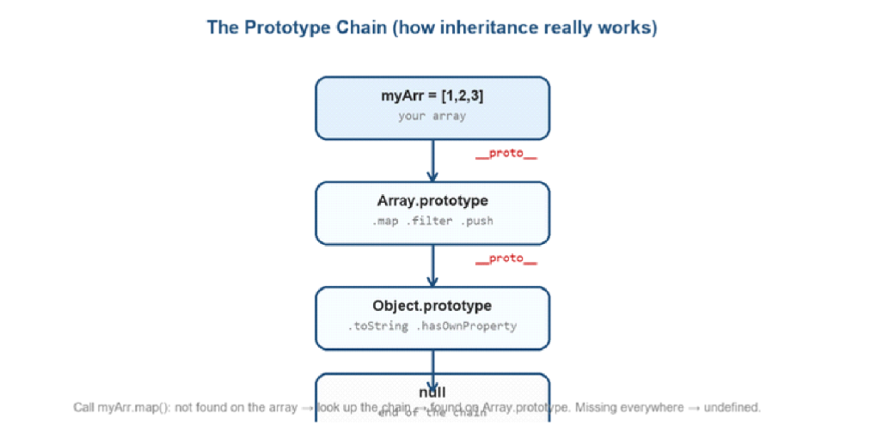
Every object links to a prototype; missing properties are looked up the chain until Object.prototype, then null.
JS is prototype-based language and its classes are primarily syntactic sugar over existing prototype-based inheritance mechanisms.
Every JS object has a hidden link (__proto__) to another object, its prototype. Ask for a property that isn't on the object and JS walks up this chain until it finds it or hits null. That's how myArr.map() works — map lives on Array.prototype, not on your array.
The ‘new’ keyword creates a new instance / context of that object. this new instance is an empty object
A constructor is called which packs all the data and methods in that empty object
Magic of Prototype in javascript | chai aur #javascript
Here's what happens behind the scenes when the new keyword is used:
- A new object is created: The new keyword initiates the creation of a new JavaScript object.
- A prototype is linked: The newly created object gets linked to the prototype property of the constructor function. This means that it has access to properties and methods defined on the constructor's prototype.
- The constructor is called: The constructor function is called with the specified arguments and this is bound to the newly created object. If no explicit return value is specified from the constructor, JavaScript assumes this, the newly created object, to be the intended return value.
- The new object is returned: After the constructor function has been called, if it doesn't return a non-primitive value (object, array, function, etc.), the newly created object is returned.

.prototype | __proto__
A Property of constructor functions / classes | A Property of objects
Used to define shared methods for instances | Points to an object's prototype
Used when creating objects with new | Used during prototype chain lookup
Access: Person.prototype | Access: person.__proto__

Object.getPrototypeOf(obj) | Object.setPrototypeOf(obj, proto)
Gets an object's prototype | Sets an object's prototype
Returns the prototype object | Returns the modified object
Preferred over obj.__proto__ | Preferred over obj.__proto__ = ...

// constructor function + 'new'
function User(name) {
this.name = name; // 'new' creates {}, binds 'this' to it, returns it
}
User.prototype.greet = function () { // shared by ALL instances (one copy)
return `Hi, ${this.name}`;
};
const u = new User("Keshav");
u.greet(); // "Hi, Keshav" (found on the prototype)
🎯 INTERVIEW “What does new do?” Four steps: (1) creates an empty object, (2) links its __proto__ to the constructor's prototype, (3) binds this to the new object and runs the constructor, (4) returns the object automatically. A frequent whiteboard question.
🎥 OOP · videos — Call and this in javascript | chai aur #javascript Bind in javascript | chai aur #javascript
function intro() { return `I'm ${this.name}`; }
const a = { name: "Keshav" };

intro.call(a); // "I'm Keshav" — call now, this = a
intro.apply(a); // same, but extra args come as an ARRAY
const bound = intro.bind(a); // returns a NEW function with this locked to a
bound(); // "I'm Keshav"
🔑 KEY IDEA call and apply invoke the function immediately (call takes args one-by-one, apply takes an array). bind does NOT invoke — it returns a new function with this permanently fixed, to call later.
🎥 OOP · videos — Class constructor and static | chai aur #javascript
- ES6 classes are cleaner syntax over the same prototype mechanism — not a new object model.
- Method Overriding: When the inherited methods are redefined in the class. If we want to run both the methods then we can use the super keyword to call the method from the Parent class.
class Child extends Parent {
constructor (a,b) {
super(a, b);
}
run () {
super.run();
this.hide();
}
}
class Animal {
constructor(name) { this.name = name; }
speak() { return `${this.name} makes a sound`; }
}

class Dog extends Animal { // inheritance
constructor(name) {
super(name); // call parent constructor FIRST
}
speak() { return `${this.name} barks`; } // override
}

const d = new Dog("Bruno");
d.speak(); // "Bruno barks"
d instanceof Animal; // true
🎥 OOP · videos — Getter Setter and Stack Overflow | chai aur #javascript
class MathUtil {
static PI = 3.14159; // belongs to the CLASS, not instances, instances cannot access static properties
static square(n) { return n * n; }
}
MathUtil.square(5); // 25 (call on the class itself)

class Temp {
#celsius = 0; // # = truly private field
get fahrenheit() { return this.#celsius * 9/5 + 32; } // read like a property
set fahrenheit(f) { this.#celsius = (f - 32) * 5/9; } // write like a property
}
const t = new Temp();
t.fahrenheit = 100; // uses the setter
t.fahrenheit; // uses the getter → 100

// low-level control
Object.freeze(obj); // no changes at all
Object.defineProperty(obj, "id", { value: 1, writable: false, enumerable: false });
🎯 INTERVIEW Know: static members are called on the class (not instances); getters/setters let a method masquerade as a property; and Object.freeze() gives shallow immutability (top level only — nested objects can still change).

Appendix · JavaScript Interview Quick-Fire
- Closure: In JavaScript, when we return a function from another function, we are effectively returning a combination of the function definition along with the function's scope. This would let the function definition have an associated persistent memory which could hold on to live data between executions. That combination of the function and its scope chain is what is called a closure in JavaScript.
- Currying:
  - Function currying is a functional programming technique where a function with multiple arguments is transformed into a sequence of functions, each taking a single argument. For eg: func(a, b, c) can be rewritten as func(a)(b)(c);
  - Without currying:
function sum(a, b, c){
return a+b+c;
}
console.log(sum(2,3,5));
  - With currying:
function curry(fn) {
return function(a) {
return function (b) {
return function (c) {
fn(a, b, c);
}
}
}
}
const curriedSum = curry(sum);
console.log(curriedSum(2)(3)(5));

Quest 2 is your “JS interview zone” week (Namaste JavaScript pairs perfectly here). Rehearse these out loud — say the answer as if to an interviewer.

Question | One-line answer
var vs let vs const | var = function-scoped + hoisted-as-undefined; let/const = block-scoped + TDZ; const can't be reassigned.
== vs === | === compares value+type without coercion (use it); == coerces first (surprises).
What is hoisting? | Declarations registered in the creation phase before code runs; var→undefined, functions full, let/const→TDZ.
What is a closure? | A function that remembers variables from the scope where it was created, even after that scope returns.
What is the TDZ? | The gap between a let/const being hoisted and being assigned; using it there throws a ReferenceError.
this in a regular vs arrow fn | Regular: set by the call site. Arrow: inherited from the surrounding scope (no own this).
Explain the event loop | Sync on the call stack; async callbacks queue; loop drains all microtasks (Promises) before each macrotask (setTimeout).
Output of Promise vs setTimeout | Promise .then (microtask) runs before setTimeout 0 (macrotask).
What does 'new' do? | Creates an object, links its prototype, binds this + runs the constructor, returns the object.
call/apply/bind | call/apply invoke now (apply takes an array); bind returns a new fixed-this function for later.
Promise.all vs race | all waits for every promise (fails if one fails); race settles on the first to settle.
null vs undefined | undefined = not assigned yet; null = intentionally empty (you set it).
shallow vs deep copy | Shallow copies top level (spread/Object.assign); nested objects stay shared. Deep = structuredClone(obj).
map vs forEach | map returns a new array (transform); forEach returns nothing (side effects), can't be chained.

🔑 KEY IDEA The one habit that beats all these notes: after each video, close it and rebuild the example from memory in the console. If you can't, rewatch that part. Recall — not re-reading — is what makes it stick under interview pressure. 🎯

