REACT
The Complete Notes
A companion to the “React JS Tutorial for Beginners” series by Codevolution
▶ Open the Codevolution channel on YouTube
Notes for Keshav Khandelwal • Operation: Dilli Chalo • The React quest (builds on the JavaScript notes)

How to use this book
These are structured, exam-ready notes for learning React from scratch — every core concept, with runnable JSX, diagrams for the ideas that are hard to picture, and boxes flagging the exact things interviewers probe and beginners trip on.
- Watch first, then read. Watch a Codevolution video, then read its section here to lock it in. These notes are revision + depth, not a replacement for building.
- Type every code block. Reading JSX teaches nothing; running it teaches everything. Spin up a Vite React app (npm create vite@latest) and try each snippet, then break it on purpose.
- The boxes matter most. 🎯 = an interviewer will ask this. ⚠️ = you will get this wrong at least once. 🔑 = the mental model to keep. 💡 = a shortcut worth knowing.

🔑 KEY IDEA Honesty note: this is a curriculum-based companion, not a transcript of any single video. The parts and topic order follow how Codevolution's React series is taught, but the wording, code, and diagrams are original. It assumes you have already worked through the JavaScript notes (functions, arrays, objects, destructuring, .map(), async/await) — React leans on all of it constantly.

The map — 11 parts
Part | What you'll be able to do
1. Why React + JSX | Explain SPAs & declarative UI, and write correct JSX
2. Components & props | Build reusable components and pass data in with props
3. State & events | Make UI interactive with useState and event handlers
4. Lists & conditionals | Render arrays with .map()+keys and show/hide UI
5. Forms | Build controlled inputs, handle submit, validate
6. useEffect | Run side effects, fetch data, clean up correctly
7. Hooks in depth | useRef, useContext, useMemo, useCallback, useReducer, custom hooks
8. Context API | Kill prop drilling with createContext + useContext
9. React Router | Client-side routing, params, nested routes, navigation
10. How React works | Virtual DOM, reconciliation, re-renders, StrictMode, batching
11. Patterns & perf | Lifting state, composition, memo, avoiding wasted renders

PART 1 · Why React + JSX

🎥 Part 1 — What React is and the SPA idea
React is a JavaScript library for building user interfaces out of components — small, reusable pieces that each return some UI. You describe WHAT the screen should look like for a given state, and React figures out HOW to update the real page.
- It's a library, not a framework. React handles the view layer. Routing, data fetching, and build tooling come from separate packages (React Router, fetch/axios, Vite).
- It powers Single-Page Applications (SPAs). The browser loads one HTML page once; React then swaps the visible UI with JavaScript as the user navigates, so there is no full page reload.
- Component-based. Your whole app is a tree of components — an <App/> at the root with children nested inside, each responsible for one bit of the screen.
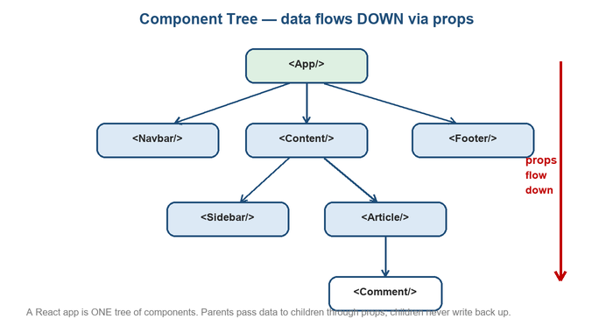
A React app is one tree of components. Data flows DOWN from parents to children through props.

🎥 Part 1 — Declarative vs imperative
This is the mental shift that makes React click. Imperative code lists the steps to change the DOM by hand; declarative code just describes the result and lets React do the DOM work.
// IMPERATIVE (vanilla JS) — you micromanage the DOM
const btn = document.querySelector("#like");
let liked = false;
btn.addEventListener("click", () => {
liked = !liked;
btn.textContent = liked ? "Liked" : "Like"; // you update the DOM yourself
});

// DECLARATIVE (React) — you describe UI for the current state
function LikeButton() {
const [liked, setLiked] = useState(false);
return (
<button onClick={() => setLiked(!liked)}>
{liked ? "Liked" : "Like"}
</button> // React updates the DOM to match this description
);
}
🔑 KEY IDEA Declarative means: UI is a function of state. You never write "go find that node and change its text." You change state; React re-derives the UI and patches the DOM for you.

🎥 Part 1 — JSX — HTML-like syntax inside JavaScript
JSX lets you write markup right inside your JavaScript. It is not HTML and not a string — it is syntax that compiles to function calls. A few rules you must follow:
- One root element. A component must return a single parent node. Wrap siblings in a <div> or an empty Fragment <>…</>.
- Self-close empty tags. <img />, <br />, <input /> — the trailing slash is required.
- className, not class. Because class is a reserved word in JS. Similarly htmlFor instead of for, and attributes are camelCase (onClick, tabIndex).
- Styles: When writing inline styles in JSX the first curly braces denote that javascript is to be written inside and second curly brace marks the javascript object.
- {expressions} for JS. Curly braces drop any JavaScript expression into JSX — a variable, a call, a ternary. Statements (if, for) are not allowed inside.
function Greeting() {
const name = "Keshav";
const isMorning = new Date().getHours() < 12;
return (
<div className="card" style = {{ font-weight:bold }}>
<h1>Hello, {name}</h1> {/* expression */}
<p>{isMorning ? "Good morning" : "Hello"}</p> {/* ternary */}
<img src="/avatar.png" alt="" /> {/* self-closed */}
</div> {/* single root */}
);
}
⚠️ COMMON MISTAKE Adjacent JSX elements must be wrapped. Returning two siblings (<h1/><p/>) without a wrapper is a syntax error. Use a Fragment <>…</> when you don't want an extra DOM node.

🎥 Part 1 — How JSX compiles to createElement
Browsers don't understand JSX. A build tool (Babel/Vite) transforms every tag into a plain function call. Understanding this demystifies the whole thing:
// what you write:
const el = <h1 className="title">Hi {name}</h1>;

// what it compiles to (React 17+ automatic runtime uses jsx(), same idea):
const el = React.createElement(
"h1", // type: tag string, or a Component function
{ className: "title" }, // props object
"Hi ", name // children
);
// createElement returns a plain JS object — a "React element":
// { type: "h1", props: { className: "title", children: [...] } }
🎯 INTERVIEW “Is JSX required to use React?” No. JSX is just sugar for React.createElement. You could write those calls by hand, but nobody does. Those element objects are the ‘virtual DOM’ nodes React later diffs (Part 10).

PART 2 · Components & Props

🎥 Part 2 — Function components
A component is a JavaScript function whose name starts with a Capital Letter and returns JSX. The capital letter is how React tells your components apart from real HTML tags. Components can’t return multiple jsx. It can return only a single JSX tag, so when we have multiple jsx tags we can wrap the entire markup in a parent element like <div>...</div> or an empty react fragment like <>...</>.
// define
function Welcome() {
return <h1>Welcome to React</h1>;
}

// use it like a tag (capitalized!)
function App() {
return (
<div>
<Welcome />
<Welcome /> {/* reusable — render as many as you like */}
</div>
);
}
⚠️ COMMON MISTAKE Lowercase component = bug. React treats <welcome /> as an unknown HTML tag, not your component. Component names and their tags MUST be capitalized.

🎥 Part 2 — Props — passing data in
Props (properties) are how a parent passes data down to a child. They arrive as a single object argument. Props are read-only and flow one way (down).
function Greet(props) {
return <h1>Hello, {props.name}! You are {props.age}.</h1>;
}

function App() {
return <Greet name="Keshav" age={22} />;
// string prop number prop needs { } braces
}
- Strings use quotes; everything else uses braces. age={22}, items={[1,2]}, user={obj}.
🔑 KEY IDEA Props are read-only (immutable). A component must NEVER modify its own props. React relies on this: given the same props, a component should render the same output (it's a ‘pure’ function of its props + state).

🎥 Part 2 — Destructuring props & default props
Reaching for props.x everywhere is noisy. Destructure them in the parameter list — you'll see this in nearly all real React code.
The default value is only used if the prop is missing or if you pass undefined
If you pass null or 0, the default value won't be used
// destructure straight in the parameters
function Greet({ name, age }) {
return <h1>Hello {name}, age {age}</h1>;
}

// default values for missing props
function Button({ label = "Click me", type = "button" }) {
return <button type={type}>{label}</button>;
}

<Button /> // renders "Click me"
<Button label="Save" /> // renders "Save"

🎥 Part 2 — The children prop
Whatever you put BETWEEN a component's opening and closing tags arrives as the special prop props.children. This is the foundation of reusable wrapper/layout components.
function Card({ children }) {
return <div className="card">{children}</div>;
}

function App() {
return (
<Card>
<h2>Title</h2> {/* these become */}
<p>Body text</p> {/* Card's children */}
</Card>
);
}
💡 TIP children is what makes composition possible — a Card, Modal, or Layout doesn't need to know what's inside it. Part 11 shows how composition beats prop drilling.

🎥 Part 2 — Conditional className
A very common need: apply a CSS class only when some condition holds. Because className takes a string, you build that string with a JS expression.
function Task({ done }) {
return (
<li className={done ? "task done" : "task"}>
{/* template literal also works well: */}
{/* className={`task ${done ? "done" : ""}`} */}
Buy milk
</li>
);
}

// toggling one class with &&-style build:
const cls = "btn" + (active ? " btn-active" : "");

PART 3 · State & Events
This is where a page becomes an app. State is data that changes over time and drives what the user sees.

🎥 Part 3 — useState — the state hook
useState gives a component memory that survives re-renders. It returns a pair: the current value and a setter function. Calling the setter tells React to re-render with the new value.
import { useState } from "react";

function Counter() {
const [count, setCount] = useState(0); // 0 = initial value
// value setter returns [value, setter]

return (
<button onClick={() => setCount(count + 1)}>
Clicked {count} times
</button>
);
}
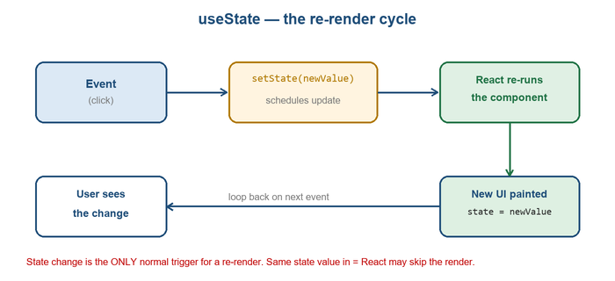
Event → setState → React re-runs the component → new UI. State change is the normal trigger for a re-render.
⚠️ COMMON MISTAKE Never assign state directly. count = count + 1 does nothing — React won't know and won't re-render. Always go through the setter (setCount(...)).

🎥 Part 3 — Event handlers
React wires events with camelCase props that take a function (not a string). You pass the function; you do not call it.
function App() {
function handleClick(e) {
console.log("clicked", e.target);
}
return (
<>
<button onClick={handleClick}>Pass the function</button>
{/* ✅ onClick={handleClick} pass reference */}
{/* ❌ onClick={handleClick()} calls it during render! */}

{/* need arguments? wrap in an arrow: */}
<button onClick={() => greet("Keshav")}>Greet</button>

<input onChange={(e) => console.log(e.target.value)} />
</>
);
}
⚠️ COMMON MISTAKE onClick={handleClick()} runs immediately. Adding parentheses calls the function while rendering (often causing an infinite loop if it sets state). Pass handleClick or wrap it: () => handleClick(arg).

🎥 Part 3 — State is a snapshot
Within one render, a state variable is a fixed value — a snapshot. It does not change mid-function even after you call the setter. This surprises everyone at first.
function Counter() {
const [count, setCount] = useState(0);

function handleThreeClicks() {
setCount(count + 1); // count is 0 here → schedules 1
setCount(count + 1); // count is STILL 0 → schedules 1
setCount(count + 1); // count is STILL 0 → schedules 1
// result: 1, not 3 — all three read the same snapshot
}
return <button onClick={handleThreeClicks}>{count}</button>;
}
🎯 INTERVIEW “Why did calling setCount three times only add 1?” Because count is captured at render time — a snapshot. All three calls read 0. The fix is functional updates (next).

🎥 Part 3 — Functional updates (prev => …)
When the next state depends on the previous state, pass a function to the setter. React calls it with the latest value, so updates queue correctly.
function handleThreeClicks() {
setCount(prev => prev + 1); // 0 → 1
setCount(prev => prev + 1); // 1 → 2
setCount(prev => prev + 1); // 2 → 3
// result: 3 ✅ — each callback gets the latest value
}
🔑 KEY IDEA Rule of thumb: if the new value is computed from the old one (counters, toggles, adding to a list), use the functional form setX(prev => …). If it's a brand-new value unrelated to the old, setX(value) is fine.

🎥 Part 3 — State vs props
Props | State
Passed IN from the parent | Owned & managed INSIDE the component
Read-only (child can't change) | Changed with the setter (useState)
Changing them = parent re-renders | Changing it = this component re-renders
Like function arguments | Like a function's local memory

🎥 Part 3 — Why state must be treated as immutable
For objects and arrays in state, you must create a NEW object/array rather than mutating the existing one. React decides whether to re-render by comparing references — mutating in place keeps the same reference, so React sees ‘no change’.
const [user, setUser] = useState({ name: "Keshav", age: 22 });

// ❌ mutation — same reference, React may not re-render
user.age = 23;
setUser(user);

// ✅ new object via spread, override the changed field
setUser({ ...user, age: 23 });

// arrays: never push/splice; build a new array
const [todos, setTodos] = useState([]);
setTodos([...todos, newTodo]); // add
setTodos(todos.filter(t => t.id !== id)); // remove
setTodos(todos.map(t => t.id === id ? { ...t, done: true } : t)); // update
🎯 INTERVIEW “Why can't I just push to a state array?” Because push mutates the same array reference; React compares by reference (Object.is) and skips the re-render. Always produce a new array/object with spread, map, or filter.

PART 4 · Rendering Lists & Conditionals

🎥 Part 4 — Conditional rendering
Three common ways to show UI only when a condition holds. All are just JavaScript expressions inside JSX.
// 1) ternary — pick between two things
{isLoggedIn ? <Dashboard /> : <LoginForm />}

// 2) && — render the right side only if the left is truthy
{cart.length > 0 && <Badge count={cart.length} />}

// 3) early return — bail out before the main JSX
function Profile({ user }) {
if (!user) return <p>Loading…</p>;
return <h1>{user.name}</h1>;
}
⚠️ COMMON MISTAKE The && number trap. {count && <X/>} renders a literal 0 on screen when count is 0, because 0 is falsy but still a renderable value. Use {count > 0 && <X/>} or a ternary.

🎥 Part 4 — Rendering lists with .map()
To turn an array of data into an array of elements, use .map() (straight from your JS notes). React renders arrays of elements directly.
const people = [
{ id: 1, name: "Aisha" },
{ id: 2, name: "Ravi" },
{ id: 3, name: "Meera" },
];

function List() {
return (
<ul>
{people.map(person => (
<li key={person.id}>{person.name}</li>
))}
</ul>
);
}

🎥 Part 4 — The key prop — and why not the index
Every element produced by .map() needs a unique key prop. Keys let React match elements between renders so it can tell what was added, removed, or reordered — the heart of efficient list updates.
- Use a stable, unique id from your data (a database id, a UUID). It must be unique among siblings and stable across renders.
- Avoid the array index as key when the list can reorder, insert, or delete. The index of an item changes when the list shifts, so React mismatches items — causing wrong content, lost input focus, and subtle bugs.
// ✅ good — stable id
{todos.map(t => <Todo key={t.id} {...t} />)}

// ⚠️ risky — index changes when list reorders/filters
{todos.map((t, i) => <Todo key={i} {...t} />)}
🎯 INTERVIEW “Why does React need keys, and why not the index?” Keys identify list items across renders so React reuses/moves DOM instead of rebuilding. Indexes break when items reorder or get inserted/removed, because an item's index isn't tied to its identity — leading to state attaching to the wrong row.

PART 5 · Forms

🎥 Part 5 — Controlled components
In a controlled input, React state is the single source of truth. The input shows the state value, and every keystroke updates the state — the DOM never holds its own copy.
function NameForm() {
const [name, setName] = useState("");

return (
<input
value={name} // state drives the input
onChange={(e) => setName(e.target.value)} // input updates state
/>
);
}
// data flow: state → value → user types → onChange → setState → re-render
🔑 KEY IDEA value + onChange together = a controlled input. Provide value without onChange and React makes the field read-only (and warns). This value-flows-down, changes-flow-up loop is the core forms pattern.

🎥 Part 5 — Handling multiple inputs
Rather than one state variable per field, hold a single object in state and key off each input's name attribute with one handler.
function SignupForm() {
const [form, setForm] = useState({ email: "", password: "" });

function handleChange(e) {
const { name, value } = e.target;
setForm(prev => ({ ...prev, [name]: value })); // computed key
}

return (
<>
<input name="email" value={form.email} onChange={handleChange} />
<input name="password" value={form.password} onChange={handleChange} type="password" />
</>
);
}
⚠️ COMMON MISTAKE Don't forget to spread prev. Returning { [name]: value } wipes the other fields. You need { ...prev, [name]: value } to keep them.

🎥 Part 5 — Submit + preventDefault + validation
A real <form> reloads the page on submit by default. In an SPA you stop that with e.preventDefault(), then validate and use the values.
function LoginForm() {
const [email, setEmail] = useState("");
const [error, setError] = useState("");

function handleSubmit(e) {
e.preventDefault(); // stop the full-page reload
if (!email.includes("@")) {
setError("Enter a valid email"); // basic validation
return;
}
setError("");
console.log("submitting", email); // send to API here
}

return (
<form onSubmit={handleSubmit}>
<input value={email} onChange={(e) => setEmail(e.target.value)} />
{error && <p className="err">{error}</p>}
<button type="submit">Log in</button>
</form>
);
}
💡 TIP Put onSubmit on the <form>, not onClick on the button — that way pressing Enter in a field also submits, which is what users expect. Keep a submit button of type="submit".

PART 6 · useEffect & Side Effects

🎥 Part 6 — What a side effect is
Rendering should be pure — just computing JSX from props and state. Anything that reaches OUTSIDE that (fetching data, timers, subscriptions, manually touching the DOM, logging) is a side effect, and belongs in useEffect so it runs at the right time, not during render.

🎥 Part 6 — useEffect & the dependency array
useEffect takes a function and an optional dependency array. The array controls how often the effect runs — this is the single most important thing to get right.
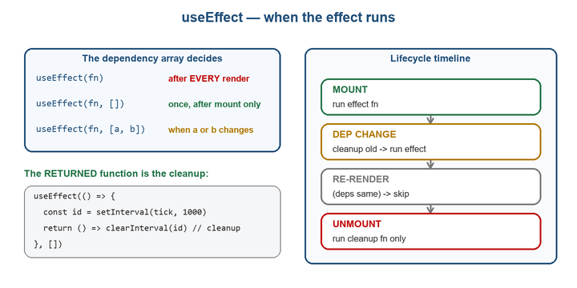
The dependency array decides when the effect runs: every render, once on mount, or when a dependency changes. The returned function is cleanup.
import { useEffect, useState } from "react";

// A) no array → runs after EVERY render (rarely what you want)
useEffect(() => { console.log("every render"); });

// B) [] empty → runs ONCE, after the first render (mount)
useEffect(() => { console.log("mounted"); }, []);

// C) [dep] → runs after mount AND whenever dep changes
useEffect(() => {
document.title = `Count: ${count}`;
}, [count]);

🎥 Part 6 — The cleanup function
If your effect sets up something ongoing (a timer, a subscription, an event listener), return a function that tears it down. React runs cleanup before the effect re-runs, and again when the component unmounts.
useEffect(() => {
const id = setInterval(() => setSecs(s => s + 1), 1000);
return () => clearInterval(id); // cleanup: stop the timer
}, []);

useEffect(() => {
function onResize() { setW(window.innerWidth); }
window.addEventListener("resize", onResize);
return () => window.removeEventListener("resize", onResize);
}, []);
⚠️ COMMON MISTAKE Forgetting cleanup leaks. Without clearInterval / removeEventListener, timers and listeners pile up on every mount, causing bugs and memory leaks — especially with StrictMode's double-mount in dev (Part 10).

🎥 Part 6 — Fetching data in an effect
The classic use: fetch data once when the component mounts, storing it in state. Handle loading and errors too.
function Users() {
const [users, setUsers] = useState([]);
const [loading, setLoad] = useState(true);

useEffect(() => {
async function load() {
try {
const res = await fetch("https://jsonplaceholder.typicode.com/users");
const data = await res.json();
setUsers(data);
} finally {
setLoad(false);
}
}
load();
}, []); // [] → fetch once on mount

if (loading) return <p>Loading…</p>;
return <ul>{users.map(u => <li key={u.id}>{u.name}</li>)}</ul>;
}

Frontend (React / HTML / JavaScript) HTTP Request Backend (Node.js + Express) Database
Problem: Frontend and Backend have different origins (protocol + domain + port, everything should be same, if even any one is different then they are on different origins) If the origin is different then there will be cors error and The browser may block the request if the backend hasn't permitted the frontend's origin.
Solution:
- CORS (discussed in backend nodejs)
- Proxy:
  - Instead of the browser directly requesting: http://localhost:3000/api
we can make the frontend request: /api
and configure the development server to forward that request to the backend.
  - Conceptually: React (localhost:5173) /api Proxy forwards Express (localhost:3000)
  - The frontend doesn't need to know the backend's complete URL.
  - Without proxy: fetch("http://localhost:3000/api/users");
  - With proxy: fetch("/api/users");
  - Different frontend bundles handle proxy differently:
    - CRA:
      - add a proxy field to your package.json, for example:
"proxy": "http://localhost:3000",
    - Vite + React:
      - Add a field “server.proxy” in vite.config.js. It Configure custom proxy rules for the dev server
      - A Vite proxy is specifically a development-server mechanism; it isn't the same thing as configuring CORS on your production backend.
// VITE
export default defineConfig({
server: {
proxy: {
// string shorthand:
// http://localhost:5173/foo http://localhost:4567/foo
'/foo': 'http://localhost:4567',

// with options:
// http://localhost:5173/api/bar http://jsonplaceholder.typicode.com/bar
'/api': {

target: 'http://jsonplaceholder.typicode.com',

changeOrigin: true,

rewrite: (path) => path.replace(/^\/api/, ''),
},

// with RegExp:
// http://localhost:5173/fallback/ http://jsonplaceholder.typicode.com/
'^/fallback/.*': {
target: 'http://jsonplaceholder.typicode.com',
changeOrigin: true,
rewrite: (path) => path.replace(/^\/fallback/, ''),
},

// Using the proxy instance
'/api': {
target: 'http://jsonplaceholder.typicode.com',
changeOrigin: true,

configure: (proxy, options) => {
// proxy will be an instance of 'http-proxy-3'
},
},

// Proxying websockets or socket.io:
// ws://localhost:5173/socket.io ws://localhost:5174/socket.io
// Exercise caution using `rewriteWsOrigin` as it can leave the proxying open to CSRF attacks.
'/socket.io': {
target: 'ws://localhost:5174',

ws: true,
rewriteWsOrigin: true,
},
},
},
});
The classic use: fetch data once when the component mounts, storing it in state. Handle loading and errors too.

🎥 Part 6 — The infinite-loop mistake
The most common useEffect bug: setting state inside an effect that runs on every render, so the state change triggers another render, which runs the effect again, forever.
// ❌ INFINITE LOOP — no dependency array
useEffect(() => {
setCount(count + 1); // re-render → effect runs → setCount → re-render …
});

// ✅ run once
useEffect(() => {
setCount(c => c + 1);
}, []);
🎯 INTERVIEW “Why is my useEffect looping forever?” Usually a missing dependency array, or a dependency that's a new object/array/function created every render (so it's ‘different’ each time). Give a correct [] / [deps], and memoize object deps (Part 7).

PART 7 · Hooks in Depth
Hooks are functions starting with ‘use’ that let function components tap into React features. Beyond useState/useEffect, these round out your toolkit.

🎥 Part 7 — useRef — DOM access & mutable values
useRef gives you a mutable box (ref.current) that persists across renders but does NOT trigger a re-render when it changes. Two uses: grabbing a DOM node, or storing a value between renders.
// 1) reference a DOM element
function SearchBox() {
const inputRef = useRef(null);
useEffect(() => { inputRef.current.focus(); }, []); // focus on mount
return <input ref={inputRef} />;
}

// 2) hold a mutable value that survives renders (no re-render)
const renderCount = useRef(0);
renderCount.current++; // changing this does NOT re-render
🔑 KEY IDEA State vs ref: change state → component re-renders. Change a ref → nothing re-renders. Use state for values the UI displays; use a ref for behind-the-scenes values (timer ids, previous value, a DOM node).

🎥 Part 7 — useContext — read shared data
useContext reads a value provided higher up the tree, skipping prop drilling. (Full setup is Part 8.)
const theme = useContext(ThemeContext); // value from the nearest Provider
return <div className={theme}>…</div>;

🎥 Part 7 — useMemo & useCallback — and when they help
Both cache something between renders so it isn't recomputed/recreated every time. useMemo caches a computed VALUE; useCallback caches a FUNCTION.
const memoizedValue = useMemo(() => computeExpensiveValue(a, b), [a, b]);,
where [a, b]: dependency array, when it changes the function reruns

const memoizedCallback = useCallback(() => {
// function body
}, [dependencies]);
// useMemo — skip an expensive recalculation unless inputs change
const sorted = useMemo(() => {
return [...items].sort(compare); // only re-sorts when items changes
}, [items]);

// useCallback — keep the SAME function reference across renders
const handleAdd = useCallback((item) => {
setCart(prev => [...prev, item]);
}, []); // stable identity → safe to pass to memoized children
⚠️ COMMON MISTAKE Don't memoize everything. useMemo/useCallback aren't free — they add memory and comparison cost. They pay off for genuinely expensive computations, or when passing stable props to React.memo children (Part 11). Wrapping trivial values just adds noise.

🎥 Part 7 — useReducer — structured state
When state logic gets complex (many sub-values, or the next state depends on an action type), useReducer centralises updates in one pure function — like a mini Redux.

const [state, dispatch] = useReducer(reducer, initialState);
function reducer(state, action) {
switch (action.type) {
case "inc": return { count: state.count + 1 };
case "dec": return { count: state.count - 1 };
case "set": return { count: action.value };
default: return state;
}
}

function Counter() {
const [state, dispatch] = useReducer(reducer, { count: 0 });
return (
<>
<button onClick={() => dispatch({ type: "dec" })}>-</button>
<span>{state.count}</span>
<button onClick={() => dispatch({ type: "inc" })}>+</button>
</>
);
}
useReducer vs useState:
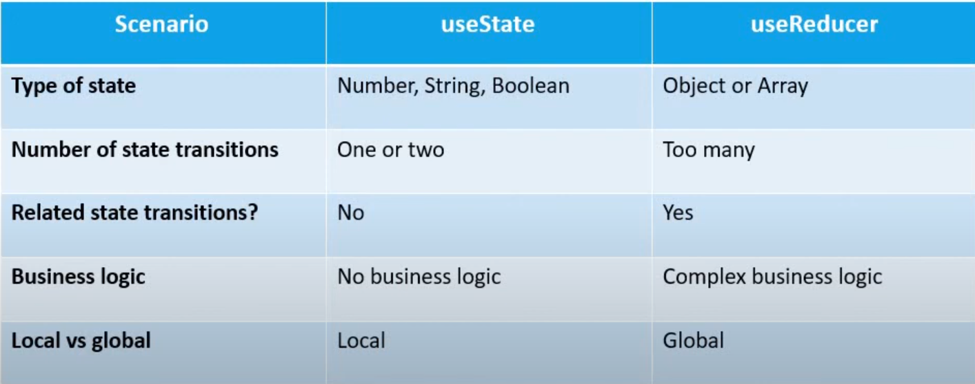

🎥 Part 7 — Custom hooks — reuse stateful logic
A custom hook is just a function starting with ‘use’ that calls other hooks. It lets you extract and reuse stateful logic across components — no duplication.
// reusable logic extracted into a hook
function useToggle(initial = false) {
const [on, setOn] = useState(initial);
const toggle = useCallback(() => setOn(o => !o), []);
return [on, toggle];
}

// use it anywhere, like a built-in hook
function Panel() {
const [open, toggleOpen] = useToggle();
return <button onClick={toggleOpen}>{open ? "Hide" : "Show"}</button>;
}

🎥 Part 7 — The Rules of Hooks
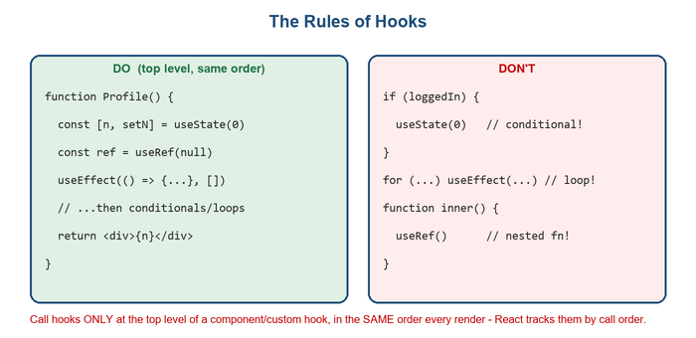
Call hooks only at the top level, in the same order every render. React tracks each hook by its call order.
- Only call hooks at the top level. Never inside conditions, loops, or nested functions. React identifies hooks by call order, so that order must be identical on every render.
- Only call hooks from React functions. From components or from other custom hooks — not from regular JS functions.
🎯 INTERVIEW “Why can't hooks go inside an if?” React has no names for your hooks — it matches them to stored state purely by the order they're called. A conditional hook changes that order between renders, so state gets assigned to the wrong hook. The eslint-plugin-react-hooks linter catches this.

PART 8 · Context API

🎥 Part 8 — The prop drilling problem
When data lives high in the tree but is needed deep down, you end up passing it through many components that don't use it themselves — just forwarding. That's prop drilling: tedious, noisy, and fragile.
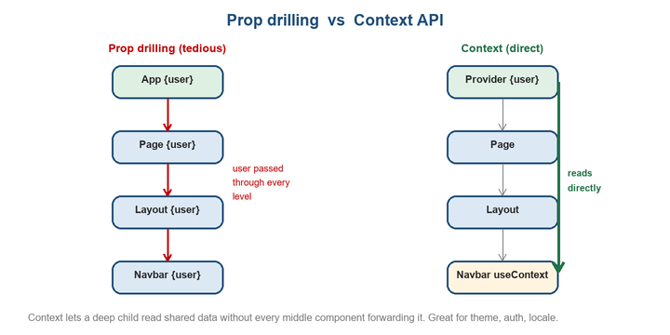
Prop drilling forwards data through every level; Context lets a deep child read shared data directly from a Provider.

🎥 Part 8 — createContext / Provider / useContext
Context is React's built-in way to share a value with a whole subtree. Three steps: create it, provide it at the top, consume it anywhere below.
import { createContext, useContext, useState } from "react";

// 1) create
const UserContext = createContext(null);

// 2) provide at a high level
function App() {
const [user] = useState({ name: "Keshav" });
return (
<UserContext.Provider value={user}>
<Layout /> {/* everything inside can read user */}
</UserContext.Provider>
);
}

// 3) consume, however deep — no props passed through Layout/Navbar
function Navbar() {
const user = useContext(UserContext);
return <span>Hi, {user.name}</span>;
}
⚠️ COMMON MISTAKE Context re-renders all consumers. When the Provider's value changes, every component that reads it re-renders. Don't put rapidly-changing state in one giant context; split contexts or memoize the value.

🎥 Part 8 — When Context vs a state library
Reach for Context when… |  | Reach for a library (Redux/Zustand) when…
Sharing fairly static global data (theme, current user, locale, language) |  | State changes very frequently and widely
A handful of values, simple updates |  | Complex state with lots of interdependent updates
You want zero dependencies |  | You need devtools, middleware, time-travel debugging
 | 🔑 KEY IDEA Context is a transport mechanism (it moves data through the tree), not a state manager by itself. You still store the value with useState/useReducer; Context just delivers it. It solves prop drilling, not necessarily large-scale state complexity.

PART 9 · React Router
React itself has no routing. React Router (react-router-dom) adds client-side routing: it swaps components based on the URL, with no full page reload — the SPA experience.
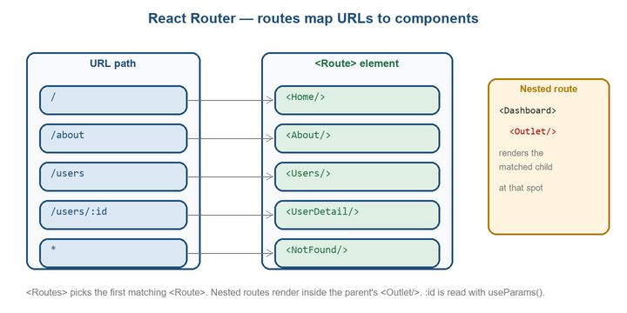
Routes map URL paths to components. Nested routes render inside the parent's <Outlet/>. :id is read with useParams().

🎥 Part 9 — createBrowserRouter, Routes & Route
// routes.js
import {
createBrowserRouter,
} from "react-router";
const router = createBrowserRouter([
{
path: "/",
element: <div>Hello World</div>,
},
{
path: "/about",
Component: <About />,
},
]); // it allows the user to define client-side routing for the react application using browser history.
// app.js
import routes from ./routes;
import {RouterProvider} from 'react-router';
function App = () => {
return (<>
<RouterProvider router = {router}/ > // it provides the router configuration to the react application
</>);
};
🔑 KEY IDEA Return the router from the <CreateBrowserRouter>. It supports features that the component router cannot, such as: Data loaders (loader), Form actions (action), Built-in error boundaries (errorElement), Deferred data loading, Better nested route management

🎥 Part 9 — Link & NavLink & Redirect
Never use a plain <a href> for internal navigation — it triggers a full page reload and kills your app state. Use <Link>; use <NavLink> when you want automatic ‘active’ styling.
Link | NavLink
Link  └── Just navigates | NavLink  ├── Navigates  └── Knows if it's the current (active) route  ↓  Can automatically apply active styles
import { Link, NavLink } from "react-router-dom";

<Link to="/about">About</Link>

<NavLink
to="/users"
className={({ isActive }) => isActive ? "active" : ""}
>
Users
</NavLink>
/* redirect: */
import { redirect } from "react-router";
export async function loader({ request }) {
let user = await getUser(request);
if (!user) {
return redirect("/login");
}
return { userName: user.name };
}

🎥 Part 9 — useParams & useNavigate
Dynamic Segments: If a path segment starts with : then it becomes a "dynamic segment". When the route matches the URL, the dynamic segment will be parsed from the URL and provided as params to other router APIs.
Splats: Also known as "catchall" and "star" segments. If a route path pattern ends with /* then it will match any characters following the /, including other / characters.
{
path: "teams/:id",
loader: async ({ params }) => {
// params are available in loaders/actions
let team = await fetchTeam(params.teamId);
return { name: team.name };
},
Component: Team,
}
{ path: ":lang?/categories"; } // Optional Segment

// Splats:
{
path: "files/*";
loader: async ({ params }) => {
params["*"]; // will contain the remaining URL after files/
};
}

const { "*": splat } = params;

import { useParams, useNavigate } from "react-router-dom";

function UserDetail() {
const { id } = useParams(); // read :id from the URL
const navigate = useNavigate(); // programmatic navigation

function goHome() {
navigate("/"); // push a new route
}
function goBack() {
navigate(-1); // like the browser back button
}
return <button onClick={goHome}>User {id} → Home</button>;
}
💡 TIP Use <Link>/<NavLink> for things the user clicks, and useNavigate for navigation triggered by code (after a successful login or form submit, or a timeout).

🎥 Part 9 — Nested routes & Outlet & Layout
Routes can nest so a parent layout (shared navbar/sidebar) stays mounted while child routes swap inside it. The parent renders an <Outlet/> where the matched child appears.
Layout Routes: No path is defined and it is used to provide a layout and load the children component
createBrowserRouter([
{
path: "/dashboard",
Component: Dashboard,
children: [
{ index: true, Component: Home },
{ path: "settings", Component: Settings },
],
},
]);

import { Outlet } from "react-router";
export default function Dashboard() {
return (
<div>
<h1>Dashboard</h1>
{/* will either be <Home> or <Settings> */}
<Outlet />
</div>
);
}
createBrowserRouter([
{
// no path on this parent route, just the component
Component: MarketingLayout,
children: [
{ index: true, Component: Home },
{ path: "contact", Component: Contact },
],
},
{
path: "projects",
children: [
{ index: true, Component: ProjectsHome },
{
// again, no path, just a component for the layout
Component: ProjectLayout,
children: [
{ path: ":pid", Component: Project },
{ path: ":pid/edit", Component: EditProject },
],
},
],
},
]);
🎯 INTERVIEW “How do nested routes work?” Child <Route>s render inside the parent's <Outlet/>. An index route is the default child shown at the parent's exact path. This keeps shared layout mounted while only the inner content changes.

🎥 Part 10 — Prefix Routes
Route with just a path and no component creates a group of routes with a path prefix.
createBrowserRouter([
{
// no component, just a path
path: "/projects",
children: [
{ index: true, Component: ProjectsHome },
{ path: ":pid", Component: Project },
{ path: ":pid/edit", Component: EditProject },
],
},
]);

🎥 Part 11 — Segments
Dynamic Segments: If a path segment starts with : then it becomes a "dynamic segment". When the route matches the URL, the dynamic segment will be parsed from the URL and provided as params to other router APIs.

createBrowserRouter([
{
// no component, just a path
path: "/projects",
children: [
{ index: true, Component: ProjectsHome },
{ path: ":pid", Component: Project },
{ path: ":pid/edit", Component: EditProject },
],
},
]);

🎥 Part 12 — Route Objects
// Loader:

import {
useLoaderData,
createBrowserRouter,
} from "react-router";
createBrowserRouter([
{
path: "/",
loader: loader,
Component: MyRoute,
},
]);
async function loader({ params }) {
return { message: "Hello, world!" };
}
function MyRoute() {
let data = useLoaderData();
return <h1>{data.message}</h1>;
}

// Action:

import {
createBrowserRouter,
useLoaderData,
useActionData,
Form,
} from "react-router";
import { TodoList } from "~/components/TodoList";
createBrowserRouter([
{
path: "/items",
action: action,
loader: loader,
Component: Items,
},
]);
async function action({ request }) {
const data = await request.formData();
const todo = await fakeDb.addItem({
title: data.get("title"),
});
return { ok: true };
}
// this data will be revalidated after the action completes...
async function loader() {
const items = await fakeDb.getItems();
return { items };
}
// ...so that the list here is updated automatically
export default function Items() {
let data = useLoaderData();
return (
<div>
<List items={data.items} />
<Form method="post" navigate={false}>
<input type="text" name="title" />
<button type="submit">Create Todo</button>
</Form>
</div>
);
}

// shouldRevalidate:

import type { ShouldRevalidateFunctionArgs } from "react-router";
function shouldRevalidate(
arg: ShouldRevalidateFunctionArgs
) {
return true; // false
}
createBrowserRouter([
{
path: "/",
shouldRevalidate: shouldRevalidate,
Component: MyRoute,
},
]);

// lazy:

createBrowserRouter([
{
path: "/app",
lazy: async () => {
// load component and loader in parallel before rendering
const [Component, loader] = await Promise.all([
import("./app"),
import("./app-loader"),
]);
return { Component, loader };
},
},
]);
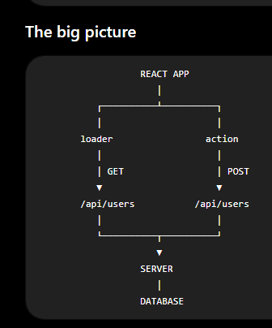
- Loader = "I need data to render this route."
- Action = "The user submitted something; change some data."
- Server = "Actually perform the operation and talk to the database."

PART 10 · React Redux

🎥 Part 10 — Introduction
Redux gives your application a central store.
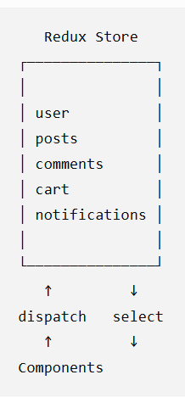
Instead of passing state through many components, components can interact with shared state through Redux
State is stored centrally, and changes to that state happen through actions processed by reducers.
Example:
Initial State: {count: 0}
The user clicks: Increment
The component doesn't directly change Redux state. Instead: Component dispatch({ type: "counter/increment" }) Redux Store Reducer { count: 1 }
Then React sees the updated state and renders again.
Store: Where the application's Redux state lives.
Action: An object describing what happened.
Reducer: A function that determines how state changes in response to an action. (calculating next stage)
Dispatch: How you send an action to Redux.
Redux Toolkit Manages the store/state
React-Redux Connects that store to React components
React Your UI
Redux is a tool for shared application state, not a replacement for every useState(). Everything React application should not go into Redux.
If multiple unrelated parts of my application need this state: use redux
Else: use useState()
Reducers Must Be Predictable
Redux state updates are immutable;
Immer lets Redux Toolkit express those updates using simpler mutation-like syntax.
Provider: Makes the Redux store available to React.
<Provider store={store}>
<App />
</Provider>

useSelector: Reads data from Redux. This is a React-Redux hook that:
- accesses the Redux store
- runs the selector
- subscribes the component to the selected value
- causes the component to update when the selected result changes
useSelector() uses reference equality by default when determining whether its selected result changed.

const count = useSelector(
state => state.counter.count
);

Simple selector: It simply retrieves something.
const selectUser = state => state.auth.user;

Derived selector: It calculates something from state.
const selectPublishedPosts = state =>
state.posts.posts.filter(
post => post.published
);

Memoized Selectors: The selector remembers the previous state and if it is unchanged then it uses the old state and does not create a new state
import { createSelector } from "@reduxjs/toolkit";

const selectPosts = state => state.posts.posts;
export const selectPublishedPosts = createSelector(
[selectPosts],
posts => posts.filter(post => post.published)
);

useDispatch: Sends actions to Redux.
const dispatch = useDispatch();
dispatch(increment());

Asynchronous action: It handles the lifecycle of an asynchronous operation.
createAsyncThunk();

import { createSlice, createAsyncThunk } from "@reduxjs/toolkit";
const initialState = {
user: null,
isAuthenticated: false,
loading: false,
error: null,
};
export const loginUser = createAsyncThunk(
"auth/loginUser",
async (credentials) => {
await new Promise((resolve) => setTimeout(resolve, 2000));
if (
credentials.email === "john@example.com" &&
credentials.password === "1234"
) {
return {
id: 1,
name: "John",
email: "john@example.com",
};
}
throw new Error("Invalid credentials");
},
);
const authSlice = createSlice({
name: "auth",
initialState,
reducers: {
logout(state) {
state.user = null;
state.isAuthenticated = false;
},
},
extraReducers: (builder) => {
builder
.addCase(loginUser.pending, (state) => {
state.loading = true;
state.error = null;
})
.addCase(loginUser.fulfilled, (state, action) => {
state.loading = false;
state.user = action.payload;
state.isAuthenticated = true;
})
.addCase(loginUser.rejected, (state, action) => {
state.loading = false;
state.error = action.error.message;
});
},
});
export const { logout } = authSlice.actions;
export default authSlice.reducer;

Middleware sits between dispatch() and the reducer. Middleware is designed for things that happen around that state transition. It can:
- log actions
- inspect state
- block actions
- modify/transform actions
- dispatch additional actions
- perform side effects
- handle async logic
RTK Query
RTK Query is Redux Toolkit's data-fetching and caching solution. It can handle:
- API requests
- loading state
- errors
- caching
- refetching
- mutations
- cache invalidation
- keeping multiple components synchronized
createAsyncThunk is good for: Perform async logic dispatch actions update Redux state. Eg: Login, Upload a file, Execute some workflow, Perform a one-off async operation
RTK Query is designed specifically for: Server API Client cache React components. Eg: Posts, Users, Products, Comments, Orders
Redux slices: Good for client/application state: auth UI state, cart state, preferences, complex client workflows
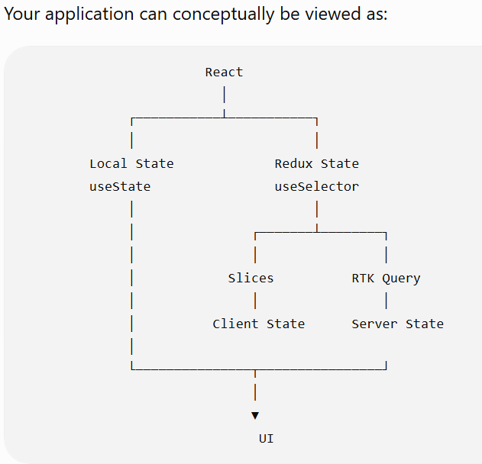
RTK Query: Good for server state: users, posts, products, comments, orders

Normalized State: normalized state means storing relational/nested data in a flat structure, similar to how tables work in a database.
createEntityAdapter: It is a utility from Redux Toolkit for managing normalized collections of entities in Redux state. It returns: Normalized State, reducers, selectors.
It becomes more attractive when you have: large collections, frequent updates by ID, many entity relationships, complex client-side entity management
RTK Query already manages server data and caching.
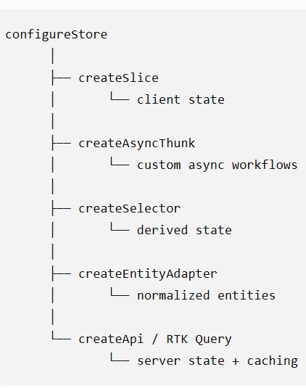
createEntityAdapter is particularly useful when you have client-side collections/entities that you need to manage efficiently.

PART 11 · Axios

🎥 Part 11 — Introduction
Axios is an HTTP client. Its job is to allow JavaScript code to communicate with servers over HTTP/HTTPS.
HTTP communication takes time.
Therefore Axios returns a Promise.
Express creates API and Axios consumes that API
npm i axios

import axios from ‘axios’;

// axios.<method>(url [, options]);
axios.get(‘/api/users’);
Axios vs fetch
fetch() does not automatically reject the Promise for HTTP errors. The response has to be checked.
Axios automatically handles JSON response parsing. Axios rejects the promise for non-success HTTP status codes by default. Axios also provides useful features such as:
- interceptors
- instances
- automatic JSON handling
- request configuration
- timeout configuration
- convenient authentication/header handling
- request cancellation
- convenient error information
Response Object: Axios doesn't simply give you the JSON rather It gives you a response object roughly like:
res = {
data: ..., // Actual response body

status: 200, // HTTP Status

statusText: "OK",

headers: ..., // Response Headers

config: ...,

request: ...

etc ......
}

Types of Requests:
// 1.) GET Request
const res = await axios.get(url [,options]);

// 2.) POST Request: Axios handles JSON serialization for you.
const res = await axios.post(url [, data [, options]]);

// 3.) PUT Request: (replace / update resource): replace/update the resource
const res = await axios.put(url [, data [, options]]);

// 4.) PATCH Request: partially update the resource
const res = await axios.patch(url [, data [, options]]);

// 5.) DELETE Request:
const res = await axios.delete(url [, options]);

Query Parameters:
// 1.) Manual method
const url = ‘http://localhost:3000/api/users?page=10&limit=5’
const res = await axios.get(url);

// 2.) Axios method:
const res = await axios.get(url, {
params: {
page: 5,
limit: 5
}
});

Error Handling:
When there is an error in resolving the request, axios throws an error which can be catch by .catch() or try{}catch(err){}
try {
await axios.get("/api/users");
} catch (error) {
// error object contains lot of info such as {response: ...}
console.log(error.response);
console.log(error.response.status);
console.log(error.response.data);
}
When an axios request fails:
// 1.) Server responded with error
Console.log( error.response );

// 2.) Request was sent but no response arrived
console.log( error.request );

// 3.) Something went wrong while creating the request
console.log( error.message );

Axois Instance:
You can configure common behaviour and default headers once. Then every request made through api inherits that configuration.
Default headers: configure headers globally
Each instance has its own configuration.
import axios from "axios";

const api = axios.create({
baseURL: "http://localhost:3000/api"

// configure common behaviour
timeout: 5000

// default headers
headers: { "Content-Type": "application/json" }
});

// default headers defined later
api.defaults.headers.common.Authorization = `Bearer ${token}`;

export default api;

Interceptors:
An interceptor allows you to run code BEFORE request or AFTER response. It is like a middleware of axios (intercepts the request / response)
Interceptors become useful for:
401 Unauthorized access token expired refresh token obtain new access token retry original request
// request interceptor
api.interceptors.request.use(
(config) => {
console.log("Request is being sent");
return config;
}
);
// response interceptor
api.interceptors.response.use(
(response) => {
return response;
},
(error) => {
return Promise.reject(error);
}
);

Transform Response
Axios allows us to transform the response data before it reaches our application code.
Cancel Request:
Sometimes you start an HTTP request and then realize you don't need its result anymore. Examples:
- User changes a search query before the previous request finishes.
- User navigates away from a page.
- A request is taking too long.
- You want to cancel an in-progress upload/download.
// create a controller
const controller = new AbortController();
// pass its signal to axios
const response = await axios.get(
"/api/users",
{
signal: controller.signal
}
);
// Then cancel:
controller.abort(); // The request is aborted.

PART 12 · How React Works

🎥 Part 12 — The Virtual DOM
The real DOM is slow to update. React keeps a lightweight JavaScript copy of the UI — the virtual DOM (those createElement objects from Part 1). When state changes, React builds a new virtual tree and compares it to the previous one.
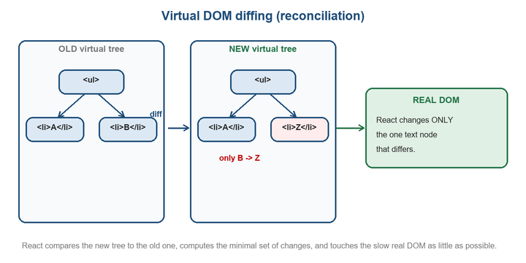
React diffs the new virtual tree against the old one and applies only the minimal changes to the slow real DOM.

🎥 Part 12 — Reconciliation & keys
Reconciliation is the diffing process: React walks both trees and works out the minimal set of real-DOM operations to go from old to new. It uses fast heuristics — comparing element types, and using keys to match list children.
- Different type at a spot → tear down and rebuild that subtree.
- Same type → keep the DOM node, update only changed attributes.
- Lists → keys tell React which item is which, so it can move/reuse nodes instead of recreating them (that's why Part 4's key rule matters).

🎥 Part 12 — What triggers a re-render
A component re-renders when:
- Its state changes (a setState call).
- Its parent re-renders (by default, children re-render when the parent does — even if their props didn't change; Part 11's React.memo can stop this).
- A context value it consumes changes.
⚠️ COMMON MISTAKE Re-render ≠ real-DOM update. ‘Re-render’ means React re-runs your component function and re-diffs. If the output is the same, the real DOM isn't touched. So a re-render is usually cheap — don't over-optimise before measuring.

🎥 Part 12 — StrictMode double-invoke
In development, wrapping your app in <React.StrictMode> intentionally runs components (and mounts effects) TWICE to help you catch impure renders and missing effect cleanups. It does NOT happen in production.
// main.jsx
<React.StrictMode>
<App />
</React.StrictMode>
// dev only: effects run mount → cleanup → mount again.
// If that breaks your code, your effect probably needs cleanup.
🎯 INTERVIEW “Why does my effect / console.log run twice?” StrictMode in development double-invokes to surface bugs (missing cleanup, side effects during render). It's stripped from production builds — don't ‘fix’ it by removing StrictMode; fix the underlying effect.

🎥 Part 12 — Batching
React groups multiple state updates that happen in the same event into a SINGLE re-render, for performance. Since React 18 this batching also covers updates inside promises, timeouts, and native handlers (automatic batching).
function handleClick() {
setCount(c => c + 1);
setFlag(f => !f);
setName("Keshav");
// React batches these → ONE re-render, not three
}

PART 13 · Patterns & Performance

🎥 Part 13 — Lifting state up
When two sibling components need the same data, move that state UP to their closest common parent, then pass it down as props (and pass down a setter for changes). The parent becomes the single source of truth.
function Parent() {
const [query, setQuery] = useState("");
return (
<>
<SearchBar query={query} onChange={setQuery} />
<Results query={query} /> {/* both share one state */}
</>
);
}
🔑 KEY IDEA ‘Lifting state up’ is the standard answer to “how do two components share/sync data?” Put the state in their common ancestor. If the ancestor is very far up and many levels forward it, that's when Context (Part 8) earns its place.

🎥 Part 13 — Composition over prop drilling
Before reaching for Context, remember that passing children through composition often removes the drilling entirely — let the parent that HAS the data render the child directly and pass it in via children/props.
// instead of drilling `user` down through Layout…
<Layout>
<Profile user={user} /> {/* parent supplies it directly as children */}
</Layout>

// Layout just renders whatever it's given:
function Layout({ children }) {
return <main>{children}</main>;
}

🎥 Part 13 — React.memo & derived state
React.memo wraps a component so it skips re-rendering when its props are unchanged (shallow compare). Pair it with useCallback/useMemo so the props you pass keep a stable identity.
const Row = React.memo(function Row({ item, onSelect }) {
return <li onClick={() => onSelect(item.id)}>{item.name}</li>;
});
// Row only re-renders when `item` or `onSelect` actually change.
// → pass a stable onSelect with useCallback, or memo does nothing.
💡 TIP Don't store derived data in state. If a value can be computed from existing props/state (a filtered list, a total), compute it during render (optionally with useMemo). Duplicating it in state means two sources of truth that drift out of sync.

🎥 Part 13 — Avoiding unnecessary renders
- Keep state as low as possible. State high up re-renders a big subtree. Push it down to the smallest component that needs it.
- Stable props. Inline objects/arrays/functions (style={{}}, onClick={() => …}) are new each render; with React.memo children, memoize them.
- Measure first. Use the React DevTools Profiler before optimising. Most re-renders are cheap; premature memoization adds complexity for no gain.

🎥 Part 13 — Folder structure
There's no official rule, but a common, scalable convention:
src/
components/ reusable UI (Button, Card, Navbar)
pages/ route-level screens (Home, About)
hooks/ custom hooks (useToggle, useFetch)
context/ context providers (ThemeContext)
utils/ plain helper functions
App.jsx
main.jsx
💡 TIP Start simple — a flat components/ folder is fine for small apps. Introduce pages/, hooks/, context/ as the app grows. Colocate a component's CSS/test next to it. Consistency matters more than the exact layout.

Appendix · React Interview Quick-Fire
Rehearse these out loud — say the answer as if to an interviewer. They cover the questions React interviews return to again and again.
Question | One-line answer
What is React & why use it? | A component-based library for building UIs declaratively; efficient updates via the virtual DOM and reusable components.
Library or framework? | A library (view layer only). Routing, data fetching, tooling come from separate packages.
What is JSX? | HTML-like syntax that compiles to React.createElement calls returning plain element objects.
Props vs state | Props are read-only data passed in from a parent; state is internal, mutable via a setter, and triggers re-renders.
Why are keys needed in lists? | So React can identify items across renders and move/reuse DOM; avoid index keys when the list can reorder.
Controlled component? | A form input whose value is driven by state and updated via onChange — state is the source of truth.
useState snapshot behaviour | State is a snapshot per render; multiple setX(x+1) read the same value — use setX(prev => …).
What does useEffect do? | Runs side effects after render; the dependency array controls when, and the returned function is cleanup.
Common useEffect infinite loop | Setting state in an effect with no/incorrect deps; the update re-triggers the effect. Fix the dependency array.
useMemo vs useCallback | useMemo caches a computed value; useCallback caches a function reference. Both keyed on deps.
Rules of Hooks | Call hooks only at the top level and only from React functions, in the same order every render.
What is the virtual DOM? | An in-memory tree React diffs against the previous one (reconciliation) to apply minimal real-DOM changes.
What triggers a re-render? | A component's own state change, its parent re-rendering, or a consumed context value changing.
Why does StrictMode double-run? | Dev-only double-invoke to surface impure renders and missing effect cleanup; absent in production.
Context vs Redux | Context transports shared/static data to avoid prop drilling; Redux/Zustand manage large, frequently-changing state.

🔑 KEY IDEA The one habit that beats all these notes: build small apps (a todo, a fetch-and-list, a multi-step form) and rebuild them from memory. React is muscle memory — recall under pressure comes from typing components, not re-reading them. 🎯

— End of notes. Now go build a component and break it on purpose. 🎮

