OPEN-SOURCE SOFTWARE LAB


PROJECT REPORT

TOPIC: STARTUP VALUATION PREDICTION

Submitted By: |  | Submitted to:
Keshav Khandelwal (21103182) |  | Deepti Singh
Siddhant Kumar (21103195)
Devansh Vashist (21103213)

Problem Statement:

In the business world, accurately predicting startup valuations is crucial for various investors and venture capitalists, etc. Traditional methods often fall short in capturing the complexity of factors influencing startups valuation. This report addresses the need for an efficient and accurate car price prediction model by employing machine learning technique Linear Regression.

Introduction:

The startup industry experiences constant fluctuations influenced by factors like reputation, expenses, location and market demand. Predicting startups valuation can provide valuable insights for investors and VCs to make informed decisions. Machine learning algorithms, specifically regression models, offer a promising approach to achieve accurate predictions.

Solutions:

To address the challenges in startup valuation prediction, regression algorithm used:

Linear Regression:
Linear Regression assumes a linear relationship between the independent variables (features) and the dependent variable (car price). By fitting a line to the data, it aims to find the best-fitting model that minimizes the difference between predicted and actual prices.

- Simple Linear Regression:
SLR is a supervised machine learning algorithms used to predict values within a continuous range, where the predicted output is continuous and has a constant slope. The formula for SLR is y=b0+b1x1. It uses traditional slope-intercept form where m and b are the variables the algorithm will try to learn to produce the most accurate predictions.

- Multiple Linear Regression:
MLR examines how multiple independent variables are related to one dependent variable and can account for nonlinear relationships and interactions between variables with great accuracy. The formula for MLR is y=b0+b1x1+b2x2+ … + bnxn. MLR can use more than one explanatory variable at one, allowing for better predictions about what might happen in the data if certain changes were made.
Algorithms Used:

- Data Preprocessing: Clean and transform the dataset, handle missing values, and encode categorical variables.

- Feature Scaling: Standardize or normalize numerical features to bring them to a common scale.

- Train-Test Split: Divide the dataset into training and testing sets for model evaluation.

- Model Training: Implement Linear Regression (Multiple Linear Regression) using appropriate libraries like scikit-learn.

Software Used:

- Programming Language: Python
- Libraries: scikit-learn, pandas, NumPy, matplotlib, seaborn
- IDE: Google Collaboratory

Code: -
# -*- coding: utf-8 -*-
"""Copy of ch_34_multiple_linear_regression.ipynb

Automatically generated by Colaboratory.

Original file is located at
https://colab.research.google.com/drive/1un6L_u6eEjTeK8zK4tvFgKr_gE58bKY4

## Importing the libraries
"""

import numpy as np
import matplotlib.pyplot as plt
import pandas as pd

"""## Importing the dataset"""

ds1 = pd.read_csv("50_Startups.csv")
X_1 = ds1.iloc[:, :-1].values
Y_1 = ds1.iloc[:, -1].values

print(X_1)

print(Y_1)

"""## Encoding categorical data"""

from sklearn.compose import ColumnTransformer
from sklearn.preprocessing import OneHotEncoder

CT = ColumnTransformer(
transformers=[("encoder", OneHotEncoder(), [-1])], remainder="passthrough"
)
X_1 = CT.fit_transform(X_1)

print(X_1)

"""## Splitting the dataset into the Training set and Test set"""

from sklearn.model_selection import train_test_split

X_1_train, X_1_test, Y_1_train, Y_1_test = train_test_split(
X_1, Y_1, test_size=0.2, random_state=0
)

print(X_1_train)

print(Y_1_train)

print(X_1_test)

print(Y_1_test)

"""## Training the Multiple Linear Regression model on the Training set"""

from sklearn.linear_model import LinearRegression

LR = LinearRegression()
LR.fit(X_1_train, Y_1_train)

"""## Predicting the Test set results"""

Y_1_pred = LR.predict(X_1_test)
print(Y_1_pred)

"""## Making a single prediction (for example the profit of a startup with R&D Spend = 160000, Administration Spend = 130000, Marketing Spend = 300000 and State = 'California')"""

print(LR.predict(CT.transform([[160000, 130000, 300000, "California"]])))

"""## Getting the final linear regression equation with the values of the coefficients"""

print(LR.coef_)
print(LR.intercept_)

# Evaluating the Model Performance

“”” ##Comparing predicted Y values with Correct Y values"""

np.set_printoptions(precision=2)
Y_1_pred_r = Y_1_pred.reshape(len(Y_1_pred), 1)
Y_1_test_r = Y_1_test.reshape(len(Y_1_test), 1)
print(np.concatenate((Y_1_pred_r, Y_1_test_r, Y_1_pred_r - Y_1_test_r), 1))

"""## R2"""

from sklearn.metrics import r2_score

print(r2_score(Y_1_test, Y_1_pred))

plt.scatter(Y_1_pred, Y_1_test, color="red")
plt.title("Multiple Linear Regression")
plt.xlabel("Y_1_test")
plt.ylabel("Y_1_pred")
plt.show()

The Equation for this Regression line: -

State = 86.6 * DV1 – 873 * DV2 + 786 * DV3

Y(Profit) = 0.733 * X₁(R&D Spend) + 0.0329 * X₂(Administration Spend) + 0.0366 * X₃(Marketing Exp) + State + 42467.53

Output: -
Dataset: -
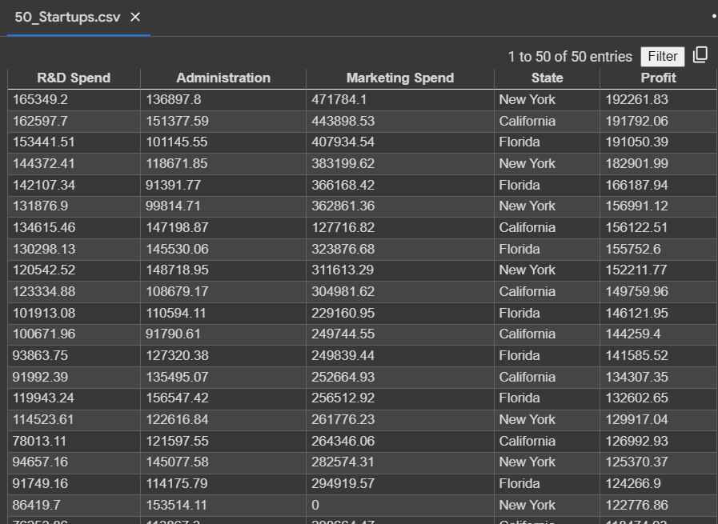

Feature Vector after encoding:
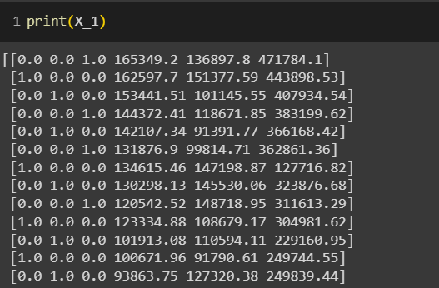

Predicting the test set results:
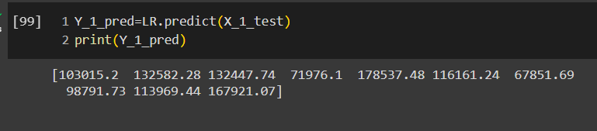

Single Prediction:
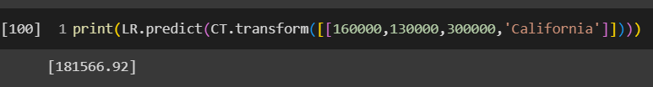

R²:
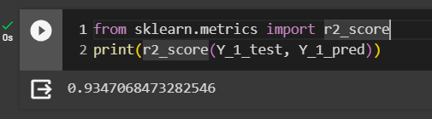

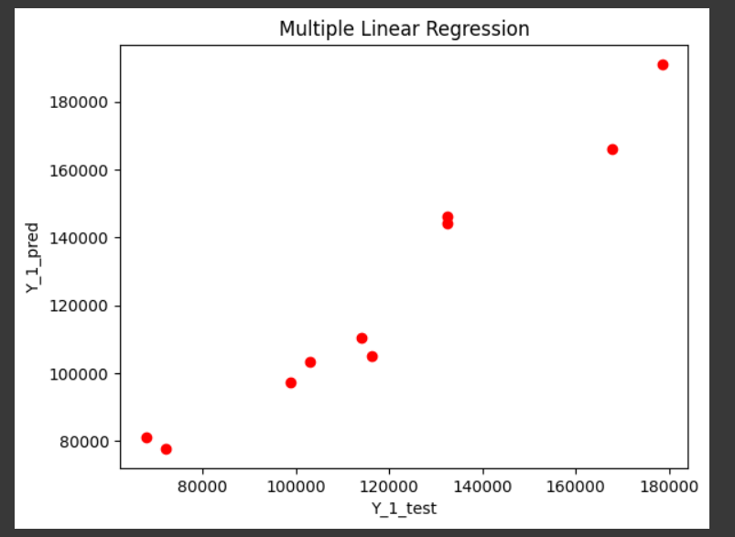

Conclusion:
The Linear Regression in predicting startup valuation reveals the strengths and limitations. Linear Regression provides a simple model.
The choice of the best model depends on the specific characteristics of the dataset and the desired balance between simplicity and accuracy.
By leveraging these regression techniques, investors in the business industry can make more informed decisions, leading to improved pricing strategies and enhanced returns.

