|  |  |  |  |  |  |  |  |
| --- | --- | --- | --- | --- | --- | --- | --- |
| **Team Name** | | **Bugs Denied** | | | | | |
| **Name of the Student** | | **Register Number** | | **Gender (M/F)** | | **Mobile Number** | |
| **Changela Vivek Vimalbhai** | | 23BCE8743 | | **M** | | **9328253710** | |
| **Amey Vinod Rasekar** | | 23BCE8587 | | **M** | | **9403320981** | |
| **V.S Akarsh** | | 23MIC7209 | | **M** | | **6360683417** | |
| **Tanishqa Rana** | | 23BCE8737 | | **F** | | **8919218174** | |
| **Samradh Agarwal** | | 23BCE9250 | | **M** | | **9118433477** | |
| **Vasavi Gayathri K** | | 23BCE9234 | | **F** | | **8884167067** | |
| **Problem Statement title** | Enhancing Rail Madad with Al-powered Complaint Management | | | | | | |
| **PS Number** | **SIH1711** | **Category (S/W or H/W)** | | | **Software** | | |
| **Domain Bucket** | **Smart Automation** | **Organization** | | | **Ministry of Railway** | | |
| **Innovation (10 Marks)** | **Clarity and details of idea (10 Marks)** | **Practicability (10 Marks)** | | | **Prototype Design**  **(10 Marks)** | | **Scale of impact**  **(10 Marks)** |
|  |  |  | | |  | |  |
| **Recommended / Not Recommended** | | | | | **Total Marks (50 Marks)** | |  |
| **Remarks:** | | | | | | | |
|  | |  | | | | | |
| **Name and Signature of the Jury Member 1** | | | **Name and Signature of the Jury Member 2** | | | | |

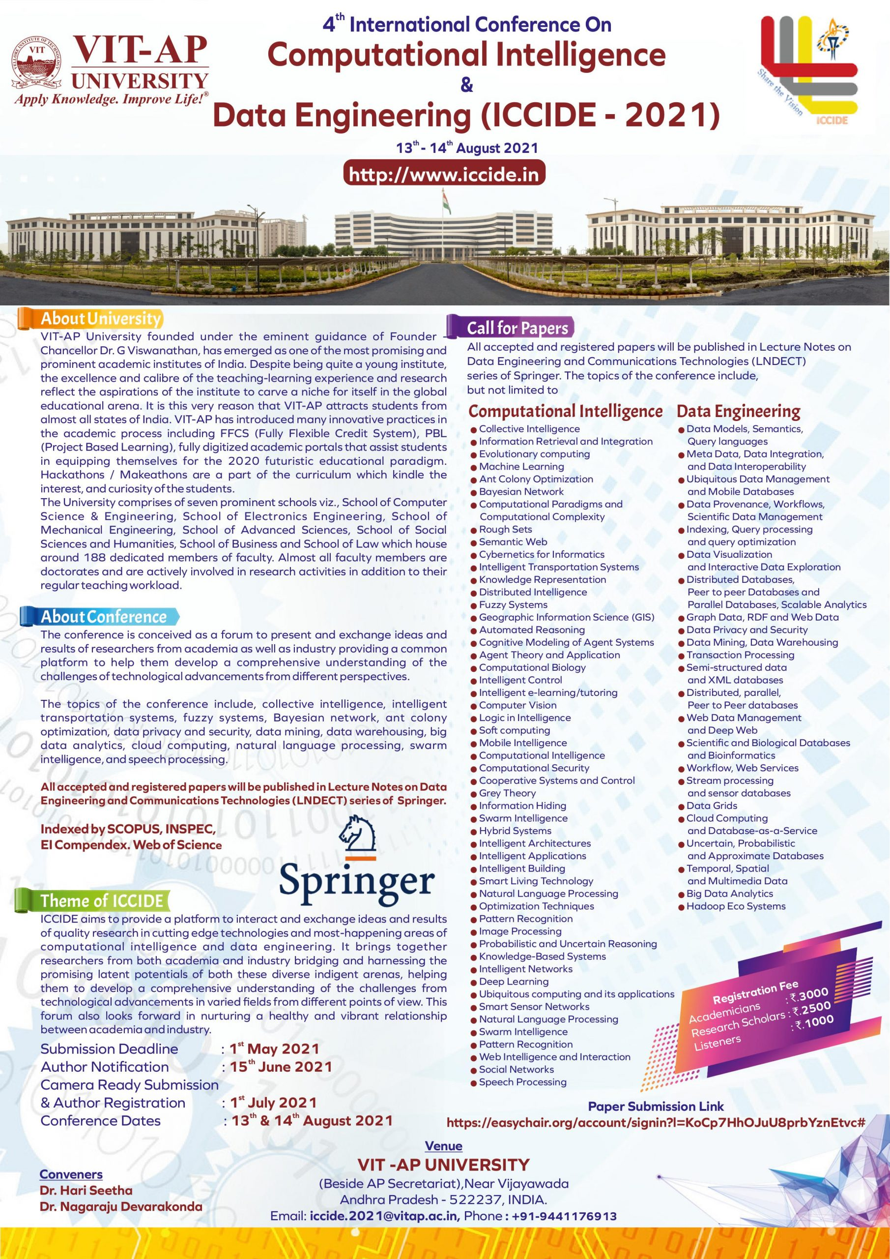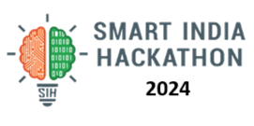

**Smart India Hackathon 2024**

**Internal Hackathon- Evaluation Sheet**

**4th September 2024**

**Fill Only Green Color Fields with Your Details**