Clothing Store Point-of-Sale System

Software Design Specification

__ March 2024

Spring 2024 Group 7

Triet Lieu, Developer

Konrad Kapusta, Designer

Prepared for

CS 250: Introduction to Software System

Instructor: Bryan Donyanavard

1. System Description

This clothing store point-of-sale system provides a time-saving tool for retail personnel to efficiently conduct all tasks needed to run a physical store, from recording inventory and transactions, to processing purchases, to looking up items. Inventory is automatically updated by integrating with purchases and returns. Items are searchable by the item’s ID, price, size, and other attributes a manager sees fit to define.

The system can be installed onto supported barcode scanners and allows for processing card payment through a third-party vendor. An app that supports both iOS and Android can be downloaded into phones and tablets. Both connect to a secure cloud database that

backs up and synchronizes data exchange across different store locations.

2. Software Architecture Overview

1. Software Architecture Diagram

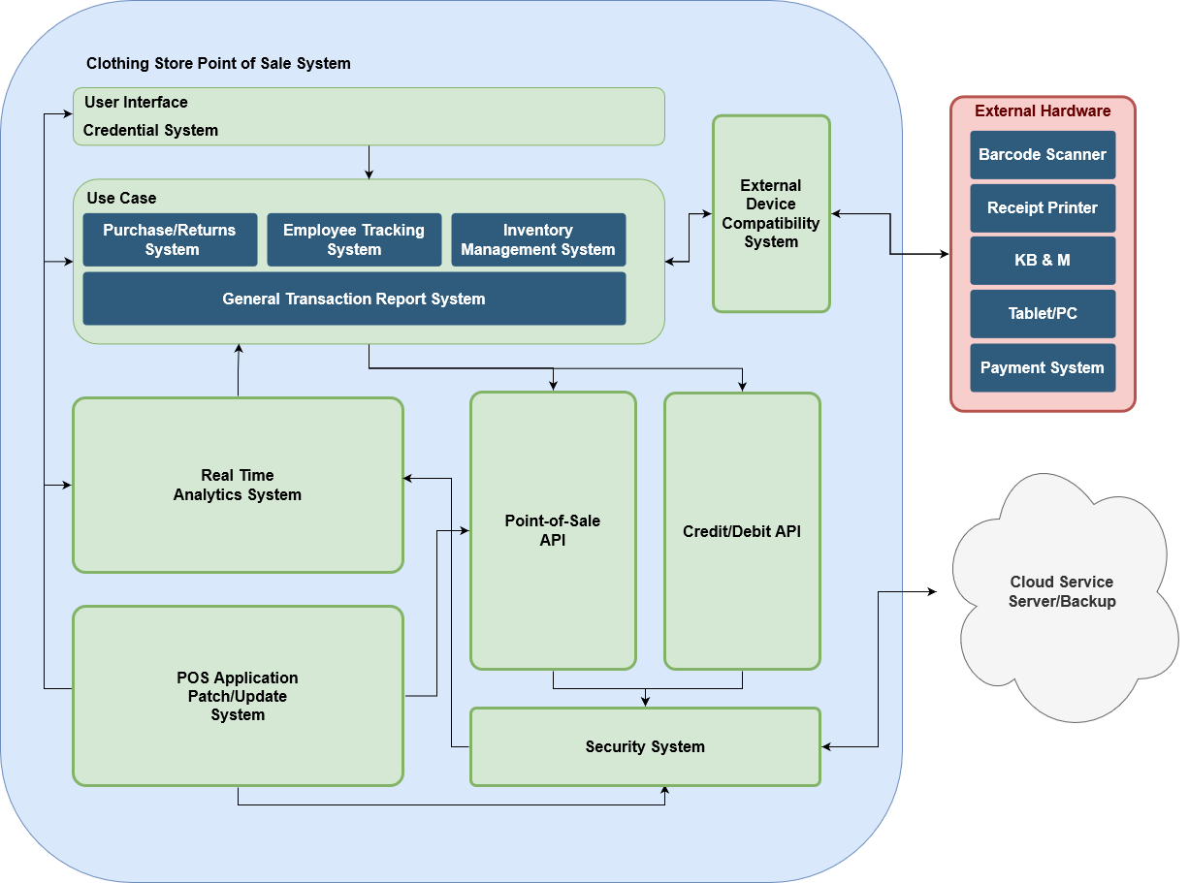

**Real Time Analytics System: An efficient and low-latency, stream-processing system likely categorizing transaction and sales data as well as updating inventory information. This is necessary to provide insights towards customer purchasing behavior.

**POS Application Patch/Update System: A system in place for users to be able to update the POS system once a patch is rolled out (if necessary).

**Point-of-Sale API: API connection for cash transactions processing

**Credit/Debit API: API for purchases with credit or debit cards.

**Security System: Naturally meant to prevent cybersecurity attacks and data leaks, but a major component of the security system is also a cloud backup of data as it is necessary to have multiple copies of data.

**User Interface // Credential System: A login system for users, such as employees, in order to make use of the POS

** External Device Compatibility System: A system in place to maintain the POS’ functionality whether or not the user connects via listed devices.

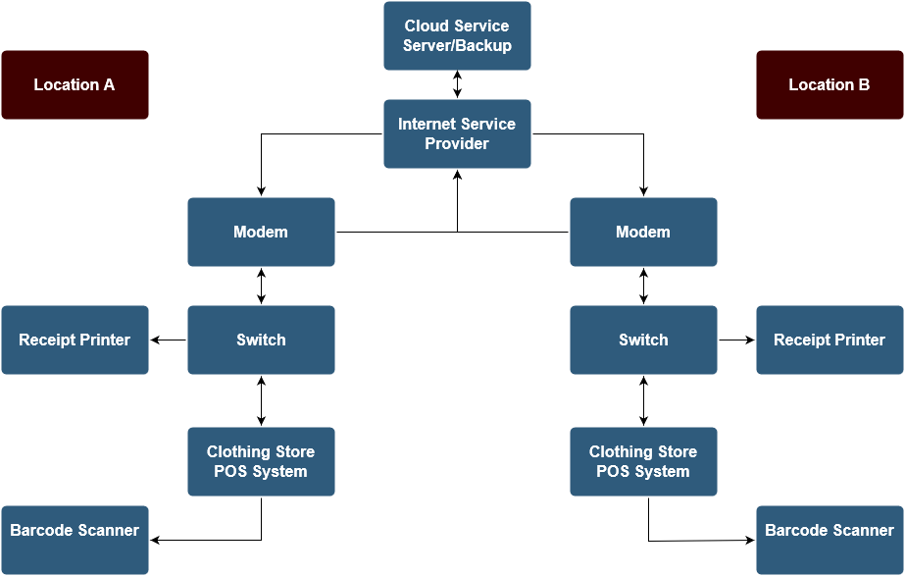

1. UML Class Diagram

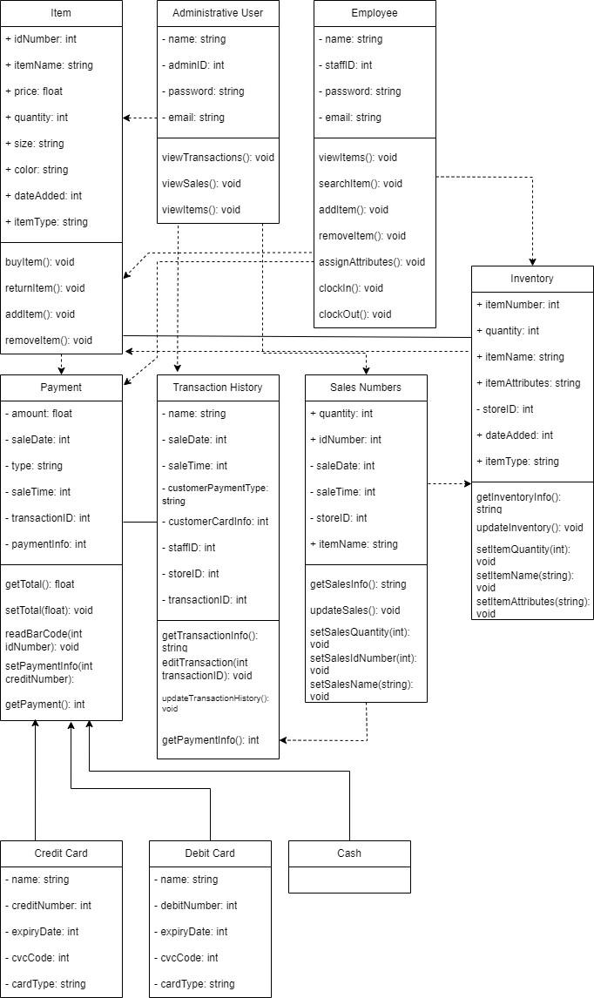

**Item: the item class is created to help create and manage sellable items in the inventory and their transactions

**Administrative User: a class meant for administrators such as managers.

**Employee: an employee class for workers to clock in and out as well as edit inventory

**Payment: a class necessary for transactions

**Transaction History: a class that would access the database of transactions to view past ones

**Sales Numbers: for general analytical viewing purposes

**Inventory: the class specifically designed for updating inventory

**General getters and setters would be included in the methods of the classes that require them

DEVELOPMENT TIMELINE

