Clothing Store Point-of-Sale System

Software Design Specification

__ March 2024

Spring 2024 Group 7

Triet Lieu, Developer

Konrad Kapusta, Designer

Prepared for

CS 250: Introduction to Software System

Instructor: Bryan Donyanavard

1. System Description

This clothing store point-of-sale system provides a time-saving tool for retail personnel to efficiently conduct all tasks needed to run a physical store, from recording inventory and transactions, to processing purchases, to looking up items. Inventory is automatically updated by integrating with purchases and returns. Items are searchable by the item’s ID, price, size, and other attributes a manger sees fit to define.

The system can be installed onto supported barcode scanners and allows for processing card payment through a third-party vendor. An app that supports both iOS and Android can be downloaded into phones and tablets. Both connect to a secure cloud database that

backs up and synchronizes data exchange across different store locations.

2. Software Architecture Overview

1. Software Architecture Diagram

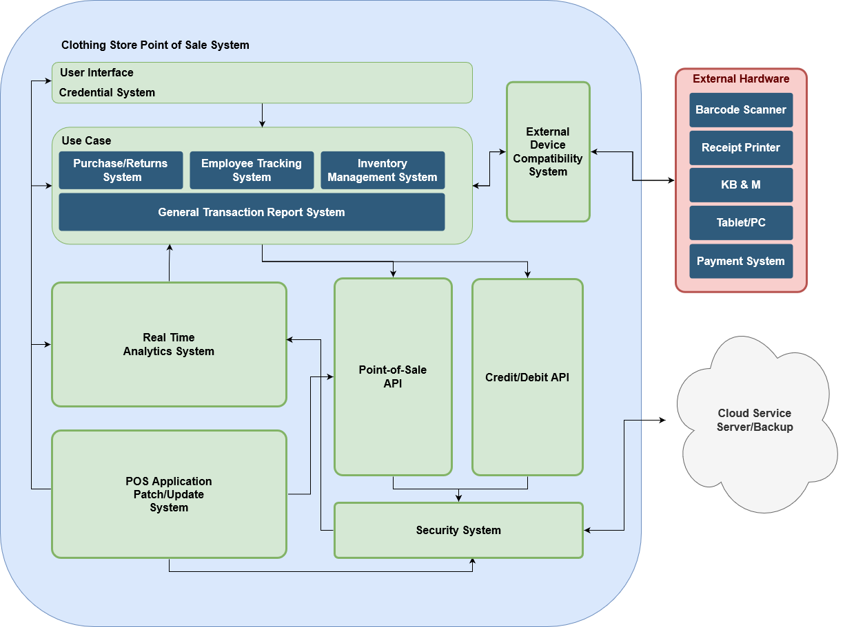

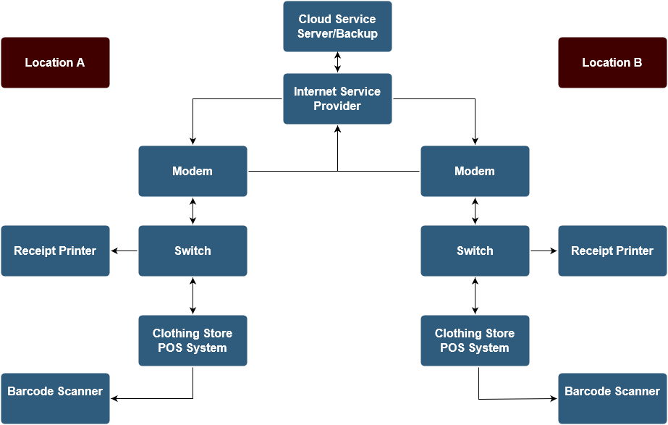

1. UML Class Diagram

