SmartCare v0.4 - Domain Implementation Workbook
Week 7 student resource

1. UML-to-Code Trace
UML element | Python element | Implemented? | Notes
Patient: patient_id, name, phone | Patient with private __patient_id/__name/__phone and read-only properties | Yes | Each must be non-empty text.
Patient: reminders_opt_in, opt_in_reminders() | Reminders_opt_in property; opt_in_for_reminders() | Yes | Operation name differs from the Stage 3 UML; the skeleton’s name was kept
Patient.book_appointment() | book_appointment() | No (stub) | Still a stub
Patient.view_upcoming_appointments() | View_upcoming_appointment() | No (stub) | Still a stub
Practitioner: practitioner_id, name | Practitoner with private __practitioner_id/ __name and read-only properties | Yes | Each must be non-empty text
Practitoner: specialty (new) | __specialty with a read-only property | Yes | Added because the Part C prompt asks for it; must be non-empty text
Practitioner.get_schedule(view) | Get_schedule(view) | No (stub) | Still a stub
Practitioner.has_conflict(when), update_status(appt, status) | Has_conflict(when) -> bool; update_status(appointment, status) | No (stub) | Restored as two separate operations as in the UML; the skeleton had merged when, both are stubs
Appointment: appointment_id, when, status,, validate() | Appointment with private attributes and read-only properties; validate() called from __init__; AppointmentStatus enum | Yes | Status: str became the AppointmentStatus enum; validate() also checks the types
Appointment.cancel(), reschedule(), record_outcome() | Cancel() implemented through __change_status(); reschedule() and record_outcome() unchanged | Partly | Only cancel() is implemented. An illegal change raises InvalidStatusTransitionError.

2. Domain Invariants
Class | Invariant / rule | How protected
Patient | Patient_id, name, and phone are always non-empty text. | Checking in __init__; stored privately with read-only properties and no setters.
Patient | Reminders_opt_in is always True or False and only changes through opt_in_for_reminders(). | Checking in __init__ and in the method; the attribute is private.
Practitioner | Practitioner_id, name, and specialty are always non-empty text. | Checked in __init__; stored privately with read-only properties and no setters.
Practitioner | No two appointments at the same time (FR-02). | Not protected yet: has_conflict() is still a stub. Also, the appointments list is public.
Appointments | Always has a real Patient, Practitioner, and datetime, and a status that is an AppointmentStatus. | Validate() runs at the end of __init__ and raises ValueError

3. Composition / Inheritance Decisions
Relationship | Decision | Rationale
Appointment - Patient | Association. Appointment holds a reference to its patient. | Same as in the Stage 3 UML (1 to 0..*). A patient carries on existing when an appointment is cancelled, so the appointment is not apart of the patient.
Appointment - Practitioner | Association. Appointment holds a reference to its practitioner. | Same as in the stage 3 UML (1 to 0..*). Neither objects owns the other’s lifetime.
Appointment - AppointmentStatus | This status is an enum value held as an attribute. | A fixed set of states replaces the free strings in stage 3 skeleton, so a typo cannot create an invalid status.
Patient/Practitioner – shared base class | No inheritance. | Stage 3 kept them as peers. They only share the id and name, and the shared text check is one helper function.
Clinic - Appointment | No Clinic class. | Unchanged Stage 3 decision: Nothing in the requirements needs a top-level owner.

4. AI Pair-Programming Record
AI contribution | Conforms? | Decision | Reason | Verification
AppointmentStatus enum and InvalidStstusTransitionError | Yes – Both asked for in the Part D prompt | Accepted | Replaces the string statuses; one exception is enough for illegal changes. | Part F4; a repeated cancel raises the exception.
Private_status, read-only status property, changes only through __change_status() | Yes – Adds no new operation to the UML | Accepted | Stops status being set from outside without adding public methods the UML doesn’t have. | Part F2; assigning to status raises AttributeError.  Part E: no setters.
Earlier draft: a new public change_status() and extra parameters on existing methods | No – Not in the Stage 3 UML | Rejected | The approved design fixes the operations, new API was not requested. | Compared the draft with the Stage 3 UML; rebuilt from the skeleton
Earlier draft: phone-number rules, reschedule rules, and conflict checking | No – Not in the prompts or the requirments | Rejected | Invented rules; the requirements don’t state them and those methods stay stubs. | Re-read the prompts and FR_01 to FR-09
Constructor keeps the status argument from the skeleton | Partly – allows an appointment to start in any status | Accepted; Flagged | Kept the Stage 3 signature; the risk is noted rather than changed | Part E review; validate() checks it is an AppointmentStatus.

5. Updated UML
Insert updated UML only if implementation revealed a justified design change. Explain every change.
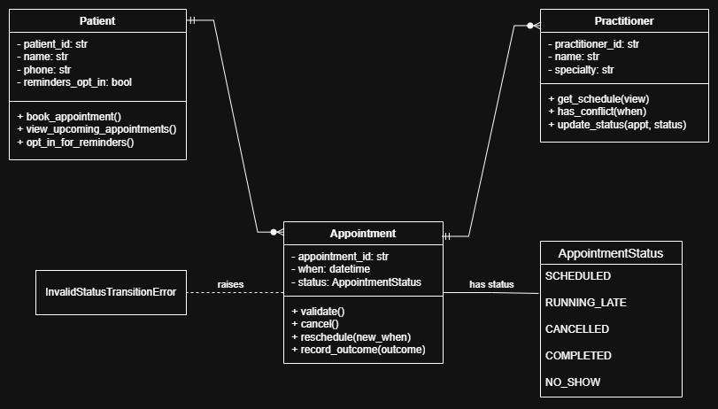
Change | Reason
Practitioner gains specialty | Asked for by the Part C prompt
Appointment.status changes from str to the AppountmentStatus enum | Asked for by the Part D prompt; a fixed set of states replaces free strings
New InvalidStatusTransitionError | Asked for by the Part D prompt; signals an illegal status change
Patient.opt_in_reminders() become opt_in_for_reminders() | The name in my Stage 3 skeleton already used opt_in_for_reminders(), so now the code and diagram agree,

