Assignment 2- Case Study (8995-G level Task)

Stage 5 Lab Activities

Refactoring SmartCare into a Layered Architecture
HUMAN ANALYSIS -> REFACTOR -> AI REVIEW -> VERIFY | 1 hour

A - Inspect SmartCare v0.4
Identify domain, workflow, data-access and presentation responsibilities currently mixed together.
book_appointment(), view_upcoming_apointments() (appointment spelt incorrectly in code, referenced here to match code), get_schedule(), update_status(), and reschedule() are stubs. Only __init__, the properties, validate(), cancel(), and opt_in_for_reminders() actually run code.
There is no data-access code anywhere, and no presentation code either – no __main__ block, no print() anywhere in the file. So there is nothing mixed in from either of those two layers to find.
Has_conflict() does not exist in the code at all, even though the approved UML diagram lists it as one of the practitioner’s 3 operations. get_schedule()’s stub error message still reads “…to check for appointment conflicts” – leftover text from what was has_conflict() before it was deleted or merged by mistake. This is a regression against the approved design, not a deliberate decision. This is fixed in part D because the service would not work without it.
2 unrelated bugs found, fixing them is not what this stage is about, so they will be left alone. opt_in_for_reminders() does self.__reminders_opt_in – opt_in (a minus sign) instead of = opt_in, so calling it does nothing. view_upcoming_apointments() is misspelled (matches the code, not the diagram, which spells it correctly.
Patient.book_appointment(practitioner, when) is a stub, but implementing it properly would require Patient to check a conflict on a different object (Practitioner), then it would need to create a 3rd object (Appointment), then link both sides. That is coordination of a multi-object use case, sitting on a single domain entity.
Evidence: then method’s own signature takes a Practitioner in, which a patient’s own data never needs to know about for anything else.

B - Propose Architecture
Draw Presentation -> Service -> Domain, with Service using a Repository abstraction and Persistence implementing it.
Since v0.4 has no data-access or presentation code yet, this will propose the target shape for v0.5 to grow into, not correcting entrenched violations.
Presentation calls Service. It is also the composition root: the one place that knows about the concrete Persistence class.
Service depends on Domain (to create and use domain objects) and on the Repository abstraction (to save them) – never on Persistence directly.
Domain depends on nothing else in the package – Innermost layer.
Persistence depends on Domain to know what it is storing and implements the Repository abstraction.

C - Create Package Structure
Create domain/, services/, repositories/, persistence/ and presentation/ or a justified equivalent.

D - Introduce AppointmentService
Move workflow coordination into a focused service without stealing Appointment domain behaviour.
Practitioner.has_conflict(when) restored. The Service cannot check a conflict without it, so this needed to exist before book_appointment could be real code rather than another stub calling a stub.
get_schedule()’s error message corrected to describe its own job, since it had has_conflict’s leftover text.
Patient.book_appointment() removed. It’s coordination job is now AppointmentService.book_appointment(patient, practitioner, when).
Appointment itself has not been touched, no domain behaviour was taken from it, only coordination that was never really its job was relocated.

E - Repository Abstraction
Define a small AppointmentRepository contract using only current use-case needs.
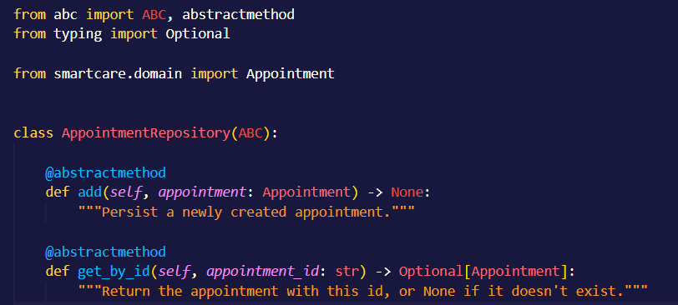
add() is needed because book_appointment has to save what it creates.
get_by_id() is needed to verify the save worked.
No list/search/update/delete methods were added, because no current use case calls for them.

Concrete implementation
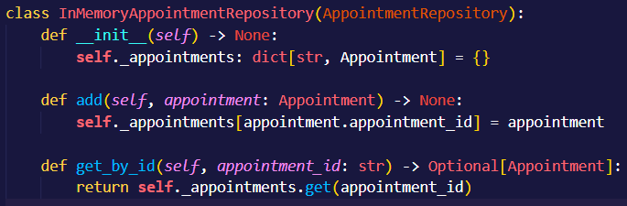

F - AI Architecture Review
Ask AI to review dependency direction, misplaced responsibilities and unnecessary complexity; request simplest justified improvements.
Accepted: Practitioner.appointments is a fully public list (not even a leading underscore) that the Service now appends to directly. Fix: add_appointments() plus a read-only property.
Modified: The module-level id counter is hidden global state that keeps climbing across unrelated calls in the same process. Rather than building a separate id-generation service, the generator became an injectable construction parameter with the same counter as its default.
Rejected (3): Splitting Repository into Read/Write interfaces, a dependency-injection framework, and microservices with an event bus. None solve a problem that exists in a single small in-process program with one developer and nine functional requirements.

G - Refactor and Verify
Apply only justified changes and confirm required behaviour remains unchanged.

Practitioner, after encapsulating the appointments list:
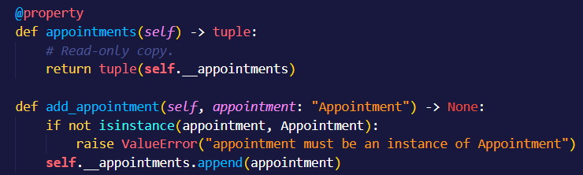

AppointmentService, after making the id generator injectable:
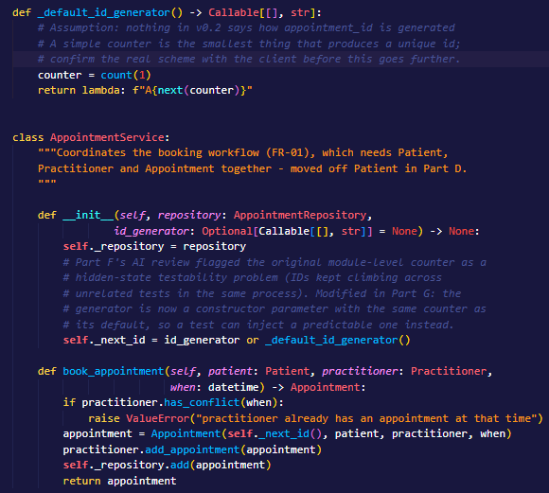

Verification
--- Booking through the service (replaces Patient.book_appointment) ---
[PASS] Booking returns a SCHEDULED appointment
[PASS] The appointment is linked to the practitioner
[PASS] The repository has the appointment
[PASS] A second booking at the same time is rejected (FR-02, now real)
[PASS] A booking at a different time succeeds
--- Practitioner.appointments encapsulation (Part G change) ---
[PASS] appointments is a read-only tuple, not the internal list
[PASS] Appending directly no longer reaches internal state
[PASS] The only way in is add_appointment(), which type-checks its argument
--- Appointment behaviour is untouched from Stage 4 ---
[PASS] Cancel still works
[PASS] Cancelling twice still raises InvalidStatusTransitionError
[PASS] A cancelled slot is free again (has_conflict, now real)
11/11 checks passed
--- Injectable id generator (Part F->G modification) ---
[PASS] A test can inject a predictable id generator (got 'FIXED-1')
Behaviour that must stay identical: cancel() still works and still rejects a repeated cancel (both untouched since stage 4).

H - Reflection
Document one AI suggestion accepted, one modified and one rejected/deferred.
Accepted: Encapsulating Practitoner’s appointment list (add_appointment() and a read-only property). This fixed a concrete problem that Service’s own code had just made worse, on a list that had no privacy marker at all in the submitted code.
Modified: The id generator. The underlying concern (hidden global counter state) was real, but the Ai’s instinct was to solve it with more architecture (a dedicated id-generation abstraction); an injectable constructor parameter was enough.
Rejected/Deferred: Splitting the repository into Read/Write interfaces, a dependency-injection framework, and microservices with an event bus. Each would add indirection that nothing in the current requirements or the current codebase’s size justifies.

Suggested AI prompt
Act as a software architecture reviewer. Review this small SmartCare Python system against separation of concerns, cohesion, coupling and introductory SOLID principles. Identify concrete layer violations and dependency risks. Prefer the simplest refactoring that solves an observed problem. Do not introduce frameworks, microservices or patterns unless current requirements justify them.

