## **Project Overview**

You will write server-side code to store a list of your favorite movies, including box art imagery and a movie trailer URL. You will then use your code to generate a static web page allowing visitors to browse their movies and watch the trailers.

## **Note**

If you have successfully completed the project for the Programming Foundations with Python course in the past (which entails having graduated from the course and having access to your course certificate), simply email us at fullstack-project@udacity.com with your passing evaluation to notify us.

## **Why this Project?**

At their core, Full Stack Web Developers are programmers - you just happen to specialize in writing applications for the web! In this project, you’ll write your first application that is accessible via a web browser.

## **What will I Learn?**

You will learn how to write an application using object-oriented Python. You will then learn how to make this application serve HTML via a web server.

## **How does this Help my Career?**

* You will establish a foundation in core programming concepts using Python
* You will understand the role a simple web server has in receiving a request, executing a block of code and generating a response

## **Project Display Example**

Note: The screenshots on this page are just examples of one implementation of the minimal functionality. You are encouraged to redesign and strive for even better solutions.

The Movie Trailer Website project consists of server-side code to store a list of movies titles, along with its respective box art imagery and movie trailer website. The data should be served as a web page allowing visitors to review the movies and watch the trailers:

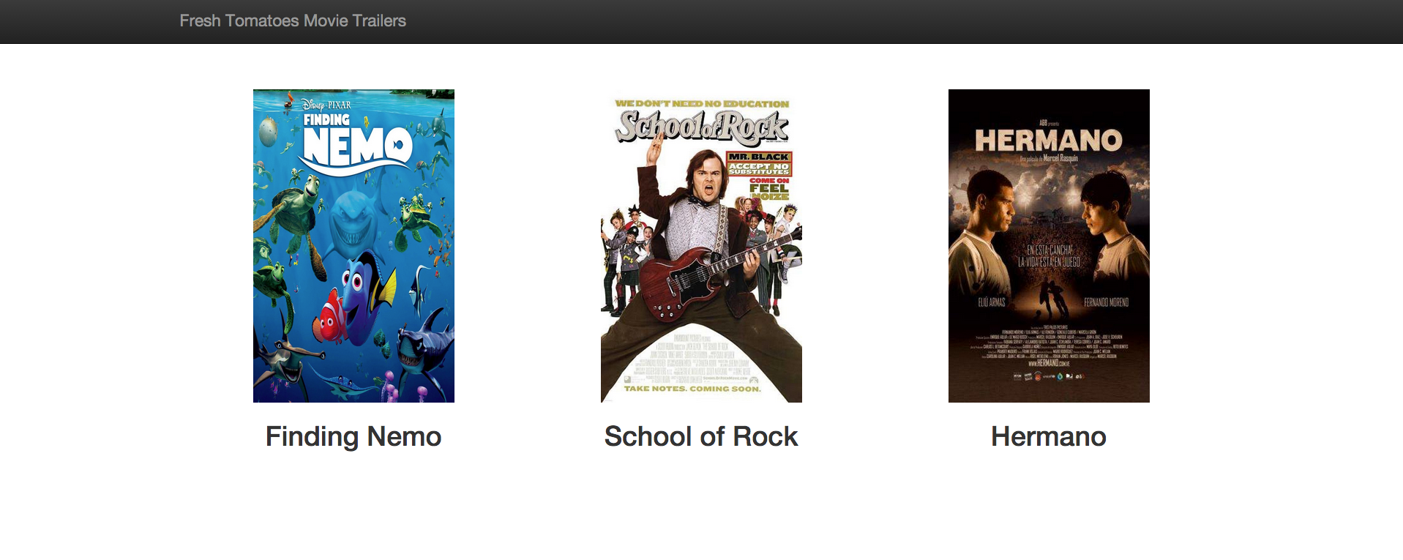

*Simple home page where movies are laid out*

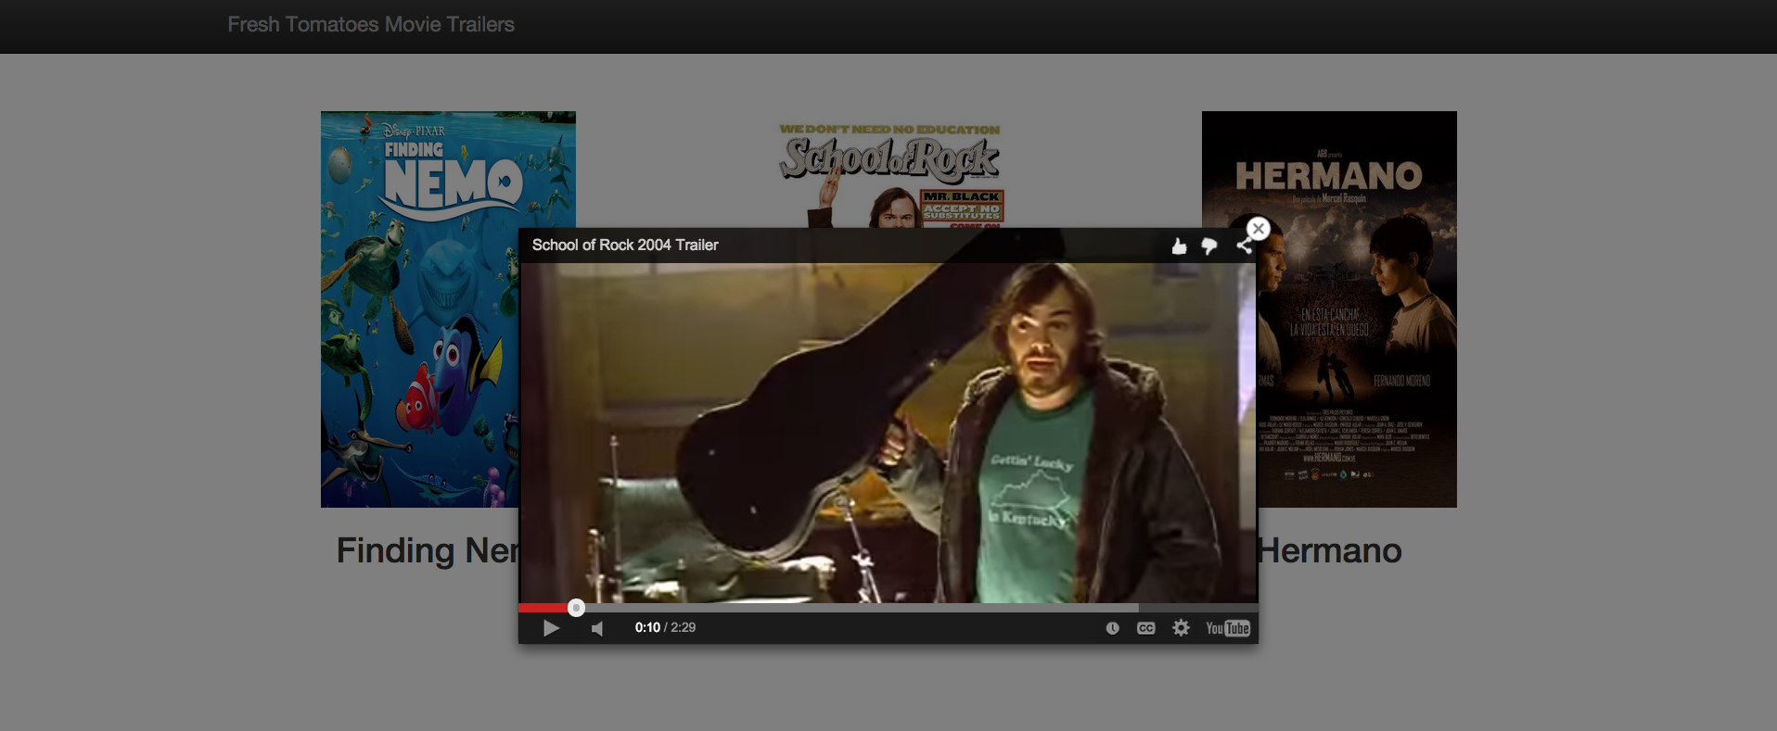

*Page allows users to click on a movie image to watch its trailer*

## **How will I complete this project?**

This project is connected to the [Programming Foundations with Python](https://classroom.udacity.com/courses/ud036) course, but depending on your background knowledge you may not need the entirety of the course to complete this project. Here's what you should do:

1. Install [Python](https://www.python.org/)
2. Create a data structure (i.e. a Python Class) to store your favorite movies, including movie title, box art URL (or poster URL) and a YouTube link to the movie trailer.
3. Create multiple instances of that Python Class to represent your favorite movies; group all the instances together in a list.
4. To help you generate a website that displays these movies, we have provided a Python module called [fresh_tomatoes.py](https://github.com/adarsh0806/ud036_StarterCode/blob/master/fresh_tomatoes.py) - this module has a function called open_movies_pagethat takes in one argument, which is a list of movies and creates an HTML file which visualizes all of your favorite movies.
5. Ensure your website renders correctly when you attempt to load it in a browser.

Get started with this helpful [guide](https://docs.google.com/a/knowlabs.com/document/d/1joDQNQl_4icYYm6tM_F9ch5hZEH_f157hlljSUGOLWs/pub?embedded=true).

You can view the code on GitHub [here](https://github.com/adarsh0806/ud036_StarterCode/blob/master/fresh_tomatoes.py)