**Hazard Prediction**

1st Prof.Neethi Narayanan

*Assistant Professor*, CSE *LBSITW, Trivandrum*

Trivandrum, Indianeethi@lbsitw.ac.in

2nd B Bhavana

*Computer Science Engineering  
LBSITW, Trivandrum*Trivandrum, India   
bhavanaboban@gmail.com

3rd Devika Lekshmy S

*Computer Science Engineering  
LBSITW, Trivandrum*Trivandrum, India devikalekshmys@gmail.com

4th Gowri Baiju

*Computer Science Engineering  
LBSITW, Trivandrum*Trivandrum, India   
gowribaiju20022@gmail.com

5th Gowri Vijaykumar

*Computer Science Engineering  
LBSITW, Trivandrum*Trivandrum, India   
gowrisandhya15@gmail.com

***Abstract- This project represents a pioneering effort to harness advanced deep learning technologies, specifically convolutional neural networks (CNNs), to predict and mitigate the impacts of natural hazards such as floods and cyclones. By meticulously analysing a vast array of environmental parameters, our system is designed to monitor and interpret the complex dynamics of weather patterns and geographical data. The utilization of CNNs, renowned for their efficiency in processing and analysing visual information, allows for the precise identification of potential natural disasters before they occur. This capability is crucial for the global community, as the timely and accurate detection of such hazards can significantly reduce the risk to human lives, infrastructure, and ecosystems. Our initiative aims to address the pressing demand for more sophisticated and reliable prediction tools in the field of disaster management, offering a ground breaking approach to early hazard identification.***

***At the heart of our approach is the commitment to leveraging the full potential of machine learning. By training our CNN models on extensive datasets that include historical weather patterns and satellite imagery, we aim to refine our predictive capabilities continuously. Through this project, we are setting a new standard for disaster management, moving towards a future where advanced technology and informed decision-making converge to protect and preserve lives and property against the unpredictable forces of nature.***

I. INTRODUCTION

Cyclones and floods are natural disasters that pose significant threats to communities around the world, causing extensive damage to infrastructure, property, and human lives. Timely detection and accurate assessment of these events are crucial for effective disaster management and response.

In this project, we provide a novel approach to automatically detecting cyclones and identifying flood areas in images using computer vision and image processing algorithms. By leveraging advanced techniques, we aim to provide a rapid and reliable means of identifying these hazardous events, aiding in early warning systems and disaster mitigation efforts.

This project utilizes advanced deep learning techniques to predict and mitigate natural hazards like floods and cyclones. By analysing, the system monitors environmental parameters and employs convolutional neural networks (CNNs) to identify disasters. Our methodology involves analysing images captured during cyclones and floods, and utilizing machine learning algorithms to classify whether a cyclone is present in the image. Additionally, we'll employ segmentation techniques to delineate flood areas within images, providing valuable insights for disaster response teams and policymakers. Cyclones and floods pose severe dangers globally, necessitating precise detection and assessment. Our goal is to provide a dependable method for identifying these hazards using advanced techniques, addressing the critical need for robust prediction methods in disaster management.

II. LITERATURE REVIEW

Flood Detection using Deep Learning

[( V Vineeth](https://ieeexplore.ieee.org/author/37089300769); [E A Neeba](https://ieeexplore.ieee.org/author/37089300678) )

Objective : In this model, an object detection algorithm is employed to identify the presence of floods and estimate their depth.  
Limitations : Object detection models face challenges in accurately identifying floods due to variations in appearance and environmental factors like lighting, terrain, and debris.

Global Disaster Tracker

(Dr. M.Mayuranathan, Annamalai J, Ashwin R, Darrel P)

Objective : The development of a website dedicated to cataloguing natural catastrophes. This proposal outlines the development of a catastrophe monitoring system that leverages the LINE API.

Limitations : This paper examines the demand for accurate and accessible NASA's Earth Observing System Data and Information System (EONET) data. It analyzes challenges in using AI and ML for disaster prediction and emphasizes the need for regular updates and maintenance to ensure real-time information and optimal functionality.

Improving visualization and functionality of natural hazard warnings on multi-hazard platforms

(Christoph Lienert, Franziska Angly Bieri, Irina Dallo, Michèle Marti)

Objective : Enhancing the readability of maps and fostering user engagement. The process of conceptualizing and executing collaborative changes for multi-hazard platforms involves the development and execution of strategies to enhance the functionality and resilience of these platforms in the face of multiple hazards.

Limitations : The lack of an established framework for the dissemination of warnings on potentially dangerous events. At now, there is an absence of a functional real-time alert system within the local community.

An Automated Early Alert System for Natural Disaster Risk Reduction: A Review

(Hawkar Jabbar H. Ali, Karwan Jacksi )

Objective : The lack of a well defined value system for the issuance of warnings on dangerous events. The use of mobile application technology in the advancement of early alert systems.

Limitations : The lack of an established framework for the dissemination of warnings on potentially dangerous events. At now, there is an absence of a functional real-time alert system within the local community.

Landslide hazard prediction and impact on community: main approaches, principles and methods

(О.М. Ivanik, V. Shevchuk, D. Kravchenko)

Objective : The primary objective of this project is to design a comprehensive system that can effectively forecast the risks associated with landslides. The creation and implementation of comprehensive landslip hazard maps

Limitations : The accuracy and trustworthiness of landslip danger maps are undisputed, but validation of local prediction techniques is lacking. The integrated technique's applicability to different locations and geological contexts remains unexplored, revealing its limitations

III. METHODOLOGY

U-NET ARCHITECTURE

U-Net stands out as a widely employed deep-learning framework tailored for semantic segmentation, a computer vision task involving the classification of every pixel in an image. The fundamental structure of U-Net can be conceptually divided into two key components: an encoding network and a decoding network. The U-Net architecture is characterized by its encoder-decoder design, a configuration that has gained prominence in the realm of image analysis. The encoder segment extracts essential features and patterns from the input image, compressing the information into a condensed representation. Following this, the decoder network works in tandem to upscale and reconstruct the spatial information, refining the output to achieve a finely detailed segmentation map.

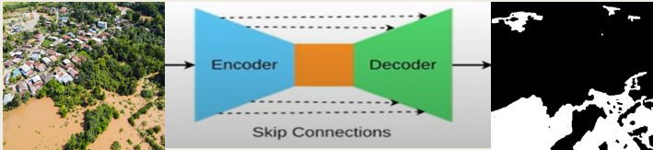

Fig 1 U-Net Diagram

U-NET ARCHITECTURE DIAGRAM

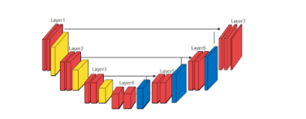

Pooling Operation

Conv + ReLU

Skip Connection

Upsampling Layer

Fig 2 U-Net Architecture

U-Net consists of the repeated application of two 3x3 convolutions (unpadded convolutions), each followed by a rectified linear unit (ReLU) and a 2x2 maxpooling operation with stride 2 for down sampling. At each down sampling step we double the number of feature channels. Every step in the expansive path consists of an up sampling of the feature map followed by a 2x2 convolution (“up-convolution”) that halves the number of feature channels, a concatenation with the correspondingly cropped feature map from the contracting path, and two 3x3 convolutions, each followed by a ReLU.The cropping is necessary due to the loss of border pixels in every convolution. At the final layer a 1x1convolution is used to map each 64-component feature vector to the desired number of classes. In total the network has 23 convolutional layers.

IV. RESULTS AND ANALYSIS

A system was developed which could detect flood from images. The flood prediction system was based on Unet as a backbone network. The system achieved an accuracy of 90.18% which completely outperformed the VGG16 model. The Unet model takes an image as input and provides the mask of the image as output which is shown in Fig:

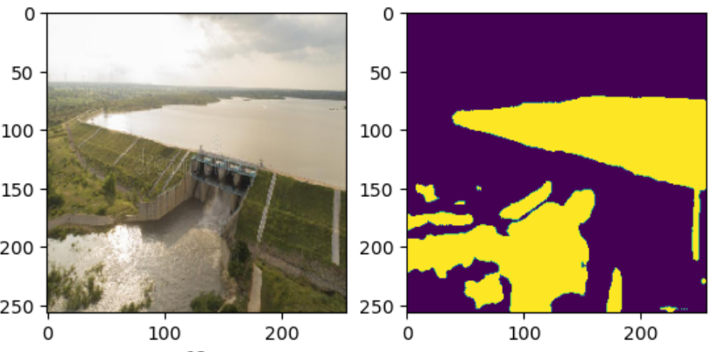

Fig 3 Mask

|  |  |
| --- | --- |
| METHOD | ACCURACY |
| Proposed Model | 90.18 |
| VGG16 | 78 |

Table 1: Comparison

The table shows the comparative study of the existing methods and it shows that the proposed system has clearly outperformed the existing methods.

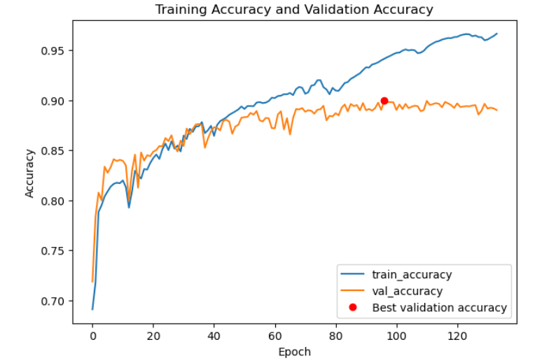

Fig 4 Model Accuracy

The figure 4 shows the accuracy graph of the model, the model achieved an accuracy of 90.18 with 134 epoch and it took 2366 seconds to complete the training. The VGG16 model achieved only an accuracy of 78%, so it shows that the UNet has completely outperformed the VGG16.

V. CONCLUSION

The U-Net model represents a pinnacle in image segmentation, thanks to its sophisticated encoder-decoder architecture designed to adeptly navigate the intricacies of segmentation tasks. Through its encoder, equipped with convolutional layers for in-depth feature extraction, and strategic max pooling for downsampling, the model effectively captures a wide range of details within images, setting a strong foundation for segmentation. This process is enhanced by a bottleneck section implementing dropout to prevent overfitting, thereby ensuring robust performance across diverse segmentation scenarios. The decoder part of the model, featuring transpose convolutional layers and skip connections, then takes center stage by upsampling and refining the feature maps, ensuring that detailed spatial information is recovered and utilized for precise segmentation. This methodical approach, which preserves critical spatial details through the integration of skip connections, alongside the dropout mechanism in the bottleneck phase, guarantees the model’s effectiveness in handling new, unseen data.

Demonstrated by its impressive learning trajectory—from a 50% training accuracy to an 85.13% validation accuracy by the 20th epoch—the U-Net model's performance solidifies its capacity for robust segmentation tasks. This leap in accuracy, paralleled by a decrease in both training and validation losses, underscores the model's ability to generalize well, making accurate predictions across different datasets. The synergy of convolutional processes, innovative upsampling, and strategic feature concatenation enables the U-Net to excel in extracting and leveraging multi-scale features and spatial information for precise segmentation outcomes, marking it as a powerful tool in the realm of image segmentation.

VI. REFERENCES

[1]Flood Detection using Deep Learning. Published in: 2021 International Conference on Advances in Computing and Communications (ICACC), Date of Conference: 21-23 October 2021

[2] Disaster event management based on Integrated Disaster Reduction and rapid Service Platform Conference: IGARSS 2016 - 2016 IEEE International Geoscience and Remote Sensing Symposium, July 2016

[3]Bera, S., & Mishra, A. K. (2018). Flood susceptibility modeling and zonation in the Upper Subarnarekha River Basin, India: A geospatial approach. Natural Hazards, 90(3), 1325-1343.

[4]Dash, S. R., & Ravan, S. (2008).Application of artificial neural network in the prediction of flood routing. Hydrological Processes, 22(14), 2387-2396.

[5] Dataset website: https://toffeeshare.com/c/C8EqvrigRs