Paleomat Figures

Andrew Gillreath-Brown

10/20/2021

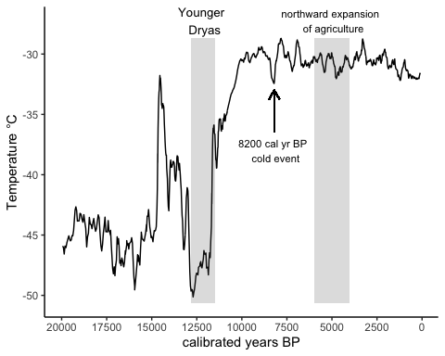

Figure 1: Temperature for the North Atlantic using Greenland ice core data (Alley 2000) for 20,000 BP to present.

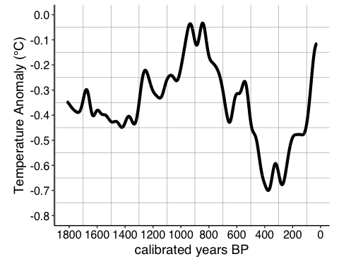

Figure 2: Low-frequency component of Moberg et al. (2005) multi-proxy reconstruction for Northern Hemisphere for 1817-25 BP.

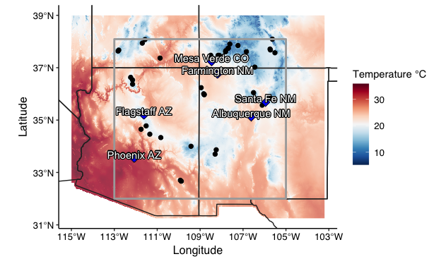

Figure 3: Locations of fossil pollen samples used in this study and extent of the Upper United States Southwest (Bocinsky and Kohler 2014).

Table 1: Metadata for the fossil pollen records used in this study.

| Site Name | Site ID | Dataset ID | Earliest date of core (BP) | Latest date of core (BP) | Minimum Depth | Maximum Depth | Longitude | Latitude | Elevation (m) |
| --- | --- | --- | --- | --- | --- | --- | --- | --- | --- |
| Alpine Pond | 9814 | 14517 | 369 | 2999 | 40.0 | 290.0 | -112.8245 | 37.63632 | 3200 |
| Alpine Pond | 9814 | 14547 | 58 | 580 | 10.0 | 60.0 | -112.8245 | 37.63632 | 3200 |
| Bear Lake | 10000 | 14951 | 132 | 13455 | 202.0 | 999.0 | -112.1472 | 36.37112 | 2778 |
| Bechan Cave | 244 | 247 | 16035 | 22010 | 43.0 | 67.0 | -110.8667 | 37.36667 | 1280 |
| Bechan Cave | 244 | 3060 | 1165 | 14630 | 7.5 | 112.5 | -110.8667 | 37.36667 | 1280 |
| Beef Pasture | 246 | 250 | -3 | 6014 | 0.5 | 392.0 | -108.1604 | 37.47310 | 3060 |
| Beef Pasture | 246 | 25551 | 14 | 2067 | 4.5 | 144.5 | -108.1604 | 37.47310 | 3060 |
| Black Mountain Lake | 10531 | 16222 | 8972 | 14945 | 220.0 | 315.0 | -107.2354 | 37.84682 | 3413 |
| Cascade Fen [Engineer Mountain Bog] | 339 | 347 | 14 | 6033 | 2.0 | 300.0 | -107.8087 | 37.64764 | 2690 |
| Chihuahueños Bog | 13680 | 20833 | -48 | 14898 | 1.0 | 444.0 | -106.5105 | 36.04767 | 2925 |
| Columbine Ranch Fen | 486 | 498 | 195 | 7376 | 5.0 | 170.0 | -107.8157 | 37.60664 | 2694 |
| Como Lake | 2957 | 3056 | 774 | 14606 | 10.0 | 300.0 | -105.5142 | 37.56952 | 3523 |
| Crane Lake | 504 | 517 | 1121 | 14024 | 20.0 | 430.0 | -112.1489 | 36.52986 | 2590 |
| Cumbres Bog | 11617 | 17419 | 303 | 19301 | 14.5 | 693.5 | -106.4505 | 37.02175 | 3100 |
| Dead Man Lake | 655 | 671 | 16638 | 35598 | 29.0 | 812.0 | -108.9517 | 36.23750 | 2759 |
| Dead Man Lake | 655 | 3076 | 32280 | 40997 | 675.0 | 1035.0 | -108.9517 | 36.23750 | 2759 |
| Fracas Lake | 9997 | 14944 | 50 | 13543 | 105.0 | 600.0 | -112.2386 | 36.63070 | 2512 |
| Hay Lake | 982 | 1013 | 958 | 44692 | 9.0 | 420.0 | -109.4250 | 34.00000 | 2780 |
| Head Lake | 2955 | 3054 | 1 | 14050 | 3.0 | 240.0 | -105.7406 | 37.71109 | 2300 |
| Hermit Lake | 23930 | 41580 | -46 | 13358 | 5.5 | 870.0 | -105.6317 | 38.08806 | 3450 |
| Hospital Flat Meadow | 26738 | 46801 | 31 | 1173 | 5.0 | 50.0 | -109.8774 | 32.66757 | 2747 |
| Hunters Lake | 13486 | 20304 | -46 | 13940 | 0.5 | 390.0 | -106.8437 | 37.61104 | 3516 |
| Jacob Lake | 1127 | 1162 | 233 | 19938 | 9.0 | 295.5 | -110.8333 | 34.33333 | 2285 |
| Lake Emma | 10061 | 15106 | -29 | 12106 | 0.0 | 206.0 | -107.6154 | 37.90210 | 3740 |
| Leonora Curtin | 14632 | 22948 | 20 | 518 | 5.0 | 29.0 | -106.1065 | 35.56948 | 1850 |
| Long Lake | 1609 | 1660 | 1111 | 24916 | 10.0 | 280.0 | -108.8333 | 36.00556 | 2727 |
| Lowder Creek Bog | 9830 | 14549 | 336 | 14784 | 20.0 | 720.0 | -112.7922 | 37.67214 | 3127 |
| Mayberry Well | 1661 | 1717 | 4981 | 36242 | 47.0 | 342.0 | -108.3000 | 33.70000 | 2080 |
| Molas Lake | 1705 | 1761 | 174 | 18996 | 2.0 | 220.0 | -107.6827 | 37.74759 | 3200 |
| Molas Pass Bog | 1706 | 1762 | 370 | 9718 | 5.0 | 140.0 | -107.6975 | 37.73778 | 3220 |
| Montezuma Well | 1710 | 1766 | -2 | 12838 | 5.0 | 1015.0 | -111.7523 | 34.64920 | 1081 |
| Posy Lake | 1905 | 1970 | 935 | 8221 | 30.0 | 592.0 | -111.6960 | 37.93746 | 2653 |
| Potato Lake | 1906 | 3560 | 1315 | 10936 | 20.5 | 105.5 | -111.3453 | 34.46222 | 2205 |
| Potato Lake | 1906 | 3561 | 1389 | 35271 | 25.0 | 925.0 | -111.3453 | 34.46222 | 2205 |
| Purple Lake | 13683 | 20838 | -55 | 8722 | 1.0 | 256.0 | -111.5712 | 38.07438 | 3226 |
| Sagehen Marsh | 2241 | 2320 | 6 | 248 | 5.0 | 60.0 | -108.5039 | 37.47389 | 2085 |
| Sagehen Marsh | 2241 | 3608 | 1350 | 1350 | 143.5 | 160.0 | -108.5039 | 37.47389 | 2085 |
| Sagehen Marsh | 2241 | 3609 | 5561 | 5749 | 155.5 | 227.5 | -108.5039 | 37.47389 | 2085 |
| San Agustin Plains | 2260 | 2340 | 8837 | 18164 | 155.0 | 361.0 | -108.2500 | 33.86667 | 2069 |
| San Agustin Plains | 2260 | 3611 | 7659 | 26899 | 87.0 | 715.0 | -108.2500 | 33.86667 | 2069 |
| San Agustin Plains | 2260 | 3612 | 189 | 12654 | 2.0 | 134.0 | -108.2500 | 33.86667 | 2069 |
| San Luis Lake | 9878 | 14650 | -37 | 1427 | 0.0 | 154.0 | -105.7247 | 37.67773 | 2293 |
| Soldier Creek Meadow | 24232 | 42645 | 41 | 1320 | 5.0 | 90.0 | -109.9204 | 32.70177 | 2860 |
| Stewart Bog | 10191 | 15356 | -31 | 13547 | 1.0 | 409.0 | -105.7220 | 35.83200 | 3115 |
| Stoneman Lake | 10449 | 15967 | -42 | 9792 | 0.0 | 200.0 | -111.5178 | 34.77887 | 2047 |
| Twin Lakes | 2785 | 2880 | 102 | 11411 | 2.5 | 395.0 | -108.1026 | 37.46906 | 3290 |
| Utricularia Lake | 2800 | 2897 | 769 | 22005 | 15.0 | 132.0 | -108.8083 | 35.96889 | 2753 |
| Whiskey Lake | 2853 | 2950 | 333 | 23199 | 5.0 | 160.0 | -108.8108 | 35.98194 | 2712 |