Paleomat Figures

Andrew Gillreath-Brown

08/29/2022

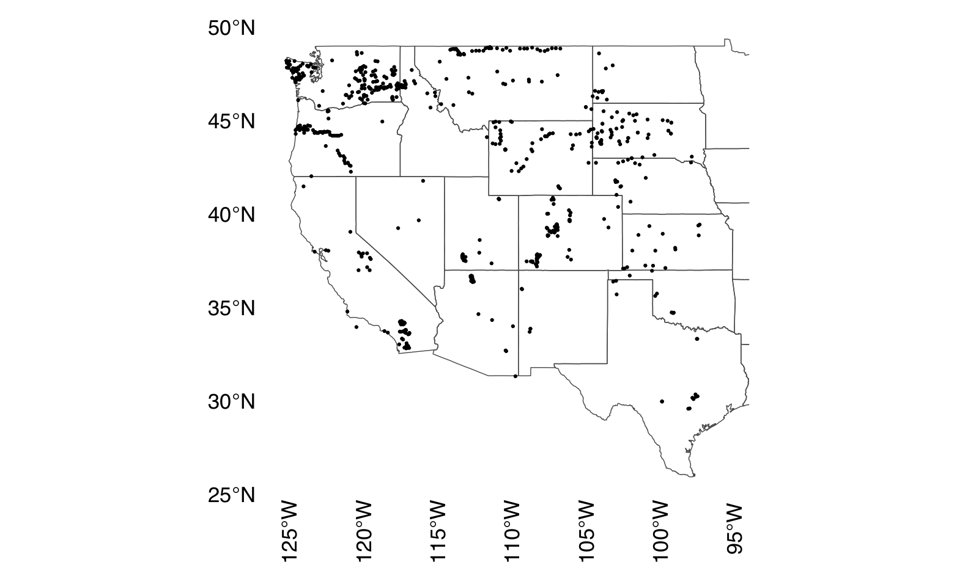

Figure 0.1: Modern pollen samples used in this study from the Neotoma Paleoecological Database.

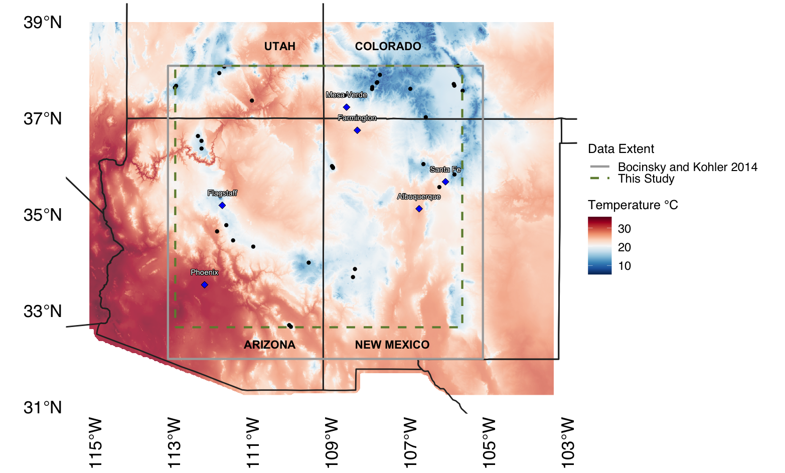

Figure 0.2: The Southwest United States (SWUS) as defined here, showing locations of fossil pollen samples used in this study. Background shading indicates mean July temperature for 1961 - 1990 from PRISM (Daly et al., 2008, 2015; PRISM Climate Group, 2019) at 800-m resolution. The solid gray box outlines the area studied by Bocinsky and Kohler (2014); the green dashed box shows the extent of the reconstruction in this study.

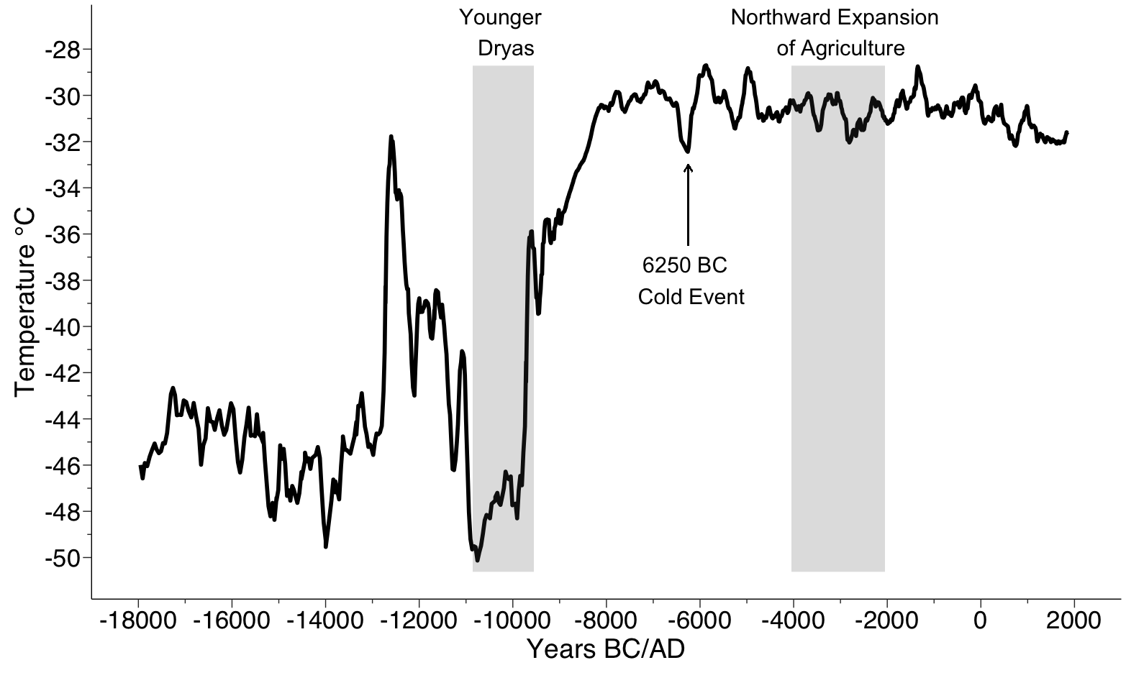

Figure 0.3: Temperature for the North Atlantic using Richard Alley’s (2000) Greenland ice core data for 18,000 BC to present with the Younger Dryas and the general period of the northward expansion of maize agriculture from Mesoamerica into the SWUS highlighted.

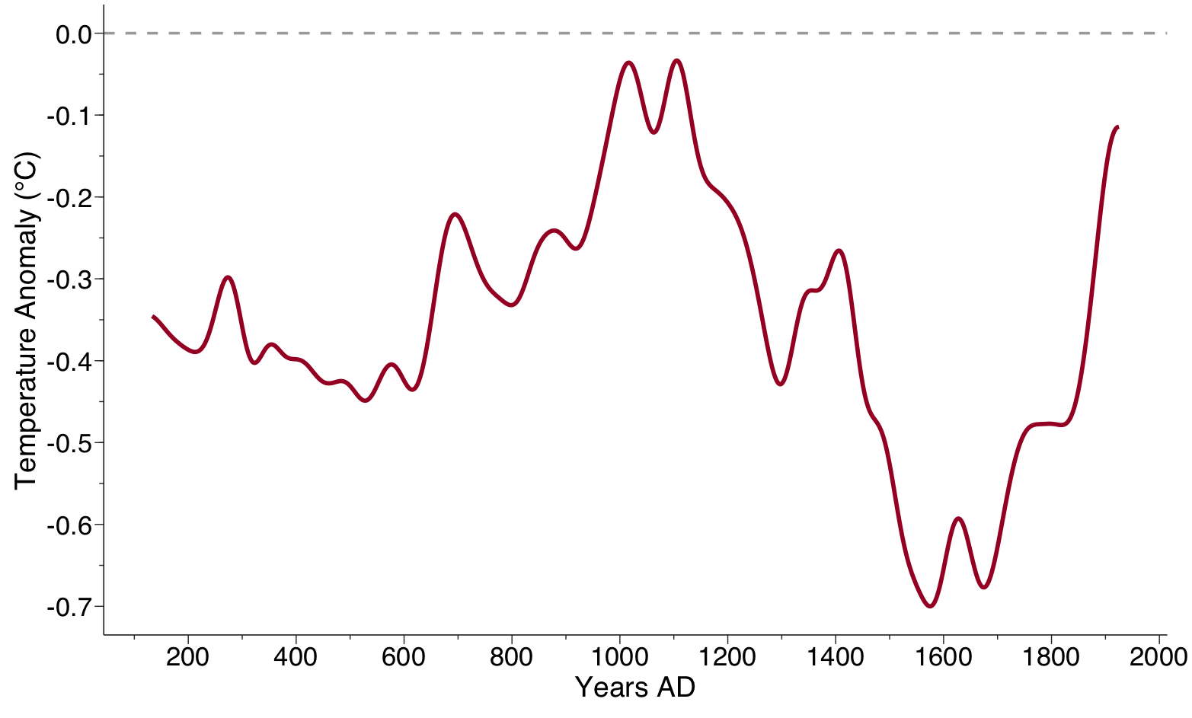

Figure 0.4: Low-frequency component of the Moberg et al. (2005) multi-proxy reconstruction for Northern Hemisphere for AD 133–1925. Anomaly is calculated in comparison to the 1961–1990 average.

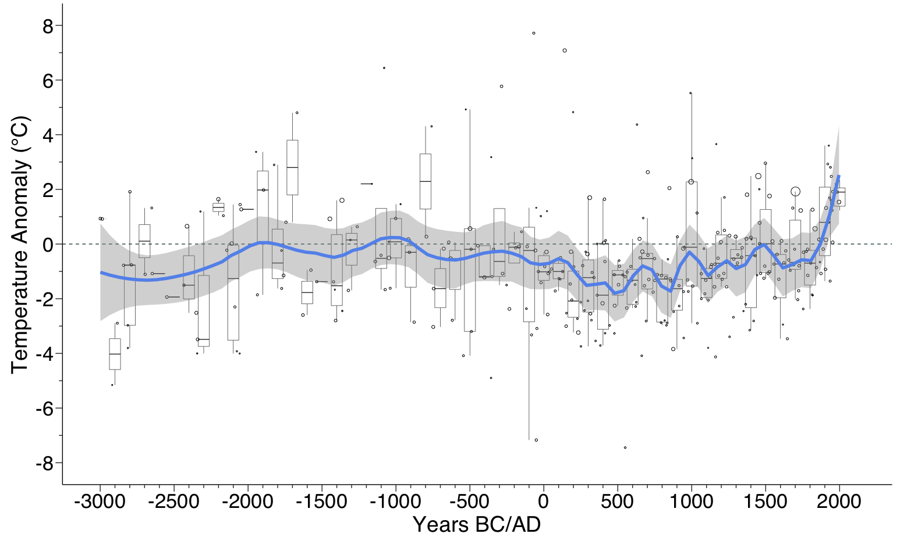

Figure 0.5: Low-frequency bootstrapped temperature anomaly loess reconstruction from this study (blue) with standard error (gray). Boxplots show estimates binned by century. Anomalies are calculated in comparison to the 1961–1990 average. The temperature predictions for each sample (not binned by century) are shown by circles; sizes of circles are inversely proportional to the sample-specific errors (size of circle ∝ 1/s1; see Simpson, 2007: 21 for calculation of s1). Anomaly estimates with larger circles are more precise.

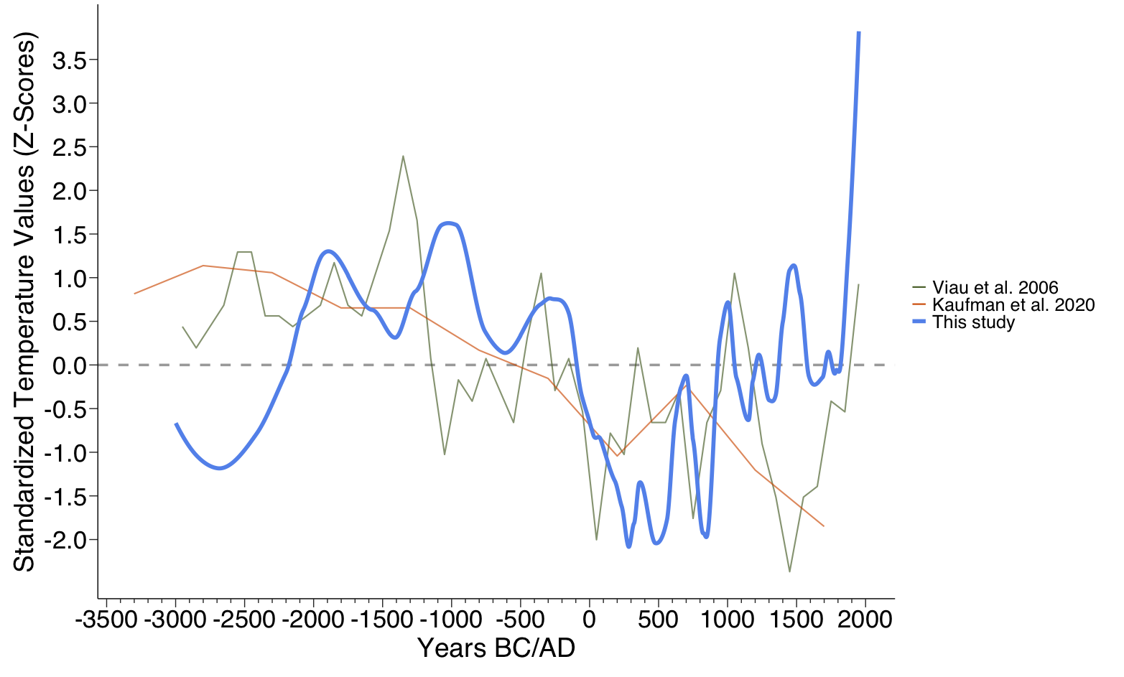

Figure 0.6: Low-frequency July temperature anomaly for the SWUS from this study, the North American July temperature reconstruction (Viau et al., 2006) from 3000 BC to AD 2000, and the terrestrial composite for 30–60 °N (Kaufman et al., 2020), from 3300 BC to AD 1700, in 500-year bins. All series standardized to a mean of 0 and an s of 1 over the period in this graph.

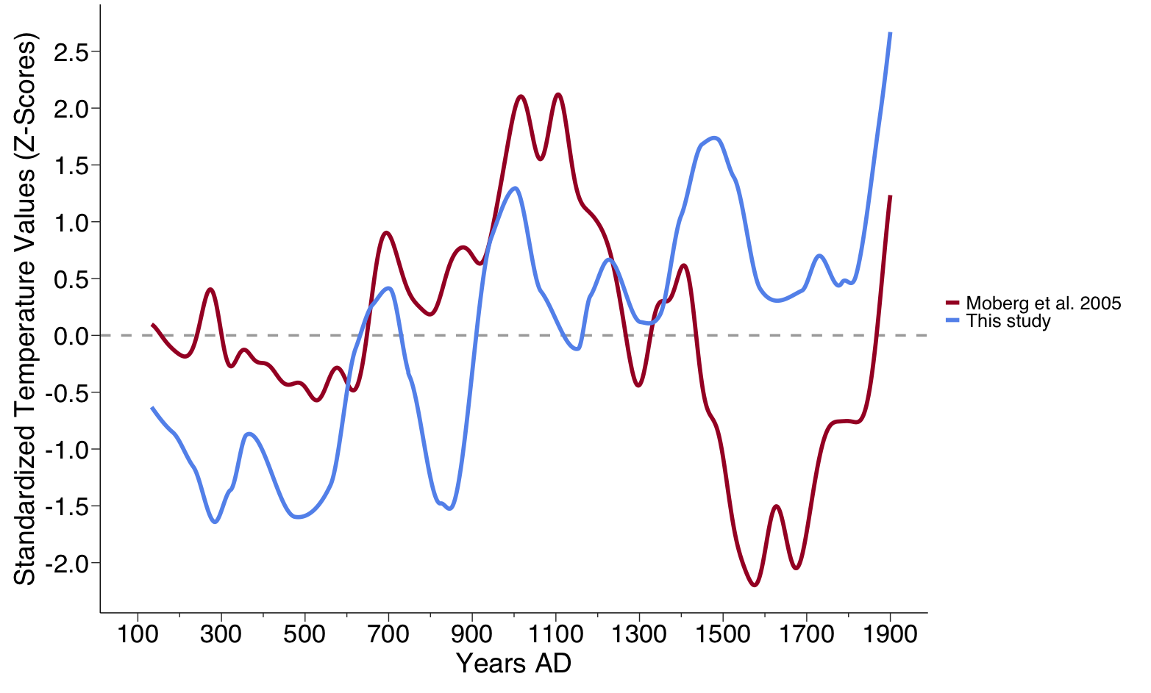

Figure 0.7: Low-frequency July temperature anomaly for the SWUS from this study and the Northern Hemisphere low-frequency component (Moberg et al. 2005) from AD 133 to 1900. Both series have been standardized to a mean of 0 and an s of 1 for this period.

# 1 Tables

Table 1.1: Metadata for the fossil pollen records (37 sites or 41 datasets) used in this study that have data after 3,550 BC. All data were downloaded from the Neotoma Paleoecological Database (Williams et al., 2018).

| Site Name | Site ID | Dataset ID | No. of Samples | Elevation (m) | Longitude | Latitude | Pass significance test? |
| --- | --- | --- | --- | --- | --- | --- | --- |
| Alpine Pond | 9814 | 14517 | 26 | 3200 | -112.8245 | 37.63632 | No |
| Alpine Pond | 9814 | 14547 | 11 | 3200 | -112.8245 | 37.63632 | No |
| Bear Lake | 10000 | 14951 | 12 | 2778 | -112.1472 | 36.37112 | Yes |
| Bechan Cave | 244 | 3060 | 12 | 1280 | -110.8667 | 37.36667 | No |
| Beef Pasture | 246 | 250 | 90 | 3060 | -108.1604 | 37.47310 | Yes |
| Beef Pasture | 246 | 25551 | 71 | 3060 | -108.1604 | 37.47310 | Yes |
| Cascade Fen [Engineer Mountain Bog] | 339 | 347 | 63 | 2690 | -107.8087 | 37.64764 | No |
| Chihuahueños Bog | 13680 | 20833 | 18 | 2925 | -106.5105 | 36.04767 | No |
| Columbine Ranch Fen | 486 | 498 | 28 | 2694 | -107.8157 | 37.60664 | No |
| Como Lake | 2957 | 3056 | 9 | 3523 | -105.5142 | 37.56952 | Yes |
| Crane Lake | 504 | 517 | 7 | 2590 | -112.1489 | 36.52986 | Yes |
| Cumbres Bog | 11617 | 17419 | 30 | 3100 | -106.4505 | 37.02175 | Yes |
| Fracas Lake | 9997 | 14944 | 7 | 2512 | -112.2386 | 36.63070 | NA (removed in a previous step) |
| Hay Lake | 982 | 1013 | 5 | 2780 | -109.4250 | 34.00000 | Yes |
| Head Lake | 2955 | 3054 | 9 | 2300 | -105.7406 | 37.71109 | No |
| Hermit Lake | 23930 | 41580 | 26 | 3450 | -105.6317 | 38.08806 | Yes |
| Hospital Flat Meadow | 26738 | 46801 | 10 | 2747 | -109.8774 | 32.66757 | No |
| Hunters Lake | 13486 | 20304 | 20 | 3516 | -106.8437 | 37.61104 | No |
| Jacob Lake | 1127 | 1162 | 5 | 2285 | -110.8333 | 34.33333 | Yes |
| Lake Emma | 10061 | 15106 | 8 | 3740 | -107.6154 | 37.90210 | No |
| Leonora Curtin | 14632 | 22948 | 12 | 1850 | -106.1065 | 35.56948 | No |
| Long Lake | 1609 | 1660 | 2 | 2727 | -108.8333 | 36.00556 | Yes |
| Lowder Creek Bog | 9830 | 14549 | 12 | 3127 | -112.7922 | 37.67214 | No |
| Mayberry Well | 1661 | 1717 | 1 | 2080 | -108.3000 | 33.70000 | Yes |
| Molas Lake | 1705 | 1761 | 25 | 3200 | -107.6827 | 37.74759 | Yes |
| Molas Pass Bog | 1706 | 1762 | 15 | 3220 | -107.6975 | 37.73778 | No |
| Montezuma Well | 1710 | 1766 | 31 | 1081 | -111.7523 | 34.64920 | No |
| Posy Lake | 1905 | 1970 | 14 | 2653 | -111.6960 | 37.93746 | No |
| Potato Lake | 1906 | 3560 | 14 | 2205 | -111.3453 | 34.46222 | No |
| Potato Lake | 1906 | 3561 | 15 | 2205 | -111.3453 | 34.46222 | Yes |
| Purple Lake | 13683 | 20838 | 39 | 3226 | -111.5712 | 38.07438 | Yes |
| Sagehen Marsh | 2241 | 2320 | 10 | 2085 | -108.5039 | 37.47389 | Yes |
| Sagehen Marsh | 2241 | 3608 | 4 | 2085 | -108.5039 | 37.47389 | No |
| San Agustin Plains | 2260 | 3612 | 6 | 2069 | -108.2500 | 33.86667 | Yes |
| San Luis Lake | 9878 | 14650 | 24 | 2293 | -105.7247 | 37.67773 | No |
| Soldier Creek Meadow | 24232 | 42645 | 16 | 2860 | -109.9204 | 32.70177 | Yes |
| Stewart Bog | 10191 | 15356 | 102 | 3115 | -105.7220 | 35.83200 | No |
| Stoneman Lake | 10449 | 15967 | 17 | 2047 | -111.5178 | 34.77887 | No |
| Twin Lakes | 2785 | 2880 | 54 | 3290 | -108.1026 | 37.46906 | No |
| Utricularia Lake | 2800 | 2897 | 11 | 2753 | -108.8083 | 35.96889 | No |
| Whiskey Lake | 2853 | 2950 | 12 | 2712 | -108.8108 | 35.98194 | Yes |

# 2 Supplemental Materials

## 2.1 Supplemental Tables

Table 2.1: Metadata for the fossil pollen records used in this study.

| Site Name | Site ID | Dataset ID | Proportion explained variance | Random TF p | Anomaly (°C) | Anomaly Bootstrapped (°C) | Mean boostrap RMSEP (°C) | Mean boostrap s1 |
| --- | --- | --- | --- | --- | --- | --- | --- | --- |
| Bear Lake | 10000 | 14951 | 0.38 | 0.02 | 6.47 | 5.24 | 3.67 | 2.03 |
| Beef Pasture | 246 | 250 | 0.24 | 0.04 | 5.49 | 5.74 | 4.13 | 0.89 |
| Beef Pasture | 246 | 25551 | 0.29 | 0.09 | 4.28 | 4.16 | 4.12 | 1.10 |
| Como Lake | 2957 | 3056 | 0.42 | 0.00 | 6.24 | 4.50 | 2.65 | 0.99 |
| Crane Lake | 504 | 517 | 0.41 | 0.03 | 3.40 | 2.73 | 4.47 | 1.66 |
| Cumbres Bog | 11617 | 17419 | 0.17 | 0.06 | 13.13 | 11.84 | 3.79 | 1.45 |
| Hay Lake | 982 | 1013 | 0.19 | 0.02 | 2.57 | 2.28 | 4.47 | 1.07 |
| Hermit Lake | 23930 | 41580 | 0.16 | 0.08 | 3.81 | 3.39 | 4.27 | 1.15 |
| Jacob Lake | 1127 | 1162 | 0.35 | 0.02 | 2.32 | 2.81 | 4.48 | 0.81 |
| Long Lake | 1609 | 1660 | 0.13 | 0.05 | 7.26 | 6.61 | 4.62 | 1.21 |
| Molas Lake | 1705 | 1761 | 0.30 | 0.00 | 4.74 | 4.04 | 4.59 | 0.69 |
| Potato Lake | 1906 | 3561 | 0.42 | 0.00 | 1.85 | 1.32 | 2.76 | 0.73 |
| Purple Lake | 13683 | 20838 | 0.55 | 0.00 | 2.36 | 1.54 | 3.90 | 0.79 |
| Sagehen Marsh | 2241 | 2320 | 0.40 | 0.07 | 4.20 | 3.59 | 3.69 | 1.02 |
| San Agustin Plains | 2260 | 3612 | 0.52 | 0.01 | 0.00 | 0.00 | 3.10 | 0.95 |
| Soldier Creek Meadow | 24232 | 42645 | 0.20 | 0.07 | 3.75 | 4.10 | 4.26 | 0.72 |
| Whiskey Lake | 2853 | 2950 | 0.46 | 0.04 | 9.81 | 10.01 | 2.71 | 1.61 |
| Alpine Pond | 9814 | 14517 | 0.03 | 0.82 | NA | NA | NA | NA |
| Alpine Pond | 9814 | 14547 | 0.21 | 0.53 | NA | NA | NA | NA |
| Bechan Cave | 244 | 3060 | 0.18 | 0.45 | NA | NA | NA | NA |
| Cascade Fen [Engineer Mountain Bog] | 339 | 347 | 0.06 | 0.76 | NA | NA | NA | NA |
| Chihuahueños Bog | 13680 | 20833 | 0.11 | 0.42 | NA | NA | NA | NA |
| Columbine Ranch Fen | 486 | 498 | 0.06 | 0.72 | NA | NA | NA | NA |
| Head Lake | 2955 | 3054 | 0.05 | 0.75 | NA | NA | NA | NA |
| Hospital Flat Meadow | 26738 | 46801 | 0.30 | 0.24 | NA | NA | NA | NA |
| Hunters Lake | 13486 | 20304 | 0.30 | 0.11 | NA | NA | NA | NA |
| Lake Emma | 10061 | 15106 | 0.16 | 0.38 | NA | NA | NA | NA |
| Leonora Curtin | 14632 | 22948 | 0.27 | 0.26 | NA | NA | NA | NA |
| Lowder Creek Bog | 9830 | 14549 | 0.11 | 0.58 | NA | NA | NA | NA |
| Mayberry Well | 1661 | 1717 | 0.23 | 0.07 | NA | NA | NA | NA |
| Molas Pass Bog | 1706 | 1762 | 0.15 | 0.57 | NA | NA | NA | NA |
| Montezuma Well | 1710 | 1766 | 0.06 | 0.56 | NA | NA | NA | NA |
| Posy Lake | 1905 | 1970 | 0.03 | 0.86 | NA | NA | NA | NA |
| Potato Lake | 1906 | 3560 | 0.43 | 0.11 | NA | NA | NA | NA |
| Sagehen Marsh | 2241 | 3608 | 0.53 | 0.33 | NA | NA | NA | NA |
| San Luis Lake | 9878 | 14650 | 0.05 | 0.80 | NA | NA | NA | NA |
| Stewart Bog | 10191 | 15356 | 0.05 | 0.47 | NA | NA | NA | NA |
| Stoneman Lake | 10449 | 15967 | 0.14 | 0.17 | NA | NA | NA | NA |
| Twin Lakes | 2785 | 2880 | 0.06 | 0.67 | NA | NA | NA | NA |
| Utricularia Lake | 2800 | 2897 | 0.21 | 0.32 | NA | NA | NA | NA |

# 3 Supplemental Figures

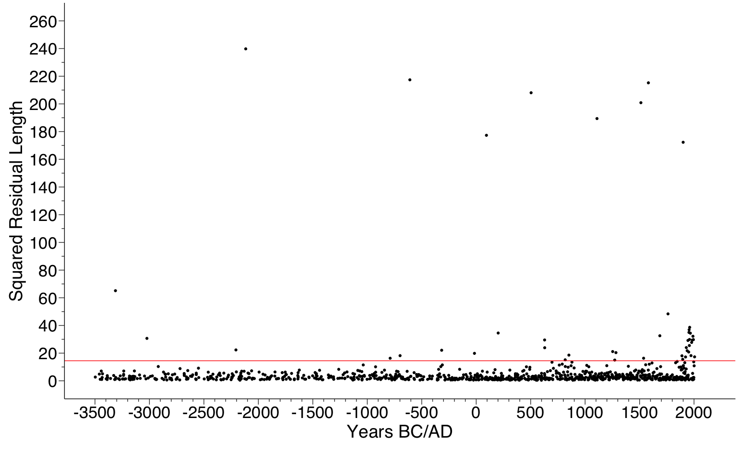

Figure 3.1: Squared residual length for the fossil assemblages vs age. Red line marks the 95% limit of the calibration set residual lengths (very poorly fitted). We removed all samples that fell above the 95% line.

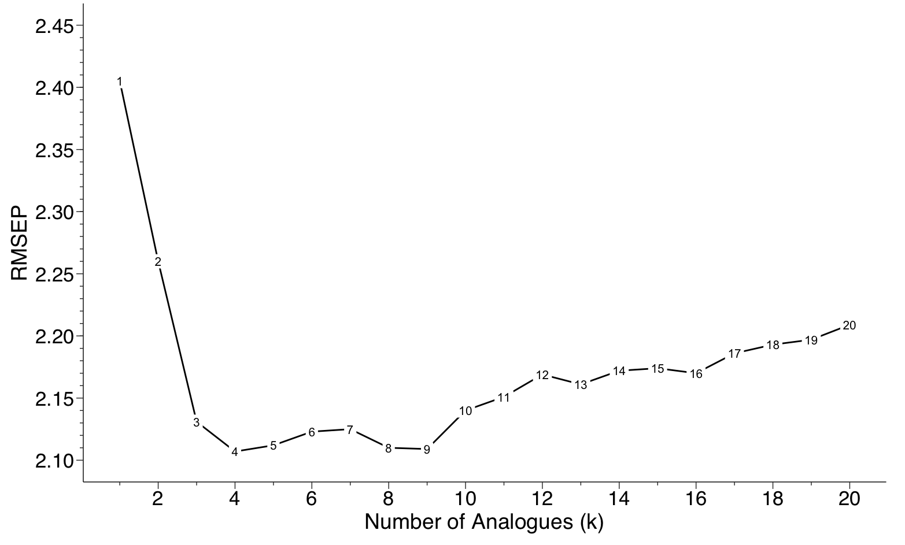

Figure 3.2: Summary diagram of the results of a MAT model applied to predict temperature from the modern pollen data set. The leave-one-out error measure (RMSEP) shows that 4 analogs provide the optimal choice (lowest RMSEP).

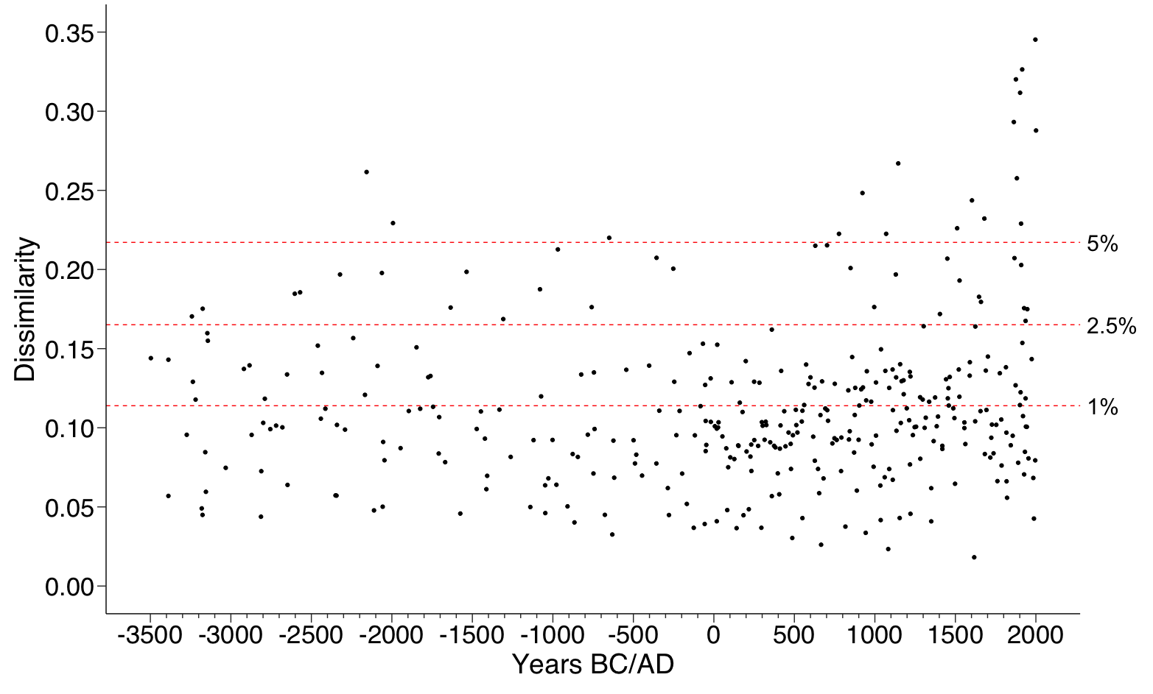

Figure 3.3: Time series plot of the minimum dissimilarity between each core (fossil) sample and the modern pollen training set samples. The dotted, horizontal lines are drawn at various percentiles of the distribution of the pair-wise dissimilarities for the training set samples. We used the 5th percentile as the cutoff for good analogs. So, samples with distances greater than the 5th percentile (above the line) were removed.

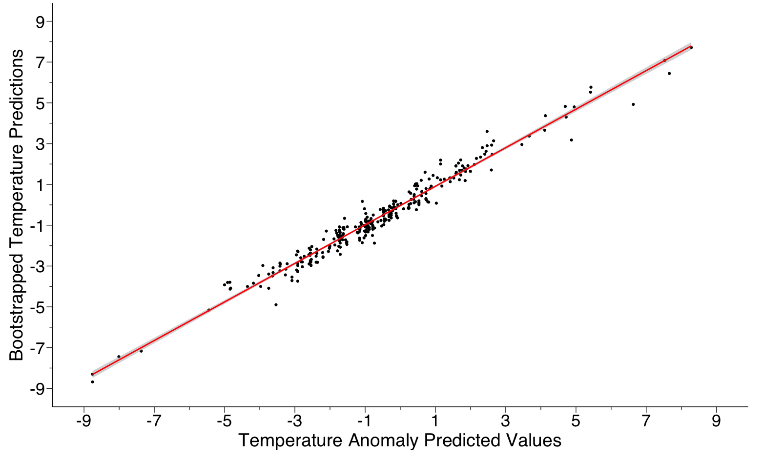

Figure 3.4: Linear regression and scatterplot between temperature anomaly predicted values and the bootstrapped temperature predictions. There is a strong linear relationship across their joint ranges (r2 = 0.96; p > F < .001).

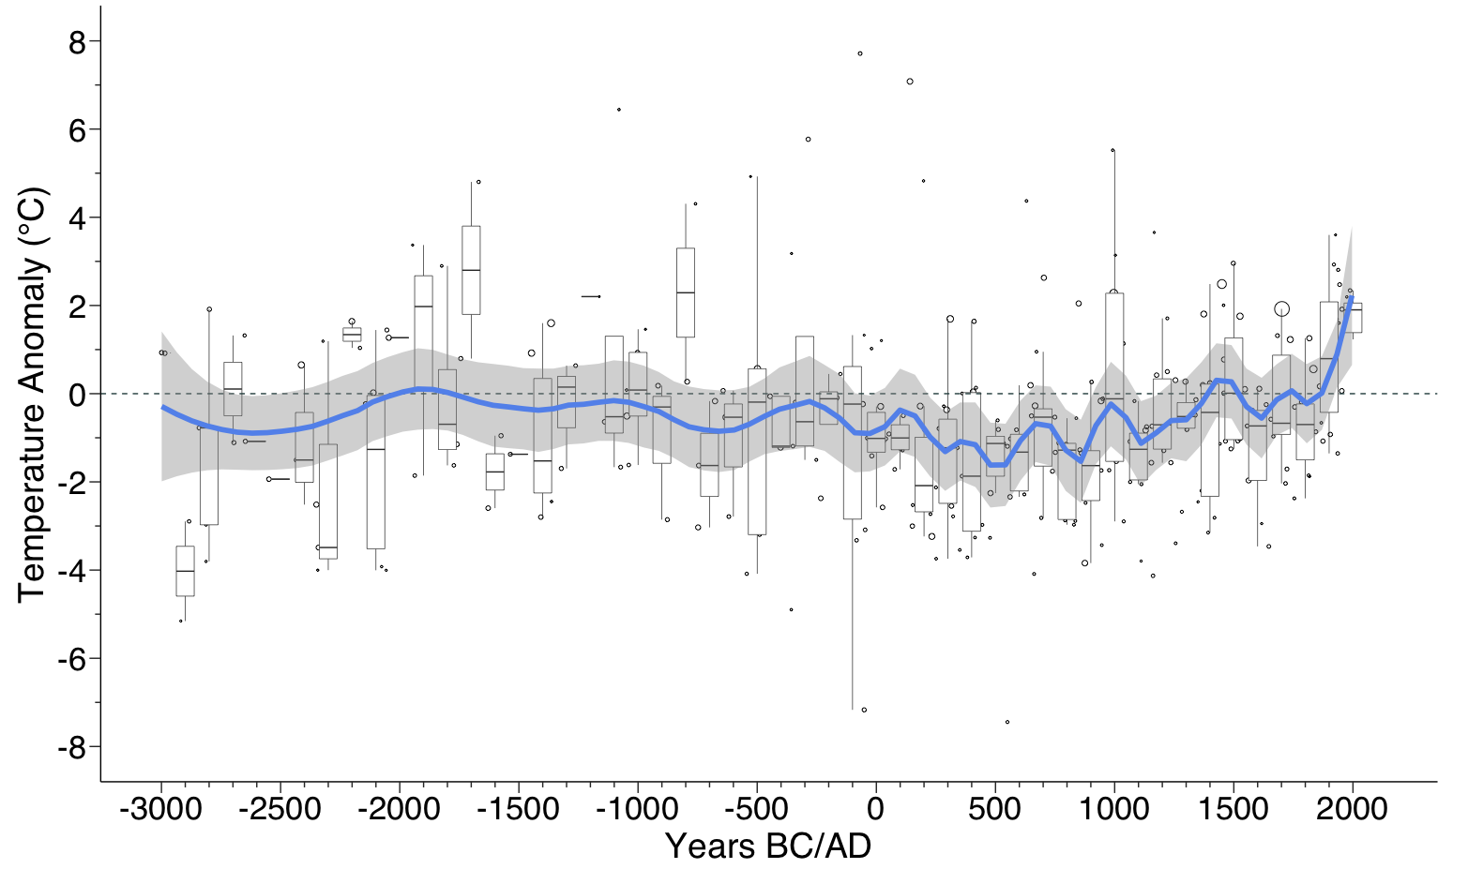

Figure 3.5: Low-frequency weighted bootstrapped temperature anomaly loess reconstruction from this study (blue) with standard error (gray). As in Figure 5 (main text) except here the loess curve (only) is weighted by the inverse of the sample-specific errors s1; see Simpson, 2007: 21 for calculation). Bubble size α 1/s1.