1. **Implement weather modeling* using the quadratic solution in stages: hard-coding variables keyboard input, read from a file, for a single set of input, multiple sets of inputs.**

**a. save all versions, debug, fix problems, create a Github account**

Implementation outline for **weather modeling using a quadratic solution**. The approach evolves in stages:

1. Hardcoding variables.
2. Accepting variables via keyboard input.
3. Reading variables from a file.
4. Processing a single set of inputs.
5. Processing multiple sets of inputs.

At the end, you will save the versions, debug, fix issues, and push the project to GitHub.

1. **Hardcoding variables.**

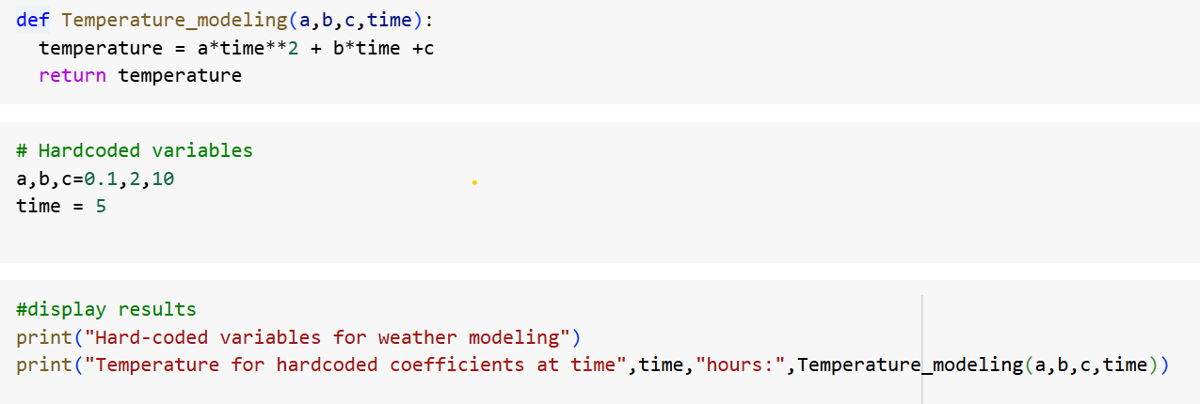

1. **Accepting variables via keyboard input**

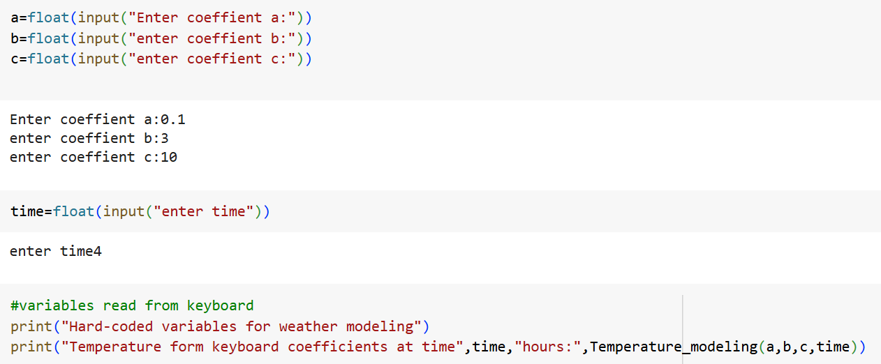

1. **Reading Variables from a File**

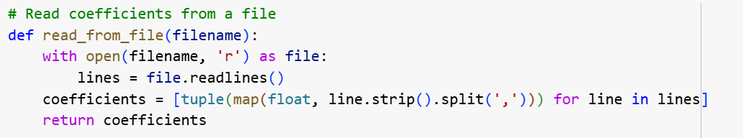

1. **Processing a single set of inputs.**

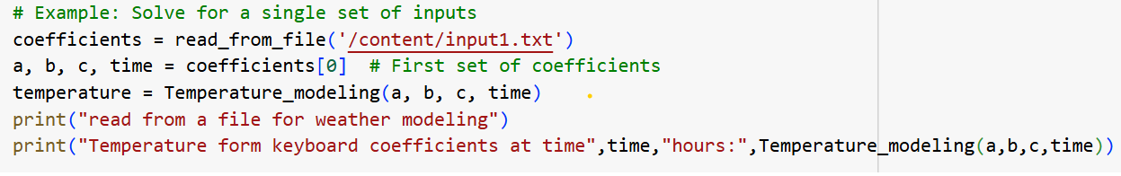

1. **Processing multiple sets of inputs**

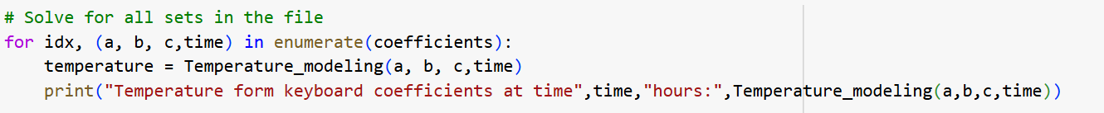

1. **At the end, you will save the versions, debug, fix issues, and push the project to GitHub.**

**Step_1:**

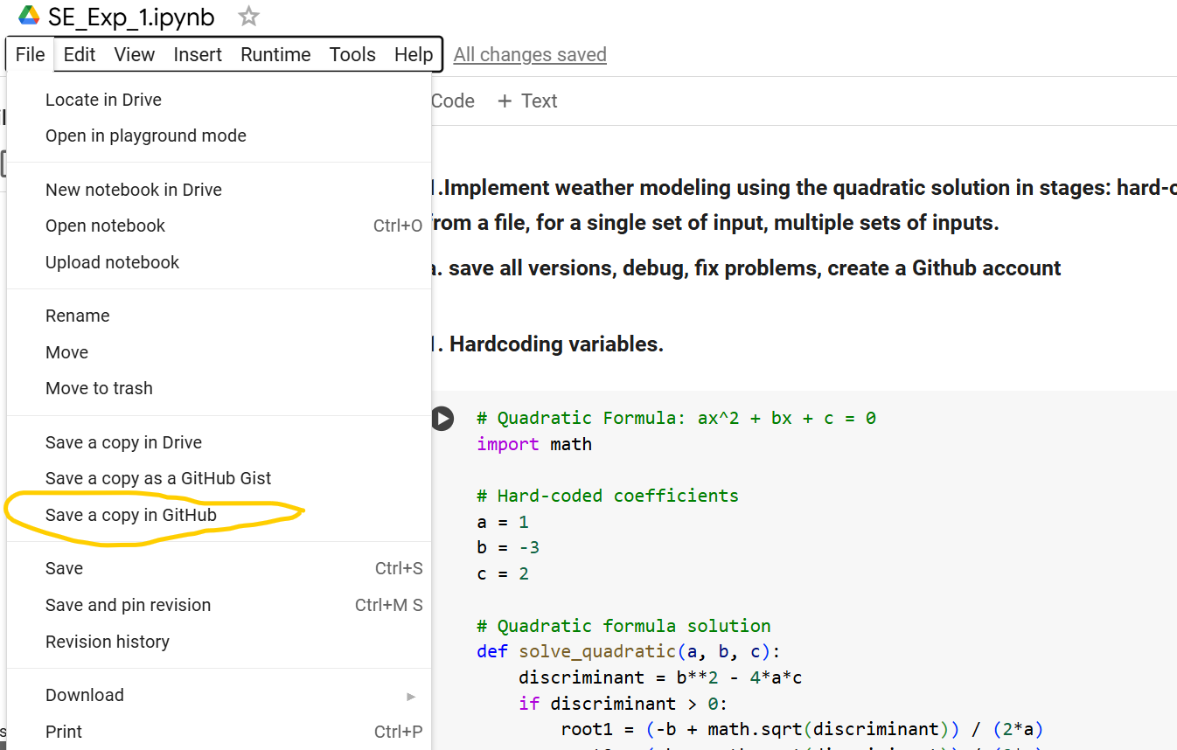

**Step_2:**

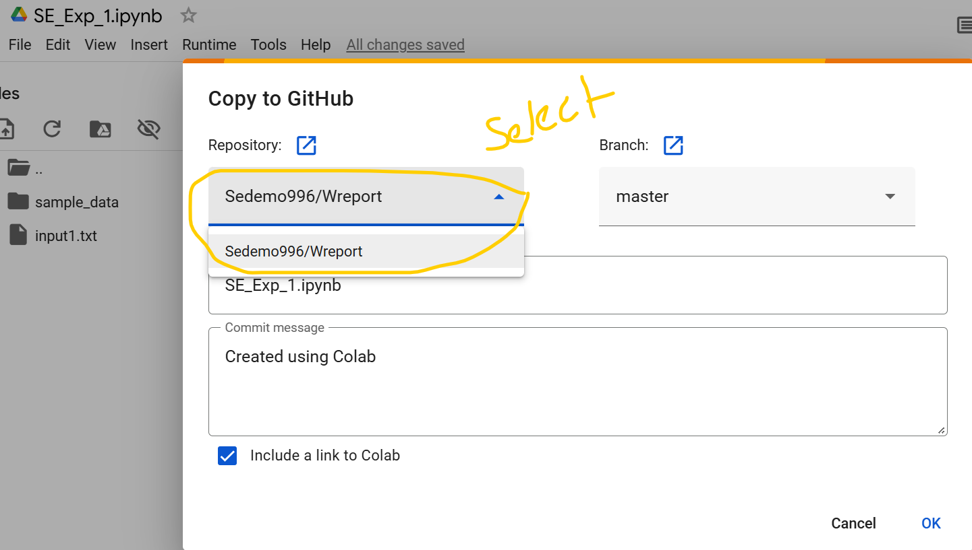

**Step_3:**

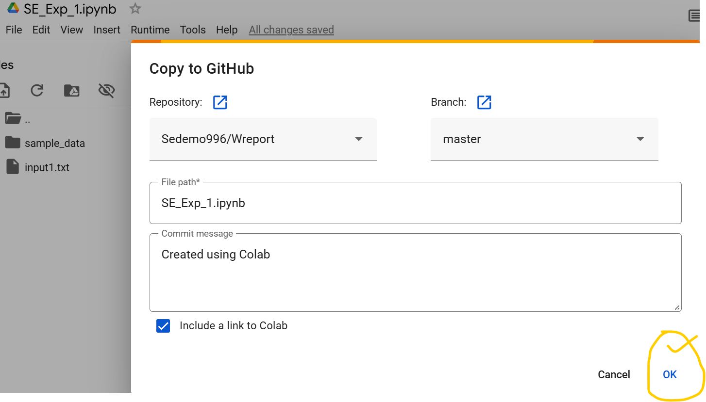

**Pushed into GitHub**

