Air Quality Index Analysis
1. Project Overview and Objective
This project analyses Air Quality Index (AQI) data across Indian states and cities to understand pollution trends, health hazards, and environmental impacts. The study involves data cleaning, transformation, exploratory data analysis (EDA), and visualization using Python libraries (Pandas, Seaborn, Matplotlib) and machine learning techniques (KNN imputation).
Assess Air Quality: Standardize pollutant measures (PM2.5, PM10, NO2, SO2, CO, O3, NH3).
Identify Trends: Track changes across cities and states.
Enable Decision-Making: Provide insights for policymakers and environmental agencies.
Raise Awareness: Categorize AQI into safe vs hazardous levels.
Predictive Analysis: Forecast pollution levels for proactive interventions.

The main objective is to demonstrate data pre-processing techniques using Python and an interactive Power BI dashboard visualization to make informed decisions.

2. Data Sources
- Source: data.Gov.in
- Timeline: Collected during 2026
- Size: 3514 records, 11 columns
- Features: Country, State, City, Station, Latitude, Longitude, Pollutant ID, Min/Max/Avg values, Timestamp
- Domain: Environment / Health Hazard

3. Problem Statement :
- To assess air quality across Indian states and cities by analyzing pollutant levels (PM2.5, PM10, NO2, SO2, CO, O3, NH3).
- To identify pollution trends and hotspots by comparing cities monitoring stations
- To evaluate the impact of pollutants on public health by categorizing them into respiratory, cardiovascular, and toxic hazards.
- To support policymakers and environmental agencies in designing interventions such as traffic restrictions, emission controls, and awareness campaigns.
- To forecast pollution levels using statistical and visualization techniques, enabling proactive decision-making.

4. Attribute (Column /Features) Details:
Attribute Name | Data Type | Description
country | String | The country where the data is collected (e.g., India).
state | String | The state name (e.g., Andhra Pradesh, Bihar, Delhi).
city | String | The city name (e.g., Kadapa, Patna, Guwahati).
station | String | The specific monitoring station (e.g., "Yerramukkapalli, Kadapa - APPCB").
last_update | Date/Time | Timestamp of the latest reading (e.g., 15-08-2026 11:00).
latitude | Float | Geographic latitude of the monitoring station.
longitude | Float | Geographic longitude of the monitoring station.
pollutant_id | String | Type of pollutant measured (e.g., PM2.5, PM10, NO2, SO2, CO, OZONE, NH3).
pollutant_min | Float | Minimum recorded value of the pollutant during the period.
pollutant_max | Float | Maximum recorded value of the pollutant during the period.
pollutant_avg | Float | Average concentration of the pollutant during the period.
Pollutant_Category | String | Derived category based on pollutant average (Low, Moderate, High, Very High).
Pollutant_Group | String | Grouped pollutant type (Particulate Matter, Gaseous Pollutant, Other).
Health_Hazard | String | Derived health impact (Respiratory, Cardiovascular, Neurological/Toxic).

5. Tools & Technologies
- Python: Data cleaning , Preprocessing of data & Exploratory data analysis
- KNN imputation: Machine Learning techniques to impute the missing value
Pandas, Seaborn & Matplotlib: to create visualization
- Power BI: DAX calculations, visualization, and interactive dashboard creation.

6. Data Pre-Processing ( Python)
Tasks Performed:
- Data Cleaning & Transformation
- Checked for duplicates (none found).
- Handled missing values in pollutant readings using KNN Imputer.
- Standardized formats (converted timestamps to datetime, rounded pollutant values).
- Renamed columns (e.g., pollutant_id → Pollutant_Name).
- Created derived columns:
- Pollutant_Category (Low, Moderate, High, Very High).
- Pollutant_Group (Particulate Matter, Gaseous Pollutant, Other).
- Health_Hazard (Respiratory, Cardiovascular, Neurological/Toxic).
- Pollutant_Range (difference between max and min values).
- Filtering & Sorting
  - Organized data by state, city, pollutant type for easier analysis.
  - Extracted Date and Time separately from last_update for trend analysis.
- Grouping
  - Grouped pollutant averages by state to compare regional air quality.
  - Grouped by Pollutant_Group to identify dominant pollutant types.
  - Crosstab analysis between Pollutant_Category vs Health Hazard for risk profiling.

7. Python Libraries:
Seaborn:
- Created statistical visualizations (histograms, boxplots, barplots, scatterplots, heatmaps, pairplots).
- Enabled quick insights into pollutant distributions, correlations, and category frequencies.
Matplotlib:
- Used for foundational plotting and customization.
- Controlled figure size, titles, labels, and layout for professional presentation.
- Complemented Seaborn by adding flexibility in chart styling.
Pollutant Average Distribution:
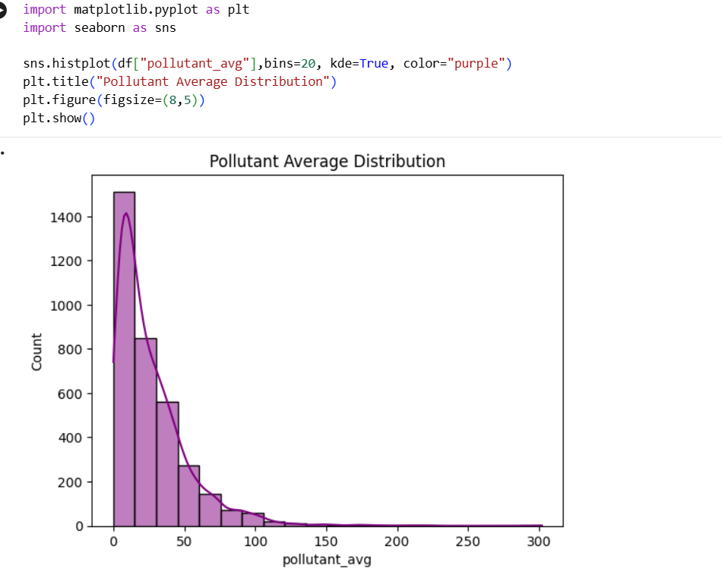

Pollutant Group Distribution
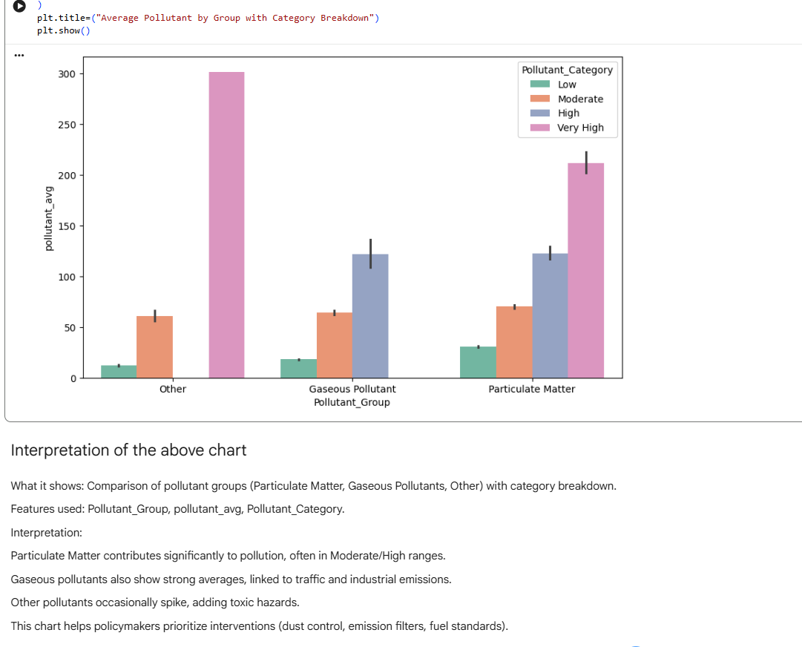
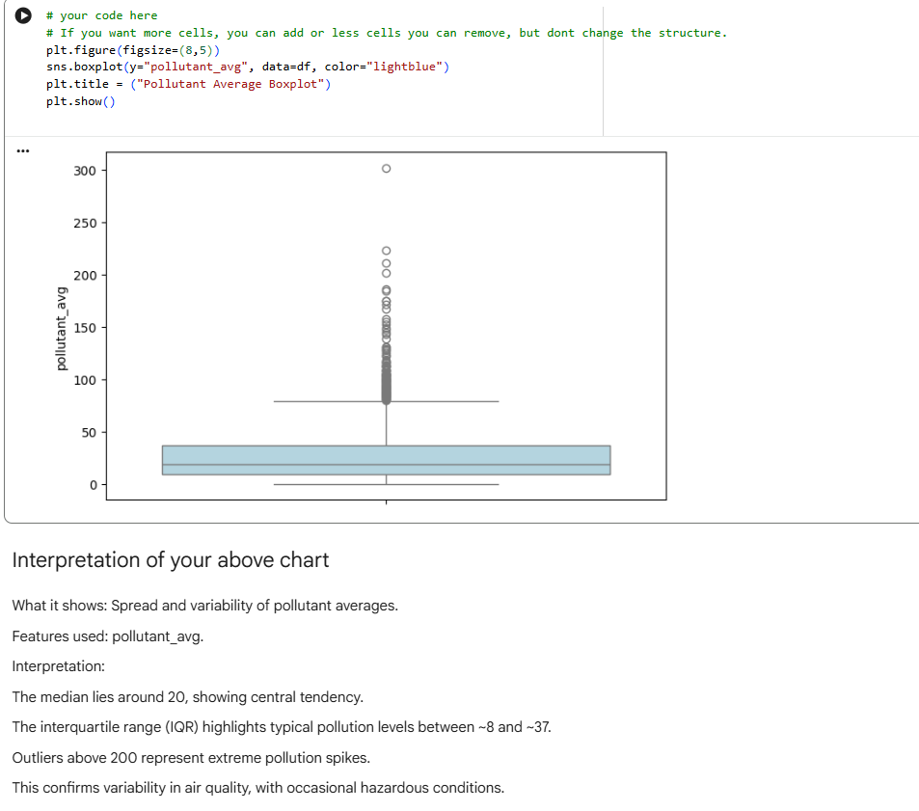

8. Analysis and Visualizations (Power BI)
Dashboard Features:
- Cards/KPIs
- Total Number Cities, Average Pollutant Level of the cities, Lowest & Highest Pollutant Value, Average Min & Max pollutant levels.
- Bar Charts
  - Average of Max Pollutant Level by State
  - Displayed top 10 States with maximum Pollutant. Delhi is in 1st position in Maximum Average Pollutant.
- Pie chart – Pollutant Category Distribution:
- Pie chart created to visualize the Pollutant Category Distribution (Low, Moderate, High, Very High).
- Low category Pollutant Average is (less than or = 50) - 86.14%
- Moderate category Pollutant Average is (less than or = 100) - 11.64%
- High category Pollutant Average is (less than or = 200) - 1.74%
- Very High category Pollutant Average is (>200) - 0.48%
- Stacked area chart :
- Top 10 station-level pollutant averages and breakdowns.
- pollutant levels over time or across categories.
- Anand Vihar (Delhi) recorded 75.43, North campus( Delhi) recorded 74.29 pollutant average
- Funnel Chart
- Top 10 states with Average Pollutant distribution
- Punjab, Tamil Nadu, Uttar Pradesh is having High average pollutant Distribution
Consolidated Dashboard Layout
- Top Section (Summary KPIs) → Cards showing overall pollutant metrics.
- Charts :
  - Bar chart of states (pollutant max/average).
  - Pie chart of pollutant categories.
  - Stacked area chat of station – wise Pollutant Average
  - Funnel chart of statewise average pollutant distribution.

SCREENSHOT OF DASHBOARD /REPORT
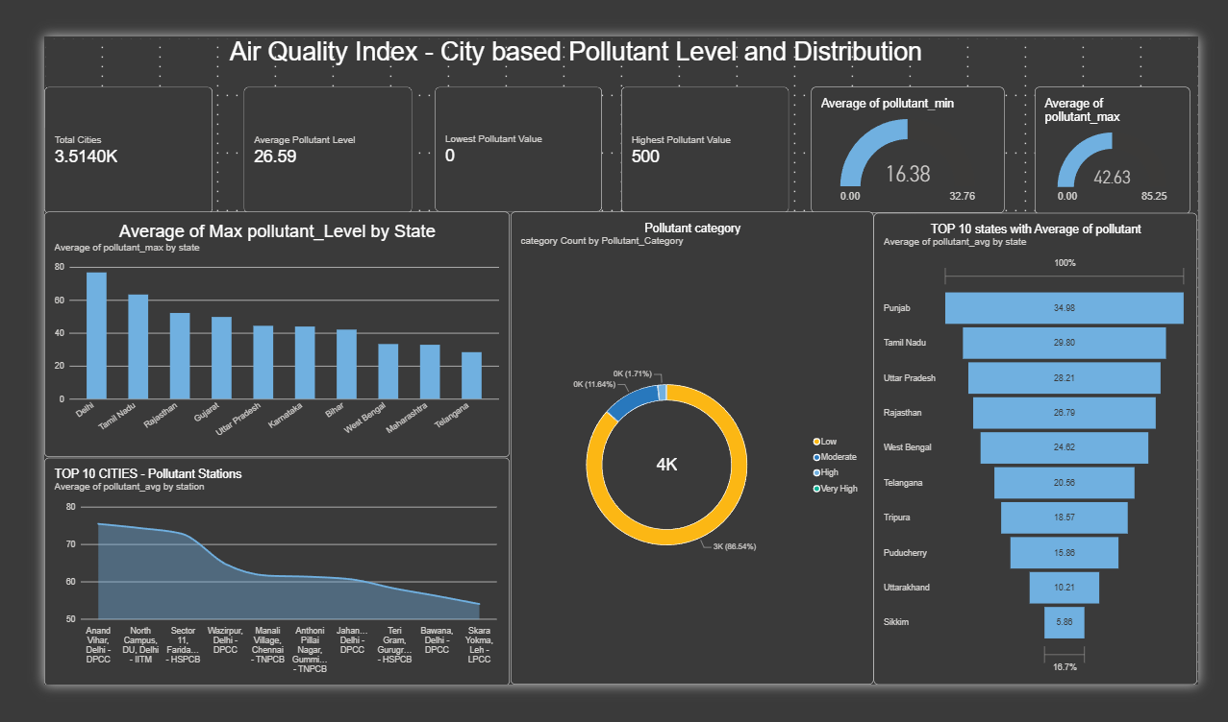

Dashboard 2: Air Quality Index – Health Hazard Distribution
- Cards/Legends
  - Health Hazard Legend (Cardiovascular, Neurological/Toxic, Respiratory).
  - Pollutant Category Legend (High, Low, Moderate, Very High).
- Bar Charts
  - Pollutant Group Count by cities – Bottom 10 Cities
  - Ahmedabad is having higher number of pollutant cities
  - Total Number of Pollutant Group Count
  - 1004 cities majorly polluted by Particulate Matter.
  - 1506 citied majorly affected by Gaseous Pollutant
  - 1004 cities affected by Other pollutant.
- Pie Chart
  - Distribution of Health Hazards – Cardiovascular affected cities 28.57%, Neurological/Toxic affected by 42.86% and Respiratory issues affected cities are 28.57%.
- Horizontal Bar Chart
  - Pollutant Categories by City (Delhi, Mumbai, Hyderabad, Bengaluru, Ahmedabad, Chennai, etc.).
- Map Visualization
  - India map showing pollutant category distribution by state (color-coded markers for pollutant levels).
Interactive Features
- Drill-down → From pollutant group → city → category.
- Filters/Slicers → By pollutant type (Particulate, Gaseous, Other), hazard type (Cardio, Neuro, Respiratory), and city/state.
Consolidated Dashboard Layout
- Legends & Summary: Hazard categories and pollutant categories.
- Charts:
  - Bar charts for pollutant counts and groups.
  - Pie chart for hazard distribution.
- Geographic & City Insights
  - Horizontal bar chart of pollutant categories by city.
  - Map of India showing pollutant distribution by state.
- Navigation → Bookmarks for switching between hazard-focused and pollutant-focused views.

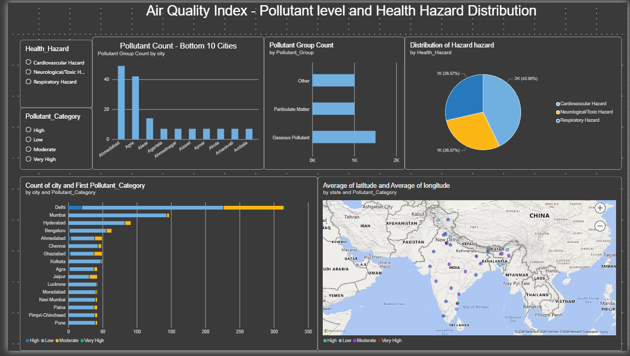

9. Insights & Conclusions
Key Findings
    - Cities like Delhi, Patna, and Noida show consistently high pollutant averages due to traffic and industry, while rural spikes are linked to seasonal crop burning.
Pollutant Groups:
    - Particulate Matter (PM2.5, PM10): Major contributor to respiratory hazards.
    - Gaseous Pollutants (NO2, SO2, CO, O3): Linked to cardiovascular risks.
    - Other pollutants (NH3): Associated with neurological/toxic hazards.
State-wise Trends:
    - Delhi, Punjab, Bihar → Highest average pollution levels.
    - Sikkim, Mizoram, Uttarakhand → Lowest averages, cleaner air.
🔹 Analysis Insights
Descriptive:
Majority of records fall under the Low category (~3000).
    - Only a small fraction are High or Very High, but these represent critical health risks.
Diagnostic:
    - Industrial belts show elevated SO2 and CO.
    - Traffic-heavy cities show high NO2.
    - Ozone peaks highlight secondary pollutant formation.
Prescriptive:
    - Policy Recommendations:
    - Stricter emission controls for vehicles and industries.
    - Improved fuel standards and monitoring of chemical plants.
    - Awareness campaigns for seasonal pollution sources.
Public Health Measures:
    - Respiratory clinics in high PM regions.
    - Cardiovascular monitoring in high NO2/SO2 zones.
10. Conclusions
    - The integration of Python (Pandas, Seaborn, Matplotlib) for data cleaning and visualization, combined with Power BI for interactive dashboards, proved effective for end-to-end AQI analysis.
    - This project demonstrates how environmental datasets can be transformed into actionable insights for policymakers, city planners, and public health agencies, while also raising awareness among the public about safe vs hazardous air conditions.
    - Future scope includes predictive modeling to forecast pollution spikes and real-time dashboards for proactive decision-making.

