Please find answers below for the given questions and do let me know if any clarification is required.

## Question 1:

You are an Automation Tester on an Agile project. You have following stories in backlog. Please write automation script(s) for following user stories.

* You may use any language, tool/framework to automate the user stories
* Your solution should reflect your level of expertise
* URL to be used for this exercise: <http://www.westpac.co.nz/>
* Navigation Flow : FX,Travel& migrant > Currency Converter
* Please upload/share your solution to online source control repositories (e.g. GitHub, CodePlex)

**Test User Story 1:**

**Priority: Major**

**As a Product Owner**

If there is no amount entered and the convert button is clicked then I want to see an error message “Please enter the amount you want to convert.” on the currency converter page.

**So that**

The user is able to get a clear indication as to what has to be rectified

**Acceptance Criteria**

The message “Please enter the amount you want to convert.” is displayed on the screen when convert button is clicked without entering a value in the Enter amount input box

**Test User Story 2:**

**Priority: Major**

**As a Product Owner**

I want the feature to Convert Currency A to a Currency B and vice versa with the currency converter

**So that**

The user gets an indication of the exchange rates and makes an informed decision on their foreign transactions

**Acceptance Criteria**

* User is able to convert 1 NZD to USD successfully
* User is able to convert 1 USD to NZD successfully
* User is able to convert 1 Pound Sterling to NZD successfully
* User is able to convert 1 Swiss Frack To Euro successfully

Please find the automation solution available in Github

## Question 2:

**Explain your choice of tool and framework if you used any?**

*I’m using UFT tool for this exercise as that’s the tool we are going to use in our organization. We can use Selenium too as we are purely working on web application.*

*I have developed two scripts for the two user stories mentioned above I have used two different approaches in developing the scripts below are the details of the approach I have used.*

**Approach 1:**

*For first script I have used stand-alone framework i.e. without use of ALM, Assume we are saving scripts in file system and not relying on ALM then we would need a centralized location from where we would want the batch to be executed to address this I have used a ExecutionController.xls file in which we will be specifying which scripts to run and which one not to.*

*When we execute the init.vbs script it opens UFT and loads driver script which in turn first invokes Run manager i.e. ‘ExecutionController.xls’ and see which test cases to be executed based on the ‘Execute’ flag and starts executing the test cases which are flagged as ‘True’*

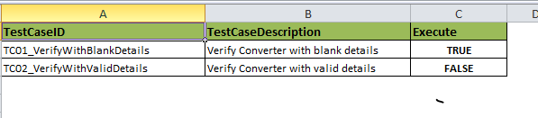

*Each test case has an entry in ‘TestData’ sheet from which the script gets the data from. If the single script needs to be executed on multiple sets of data then we will have multiple rows with same test case name with an increment in ‘Iteration’ column (which is not implemented in the framework due to time constraint).*

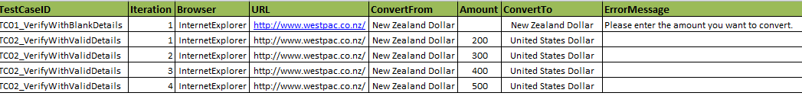

*Results will be stored in ‘Results’ folder along with screenshots if script encounters any failure.*

*Used shared OR concept which is associated to driver script.*

**Approach 2:**

*If we are using ALM we don’t need a run manager as we can directly pull the test scripts from ‘Test Plan’ into ‘Test Lab’ and execute that particular test set.*

*So I have written a stand-alone script which can be uploaded directly to ALM. I have used data driven approach for this script in combination with descriptive programming.*

## Question 3:

**Do you think that the priorities of the user story are appropriate in relation the overall need of currency converter?**

*In my opinion user story 1 can be minor & user story 2 can be critical.*

*As user story 1 talks about a field level validation it’s a must have from usability standpoint where as user story 2 is the core feature of the application under test and would impact the bank business.*

## Question 4:

**What are the possible points at which your tests can fail and how can you handle them?**

*Tests can fail at any given point hence it’s always good to write error handling code after every action.*

*Here in the scripts I have used “err.number” to check if there is any error encountered after every click/verify/operation and exist gracefully by taking a snapshot so that we can refer to it during execution analysis.*

## Question 5:

**How can we drive your tests using any CI tool?**

*I have used UFT tool for this exercise, when I was working in Wells Fargo there was a team who was working on CI integration POC. So was not part of that POC but I did came to know that latest version of ALM does support integration with build deployment tools and allows user to configure a particular test set from its “Test Lab” to be executed once build is triggered So we can pretty much use this feature for CI.*

*Other way is to write vbs file using AOM concept (the one which I wrote as part of approach1 above) and trigger driver script which will login to ALM and open/load the script followed by executing it, This vbs file is to be executed by writing a small piece of code in build deployment tool (I have got this idea and when discussed with my current project dev team they said it’s possible and so in few blogs when I googled)*

*As talked in interview I have never got a chance to work with any of the CI tools before, so I have never implement/used these approaches.*