Linux Practice Tasks - Step by Step Commands (Task 1 to Task 10)
==============================
Task 1: Clear Existing Deployment
==============================
1. Stop services:
sudo systemctl stop apache2
sudo systemctl stop mariadb
2. Remove Apache:
sudo apt remove --purge apache2 apache2-utils apache2-bin apache2.2-common -y
3. Remove MariaDB:
sudo apt remove --purge mariadb-server mariadb-client mariadb-common -y
4. Remove unused packages:
sudo apt autoremove -y
sudo apt autoclean
5. Remove application directory:
sudo rm -rf /var/www/html/*
6. Verify port 80 is free:
sudo netstat -tulnp | grep :80
==============================
Task 2: Deploy Application Again
==============================
1. Update packages:
sudo apt update
2. Install Apache & MariaDB:
sudo apt install apache2 mariadb-server -y
3. Start services:
sudo systemctl start apache2
sudo systemctl start mariadb
4. Enable services:
sudo systemctl enable apache2
sudo systemctl enable mariadb
5. Verify services:
sudo systemctl status apache2
sudo systemctl status mariadb
==============================
Task 3: Service Health Check Script
==============================
1. Create script:
nano /home/archana/health_check.sh
2. Add below content:
#!/bin/bash
echo "===== Service Health Check ====="
echo "Date: $(date)"
echo "Apache Status:"
systemctl is-active apache2
echo "MariaDB Status:"
systemctl is-active mariadb
3. Make executable:
chmod +x /home/archana/health_check.sh
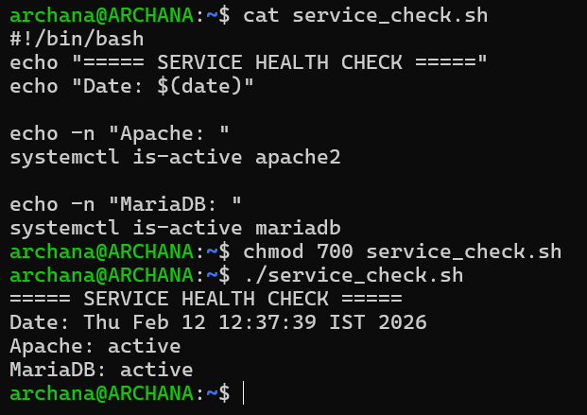
4. Run script:
/home/archana/health_check.sh
==============================
Task 4: Automate Health Check
==============================
1. Create directory:
mkdir -p /home/archana/health_logs
2. Open crontab:
crontab -e
3. Add:
*/5 * * * * /home/archana/health_check.sh >> /home/archana/health_logs/service_status.log
4. Verify:
crontab -l
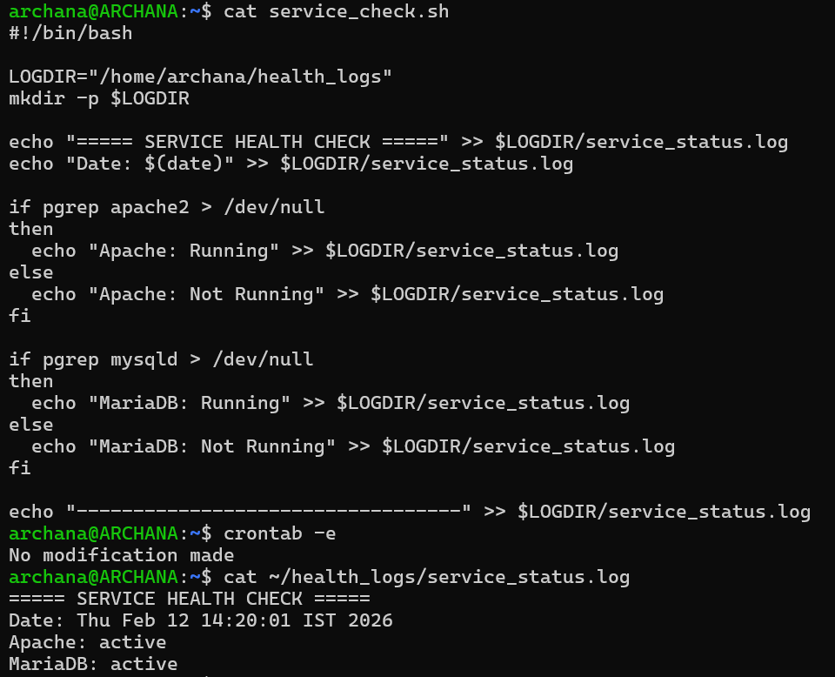
==============================
Task 5: Log Cleanup Script
==============================
1. Create backup directory:
mkdir -p /home/archana/log_backup
2. Create script:
nano /home/archana/log_cleanup.sh
3. Add:
#!/bin/bash
SOURCE="/var/log"
BACKUP="/home/archana/log_backup"
echo "Cleanup started at $(date)"
find $SOURCE -type f -mmin -60 -exec cp {} $BACKUP \;
find $SOURCE -type f -mmin -60 -exec rm {} \;
echo "Cleanup completed at $(date)"
4. Make executable:
chmod +x /home/archana/log_cleanup.sh
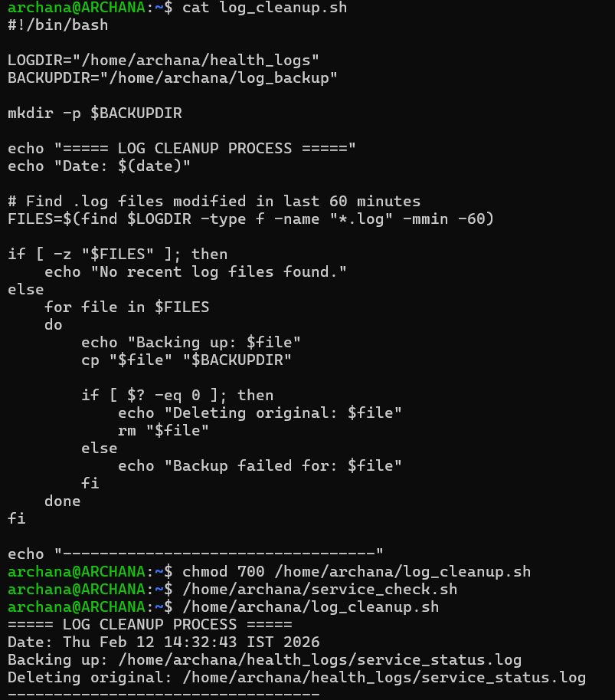
==============================
Task 6: Automate Log Cleanup
==============================
1. Open crontab:
crontab -e
2. Add:
0 * * * * /home/archana/log_cleanup.sh >> /home/archana/log_backup/cleanup.log
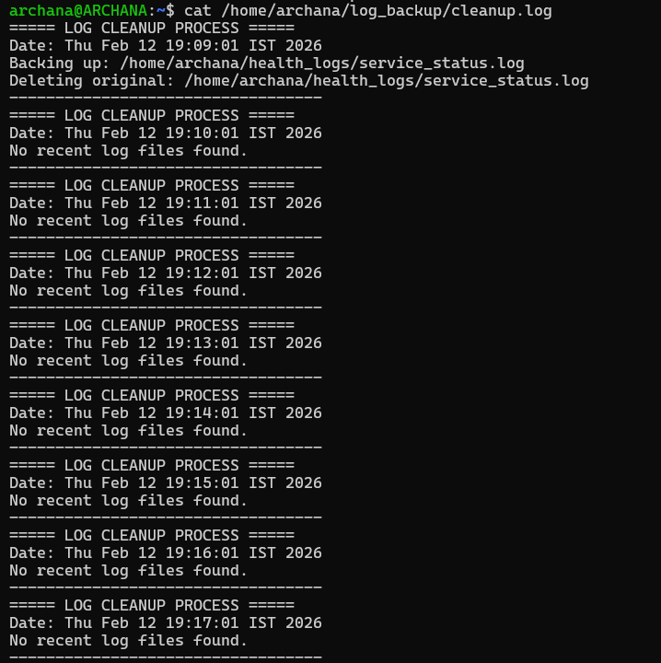
==============================
Task 7: Database Backup Script
==============================
1. Create backup directory:
mkdir -p /home/archana/db_backup
2. Create script:
nano /home/archana/db_backup.sh
3. Add:
#!/bin/bash
DATE=$(date +"%Y-%m-%d_%H-%M-%S")
BACKUP_DIR="/home/archana/db_backup"
mysqldump -u backupuser -p ecomdb > $BACKUP_DIR/ecomdb_$DATE.sql
4. Make executable:
chmod +x /home/archana/db_backup.sh
5. Run:
/home/archana/db_backup.sh
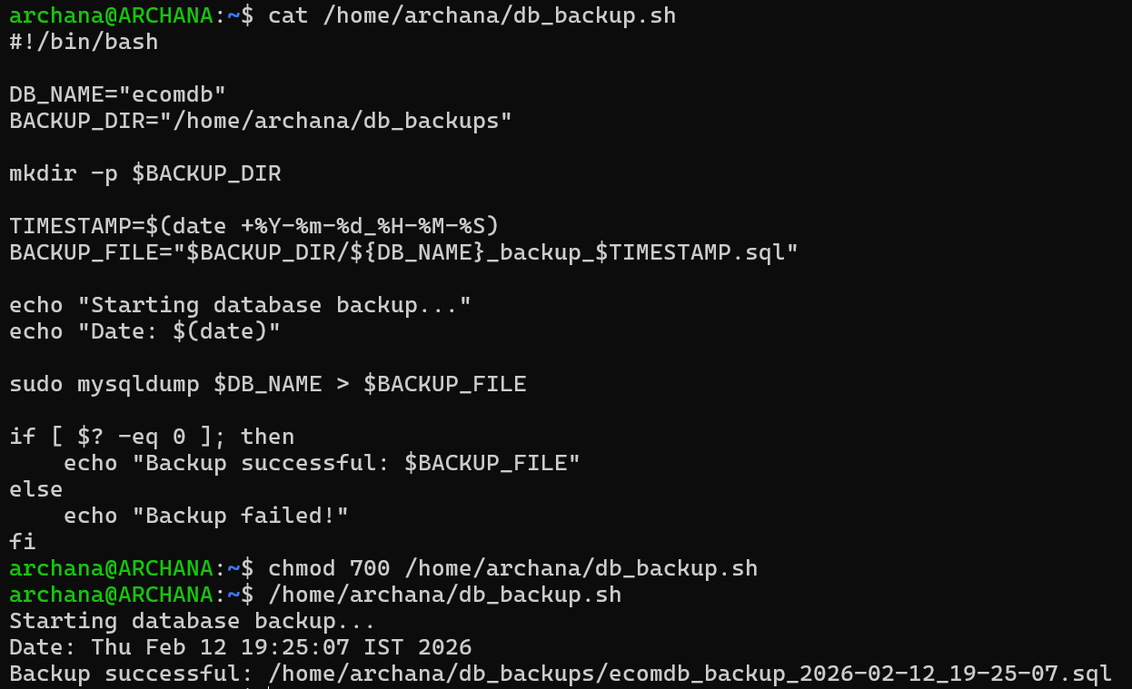
==============================
Task 8: Disk Space Protection Script
==============================
1. Create script:
nano /home/archana/disk_check.sh
2. Add:
#!/bin/bash
THRESHOLD=80
USAGE=$(df / | tail -1 | awk '{print $5}' | sed 's/%//g')
if [ $USAGE -gt $THRESHOLD ]; then
echo "$(date): WARNING - Disk usage above limit" >> /home/archana/disk_warning.log
fi
3. Make executable:
chmod +x /home/archana/disk_check.sh
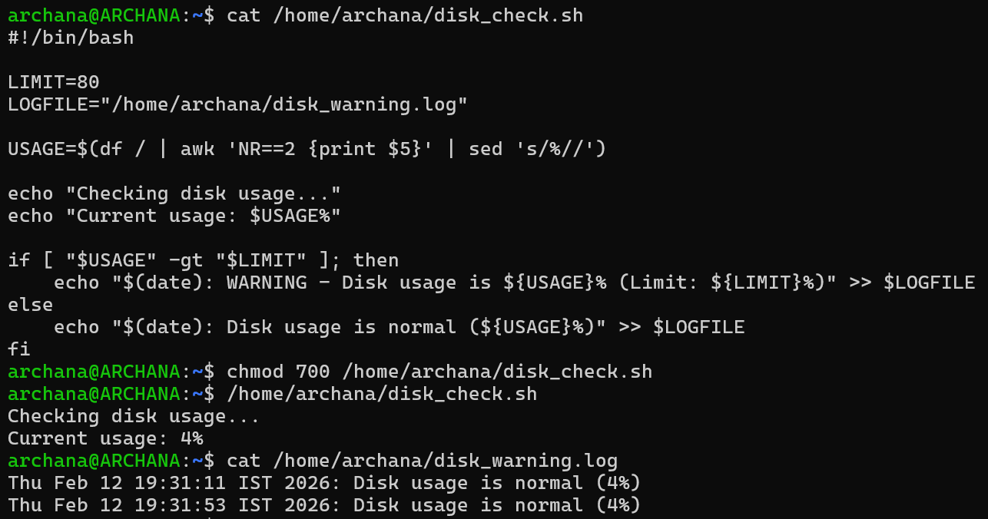
==============================
Task 9: Application Availability Check
==============================
1. Create script:
nano /home/archana/app_check.sh
2. Add:
#!/bin/bash
STATUS=$(curl -s -o /dev/null -w "%{http_code}" http://localhost)
if [ $STATUS -eq 200 ]; then
echo "$(date): Application is UP (HTTP 200)" >> /home/archana/app_status.log
else
echo "$(date): Application is DOWN" >> /home/archana/app_status.log
fi
3. Make executable:
chmod +x /home/archana/app_check.sh
4. Run:
/home/archana/app_check.sh
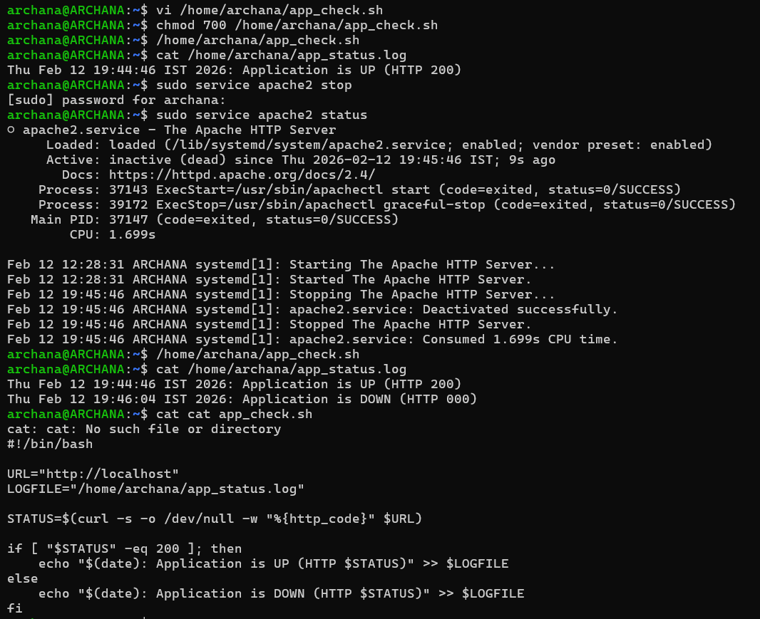
==============================
Task 10: System Health Report
==============================
1. Create script:
nano /home/archana/system_report.sh
2. Add:
#!/bin/bash
REPORT="/home/archana/system_health_report.txt"
echo "System Health Report - $(date)" > $REPORT
echo "Apache Status: $(systemctl is-active apache2)" >> $REPORT
echo "MariaDB Status: $(systemctl is-active mariadb)" >> $REPORT
echo "Port 80 Status:" >> $REPORT
sudo netstat -tulnp | grep :80 >> $REPORT
echo "Disk Usage:" >> $REPORT
df -h >> $REPORT
echo "Memory Usage:" >> $REPORT
free -h >> $REPORT
3. Make executable:
chmod +x /home/archana/system_report.sh
4. Run:
/home/archana/system_report.sh
