DEVOPS ASSIGNMENT - Git and GitHub

Question 1
1. Create a new folder
2. Create files: code.txt, log.txt, output.txt
3. Stage code.txt and output.txt
4. Commit them
5. Push to GitHub

Solution - Commands Used
mkdir project1
cd project1
git init
touch code.txt log.txt output.txt
git add code.txt output.txt
git commit -m "Added code and output files"
git remote add origin <your-github-repo-url>
git push -u origin master
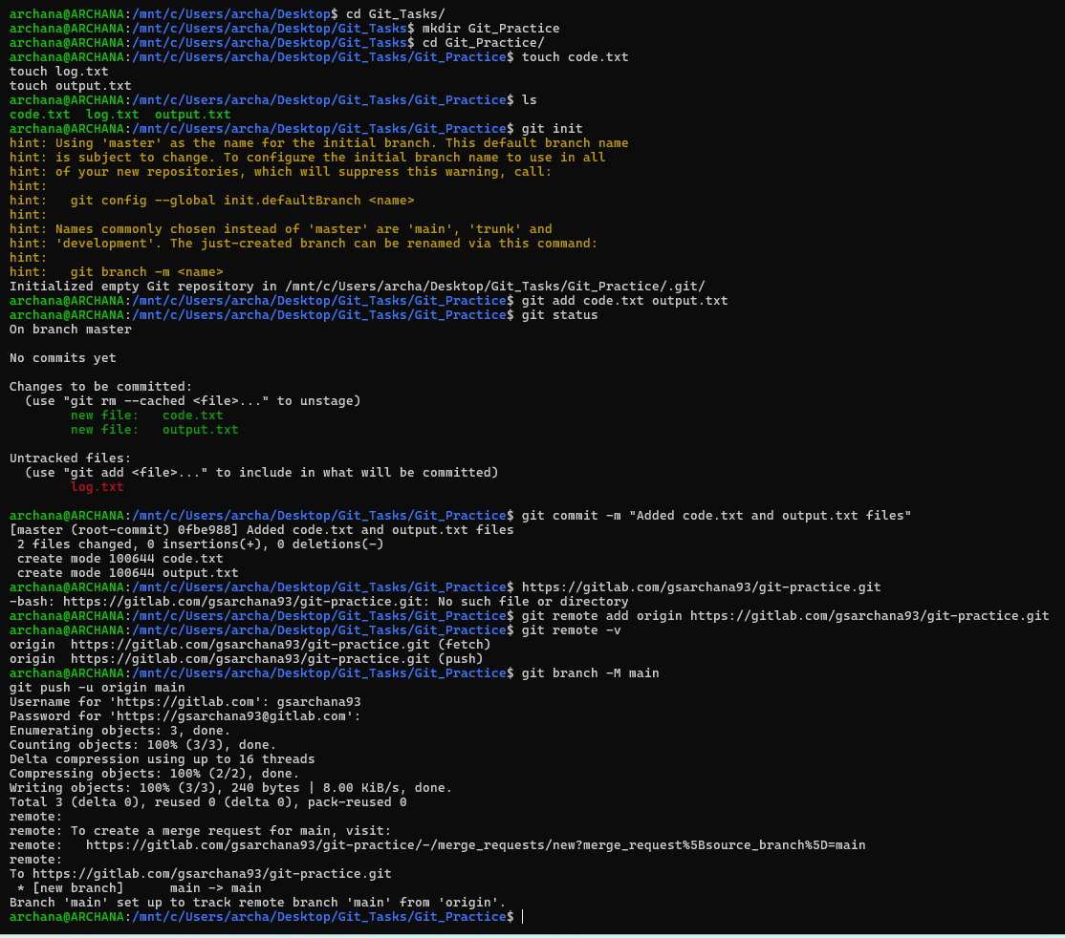

Question 2
Create feature1.txt & feature2.txt in master.
Create branches develop, feature1, feature2.
Stash develop.txt.
Commit new.txt in feature1.
Unstash in develop and commit.

Solution - Commands Used
git init
touch feature1.txt feature2.txt
git add .
git commit -m "Initial commit"
git branch develop
git branch feature1
git branch feature2
git checkout develop
touch develop.txt
git stash
git checkout feature1
touch new.txt
git add new.txt
git commit -m "Added new.txt"
git checkout develop
git stash pop
git add develop.txt
git commit -m "Committed develop.txt after unstash"
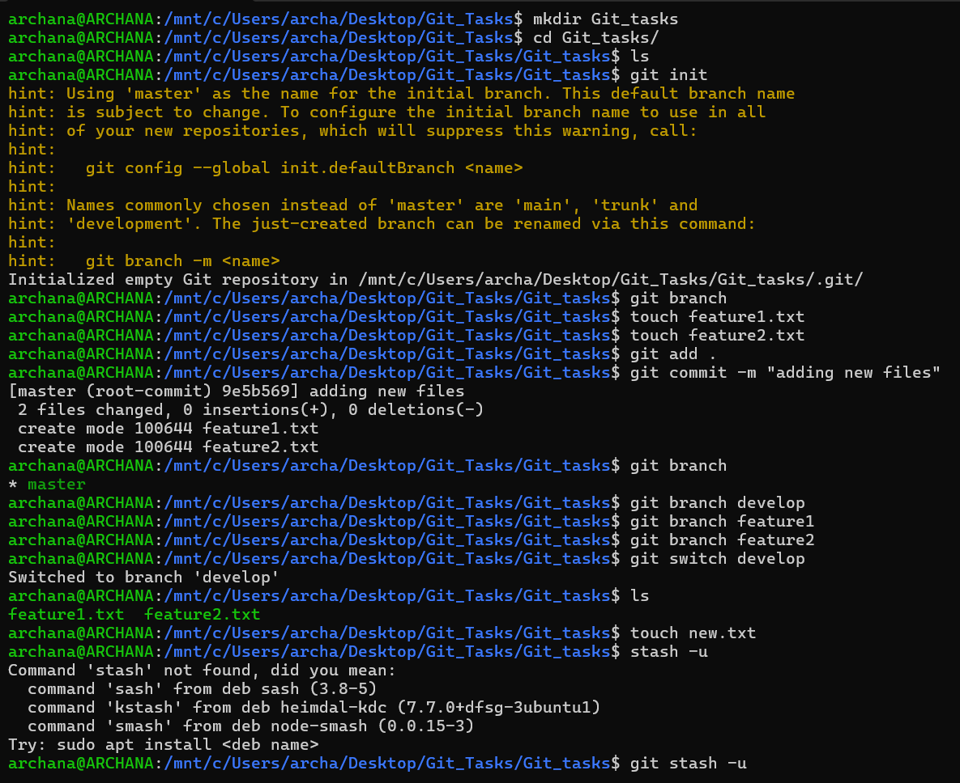
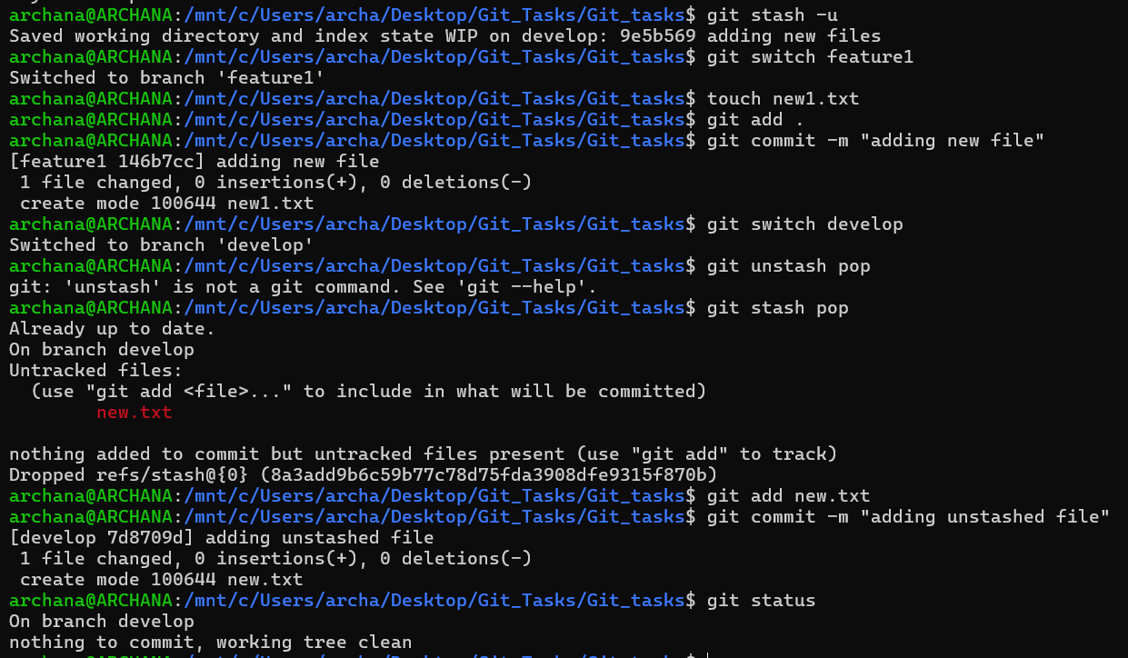

Question 3
Create branches develop, f1, f2.
Commit main.txt in master.
Push all branches.
Delete f2 locally and remotely.

Solution - Commands Used
git init
touch main.txt
git add main.txt
git commit -m "Added main.txt"
git branch develop
git branch f1
git branch f2
git checkout develop
touch develop.txt
git add develop.txt
git commit -m "Added develop.txt"
git checkout f1
touch f1.txt
git add f1.txt
git commit -m "Added f1.txt"
git checkout f2
touch f2.txt
git add f2.txt
git commit -m "Added f2.txt"
git push origin --all
git branch -d f2
git push origin --delete f2
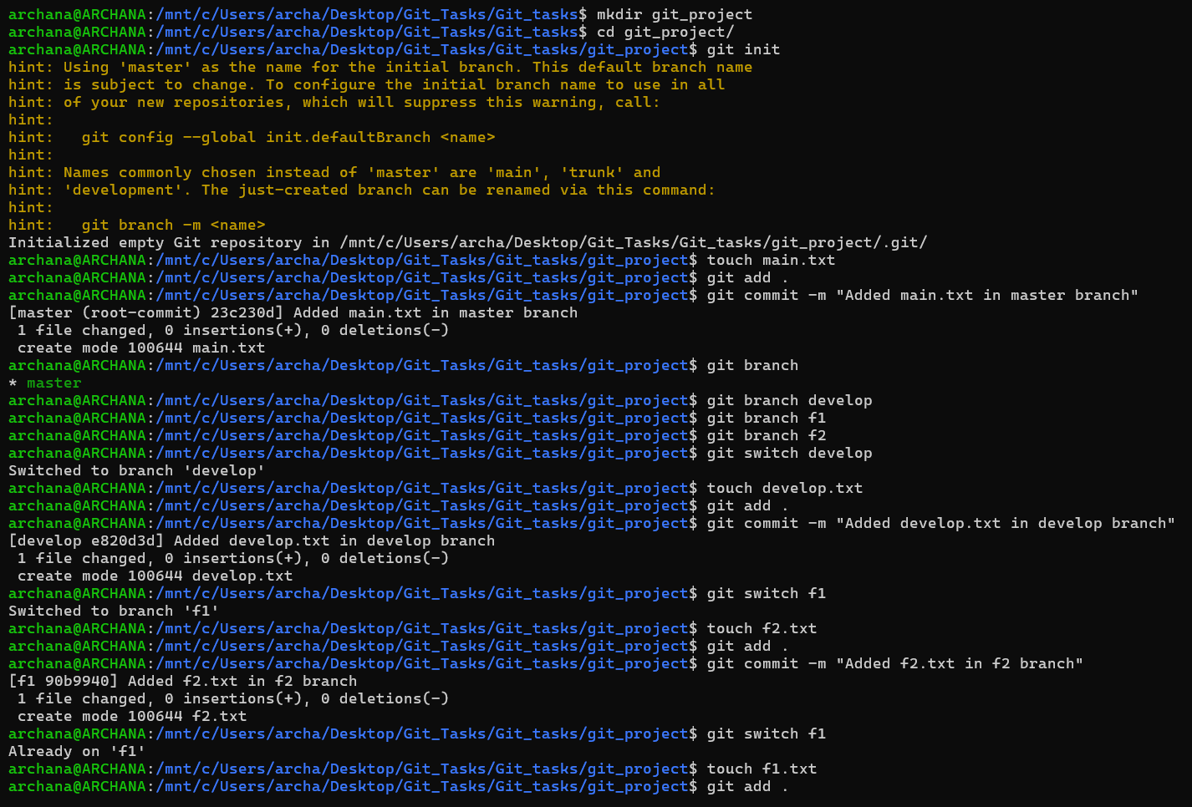
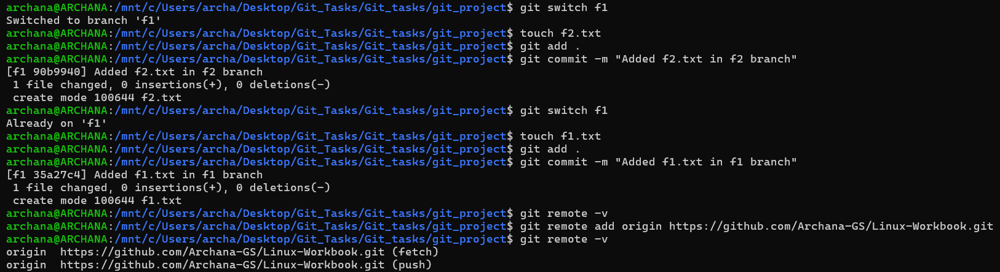
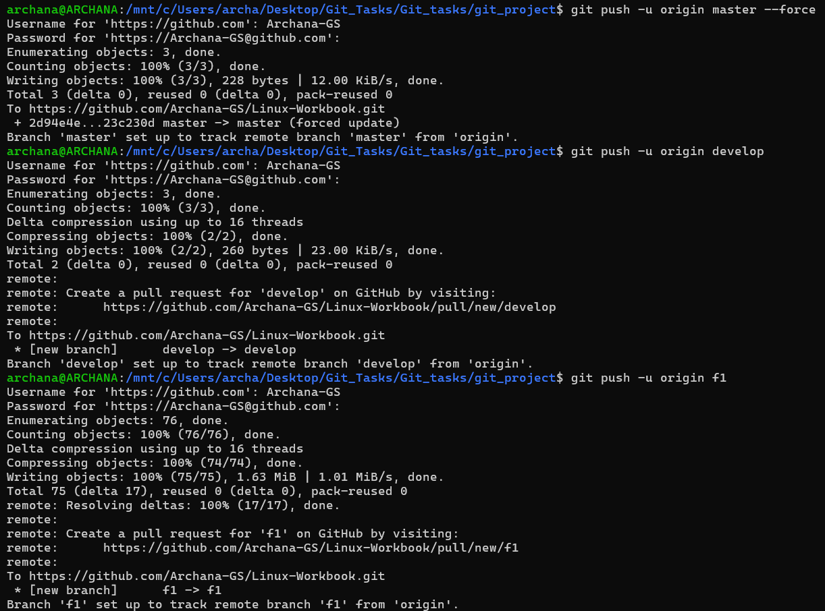
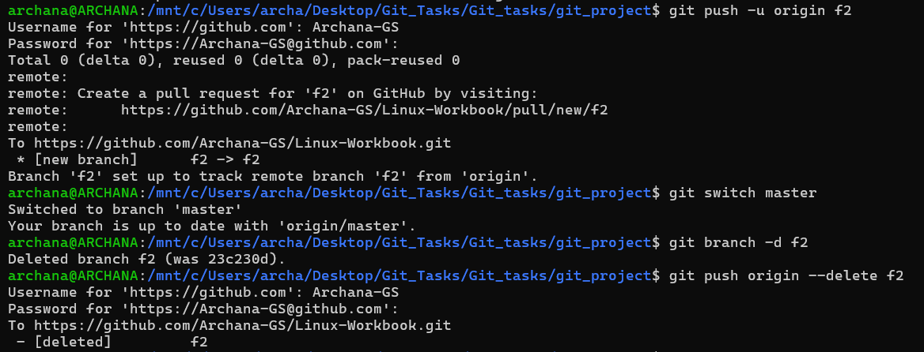

Question 4
Branch creation, merging public branches, updating private branch.

Solution - Commands Used
touch master.txt
git add master.txt
git commit -m "Added master.txt"
git branch public1
git branch public2
git branch private
git checkout public1
touch public1.txt
git add public1.txt
git commit -m "Added public1.txt"
git checkout master
git merge public1
git merge public2
git checkout private
echo "Updated content" >> master.txt
git add master.txt
git commit -m "Updated master.txt"
git checkout public1
git merge private
git checkout public2
git merge private
git checkout master
git merge private
git checkout private
git merge master
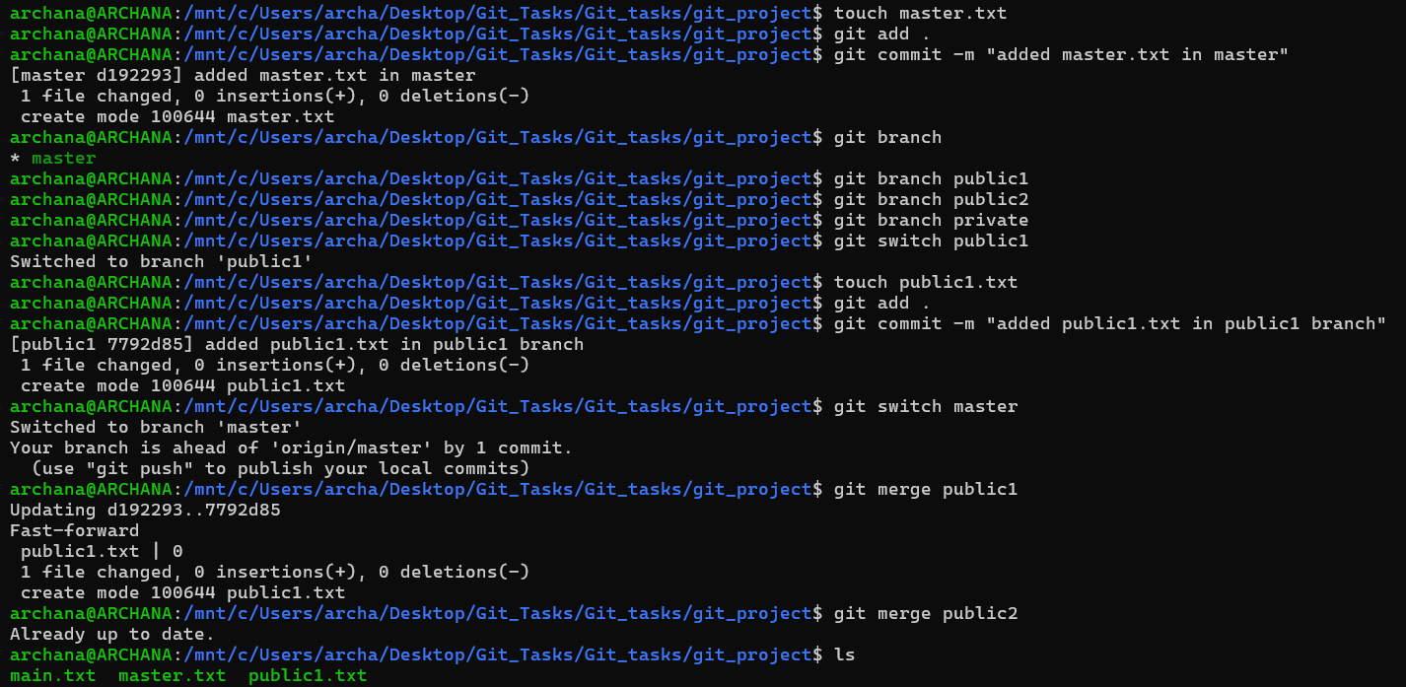
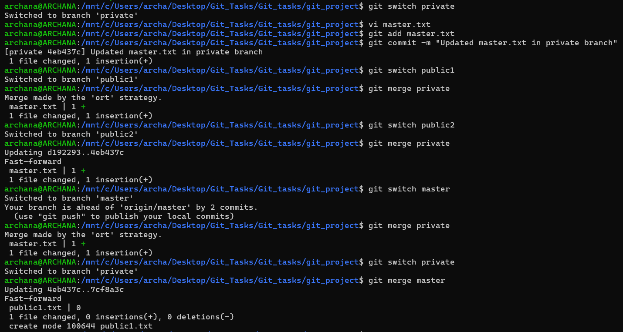

Question 5
Implement Git Flow with feature and hotfix branches.

Solution - Commands Used
git init
git checkout -b develop
git checkout -b feature/login
git checkout develop
git merge feature/login
git checkout master
git merge develop
git checkout -b hotfix/urgent master
echo "Urgent fix" > urgent.txt
git add urgent.txt
git commit -m "Hotfix added"
git checkout master
git merge hotfix/urgent
git checkout develop
git merge hotfix/urgent
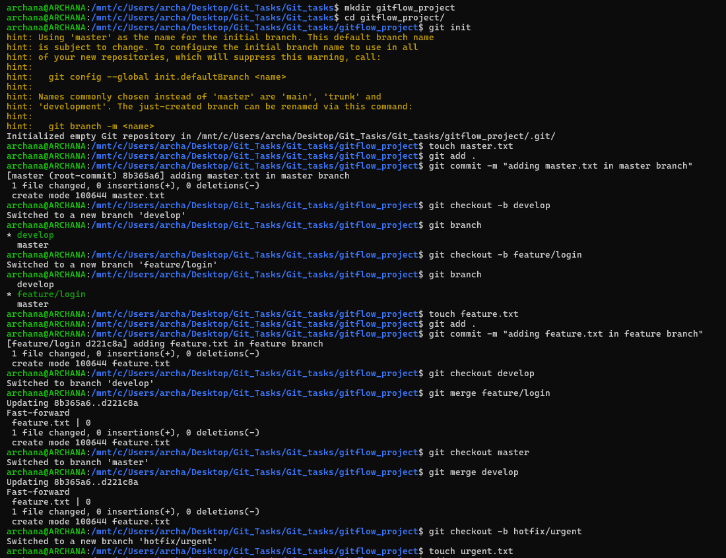
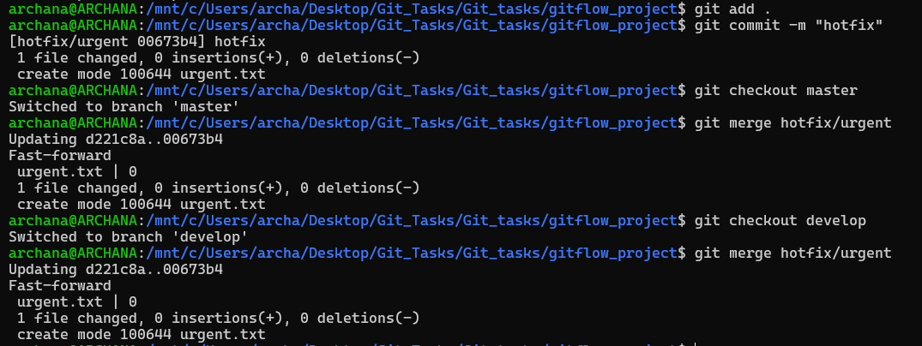

Question 6
Initialize repository and configure .gitignore to ignore secrets.txt and *.png

Solution - Commands Used
mkdir gitignore_project
cd gitignore_project
git init
touch notes.txt secrets.txt image.png
echo "secrets.txt" > .gitignore
echo "*.png" >> .gitignore
git status
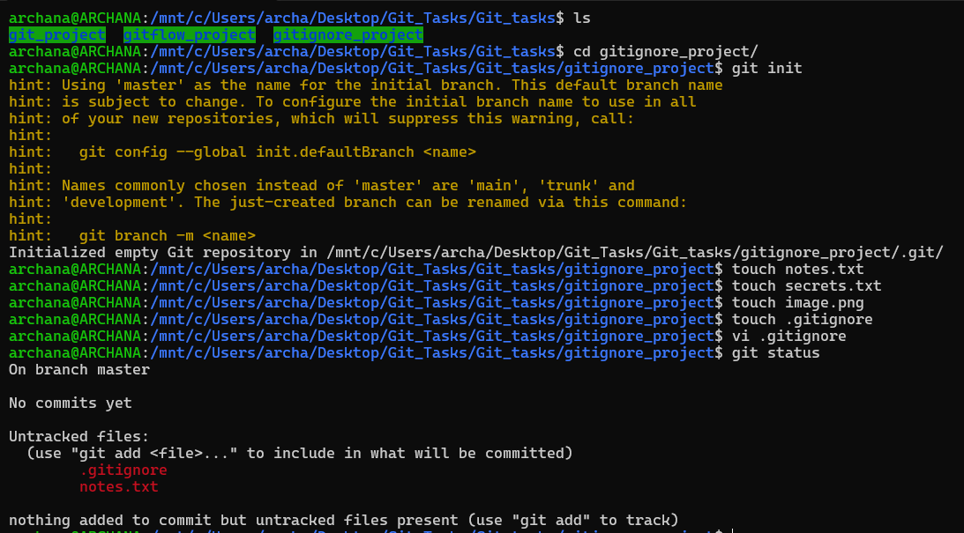

Question 7
Set up SSH authentication with GitHub and push without password.

Solution - Commands Used
ssh-keygen -t ed25519 -C "your_email@example.com"
eval "$(ssh-agent -s)"
ssh-add ~/.ssh/id_ed25519
cat ~/.ssh/id_ed25519.pub
# Add key in GitHub -> Settings -> SSH Keys
ssh -T git@github.com
git clone git@github.com:username/repository.git
cd repository
echo "Testing SSH" >> test.txt
git add test.txt
git commit -m "SSH test"
git push origin master
