F21DL
Data Mining and Machine Learning Coursework

Predicting Myocardial Infarction: A Comparative Analysis of Regression Models on Clinical Data and Image-Based Classification of ECG Patterns​

Group Members:
Archana Tharammal, Diab Rafeek, Furwa Asim, Harshitha Srikanth, Sana Sajesh



Link to GitHub repository: https://github.com/harshis15/F21DLGroup10
Table of Contents

I. Introduction 3
II. Related Work 3
III. Methodology 4
Dataset Description and Analysis 4
1. Heart Disease Dataset 4
2. ECG Image Dataset 4
Experimental Setup 4
Clustering 5
1. K-Means 5
Machine Learning Algorithms 5
General Method: 5
1. Logistic Regression 6
2. Decision Trees 6
3. SVM 7
4. Naïve Bayes 7
Deep Learning Algorithms 7
1. MLP 7
2. CNN 8
IV. Results 9
V. Discussions and Conclusions 10
References 11

I. Introduction
Myocardial Infarction (MI) is a leading global cause of death, with 18.8% mortality among hospitalized patients according to Rohani et al. (2022) [1]. As a result, early detection is critical to reducing risks and saving lives. Machine learning offers a powerful solution by analyzing large datasets, uncovering hidden patterns, and enabling accurate MI predictions, surpassing traditional diagnostic methods.

II. Related Work
Velusamy et al. (2024) [2] explores the application of Machine Learning (ML) algorithms, with a particular focus on Convolutional Neural Networks (CNNs), to predict myocardial infarction (MI) using clinical and demographic data. Preprocessing steps, including normalization and feature selection were applied on the datasets.
CNNs were employed alongside Support Vector Machines (SVMs) for MI prediction. The process included training the models with various hyperparameter tunings and cross-validation, and as a result the CNNs were able to effectively identify intricate patterns within the data. The performance evaluation, based on metrics such as accuracy, sensitivity, specificity, and AUC, revealed that the CNNs achieved high accuracies. For instance, SVMs with Gaussian kernels reached 92% accuracy after addressing data imbalance and fine-tuning hyperparameters.
The study focuses on clinical implications of using CNNs for early MI detection, highlighting their potential to improve patient outcomes and reduce healthcare costs. The authors also acknowledge limitations, including data biases, and suggest exploring more diverse datasets and refining ML models in future research.

III. Methodology

Dataset Description and Analysis

1. Heart Disease Dataset
This data set consists of 2 classes which predict whether a patient has MI or not. It contains a total of 1190 entries with 12 attributes as shown in Figure 1.
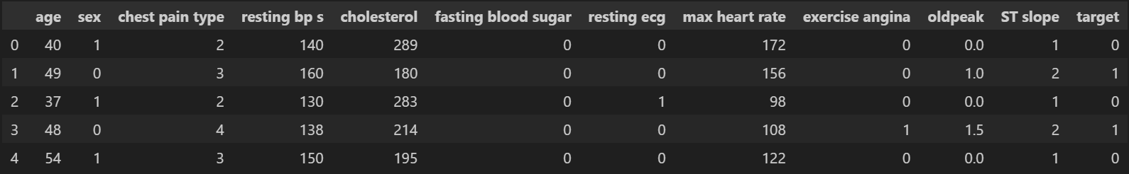
Figure 1: Table showing the heart disease dataset
No missing values were found in the dataset. However, duplicate rows were detected (272) and removed, leaving 918 unique records. Several columns were then converted to categorical variables to facilitate analysis. The cholesterol columns contained zero values, which were then replaced with the mean value. A Pearson correlation matrix was also calculated which showed moderate negative correlation between age and maximum heart rate, as expected – older individuals tend to have lower maximum heart rates.

2. ECG Image Dataset
The image processing involves preprocessing and augmentation techniques to create a diverse dataset for analysis. It starts with loading images, converting them into grayscales, and resizing them. The pixel values are normalized to [0,1] range and then flattened into a 1D array, and saved with the prefix “original_.”. Next the images are augmented, which includes small random rotations (±5 degrees), shifts along horizontal or vertical axis (±10% of the image size), Gaussian noise, and tweaking brightness (0.7-1.1) and contrast (0.7-1.3). These augmented images are saved with the prefix “augmented_.”.
By combining these, the dataset is doubled, creating a more diverse set of data, which helps the models generalize better when faced with real-word scenarios.

Experimental Setup
The implementation utilized various frameworks and libraries: Pandas, NumPy, and Scikit-learn for data processing; TensorFlow, Keras, and PyTorch for deep learning; Matplotlib and Seaborn for visualization; and SciPy or Scikit-learn for cluster analysis, specifically for K-Means clustering. These tools ensured efficient processing, modeling, and analysis.

Clustering

1. K-Means
The first step is to find the total number of clusters of the clusters are created. To determine the optimal number of clusters k, the Elbow method and the silhouette analysis were employed, Elbow Method: the curve starts to flatten around k=4, Also this indicates a knee point which suggests that adding more points after k=4, will yield diminishing returns. Silhouette Analysis: Although k=2 gives the best score, it may oversimplify the data as shown in Figure 2. Considering both the plots k=3 is best value for k, which also provides a cluster with purity of 0.792(79.2%).
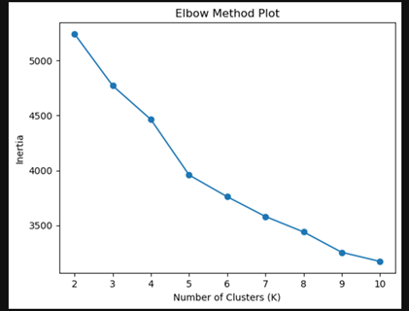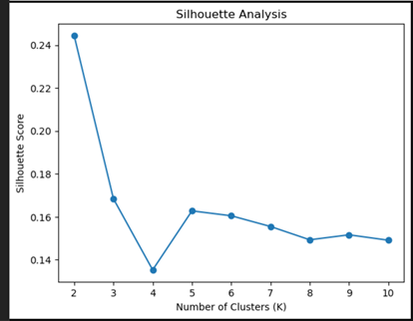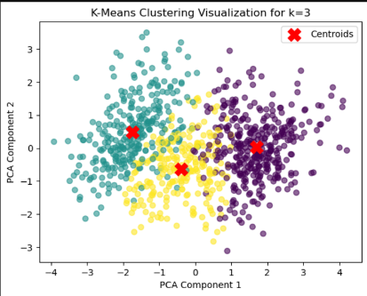
Figure 2: Elbow Method, Silhouette Analysis and Cluster visualizations
After which we created a new dataset with a new column called ‘cluster’ which has values ranging from 0-2 (k=3) clusters, also we did a cluster summary to identify distinct patterns and characteristics within each group.
Cluster 0: “Older Men Group with Lower Heart rate”: Higher average age (57.7) years, Majority male (88.8%), Exercise-induced angina is common (85.43%), max-heart rate (121).
Cluster 1: “Younger Men/Women Group with Higher Heart Rate”: Average age (49.55), Balanced gender ratio (56.57% male), max-heart rate (154).
Cluster 2: “Middle-Aged Group with Moderate Heart Rate”: Average age (51.94), max-heart rate (138).
Also, we plot the likelihood of MI for each cluster it looks like people in cluster 0 have a much higher risk (89%) while the risk is much lower for those in cluster 1 (only 13%). Cluster 2 is somewhere in between, at around 55%. This tells us that people in cluster 0 may need the most attention for heart health.

Machine Learning Algorithms

General Method:
To implement the algorithms, the data is pre-processed, split, and used for training the model. After this, the model performance is evaluated, and the model is fine-tuned by experimenting with hyperparameters to achieve enhanced results.
The goal is to apply different algorithms on data clustered by the k-means algorithm to train the model to predict which cluster a patient belongs to. By doing so, the likelihood of the patient being in a cluster, and hence their chances of having MI, can be analyzed.

1. Logistic Regression
Logistic regression is a type of supervised learning algorithm used in classification problems which uses one or more independent variables to describe the relationship between dependent (target) and independent (predicator) variable [3].
It calculates the probability that an input belongs to a specific class, making it for medical diagnosis like predicting MI based on clinical features. Unlike linear regression, which predicts continuous values, it uses the logistic sigmoid function to transform its output into probability. This probability can then be mapped to one of two or more discrete classes, making it ideal for classification tasks. The data is divided into training and testing sets and the features are standardized. A confusion matrix, ROC curve and accuracy scores (Figure 3) show the performance in distinguishing between the risk of the patient having MI based on the cluster [4].
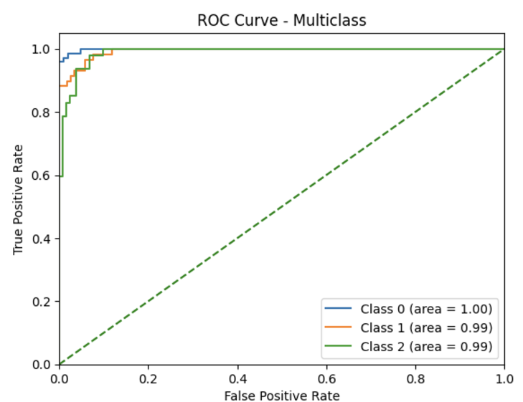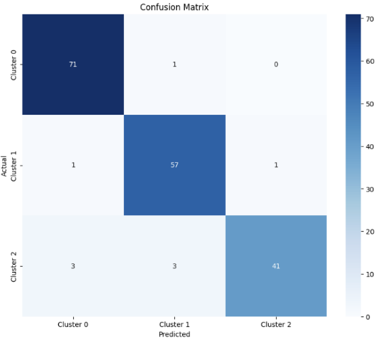
Figure 3 - Logistic Regression ROC and Confusion Matrix

2. Decision Trees
Decision trees are versatile tools for classification and regression. They organize data into a tree-like structure with certain decision rules at nodes and outcomes at leaves [5] [6]. However, single trees often overfit and struggle with complex patterns. Random Forest [7] addresses these issues by using ensemble learning to create multiple decision trees, averaging their predictions to improve model results and handle diverse data types.
To implement the algorithm, class weight balancing and GridSearch were used to optimize the model for imbalanced clusters. The results showed a validation accuracy of 92.70%, a mean cross-validation accuracy of 91% with 0.02 standard deviation, and a test accuracy of 90.03% i.e. supported by a balanced confusion matrix and low false positive rate as per the ROC curve, as seen in Figure 4 below. The findings show that RF leverages clinical data for reliable predictions of patient clusters, demonstrating significant predictive power for understanding the clusters and assessing the risk of a patient having MI based on the cluster they lie in.
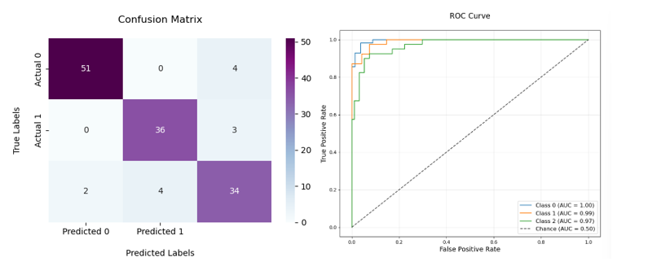
Figure 4 - RF Confusion Matrix and ROC Curve

3. SVM
The Support Vector Machine (SVM) algorithm was applied to the "Heart Cleveland Hungary " dataset, focusing on features such as age, sex, chest pain type, resting blood pressure, and heart rate. The model utilized an RBF kernel with parameters optimized through grid search, achieving an accuracy of approximately 85%. Data preprocessing included scaling to ensure feature normalization. Evaluation metrics, such as the confusion matrix and classification report, revealed robust performance in predicting heart disease.
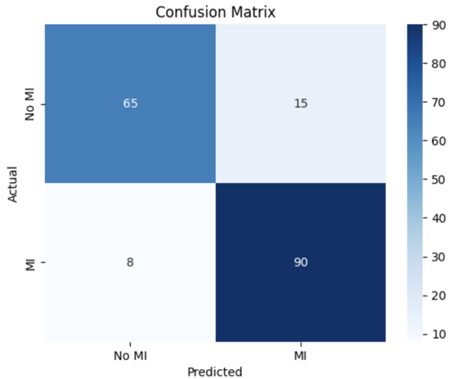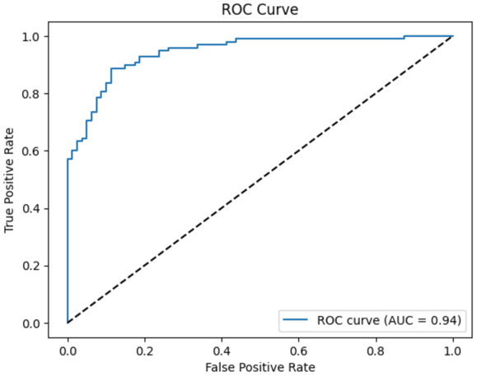
Figure 5 - SVM Confusion Matrix and ROC Curve

4. Naïve Bayes
Naïve Bayes Classifiers are efficient probabilistic models widely used in healthcare for disease prediction using clinical datasets [8] algorithm on a medical dataset with features such as age, sex, chest pain type, resting blood pressure, max heart rate, and exercise-induced angina. Dimensionality reduction with PCA was applied to optimize the feature set for classification. This model achieved the test accuracy of 85%, effectively predicting outcomes like myocardial infarction (MI) and other conditions. Key evaluations include accuracy, confusion matrix, and classification reports, showcasing the model's efficiency in handling real-world medical data can be seen in Figure 5. This demonstrates Naive Bayes strength as a simple yet effective classifier.
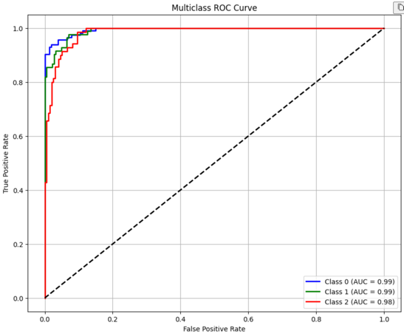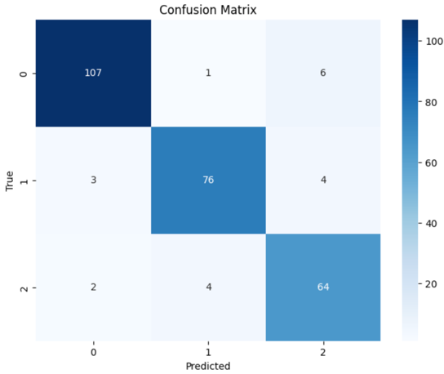
Figure – Naïve Bayes ROC Curve and Confusion Matrix

Deep Learning Algorithms

MLP
A Multi-Layer Perceptron (MLP) is a type of fully connected, feedforward artificial neural network, chosen for their ability to model complex, non-linear relationships through fully connected layers and activation functions. This makes them well-suited for processing tabular or one-dimensional data where such patterns are prevalent. [8] [9] [10]
The algorithm implementation involves converting images to a NumPy array, applying PCA for dimensionality reduction, and using the augmented data. The model architecture consists of an input layer (256 neurons after PCA), two hidden layers (256 and 128 neurons with ReLU activation), and an output layer with 4 neurons and Softmax activation for multiclass classification. It was then trained with categorical cross-entropy loss and Adam optimizer. The MLP model achieved a test accuracy of 62.05%. Evaluation metrics include accuracy, loss, confusion matrix, classification report, and ROC AUC analysis, which shows potential for improvement.
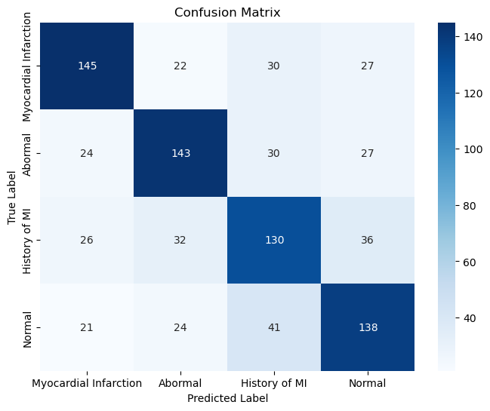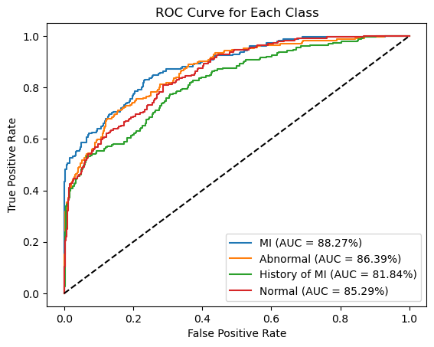
Figure : MLP Confusion Matrix and ROC Curve

CNN
CNNs are chosen for their ability to automatically learn spatial hierarchies and complex patterns from image data [11] [12], improving results gotten from traditional algorithms that rely on manual and error-prone feature extraction. They are particularly effective for tasks like ECG image classification due to their capability to capture subtle variations, which is critical in medical data.
The Convolutional Neural Network (CNN) used for ECG image classification consists of the following: input layer (grayscale augmented images resized to 128x128 pixels), three convolutional layers (with 32, 64, and 128 filters), with ReLU activation and max pooling. After flattening the convolutional output, the data passes through dense layers, with the final output layers having 4 neurons and Softmax activation. The CNN model achieved a test accuracy of 84.49%. Evaluation metrics include accuracy, loss, confusion matrix, classification report, and ROC AUC analysis, indicating good class discrimination.
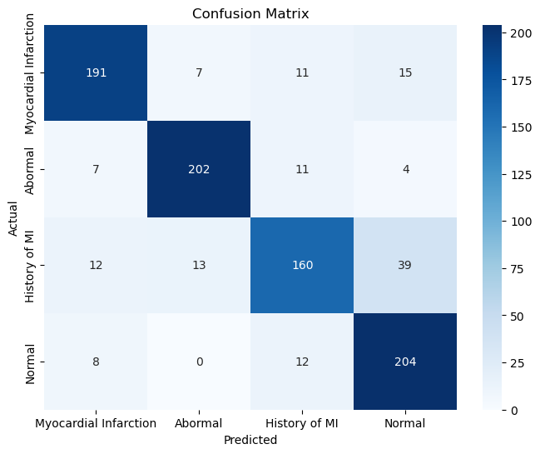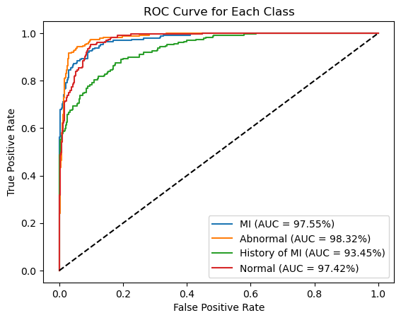
Figure : CNN Confusion Matrix and ROC Curve

IV. Discussions and Conclusions
As per research in related works, multiple algorithms were applied for predictive analysis of MI using a vast variety of techniques on both clinical and ECG image data. Clustering (K-Means) provided important insights by segmenting patients into 3 distinct risk groups. Random Forest achieved the highest accuracy (92.7%) for clinical data prediction. Deep learning, particularly CNNs, did well in ECG image classification (84.49%), proving their ability to capture complex patterns. Data augmentation improved model generalization, though MLPs performed poorly (62.05%). Challenges like data imbalance and generalization were addressed through preprocessing. For future, further validation on diverse datasets and explainability frameworks is required.

References

[1] | J. H. M. Rohani C, "Mortality in patients in patients with mycocardinal infarction and potential risk factors. A five year analysis," 2022.
[2] | J. S. V. M. ,. T. a. S. Velusamy, "Enhancing Myocardinal Infarction Prediction with Machine Learning," in International Technology Conference (OTCON), Rajgarh,India, 2024.
[3] | M. S. R.Bhuvana, "Predict the Heart Disease Using a Logistic Regression Classifier Algorithm," in 12th International Conference on System Modeling & Advancement in Research Trends(SMART), Moradabad, India, 2023.
[4] | H. V. S. K. S. S. V. M. M. B. Narang, "A Study on Prediction of Cardiac Disease Utlising a Machine Learning Approach for Logisttic Regression," International Journal of Advanced Research and Publications , vol. 3, no. 8, p. 6, 2023.
[5] | A. J. Myles, R. N. Feudale, Y. Lui, N. A. Woody and S. D. Brown, "An introduction to decision tree modelling," Journal of Chemometrics, vol. 18, no. 6, pp. 275-285, 2004.
[6] | R. D. Joshi and C. K. Dhakal, "Predicting Type 2 Diabetes Using Logistic Regression and Machine Learning Approaches," International Journal of Enviornmental Research and Machine Learning Approaches, vol. 18, no. 14, p. 7346, 2021.
[7] | Y. Sun, H. Cheng, S. Zhang, M. K. Mohan, Y. G and G. De Schutter, "Prediction & optimization of alkali-activated concrete based on the random forest machine learning algorithm," Construction and Building Materials, vol. 385, p. 131519, 2023.
[8] | Z. Car, B. Segota, N. Andelic, I. Lorencin and V. Mrzljak, "Modeling the spread of COVID‐19 infection using a multilayer perceptron," Computational and mathematical methods in medicine, vol. 1, no. 5714714, 2020.
[9] | H. Hartono, M. Sadikin, D. Sari, N. Anzelina, S. Lestari and W. Dari, "Implementation of Artifical Neural Networks with Multilayer Perceptron for Analysis of Acceptance of Permanent Lecturers," Jurnal Mantik, vol. 4, no. 2, pp. 1389-1396, 2020.
[10] | A. Heidari, H. Faris, S. Mirjalili and I. M. M. Aljarah, "Ant lion optimizer: theory, literature review, and application in multi-layer perceptron neural networks," Nature-inspired optimizers: theories, literature reviews and applications, pp. 23-46, 2020.
[11] | N. Ketkar, J. Moolayil, N. Ketkar and J. Moolayil, "Convolutional Neural Networks," Deep learning with Python: learn best practices of deep learning models with PyTorch, pp. 197-242, 2021.
[12] | Z. Li, L. F. W. Yang, S. Peng and J. Zhou, "A survey of convolutional neural networks: analysis, applications, and prospects," IEEE transactions on neural networks and learning systems, vol. 33, no. 12, pp. 6999-7019, 2021.

