REG NO: 727721EUAI005

NAME: ARCHANA.V

SOFTWARE TESTING –CC1

**QUESTION: 1**

**package** qn1;

**import** org.openqa.selenium.By;

**import** org.openqa.selenium.WebDriver;

**import** org.openqa.selenium.WebElement;

**import** org.openqa.selenium.edge.EdgeDriver;

**import** io.github.bonigarcia.wdm.WebDriverManager;

**public** **class** sample1 {

**public** **static** **void** main(String[] args) {

WebDriverManager.*edgedriver*().setup();

WebDriver driver=**new** EdgeDriver();

driver.get("https://www.saucedemo.com/");

driver.manage().window().maximize();

WebElement user = driver.findElement(By.*id*("user-name"));

user.sendKeys("standard_user");

WebElement pass = driver.findElement(By.*id*("password"));

pass.sendKeys("secret_sauce");

WebElement login = driver.findElement(By.*id*("login-button"));

login.click();

driver.findElement(By.*xpath*("//*[@id=\"add-to-cart-sauce-labs-backpack\"]")).click();

String cartCount = driver.findElement(By.*xpath*("/html/body/div/div/div/div[1]/div[1]/div[3]/a/span")).getText();

driver.findElement(By.*xpath*("/html/body/div/div/div/div[1]/div[1]/div[3]/a")).click();

String product = " Backpack";

driver.findElement(By.*xpath*("//*[@id=\"checkout\"]")).click();

driver.findElement(By.*xpath*("//*[@id=\"first-name\"]")).sendKeys("Archana");

driver.findElement(By.*xpath*("//*[@id=\"last-name\"]")).sendKeys("V");

driver.findElement(By.*xpath*("//*[@id=\"postal-code\"]")).sendKeys("72368");

driver.findElement(By.*xpath*("//*[@id=\"continue\"]")).click();

System.***out***.println("Name of the product: " + driver.findElement(By.*xpath*("/html/body/div/div/div/div[2]/div/div[1]/div[3]/div[2]/a/div")).getText());

System.***out***.println("Price of the product: " + driver.findElement(By.*xpath*("/html/body/div/div/div/div[2]/div/div[1]/div[3]/div[2]/div[2]/div")).getText());

}

}

🡪OUTPUT:

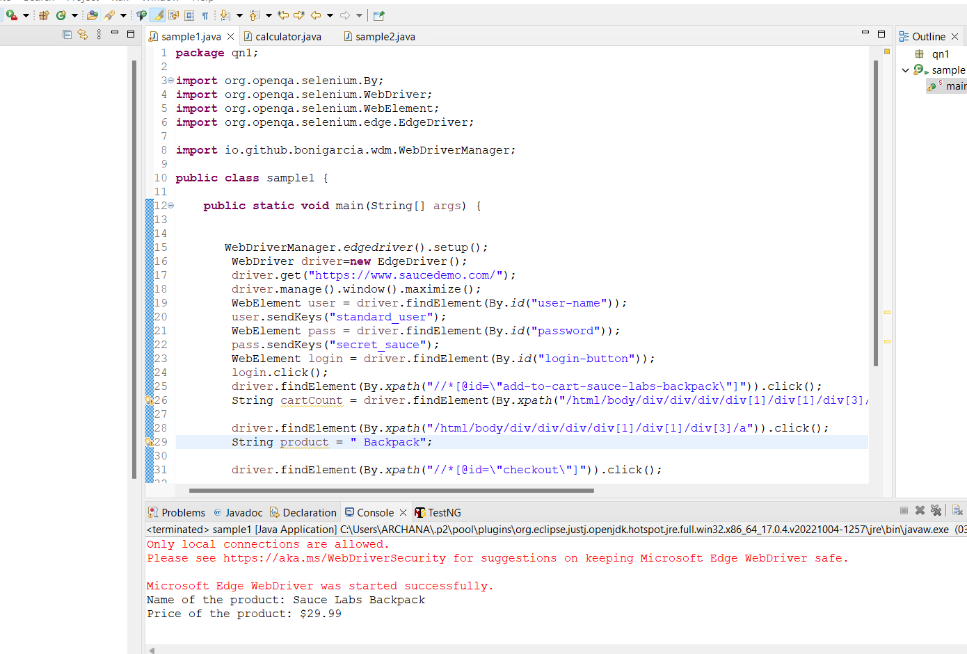

**QUESTION 2:**

**package** qn1;

**import** org.openqa.selenium.By;

**import** org.openqa.selenium.WebDriver;

**import** org.openqa.selenium.WebElement;

**import** org.openqa.selenium.edge.EdgeDriver;

**import** io.github.bonigarcia.wdm.WebDriverManager;

**public** **class** sample2{

**public** **static** **void** main(String[] args) **throws** InterruptedException {

WebDriverManager.*edgedriver*().setup ();

WebDriver driver=**new** EdgeDriver();

driver.get ("https://www.saucedemo.com/");

driver.manage().window().maximize() ;

WebElement txtBoxl=driver.findElement(By.*xpath*("//*[@id=\"user-name\"]"));

txtBoxl.sendKeys("standard_user");

WebElement txtBox2=driver.findElement(By.*xpath*("//*[@id=\"password\"]"));

txtBox2.sendKeys("secret_sauce");

driver.findElement(By.*xpath*("//*[@id=\"login-button\"]")).click();

String t1=driver.findElement(By.*xpath*("//*[@id=\"item_4_title_link\"]/div")).getText();

System.***out***.println(t1);

driver.findElement(By.*xpath*("//*[@id=\"header_container\"]/div[2]/div/span/select")).click();

driver.findElement(By.*xpath*("//*[@id=\"header_container\"]/div[2]/div/span/select/option[2]")).click();

String t2=driver.findElement(By.*xpath*("//*[@id=\"item_3_title_link\"]/div")).getText();

System.***out***.println(t2);

System.***out***.println("filter (A-Z and Z-A) used smoothly");

driver.findElement(By.*xpath*("//*[@id=\"header_container\"]/div[2]/div/span/select")).click();

driver.findElement(By.*xpath*("//*[@id=\"header_container\"]/div[2]/div/span/select/option[3]")).click();

String t3=driver.findElement(By.*xpath*("//*[@id=\"inventory_container\"]/div/div[1]/div[2]/div[2]/div")).getText();

System.***out***.println(t3);

driver.findElement(By.*xpath*("//*[@id=\"header_container\"]/div[2]/div/span/select")).click();

driver.findElement(By.*xpath*("//*[@id=\"header_container\"]/div[2]/div/span/select/option[4]")).click();

String t4=driver.findElement(By.*xpath*("//*[@id=\"inventory_container\"]/div/div[1]/div[2]/div[2]/div")).getText();

System.***out***.println(t4);

System.***out***.println("filter (low price- high price and high price - low price )used smoothly");

Thread.*sleep*(5000);

}

}

🡪Output:

