**Spring Boot:**

Spring Boot is not a framework to write applications, it helps you to develop and build, package and deploy application with minimal configuration or zero configuration.

It is approach to develop spring based application with very less configuration. It **provides defaults** for code and annotation configuration to **quick start new spring projects** within no time.

It provides Embedded HTTP servers like Tomcat, Jetty etc. to develop and test our web applications very easily.

**Steps to create a Spring boot application:**

Step 1:

Select the **New** > **Spring Starter Project** menu item from the **File** menu

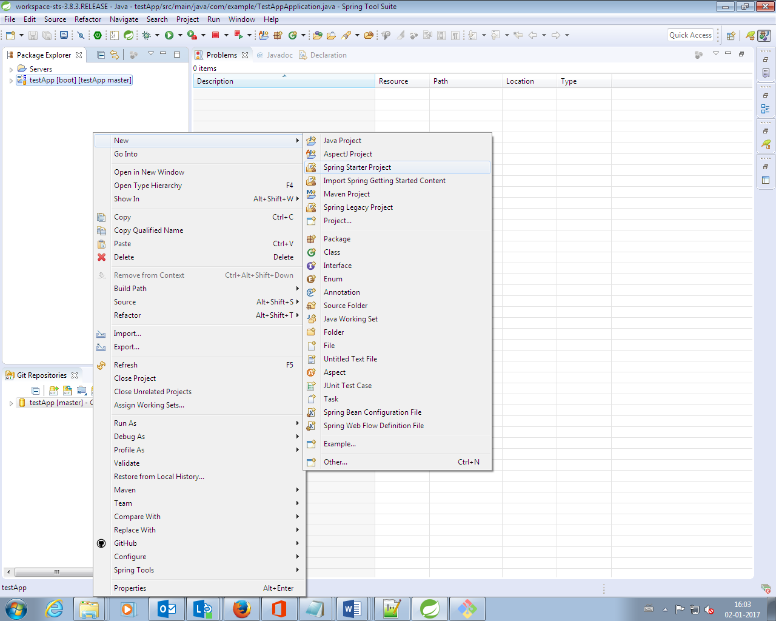

Step 2:

We will get the following “**Spring Starter Project**” Wizard to provide our project related information.

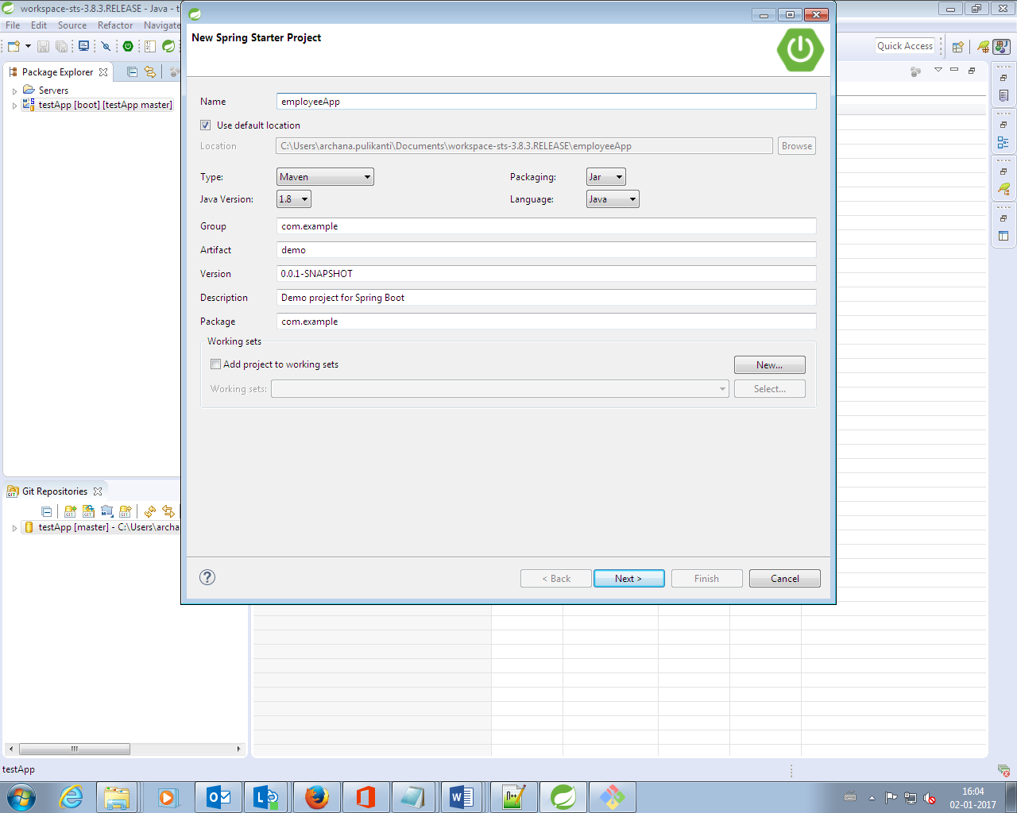

Step 3:

Click on “**Finish**” button to create our new Spring Boot Project.  
  
**Step 4:** Now Spring STS Suite creates a **Maven Project** and downloads all required Jars to our Maven Local Repository. Now the folder structure looks as below

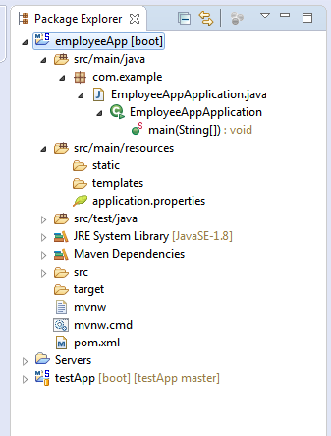

**Step 5:** Once the project has been imported into your workspace, you’re ready to start developing your application.  
  
**Step 6:** Execute Spring Boot Application **Run As > Spring Boot Application** from the **Run** menu.

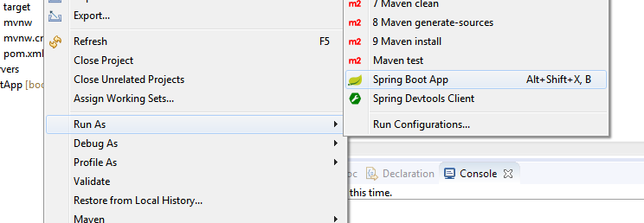

Step 7: The output will be something like below

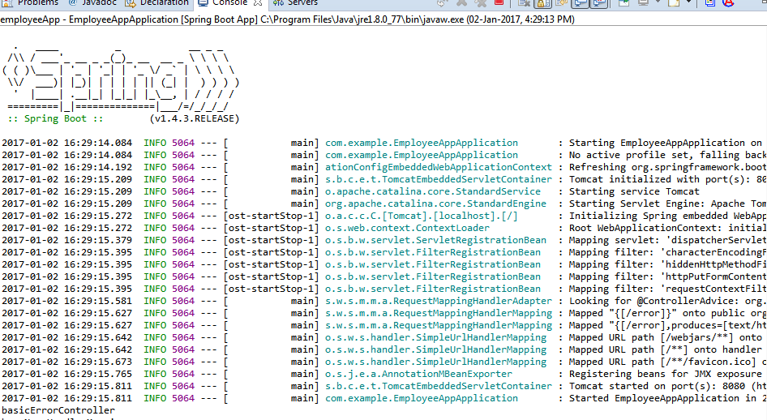

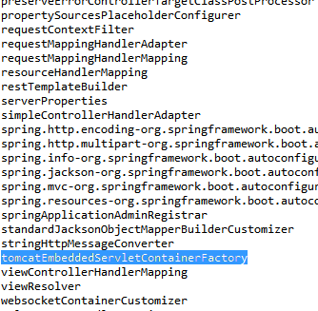

Above are beans created by spring boot to ease spring based application.

**@SpringBootApplication annotation:**

**@SpringBootApplication** does the following things:

* Because of **@Configuration** annotation, It scans for **@Bean** methods to create beans.
* Because of **@ComponentScan** annotation, It does component scanning (Components means Beans annotated with **@Component,@Service,@Repository,@Controller** etc).
* Because of **@EnableAutoConfiguration** annotation, It triggers Spring Boot Auto-Configuration.

When we run **main()** method, it make a calls to “**SpringApplication.run()**” method. Then this call done following things

* This call is used to create “**AnnotationConfigEmbeddedWebApplicationContext**”.
* This “**AnnotationConfigEmbeddedWebApplicationContext**” instance is used to create an instance of “**TomcatEmbeddedServletContainerFactory**” class.
* This “**TomcatEmbeddedServletContainerFactory**” is used to create an instance of “**TomcatEmbeddedServletContainer**” class.
* “**TomcatEmbeddedServletContainer**” instance starts a Tomcat Container at default port number: **8080** and deploys our Spring Boot **WebApplication**.