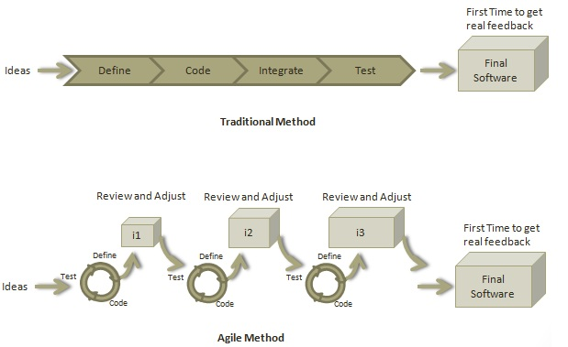

Roles in Agile:

1. Product Owner
2. Team
3. Scrum Master

Scrum has five meetings:

1. Backlog Grooming (aka Backlog Refinement)
2. Sprint Planning
3. Daily Scrum (aka 15-minute standup)
4. Sprint Review Meeting
5. Sprint Retrospective Meeting.

Point

A Point defines how much a team can commit. A point usually refers to 8 hours. Each story is estimated in points.

### Capacity

Capacity defines how much an individual can commit. Capacity is estimated in hours.

## **What is a User Story?**

A user story is a requirement which defines what is required by the user as functionality.

## **Relationship of User Stories and Tasks**

* User story talks about what is to be done. It defines what a user needs.
* Task talks about how it is to be done. It defines how a functionality is to be implemented.
* Stories are implemented by tasks. Each story is a collection of tasks.
* User story is divided into tasks when it is planned in current iteration.
* Tasks are estimated in hours, typically from 2 to 12 hours.
* Stories are validated using acceptance tests.

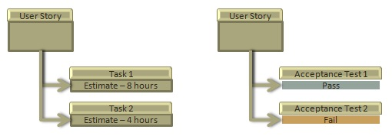

## **When a Story is done**

The team decides what **done** means. The criteria may be −

* All tasks (development, testing) are completed.
* All acceptance tests are running and are passed.
* No defect is open.
* Product owner has accepted the story.
* Deliverable to the end-user.

## **What is Acceptance Criteria?**

Criteria defines the functionality, behaviour, and performance required by a feature so that it can be accepted by the product owner. It defines what is to be done so that the developer knows when a user story is complete.

## **How the Requirements are defined?**

Requirements are defined as

* A User Story,
* With Acceptance Criteria, and
* Tasks to implement the story.