This task requires -
1> fetching real-time weather data using OpenWeatherMap API
2> Handling JSON data & displaying key weather details
3> building a CLI or GUI-based application(Tkinter is Optional)
4>Implementing error handling for invalid inputs or API issues

https://openweathermap.org/api
Api key - 7a8d01a5b65efd47d45a9e9b28cef7b2
tkinter application for weather data

Next check error handling for invalid inputs or API issues

First created an account IN OpenWeatherMap API, then use the key of your account to link with the code created. Or else generate a new key with some new name and use it as the priorty and active key and accordingly we have to change in the code as well for it. But I haven’t experimented fully with new key as I got error api.

Next create command line coding or GUI based library for graphical weather data using tkinter library.

Next feed whatever response you want in return using API of OpenWeatherMap it may be city or any details that you like to get displayed

# Archu_API_KEY = "0ef9fdabd5826a30932cf41048fd6553"

OUTPUT
In terminal type python index.py

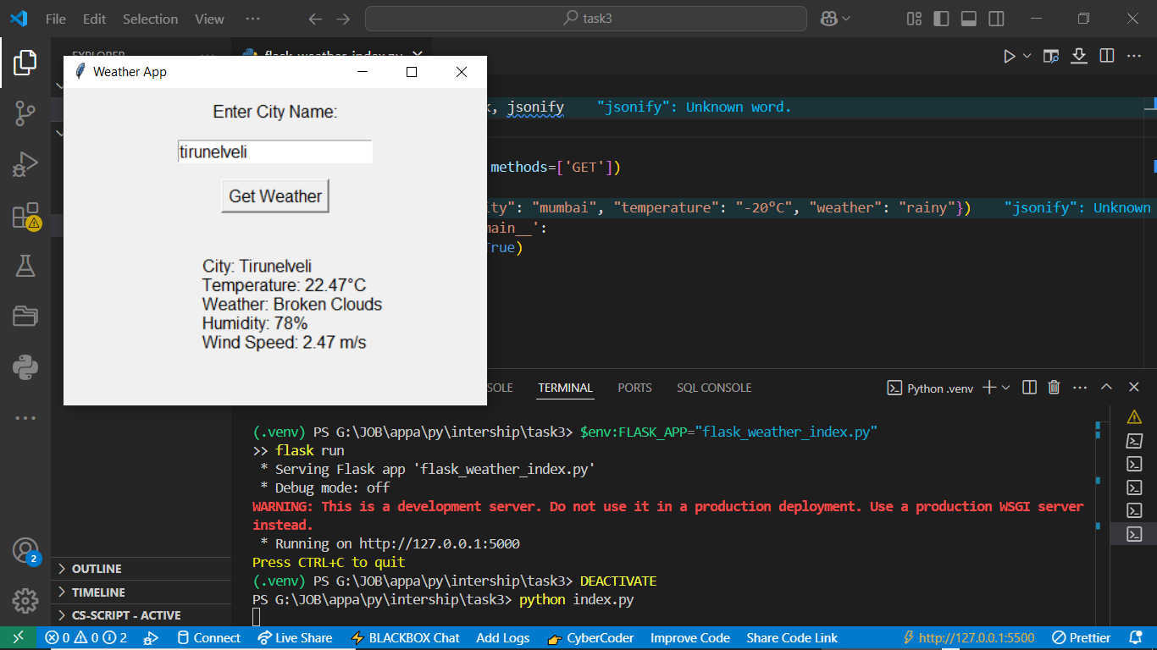

______________________________________________________________________________

Now how to simply get the output in the terminal for the same without linking it, is what the weather_Data output shows.
If we does in this way then it will not get connected with the weather application of API, so it will show country is undetected.
OUTPUT
PS G:\JOB\appa\py\intership\task3> python weather_index.py
Enter city name: mumbai
City not found. Please check the name and try again.
PS G:\JOB\appa\py\intership\task3> python weather_index.py
Enter city name: italy
City not found. Please check the name and try again.

_____________________________________________________________________________
Install flask
Pip install flask
Write code in python and save with extension .py
Then run the code if warning is visible then type in terminal to remove warnings

pip install gunicorn
gunicorn -w 4 flask_weather_index:app

Next activate python virtual environment
Then
& g:/JOB/appa/py/intership/task3/.venv/Scripts/Activate.ps1

Then enter
$env:FLASK_APP="flask_weather_index.py"
flask run

Then open
http://127.0.0.1:5000/
It will show error, so then type
http://127.0.0.1:5000/weather
YOU WILL GET JOSNIFY OUTPUT THAT YOU ENTERED IN THE SCRIPT

