Task Management Application

Task Management Application: Python Development Project

Objective:
The goal of this project is to create a simple task management application where users can create, update, delete, and view their tasks. The project will help beginners learn CRUD (Create, Read, Update, Delete) operations, basic Python programming, and file handling or database integration.
Tasks in Steps
Phase 1: Planning and Setup

Define Features:
  - Add a new task.
  - Mark a task as completed.
  - Delete a task.
  - View all tasks.

Set Up Environment:
  - Install Python and an IDE like PyCharm or VS Code.
  - Use Python libraries like os, datetime, or sqlite3 (optional).
Phase 2: Backend Development

Create a Task Class:
  - Define a Task class to represent tasks with attributes like id, title, description, status
(e.g., Pending/Completed), and due_date.

Set Up Data Storage:
  - Option 1: Use a text file (e.g., tasks.txt) to store tasks.
  - Option 2: Use SQLite (via sqlite3 library) for database storage.

Implement CRUD Operations:
  - Create Task: Write a function to add a new task to the storage.
  - Read Tasks: Write a function to list all tasks with their details.
  - Update Task: Write a function to update a task’s status or details.
  - Delete Task: Write a function to remove a task by its ID.
Phase 3: User Interface (Command-Line Interface)

Build a Menu for User Interaction:
  - Display options to the user (e.g., Add Task, View Tasks, Update Task, Delete Task).
  - Use a loop to continuously show the menu until the user chooses to exit.

Handle User Inputs:
  - Accept user input to perform actions like adding, updating, or deleting tasks.
  - Validate inputs (e.g., check if IDs exist before updating or deleting tasks).

Display Task Details:
  - Format and display tasks in a readable way (e.g., tabular format).

Phase 4: Additional Features (Optional)

Add Due Date Reminders:
  - Use the datetime library to calculate and display upcoming deadlines.

Search and Filter Tasks:
  - Allow users to filter tasks by status (Pending/Completed) or search by keyword.

Export Tasks:
  - Add an option to export all tasks to a CSV file using the csv library.
Phase 5: Testing and Finalization

Test the Application:
  - Check all CRUD operations for accuracy.
  - Test edge cases (e.g., updating a non-existent task).

Optimize Code:
  - Ensure code readability by adding comments and following best practices.
  - Use functions to avoid repetition.
Submission Guidelines

Codebase:
  - Submit the complete Python script (.py file).
  - If using a database, include the database file or SQL schema.

Project Report:
  - Include the following sections in a document:
    - Objective of the project.
    - Description of features implemented.
    - Screenshots of application output (e.g., task list display).

Optional Features (If Implemented):
  - Provide files for exported tasks (e.g., CSV file).
  - Mention additional features like search or reminders.

Video Demonstration (Optional):
  - Record a short video showcasing the app's features and submit it.

Output for task_management.py
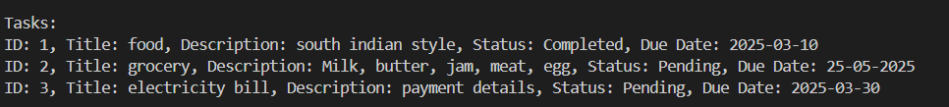
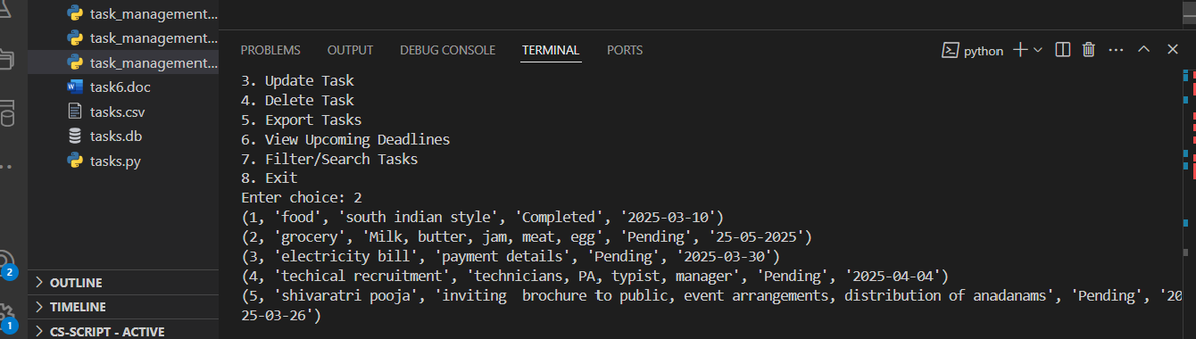
Next it is the code for output of task_management1.py
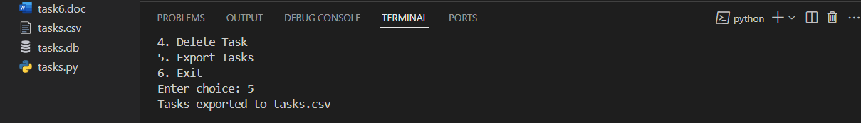
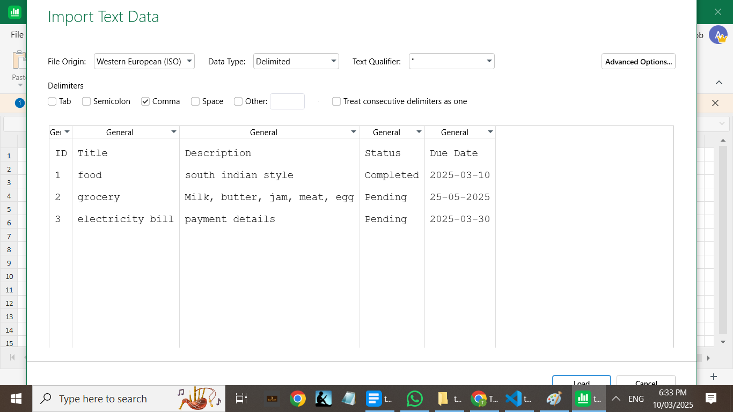

Since we already placed the name of the previous csv as task so for task_management2.py I have renamed the csv file as tasks1.csv
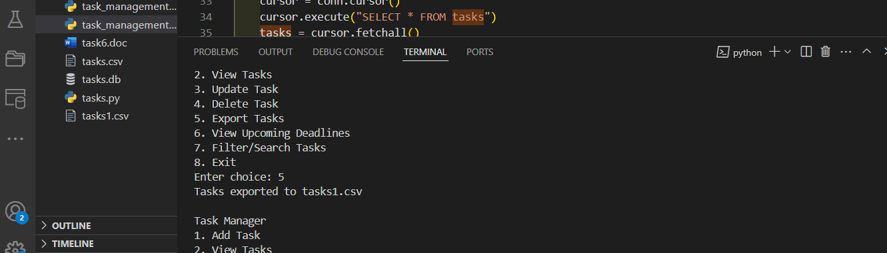
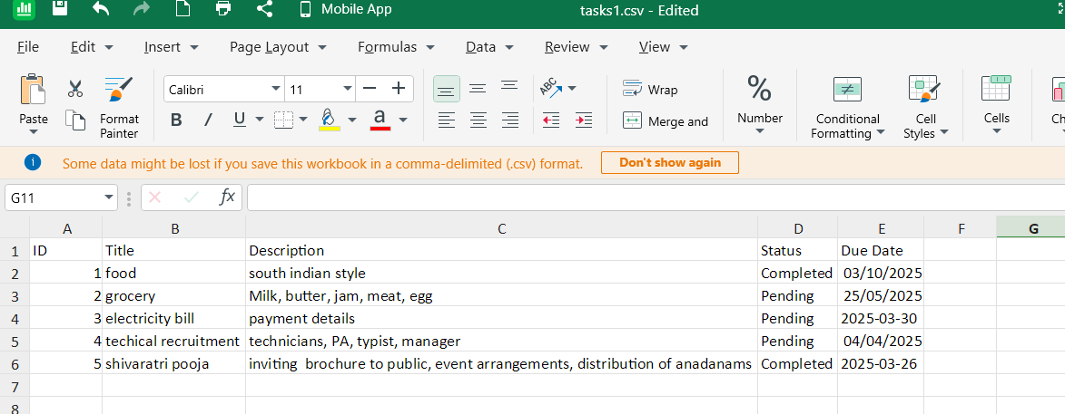
AFTER DELETION OF TASK
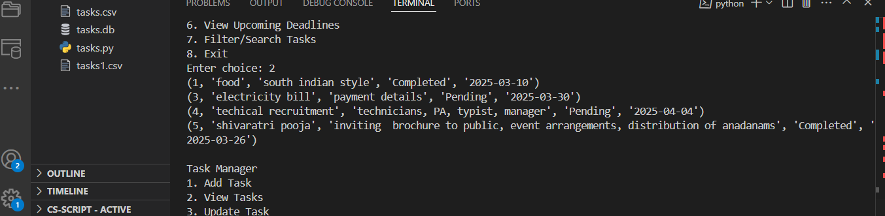
AFTER DELETION
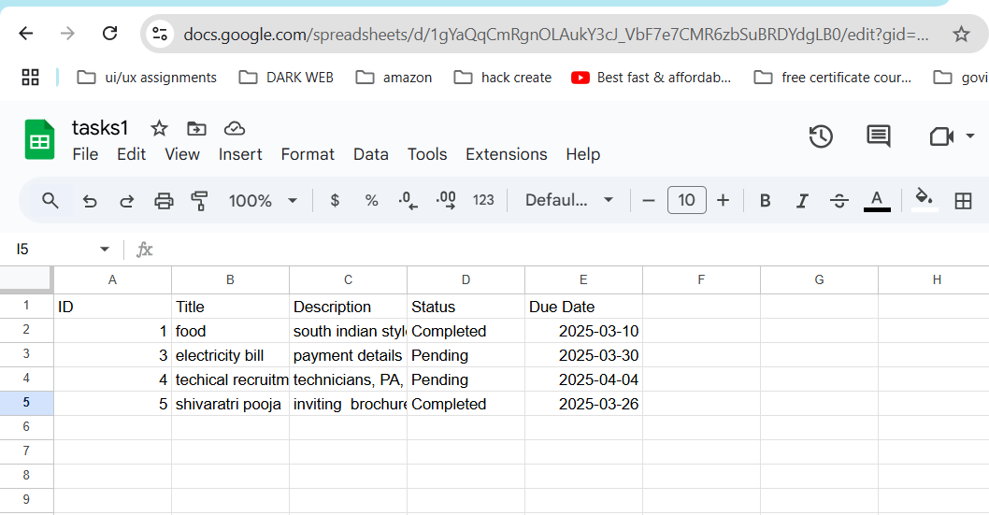

Filtered search
