- Write a Python program to create two lists and find sum.

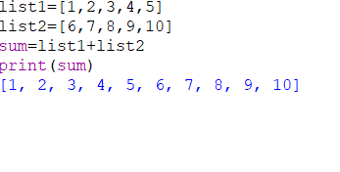

2. Write a Python program to.:
-create dictionary
-retrieve keys from dictionary
-retrieve values from dictionary
-create tuple
- create set

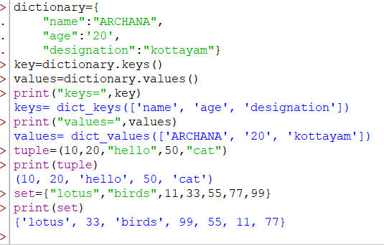

3.Find Datatypes ?
n1 = 123
n2 = 45.90
n3= [ 3,8,4 ]
n4 = “hii welcome”
n5 = (3,8,4)
n6= {3,8,9}
n7= 4+2j
n8= {“a”:3, “b”:8, “c”:4}

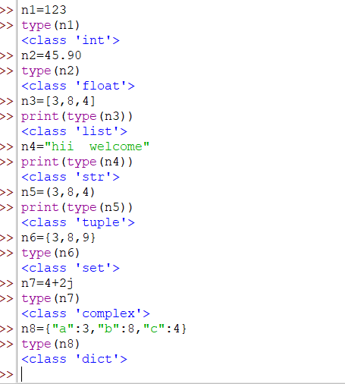

4. Find average of two numbers?

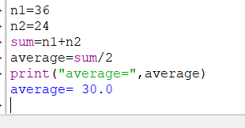

5. A= 6
B= 3
Write a program to perform arithmetic operations.

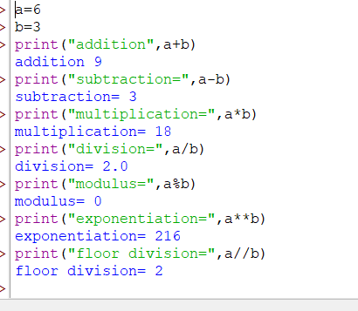

6. Write a prgm to perform comparison operators.

