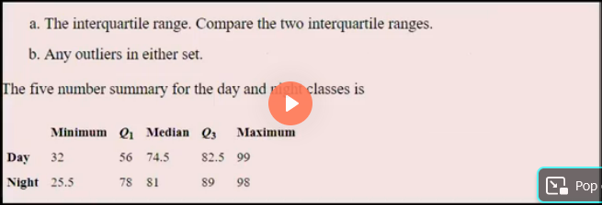

DAY: IQR=Q3-Q1

IQR=82.5-56

IQR=26.5

NIGHT: IQR=Q3-Q1

IQR=89-78

IQR=11

DAY

Lesser outlier=Q1-1.5\*IQR

Lesser outlier=56-1.5\*26.5

Lesser outlier=16.25

Greater outlier=Q3-1.5\*IQR

Greater outlier=82.5-1.5\*26.5

Greater outlier=122.25

NIGHT

Lesser outlier=Q1-1.5\*IQR

Lesser outlier=78-1.5\*11

Lesser outlier=61.5

Greater outlier=Q3-1.5\*IQR

Greater outlier=89-1.5\*11

Greater outlier=105.5

In Day night min value is 32 and max value is 99,lesser outlier is 16.25 and greater outlier is 122.25. so, it has both Lesser and Greater outliers.

In Day night min value is 21.5 and max value is 98,lesser outlier is 61.5and greater outlier is 105.5. so, it has only Greater outliers.