Duke Conversations

CS 316

NOah BURRELL, Anne Driscoll, KImberley eddleman, summer smith, sarp uner

# Application

## The Problem

Duke Conversations is a program run through the provost’s office, not through the UCAE, that holds dinners twice or three times a dinner with faculty members, as a way to bring together the Duke community. The goal of the program is to create more small group interaction between faculty members and students, and create an atmosphere of academic engagement.

Currently, the program accepts dinner applications through google forms, where individuals on the planning committee accept or reject applicants. The intent is to accept people who haven’t been to the program before, and create a dinner that reflects Duke’s diversity. Unfortunately, because different members of the planning committee work on different dinners, and may not be familiar with the names from previous dinners that they didn’t work on, people can slip through the cracks. That can take the form of people who may have applied many times and never been accepted, people who have consistently been accepted, or people who have skipped previous dinners and continue to be accepted.

## The Application

The application we intend to build will help the organizing team keep track of attendees. By keeping count of how many times each person has applied, and if they’ve attended previous dinners, we’ll be able to ensure that the selection process is standardized, and the team won’t have to try to remember the names of all the people that went to (or applied to) dinners that they didn’t manage.

To do that, we’ll have to create a login process for both sets of parties, a way for people to apply, and a way for planners to select applicants.

# Database Design

# Sample Data

# Data Assumptions

# Final Interface Goals

## Users

The user interface caters to two types of users: attendees, who use the site to sign up for events and give reviews of the events, and admins, who manage the events that can be signed up for, look at user/event statistics, and generate the list of people who can attend.

As such, the user interface design has two main views, a public view, accessible to anyone, and an admin view, accessible with a password or other login system.

## Design

The website is designed as a multi-page site with tabs at the top of every page to navigate around.

The public view has 4 main tabs, Home, Calendar, Sign Up and Review. It also has an “Admin View” button which can be used to switch over to the admin view.

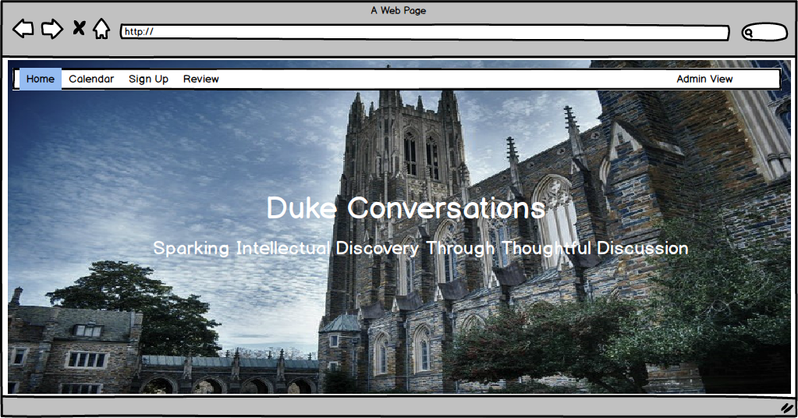

The calendar, which may or may not be implemented, depending on the final needs of the group, will include a visual view of all the upcoming event.

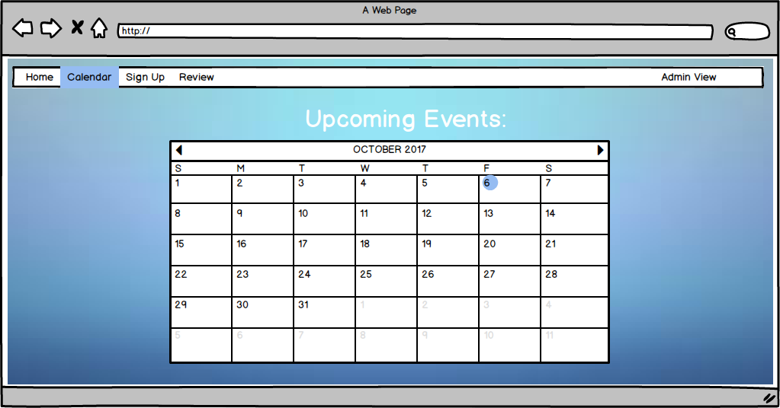

The sign up page will be where attendees can choose which event they want to sign up for. In implantation, the design will be an actual form with more information than shown below.

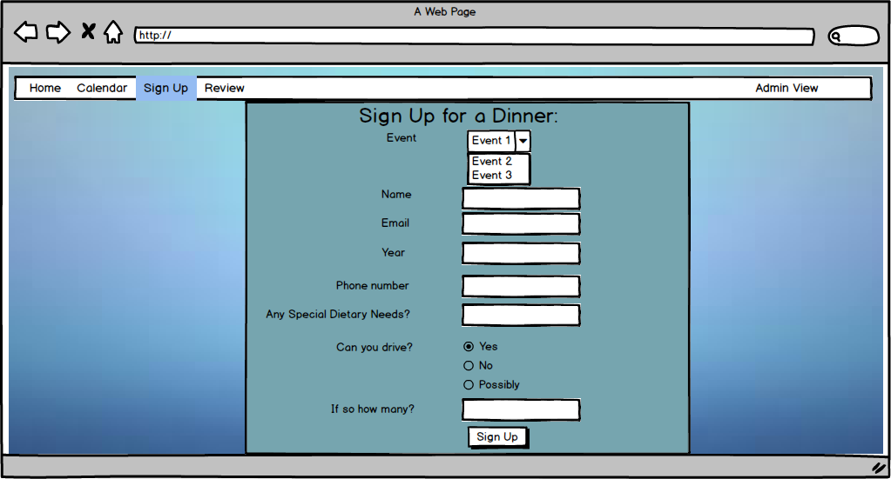

The sign up confirmation page will let users know that they have submitted their forms.

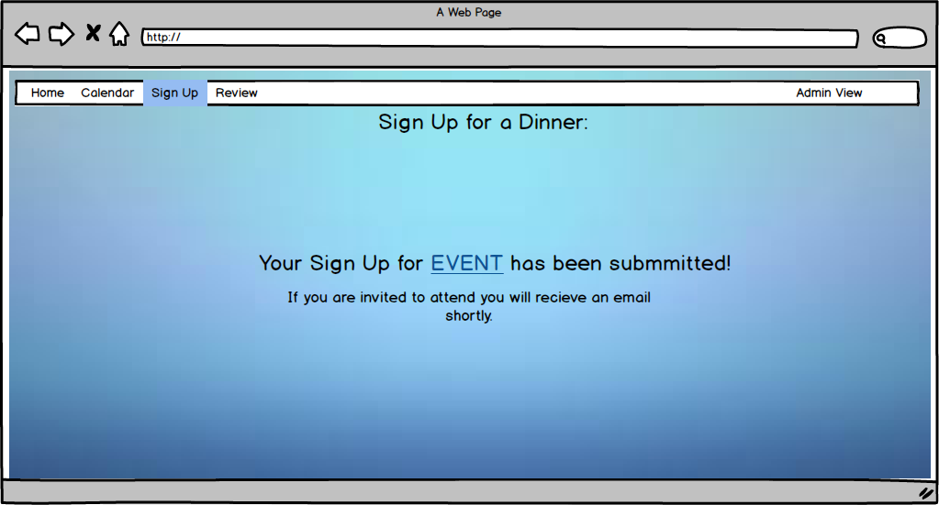

The review tab will be similar to the sign up tab, but with questions about how their experience at the dinner was, rather than an application for the dinner.

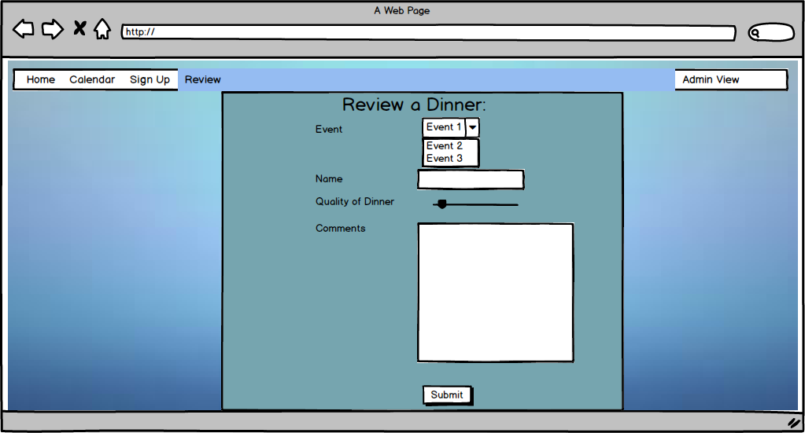

The review confirmation page will confirm the actual submitted review.

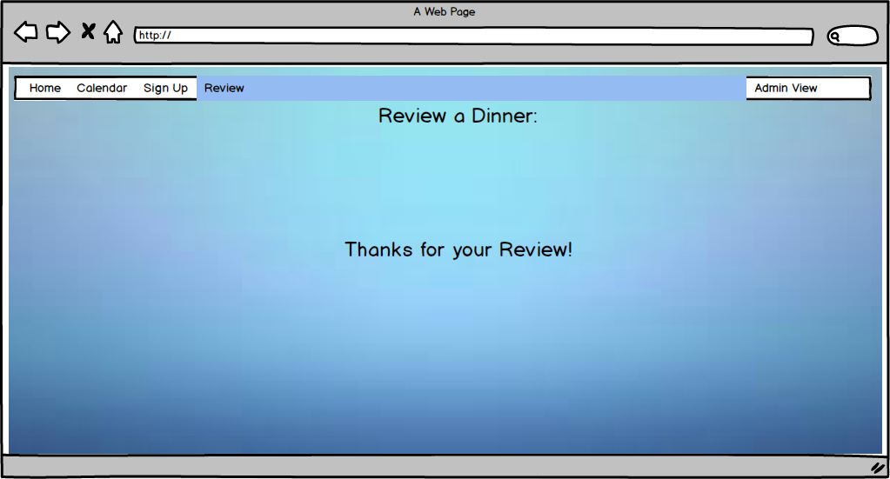

On the admin switch page, the user will be prompted with a box asking for a password. If the correct password is entered, the view will transition to the homepage of the Admin view. Otherwise, the box will tell the user they entered the correct password. In implementation, a more advanced login might be used to keep data more secure.

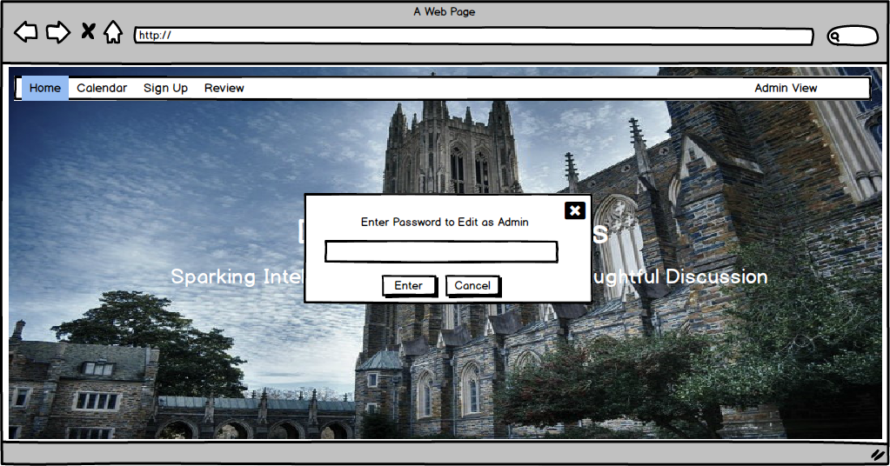

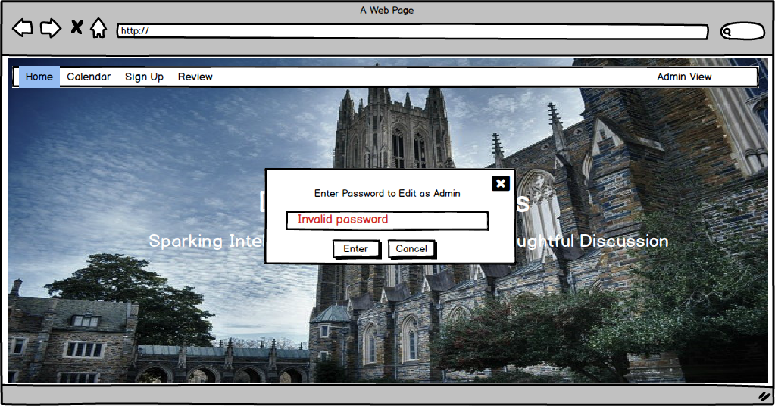

The Admin View is what allows administrators to view the data, change the events it is possible to sign up for, and generate a list of people to attend the events based on various criteria. It has 4 main tabs, Home, Edit Form, View Data, and Choose Event Attendees. It also has a button to return to the public view.

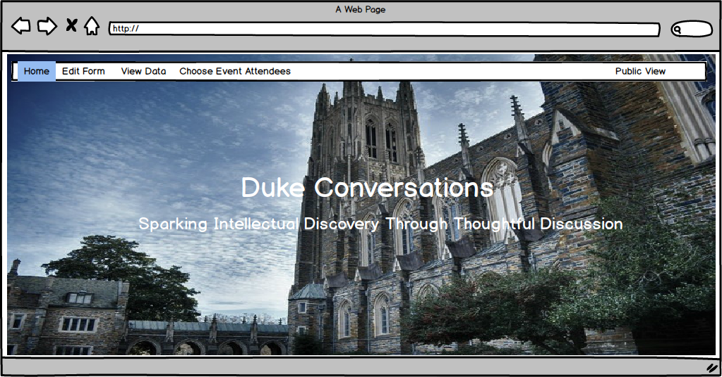

The edit form tab allows for the form to be updated to include new events to be signed up for or remove events that no longer can be signed up for. Each event currently in the sign up can be edited by clicking on the pencil or deleted by clicking on the trashcan. New events can be added with the plus.

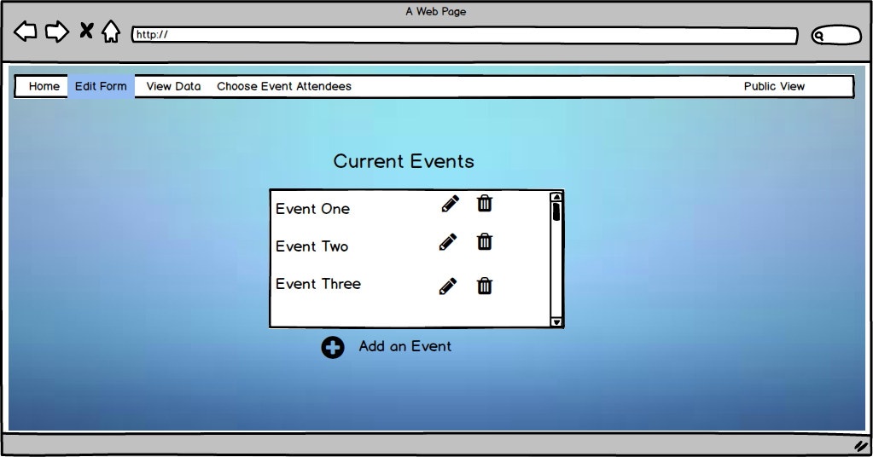

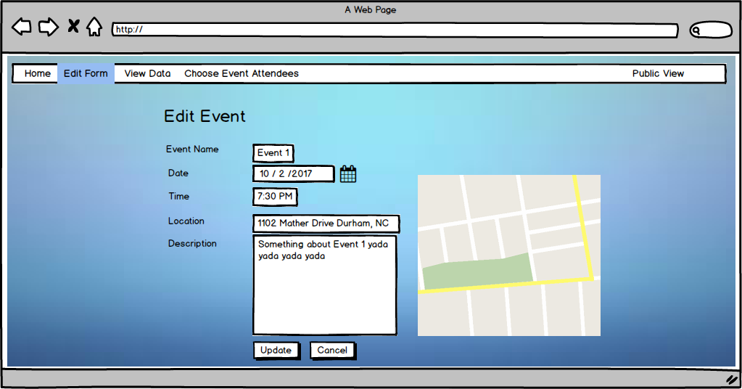

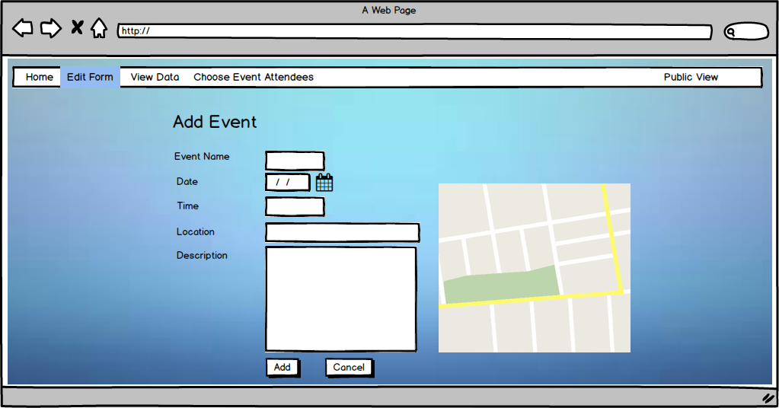

The View Data tab allows admins to see all the data organized in a neat form. The data is organized into four categories: Students (all the students who have filled out at least one of the sign ups), Professors, Events (each dinner that has or will be happening), and Applications (a list of each application/review that has been submitted). Each entry can be opened up and viewed in more detail (for example, student, professor, event, etc). Additionally each tab can be sorted or filtered by various criteria)

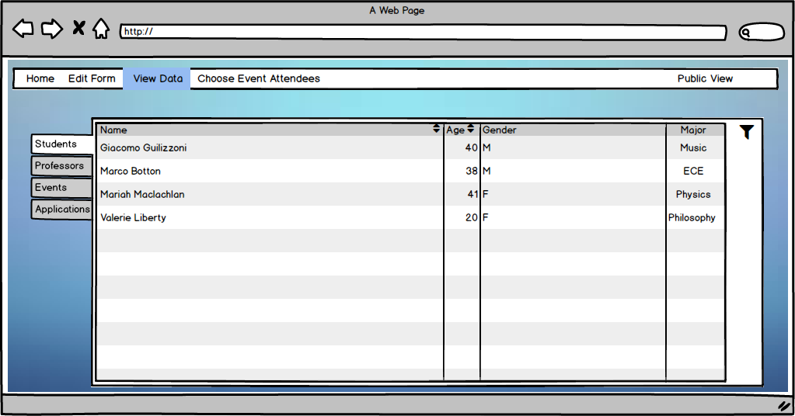

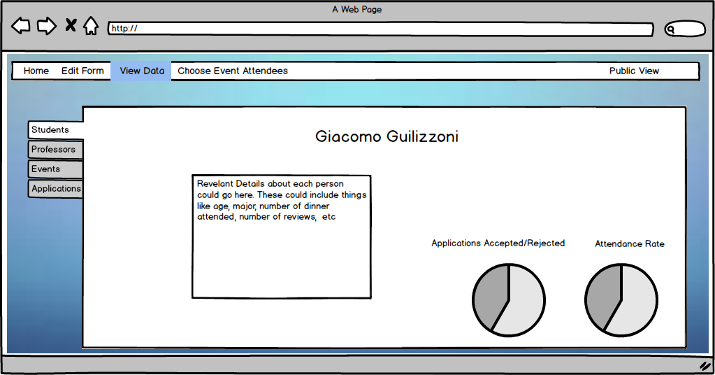

The choose attendees tab will use a variety of algorithms to determine a list of people for a new event. Different specifications can be requested and a list can be generated based off of these specifications. Once the list is created, it can be viewed and confirmed or canceled.

