**ARTIFICIAL INTELLIGENCE_PHASE – 3_PROJECT SUBMISSION ON MEASURE ENERGY CONSUMPTION**

**TEAM MEMBER : ARCHANA. B – [ 411521104007 ]**

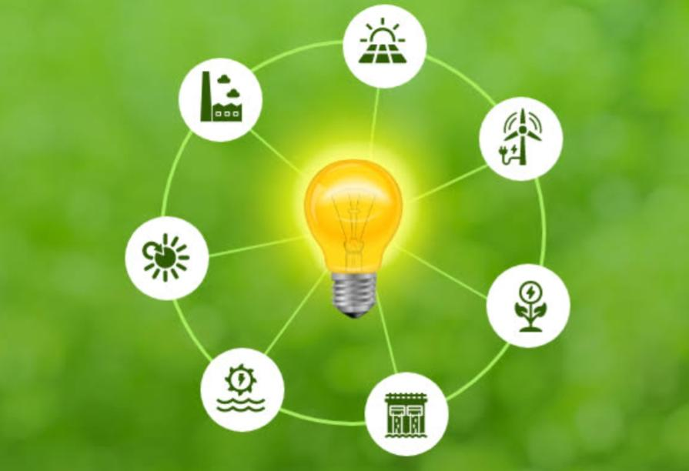

**INTRODUCTION :**

* When we talk about measuring energy consumption, we’re essentially looking at how much energy we use in various activities or devices. It’s like keeping tabs on how many slices of pizza we eat or how many hours we spend playing video games. By tracking our energy usage, we can identify patterns, understand where we’re using the most energy, and find ways to be more efficient.
* To measure energy consumption, we often rely on devices like energy meters or smart plugs. These devices help us monitor the amount of electricity consumed by specific appliances or areas in our homes. We can also analyze our utility bills to get an idea of our overall energy usage over time.
* But it’s not just about the numbers! Measuring energy consumption allows us to make informed decisions about our energy usage. We can identify energy-intensive activities or appliances and find ways to reduce their impact.
* Ultimately, measuring energy consumption empowers us to be more mindful of our energy usage, conserve resources, and contribute to a greener and more sustainable future. It’s an exciting field that combines technology, data analysis, and our individual efforts to make a positive impact on the environment.

**CONTENT FOR PHASE-3_PROJECT :**

In this phase I’ve designed an innovation to solve the problem.

**DATA SOURCE :**

The data source for measuring the energy consumption is obtained from the below dataset.

DATASET:<https://www.kaggle.com/datasets/robikscube/hourly-energy-consumption>

**MODULE :**

When it comes to measuring energy consumption, there are a few key modules that are typically involved:

**1️.Sensors:**

These devices are responsible for collecting data on energy usage. They can include electricity meters, smart plugs, or other monitoring devices.

**2️.Data Acquisition:**

This module focuses on gathering and recording the energy consumption data from the sensors. It ensures that the data is accurately captured and stored for further analysis.

**3️.Data Processing:**

This module involves analyzing and Processing the collected data. It often uses programming Languages like Python and data analysis tools like pandas to Calculate energy consumption metrics and identify patterns or Trends.

**4️.Visualization:**

This module helps to present the energy Consumption data in a visual format. It can include charts, graphs, Or dashboards that make it easier to understand and interpret the Data.These modules work together to provide insights into energy Usage and help identify opportunities for energy efficiency Improvements.

**MODEL DEVELOPMENT:**

To develop a model for measuring energy consumption, you can

Follow these steps:

**1️. Collect data:**

Gather energy consumption data from sensors or Smart meters. This data should include variables like time, date, and energy usage.

**2️. Pre-process the data:**

Clean the data by handling missing values, outliers, and formatting issues. You may need to convert he data into a suitable format for analysis.

**3️. Feature engineering:**

Extract relevant features from the data that can help in predicting energy consumption. This can include factors like weather conditions, occupancy, or time of day.

**4️. Split the data:**

Divide the dataset into training and testing sets. The training set is used to train the model, while the testing set is used to evaluate its performance.

**5. Choose and train a model:**

Select a suitable machine learning algorithm, such as linear regression, decision trees, or neural networks. Train the model using the training data.

**6. Evaluate the model:**

Assess the model’s performance using evaluation metrics like mean squared error or R-squared. This will help you understand how well the model predicts energy consumption.

**7. Fine-tune and validate:**

Adjust the model’s parameters and hyper parameters to improve its performance. Validate the model using cross-validation techniques to ensure its generalizability.

**8. Deploy and monitor:**

Once you’re satisfied with the model’s performance, deploy it in a production environment. Continuously monitor its predictions and update the model as needed.

**PYTHON PROGRAM FOR MEASURE ENERGY CONSUMPTION : EXAMPLE MODEL -1**

#python program for measuring energy consumption

Import pandas as pd

Import matplotlib.pyplot as plt

# Read energy consumption data from a CSV file

Data = pd.read_csv(‘energy_data.csv’)

To represent energy consumption using a bar diagram, you can

Use Python’s matplotlib library.

# Sample data

Categories = [‘Category 1️’, ‘Category 2️’, ‘Category 3️’]

Consumption = [1️0, 2️0, 1️5] # Energy consumption values

# Create the bar plot

Plt.bar(categories, consumption)

# Add labels and title

Plt.xlabel(‘Categories’)

Plt.ylabel(‘Energy Consumption’)

Plt.title(‘Energy Consumption by Category’)

# Show the plot

Plt.show()

This code creates a bar plot with categories on the x-axis and

Energy consumption values on the y-axis.

# Plot the energy consumption over time

Plt.plot(data[‘Date’], data[‘Energy Consumption’])

Plt.xlabel(‘Date’)

Plt.ylabel(‘Energy Consumption’)

Plt.title(‘Energy Consumption Over Time’)

Plt.show()

# plotting

Import matplotlib.pyplot as plt

Import numpy as np # linear algebra

Import os # accessing directory structure

Import pandas as pd # data processing, CSV file I/O (e.g.

Pd.read_csv)

Import seaborn as sns

Plt.style.use(‘ggplot’) # Make it pretty

In [2️]:

# Data is saved in parquet format so schema is preserved.

Df = pd.read_parquet(‘../input/est_hourly.paruqet’)

**EXAMPLE MODEL – 2 :**

Import matplotlib.pyplot as plt # plotting

Import numpy as np # linear algebra

Import os # accessing directory structure

Import pandas as pd # data processing, CSV file I/O (e.g. pd.read_csv)

Import seaborn as sns

Plt.style.use(‘ggplot’) # Make it pretty

In [2]:

# Data is saved in parquet format so schema is preserved.

Df = pd.read_parquet(‘../input/est_hourly.paruqet’)

Data index is the date/hour, columns are for different regions within PJM.

Regions joined at different times, so not all have data for all dates. Regions also split (PJM_Load split to East and West)

In [3]:

#Show PJM Regions

From IPython.display import Image

Image(url= <http://slideplayer.com/4238181/14/images/4/PJM+Evolution.jpg>)

Out[3]:

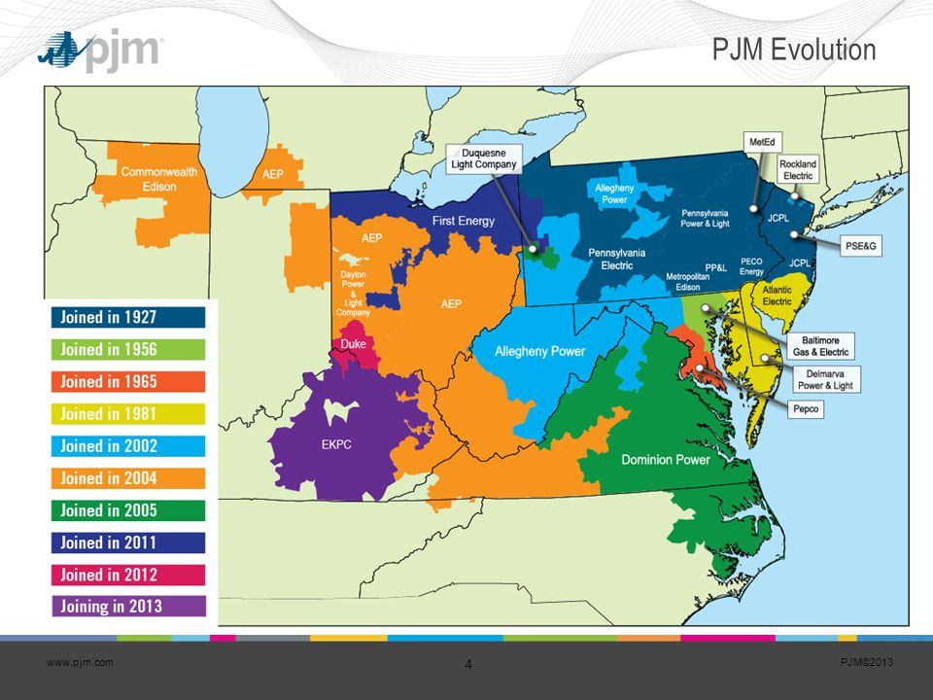In [4]:

Df.head()

Out[4]:

In [5]:

**AEP COMED DAYTON DEOK DOM DUQ EKPC FE NI PJME PJMW PJM_Load**

Datetime

1998-12-31 01:00:00 NaN NaN NaN NaN NaN NaN NaN NaN NaN NaN NaN 29309.0

1998-12-31 02:00:00 NaN NaN NaN NaN NaN NaN NaN NaN NaN NaN NaN 28236.0

1998-12-31 03:00:00 NaN NaN NaN NaN NaN NaN NaN NaN NaN NaN NaN 27692.0

1998-12-31 04:00:00 NaN NaN NaN NaN NaN NaN NaN NaN NaN NaN NaN 27596.0

1998-12-31 05:00:00 NaN NaN NaN NaN NaN NaN NaN NaN NaN NaN NaN 27888.0

Df.describe().T

Count mean std min 25% 50% 75% max

AEP 121273.0 15499.513717 2591.399065 9581.0 13630.0 15310.0 17200.00 25695.0

COMED 66497.0 11420.152112 2304.139517 7237.0 9780.0 11152.0 12510.00 23753.0

DAYTON 121275.0 2037.851140 393.403153 982.0 1749.0 2009.0 2279.00 3746.0

DEOK 57739.0 3105.096486 599.859026 907.0 2687.0 3013.0 3449.00 5445.0

DOM 116189.0 10949.203625 2413.946569 1253.0 9322.0 10501.0 12378.00 21651.0

DUQ 119068.0 1658.820296 301.740640 1014.0 1444.0 1630.0 1819.00 3054.0

EKPC 45334.0 1464.218423 378.868404 514.0 1185.0 1386.0 1699.00 3490.0

FE 62874.0 7792.159064 1331.268006 0.0 6807.0 7700.0 8556.00 14032.0

NI 58450.0 11701.682943 2371.498701 7003.0 9954.0 11521.0 12896.75 23631.0

PJME 145366.0 32080.222831 6464.012166 14544.0 27573.0 31421.0 35650.00 62009.0

PJMW 143206.0 5602.375089 979.142872 487.0 4907.0 5530.0 6252.00 9594.0

PJM_Load 32896.0 29766.427408 5849.769954 17461.0 25473.0 29655.0 33073.25 54030.0

_ = df[‘PJME’].plot.hist(figsize=(15, 5), bins=200, title=’Distribution of PJME Load’)

Df.describe().T_ = df[‘PJME’].plot.hist(figsize=(15, 5), bins=200, title=’Distribution of PJME Load’)

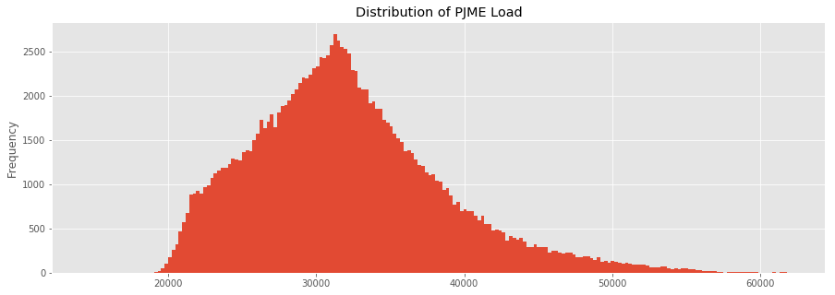

Out[5]:

In [6]:

_ = df[‘DOM’].plot.hist(figsize=(15, 5), bins=200, title=’Distribution of DOMINION Load’)

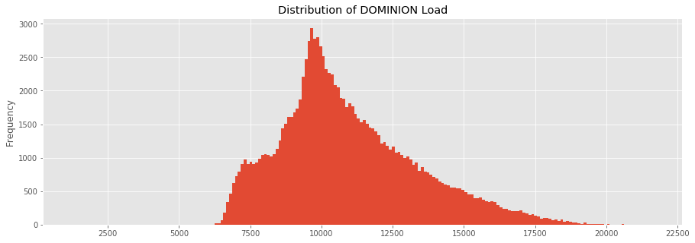

Import matplotlib.pyplot as plt # plotting

Import numpy as np # linear algebra

Import os # accessing directory structure

Import pandas as pd # data processing, CSV file I/O (e.g. pd.read_csv)

Import seaborn as sns

Plt.style.use(‘ggplot’) # Make it pretty

# Data is saved in parquet format so schema is preserved.

Df = pd.read_parquet(‘../input/est_hourly.paruqet’)

Data index is the date/hour, columns are for different regions within PJM.

Create Time Series Features

In [13]:

Df[‘dow’] = df.index.dayofweek

Df[‘doy’] = df.index.dayofyear

Df[‘year’] = df.index.year

Df[‘month’] = df.index.month

Df[‘quarter’] = df.index.quarter

Df[‘hour’] = df.index.hour

Df[‘weekday’] = df.index.weekday_name

Df[‘woy’] = df.index.weekofyear

Df[‘dom’] = df.index.day # Day of Month

Df[‘date’] = df.index.date

In [14]:

## **Plot Time Series**

In [9]:

plot = df.plot(style='.', figsize=(15, 8), title='Entire PJM Load 1998-2001')

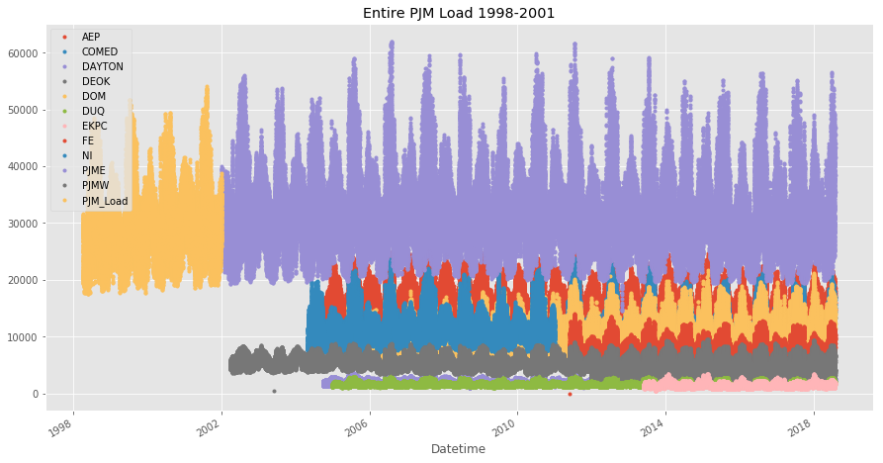

# **Plotting Regions**

In [10]:

_ = df[['PJM_Load','PJME','PJMW']] \

.plot(style='.', figsize=(15, 5), title='PJM Load 1998-2002 - Split East and West 2002-2018')

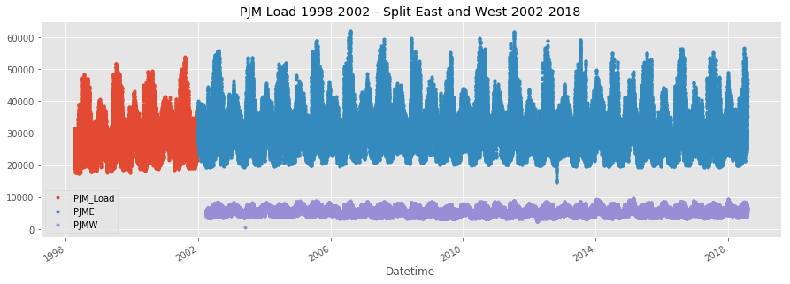

= df[[‘PJM_Load’,’hour’]].plot(x=’hour’,

Y=’PJM_Load’,

Kind=’scatter’,

Figsize=(14,4),

Title=’Consumption by Hour of Day’)

**CONCLUSION :**

So, when it comes to the conclusion for measuring energy consumption, it’s all about being aware of our energy usage and making conscious choices to reduce it. By measuring and monitoring our energy consumption, we can identify areas of improvement and implement energy-saving strategies. This not only helps us save money on our bills, but also contributes to a more sustainable and eco-friendly lifestyle. So let’s keep track of our energy usage and make a positive impact together.