Issues Encountered

|  |  |  |  |  |  |  |  |
| --- | --- | --- | --- | --- | --- | --- | --- |
| **Issue#**  **S No** | **API** | **Scenario** | **Issue Type** | **Expected** | **Actual** | **Test Status** | **Test case Count** |
| Issue#1 | Search | Mandate fields | Functional | Result with issues = 0 | Results are with fields missing | FAILED | 5 |
| Issue#2 | Search, Lookup | View URLs | Functional | Clickable | Non clickable | FAILED | 2 |
| Issue#3 | Search, Lookup | View URLs response time | Functional | <3sec | >3sec | FAILED | 2 |
| Issue#4 | Search, Lookup | View URLs secured | Functional | Https | Http | FAILED | 3 |
| Issue#5 | Lookup | result not empty | Functional | Result count>0 | Result count=0 | FAILED | 1 |
| Issue#6 | Lookup | Result response | Requirement | Documentation on result fields should be available | Documentation on result fields is not available | FAILED | 1 |

Defects Identified

|  |  |  |  |  |
| --- | --- | --- | --- | --- |
| **Defect ID** | **Root cause** | **Issues/Scenarios impacted** | **API impacted** | **Test case Impacted** |
| DefectID_01 | Results are with fields missing for Search API | Issue#1/Mandate fields | Search | 5 |
| DefectID_02 | Broken URL | Issue#1,2,3/ View URLs, View URLs response time, View URLs secured | Search, Look Up | 3 |
| DefectID_03 | non-secure URL | Issue#4/ View URLs secured | Look Up | 2 |
| DefectID_04 | [No](http://www.yelp.com) search results | Issue#1,2,3,5/ View URLs, View URLs response time, View URLs secured, Results not empty | Look Up | 3 |
| DefectID_05 | Requirement | Issue#6/Result response req missing | Look Up | 1 |

**DefectID_01:** Results are with fields missing for Search API

|  |  |  |  |  |  |  |  |
| --- | --- | --- | --- | --- | --- | --- | --- |
| **Issue#**  **S No** | **API** | **Scenario** | **Root cause** | **Expected** | **Actual** | **Test Status** | **Test case Count** |
| Issue#1 | Search | Mandate fields | Results are with fields missing | Result with issues = 0 | Results are with fields missing | FAILED | 5 |

Issue#1 : Results are with fields missing for Search API

|  |  |  |
| --- | --- | --- |
| API | Missing field | Missing in no of requests |
| <https://itunes.apple.com/search?term=jack+johnson> | CollectionName | 5 |
| <https://itunes.apple.com/search?term=jack+johnson&limit=25> | CollectionName | 5 |
| <https://itunes.apple.com/search?term=jack+johnson&entity=musicVideo> | CollectionName | 9 |
| <https://itunes.apple.com/search?term=jim+jones&country=ca> | ‘kind’, ’trackName’ | 9 |
| <https://itunes.apple.com/search?term=yelp&country=us&entity=software> | CollectionName | 50 |

<https://itunes.apple.com/search?term=jack+johnson> has ‘CollectionName’ field missing for 5 search result

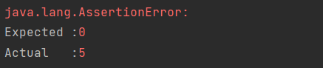

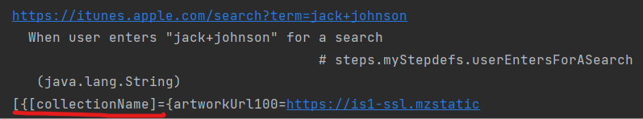

https://itunes.apple.com/search?term=jack+johnson&limit=25 has ‘CollectionName’ field missing for 5 search result



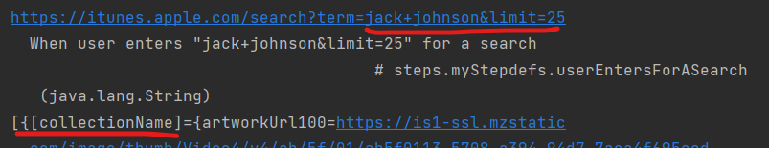

<https://itunes.apple.com/search?term=jack+johnson&entity=musicVideo> has ‘CollectionName’ field missing for 9 search result

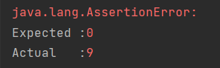

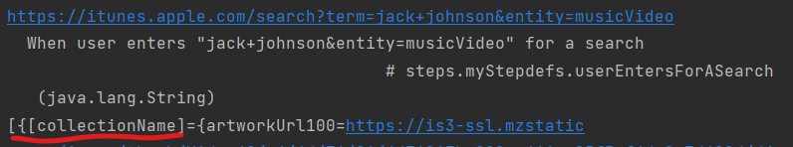

<https://itunes.apple.com/search?term=jim+jones&country=ca> has ‘kind’, ’trackName’ fields missing for 9 search result

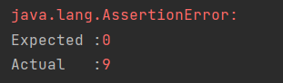

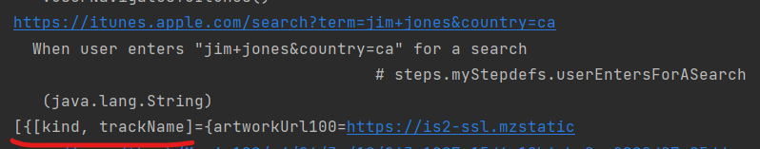

https://itunes.apple.com/search?term=yelp&country=us&entity=software has ‘CollectionName’ field missing for 50 search result

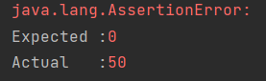

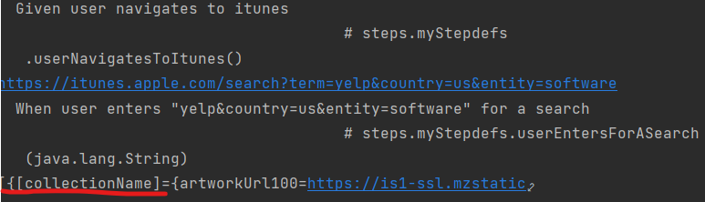

**DefectID_02:**  API are non-clickable/broken in search and lookupAPI

|  |  |  |
| --- | --- | --- |
| **API** | **Broken URL** | **Exception** |
| <https://itunes.apple.com/search?term=yelp&country=us&entity=software> | <https://app.fleksy.com> | UnknownHost exception |

|  |  |  |  |  |  |  |  |
| --- | --- | --- | --- | --- | --- | --- | --- |
| **Issue#**  **S No** | **API** | **Scenario** | **Root Cause** | **Expected** | **Actual** | **Test Status** | **Test case Count** |
| Issue#2 | Search | View URLs | Broken URL | Clickable | Non clickable | FAILED | 1 |
| Issue#3 | Search | View URLs response time | Broken URL | <3sec | >3sec | FAILED | 1 |
| Issue#4 | Search | View URLs secured | Broken URL | Https | Http | FAILED | 1 |

**DefectID_03:**  API are non-secure in search and lookup

|  |  |
| --- | --- |
| **API calls** | **Non-secure URL** |
| <https://itunes.apple.com/search?term=yelp&country=us&entity=software> | <http://www.yelp.com> |
| <https://itunes.apple.com/lookup?id=284910350> | <http://www.yelp.com> |

|  |  |  |  |  |  |  |  |
| --- | --- | --- | --- | --- | --- | --- | --- |
| **Issue#**  **S No** | **API** | **Scenario** | **Root Cause** | **Expected** | **Actual** | **Test Status** | **Test case Count** |
| Issue#4 | Search, Lookup | View URLs secured | non-secure URL | Https | Http | FAILED | 2 |

**DefectID_04:**  Search results are empty for API

|  |  |
| --- | --- |
| **API** | **Search results** |
| <https://itunes.apple.com/lookup?amgVideoId=17120> | [No](http://www.yelp.com) search results found |

|  |  |  |  |  |  |  |  |
| --- | --- | --- | --- | --- | --- | --- | --- |
| **Issue#**  **S No** | **API** | **Scenario** | **Root Cause** | **Expected** | **Actual** | **Test Status** | **Test case Count** |
| Issue#2 | Lookup | View URLs | [No](http://www.yelp.com) search results | Clickable | Non clickable | FAILED | 1 |
| Issue#3 | Lookup | View URLs response time | [No](http://www.yelp.com) search results | <3sec | >3sec | FAILED | 1 |
| Issue#4 | Lookup | View URLs secured | [No](http://www.yelp.com) search results | Https | Http | FAILED | 1 |
| Issue#5 | Lookup | result not empty | Functional | Result count>0 | Result count=0 | FAILED | 1 |

**DefectID_05:**  Documentation on look up results are missing

|  |  |  |  |  |  |  |  |
| --- | --- | --- | --- | --- | --- | --- | --- |
| **Issue#**  **S No** | **API** | **Scenario** | **Root cause** | **Expected** | **Actual** | **Test Status** | **Test case Count** |
| Issue#6 | Lookup | Result response | Requirement | Documentation on result fields should be available | Documentation on result fields is not available | FAILED | 1 |