**Test Framework details**

Framework: Cucumber, Rest Assured, Junit

**Test Execution Stats:**

Total Test case Executed: 85

Passed Test Case: 71

Failed Test Case: 14 (includes 1 test case on requirement)

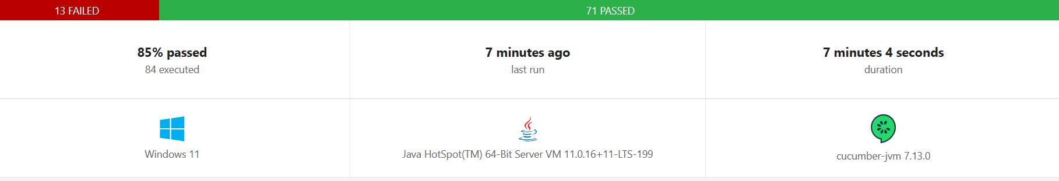

**Issues Encounter: (please refer defect documentation-Defects.docx)**

|  |  |  |  |  |  |  |
| --- | --- | --- | --- | --- | --- | --- |
| **API** | **Scenario** | **Issue Type** | **Expected** | **Actual** | **Test Status** | **Test case Count** |
| Search | Mandate fields | Functional | Result with issues = 0 | Results are with fields missing | FAILED | 5 |
| Search, Lookup | View URLs | Functional | Clickable | Non clickable | FAILED | 2 |
| Search, Lookup | View URLs response time | Functional | <3sec | >3sec | FAILED | 2 |
| Search, Lookup | View URLs secured | Functional | Https | Http | FAILED | 3 |
| Lookup | result not empty | Functional | Result count>0 | Result count=0 | FAILED | 1 |
| Lookup | Result response | Requirement | Documentation on result fields should be available | Documentation on result fields is not available | FAILED | 1 |

**Total Scenarios Executed Summary**

|  |  |  |  |  |  |
| --- | --- | --- | --- | --- | --- |
| **API** | **Scenario** | **Expected** | **Actual** | **Test Status** | **Test case Count** |
| Search | iTunes search URL is secure | Https | Https | PASSED | 1 |
| Search | result not empty | Result count>0 | Result count>0 | PASSED | 5 |
| Search | Mandate fields | Request with issues = 0 | 5 | FAILED | 5 |
| Search | explicitness and censored Name in result | Fields should present | Fields are present | PASSED | 5 |
| Search | View URLs | clickable | clickable | PASSED | 4 |
| Search | View URLs | clickable | clickable | FAILED | 1 |
| Search | View URLs response time | <3sec | <3sec | PASSED | 4 |
| Search | View URLs response time | <3sec | >3sec | FAILED | 1 |
| Search | View URLs secured | Https | Https | PASSED | 4 |
| Search | View URLs secured | Https | Http | FAILED | 1 |
| Search | Preview URL, track Time Millis | available in response | available in response | PASSED | 5 |
| Lookup | result not empty | Result count>0 | Result count>0 | PASSED | 11 |
| Lookup | result not empty | Result count>0 | Result count=0 | FAILED | 1 |
| Lookup | View URLs | clickable | clickable | PASSED | 11 |
| Lookup | View URLs | clickable | clickable | FAILED | 1 |
| Lookup | View URLs response time | <3sec | >3sec | PASSED | 11 |
| Lookup | View URLs response time | <3sec | >3sec | FAILED | 1 |
| Lookup | View URLs secured | Https | Https | PASSED | 10 |
| Lookup | View URLs secured | Https | Http | FAILED | 2 |

**Scenarios test results in detail:**

|  |  |  |  |  |  |
| --- | --- | --- | --- | --- | --- |
| **API** | **Scenario** | **Expected** | **Actual** | **Test Status** | **Test case Count** |
| Search | iTunes search URL is secure | Https | Https | PASSED | 1 |

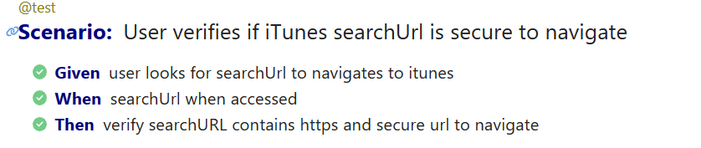

|  |  |  |  |  |  |
| --- | --- | --- | --- | --- | --- |
| **API** | **Scenario** | **Expected** | **Actual** | **Test Status** | **Test case Count** |
| Search | result not empty | Result count>0 | Result count>0 | PASSED | 5 |

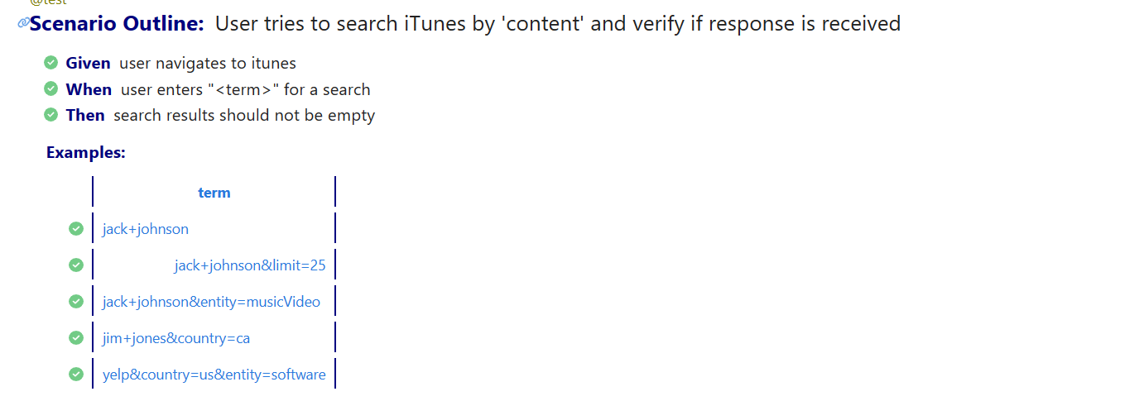

|  |  |  |  |  |  |
| --- | --- | --- | --- | --- | --- |
| **API** | **Scenario** | **Expected** | **Actual** | **Test Status** | **Test case Count** |
| Search | Mandate fields | Request with issues = 0 | 5 | FAILED | 5 |

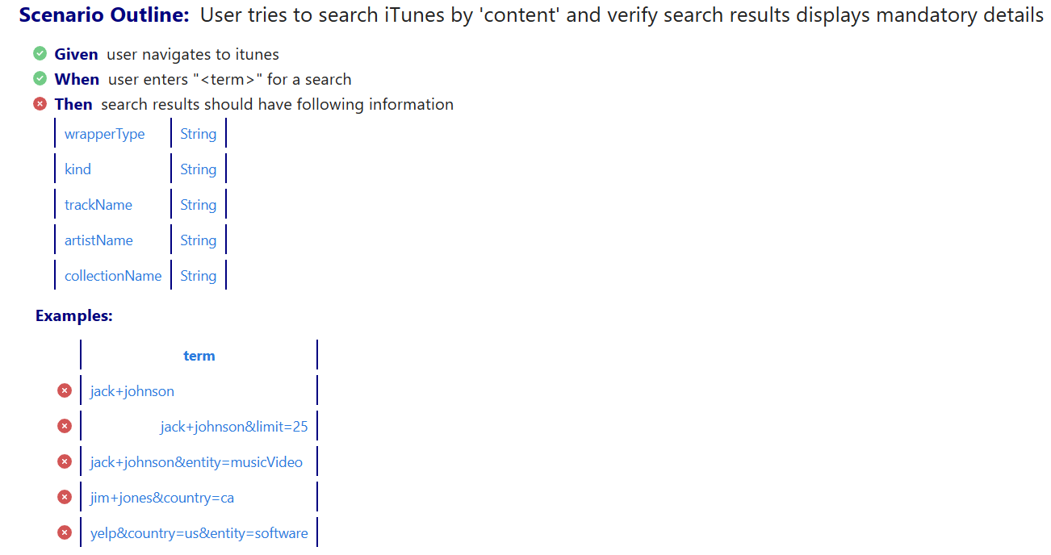

<https://itunes.apple.com/search?term=jack+johnson> has ‘CollectionName’ field missing for 5 search result

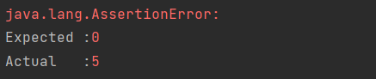

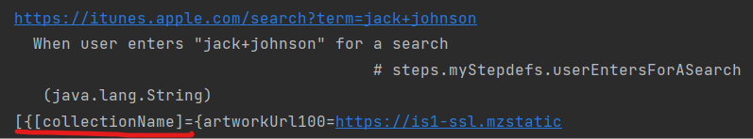

https://itunes.apple.com/search?term=jack+johnson&limit=25 has ‘CollectionName’ field missing for 5 search result



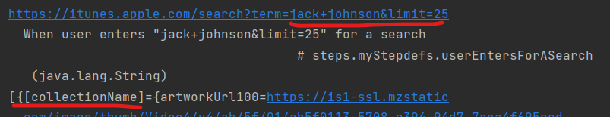

<https://itunes.apple.com/search?term=jack+johnson&entity=musicVideo> has ‘CollectionName’ field missing for 9 search result

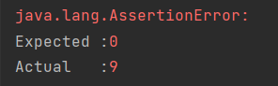

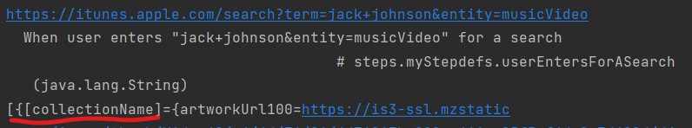

<https://itunes.apple.com/search?term=jim+jones&country=ca> has ‘kind’, ’trackName’ fields missing for 9 search result

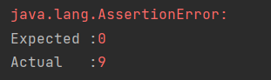

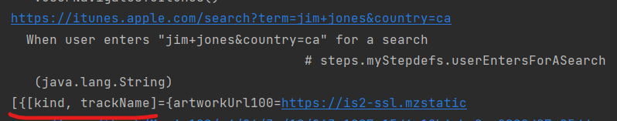

https://itunes.apple.com/search?term=yelp&country=us&entity=software has ‘CollectionName’ field missing for 50 search result

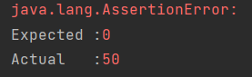

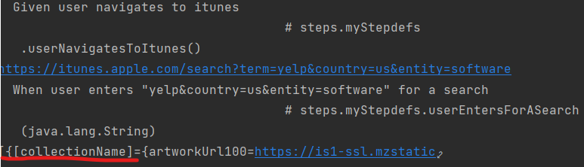

|  |  |  |  |  |  |
| --- | --- | --- | --- | --- | --- |
| **API** | **Scenario** | **Expected** | **Actual** | **Test Status** | **Test case Count** |
| Search | explicitness and censored Name in result | Fields should present | Fields are present | PASSED | 5 |

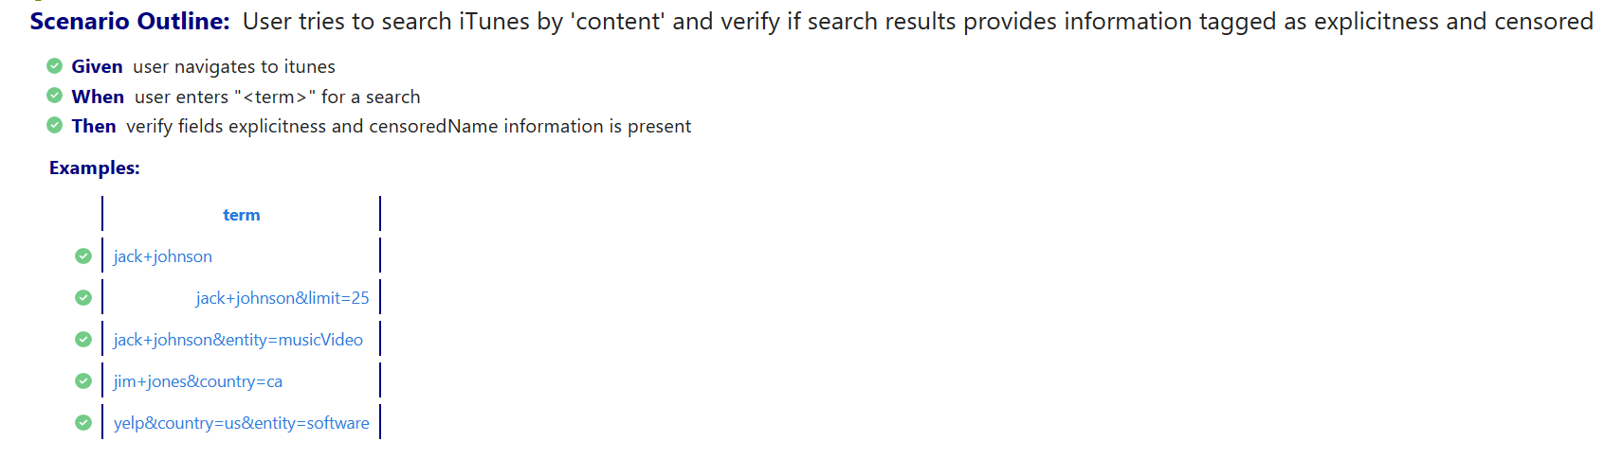

|  |  |  |  |  |  |
| --- | --- | --- | --- | --- | --- |
| **API** | **Scenario** | **Expected** | **Actual** | **Test Status** | **Test case Count** |
| Search | View URLs | clickable | clickable | PASSED | 4 |
| Search | View URLs | clickable | Non clickable | FAILED | 1 |

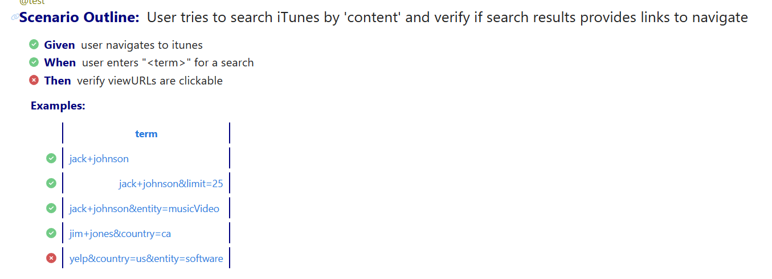

UnknownHost exception for https:app.fleksy.com

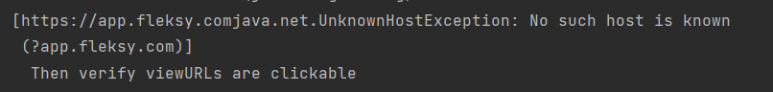

|  |  |  |  |  |  |
| --- | --- | --- | --- | --- | --- |
| **API** | **Scenario** | **Expected** | **Actual** | **Test Status** | **Test case Count** |
| Search | View URLs response time | <3sec | <3sec | PASSED | 1 |
| Search | View URLs response time | <3sec | >3sec | FAILED | 4 |

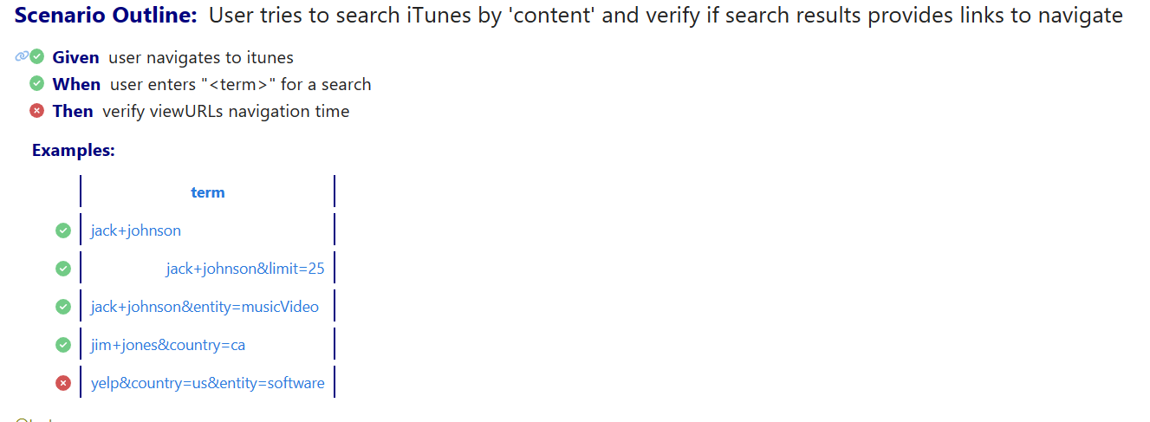

UnknownHost exception for https:app.fleksy.com



|  |  |  |  |  |  |
| --- | --- | --- | --- | --- | --- |
| **API** | **Scenario** | **Expected** | **Actual** | **Test Status** | **Test case Count** |
| Search | View URLs secured | Https | Https | PASSED | 4 |
| Search | View URLs secured | Https | Http | FAILED | 1 |

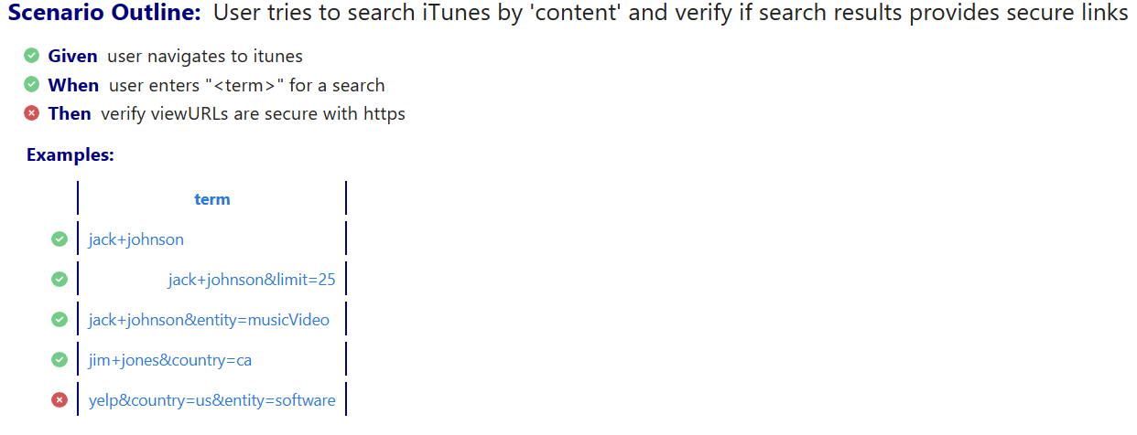

Non secure link <http://www.yelp.com>



|  |  |  |  |  |  |
| --- | --- | --- | --- | --- | --- |
| **API** | **Scenario** | **Expected** | **Actual** | **Test Status** | **Test case Count** |
| Search | Preview URL, track Time Millis | available in response | available in response | PASSED | 5 |

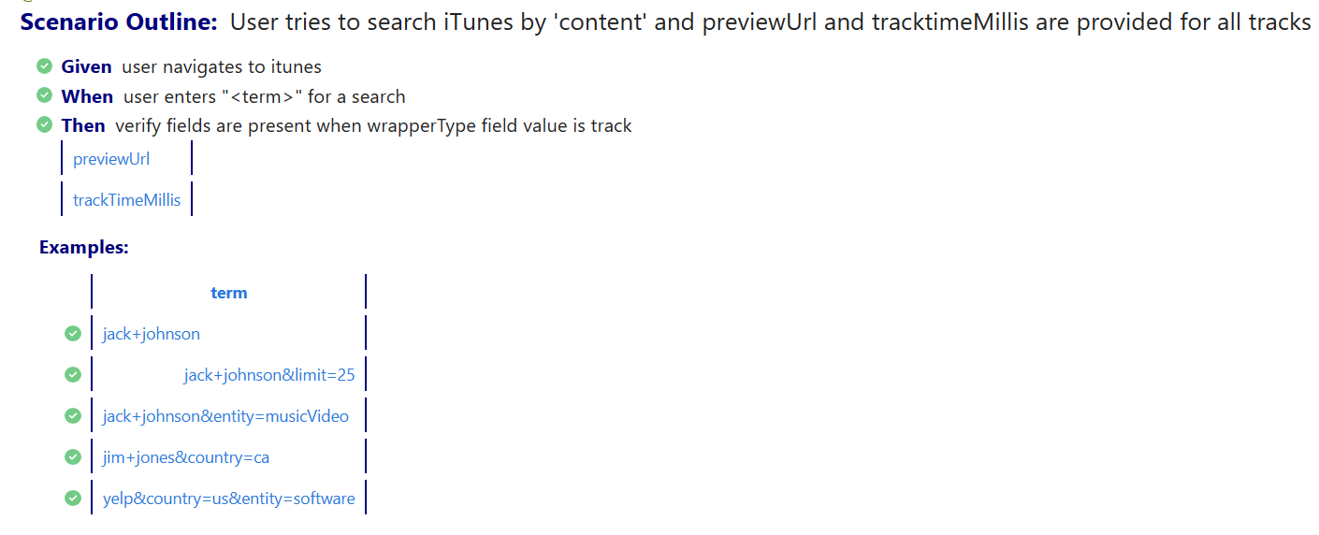

|  |  |  |  |  |  |
| --- | --- | --- | --- | --- | --- |
| **API** | **Scenario** | **Expected** | **Actual** | **Test Status** | **Test case Count** |
| Lookup | result not empty | Result count>0 | Result count>0 | PASSED | 11 |
| Lookup | result not empty | Result count>0 | Result count=0 | FAILED | 1 |

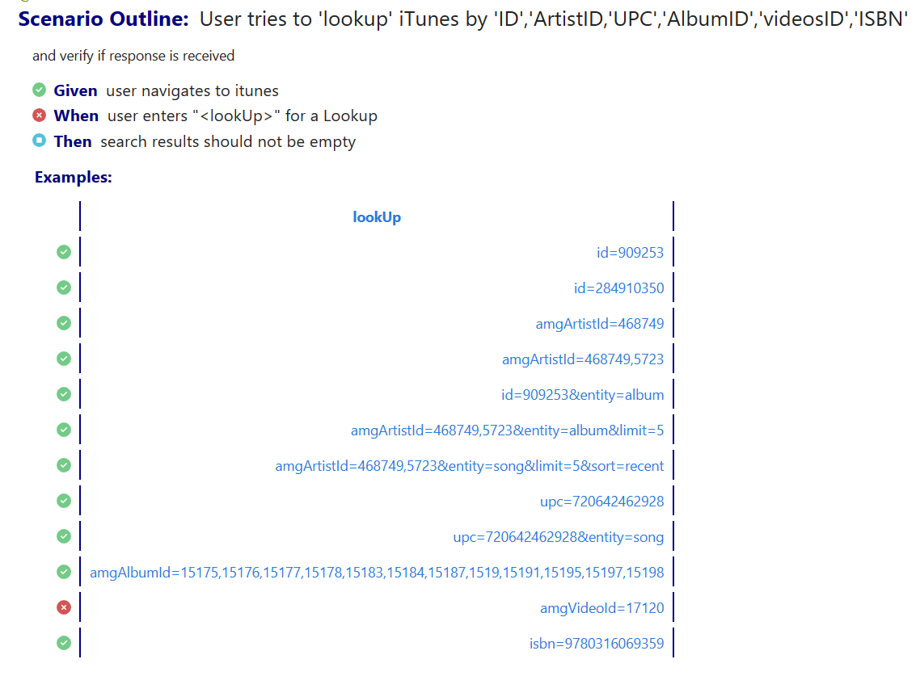

No Search results found: https://itunes.apple.com/lookup?amgVideoId=17120

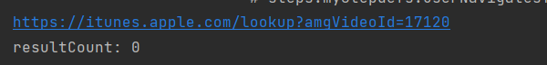

|  |  |  |  |  |  |
| --- | --- | --- | --- | --- | --- |
| **API** | **Scenario** | **Expected** | **Actual** | **Test Status** | **Test case Count** |
| Lookup | View URLs | clickable | clickable | PASSED | 11 |
| Lookup | View URLs | clickable | Non clickable | FAILED | 1 |

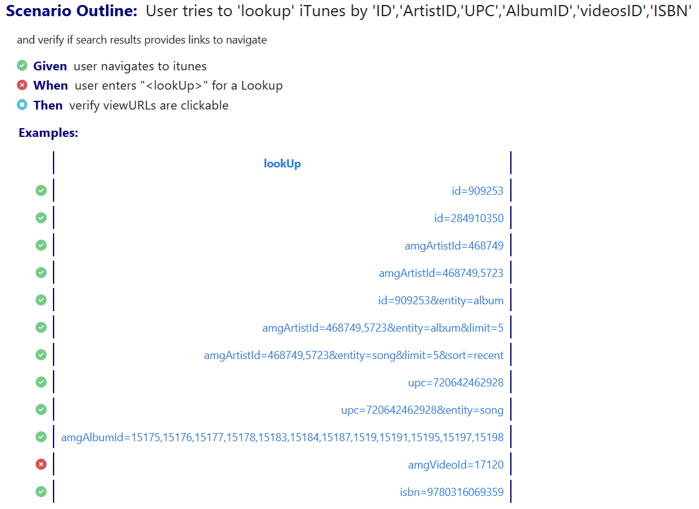

No Search results found: https://itunes.apple.com/lookup?amgVideoId=17120



|  |  |  |  |  |  |
| --- | --- | --- | --- | --- | --- |
| **API** | **Scenario** | **Expected** | **Actual** | **Test Status** | **Test case Count** |
| Lookup | View URLs response time | <3sec | >3sec | PASSED | 11 |
| Lookup | View URLs response time | <3sec | >3sec | FAILED | 1 |

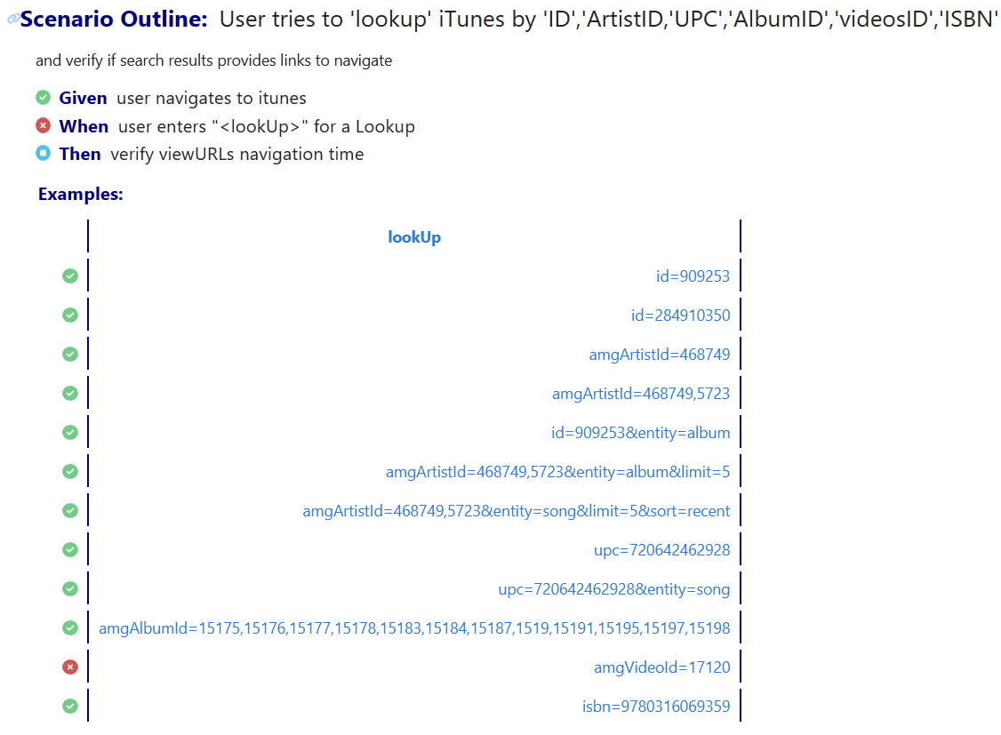

No Search results found: <https://itunes.apple.com/lookup?amgVideoId=17120>



|  |  |  |  |  |  |
| --- | --- | --- | --- | --- | --- |
| **API** | **Scenario** | **Expected** | **Actual** | **Test Status** | **Test case Count** |
| Lookup | View URLs secured | Https | Https | PASSED | 10 |
| Lookup | View URLs secured | Https | Http | FAILED | 2 |

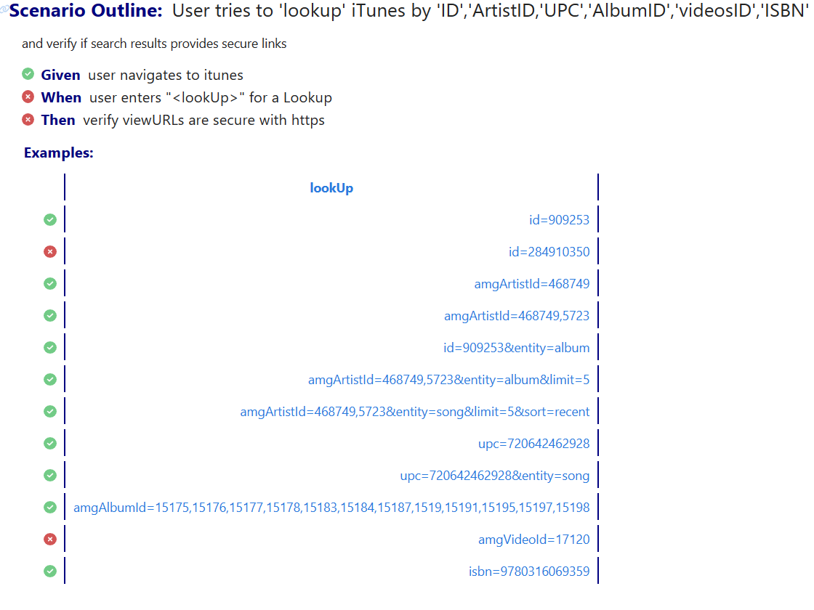

No Search results found: <https://itunes.apple.com/lookup?amgVideoId=17120>



Non secure link <http://www.yelp.com>

