## **SCM - 656 PROJECT MANAGEMENT**

**FINAL PROJECT**

Instructor - Prof. Gary La Point.



**Submitted By:**

**Name:** Archana Deshpande

**SU ID:** 407799908

**Email ID:** [avdeshpa@syr.edu](mailto:avdeshpa@syr.edu)

**EXECUTIVE SUMMARY**

**Executive Summary of the Drumlins Country Club Renovation Project**

**Project Overview:** The Drumlins Country Club Renovation, led by Syracuse University's CPDC team, targets comprehensive upgrades to modernize the club. This renovation encompasses the Bistro, Bar, Restrooms, Locker Rooms, Kitchen, and Mechanical Systems, aiming to enhance aesthetics, functionality, and safety.

**Problem Statement:** Faced with outdated facilities and inefficiencies, the Drumlins Country Club needs an upgrade to align with contemporary standards and member expectations. The project addresses these challenges, aiming to revitalize the club’s appeal and operational efficiency.

**Project Scope:**

* Redesign of the Bistro and Bar for a contemporary look.
* Upgrades to Restrooms and Locker Rooms for improved functionality.
* Kitchen modernization for operational efficiency.
* Overhaul of Mechanical Systems for energy efficiency.
* Ensuring compliance with current building and safety standards.

**Time and Schedule Estimates:**

* **Start Date:** January 2nd.
* **Key Milestones:** Completion of Bistro/Bar, Restrooms/Locker Rooms and Kitchen/Mechanical Systems by end of April.
* **Projected Completion:** Before the next peak season, minimizing operational disruptions.

**Budget and Resources:** The project, approximately budgeted at $250k, will utilize efficient resource management, encompassing skilled labor, quality materials, and modern equipment.

**Stakeholder Involvement:** Managed by Syracuse University’s CPDC and involving key stakeholders like the club’s managing director and the VP of Facilities, the project is set to align with both the club’s operational needs and strategic goals.

**Conclusion:** This renovation represents a pivotal step in enhancing the Drumlins Country Club’s stature. By focusing on modernization and efficiency, the project aims to elevate the club’s status as a top-tier recreational and social hub.

**PROJECT CHARTER**

|  |  |
| --- | --- |
| **PROJECT NAME:**  **RE-MODEL DRUMLINS COUNTRY CLUB** | **PROJECT NUMBER:**  **P001** |
| **PROJECT MANAGER:**  **ARCHANA DESHPANDE** | **PROJECT SPONSOR:**  **PETE SALA** |

|  |
| --- |
| **PROJECT TEAM** |
| The following members will be part of the team to renovate the house:   * Chip Shott * Brenda Murphy * Chef Cooksalot * Dave Fixer * Margarita Rush * Ralph Lauren * John Law * Percy Faith * Architect * Engineer * Contractor * Interior Designer * Technology Specialist * Electricians * HVAC Specialists * Plumber |
| **PROBLEM STATEMENT** |
| To address the aging infrastructure and facilities of Drumlins Country Club while enhancing its amenities and services to meet the evolving needs of members and guests, ensuring a seamless and enjoyable experience. |
| **BUSINESS CASE** |
| To invest in the renovation and upgrade of Drumlins Country Club to increase its attractiveness, competitiveness, and revenue generation potential, aligning with Syracuse University's long-term strategic goals. |
| **HIGH LEVEL SCOPE** |
| The high-level scope requirements for the project include the following:   * Bistro Renovation: Upgrade interior with new flooring, lighting, furniture, and tech enhancements. * Bar Makeover: Replace bar essentials and upgrade decor and tech. * Restroom Overhaul: Modernize with new fixtures, partitions, and aesthetics. * Locker Room Update: Replace lockers, shower fixtures, and improve overall ambiance. * Kitchen Revamp: Upgrade flooring, electricals, and wall finishes. * Mechanical Systems Upgrades: Enhance fire protection, emergency lighting, exterior ventilation, and install new mechanical ventilation systems. |
| **PROJECT GOAL** |
| The goal of the Drumlins Country Club renovation project is to modernize and enhance its key facilities, preserving its original charm, within a specific timeline for completion. |
| **PROJECT OBJECTIVES** |
| From the above defined goal, the following are the objectives that will lead to success of the project:   * Upgrade Bistro with modern décor and technology while maintaining its original ambiance. * Renovate the Bar area, incorporating new design elements and updated technology. * Overhaul Restrooms to meet contemporary standards with new fixtures and design. * Modernize Locker Rooms with new amenities and improved aesthetics. * Remodel the Kitchen with upgraded appliances and infrastructure. * Enhance Mechanical Systems for safety, efficiency, and compliance. * Ensure all renovations respect the club's traditional character and are completed within the designated timeline. |
| **SUCCESS CRITERIA** |
| For the project to be successful, the following criteria should be satisfied:   * Complete electrical upgrades for modern utility requirements. * Ensure all plumbing is compliant with current legal standards. * Upgrade all designated areas including Bistro, Bar, Restrooms, Locker Rooms, and Kitchen with modern amenities. * Maintain the club's traditional character while incorporating modern enhancements. * Adhere to the project timeline, ensuring completion before a specified deadline. * Complete the project within the allocated budget. |
| **ASSUMPTIONS** |
| The following assumptions are made in this project:   * Availability of skilled workers throughout the project duration. * Adequate resources and materials to meet all project objectives. * Favorable weather conditions allowing uninterrupted work. * Timely issuance of all necessary legal permits and approvals by government authorities. * We are assuming that there are only two restrooms and one locker room that are to be redesigned. |
| **RISKS/CONSTRAINTS** |
| The following are the risks/constraints that may affect the project:   * Renovations must adhere to specific styles and designs mandated by local regulations or historical preservation guidelines. * Potential supply chain disruptions, possibly exacerbated by global events like pandemics. * Challenges in obtaining approval from the town board, known for meticulous scrutiny of property development proposals. * Safety risks associated with renovation activities near public areas, particularly sidewalks. * Scarcity of skilled labor, which could lead to delays and impact the project timeline. |
| **STAKEHOLDERS** |
| The following are the stakeholders for the project:   * Project Manager * Club Management or Project Sponsor * Architectural Firm * General Contractor * Interior Designer * Civil/Structural Engineer * Club Members and Patrons * Local Regulatory Bodies (e.g., Town Board) * Neighboring Residents or Businesses * On-site Construction and Renovation Workers |
| **STAKEHOLDER REGISTER** |

|  |  |  |  |  |  |
| --- | --- | --- | --- | --- | --- |
| ID | NAME | CONTACT | CATEGORY | INFLUENCE | INTEREST |
| DRU01 | Project Manager | xxx-xxx-1001 | Internal | High | High |
| DRU02 | Club Management | xxx-xxx-1002 | Internal | High | High |
| DRU03 | Architectural Firm | xxx-xxx-1003 | Internal | High | High |
| DRU04 | General Contractor | xxx-xxx-1004 | Internal | High | High |
| DRU05 | Interior Designer | xxx-xxx-1005 | Internal | Medium | Medium |
| DRU06 | Civil Engineer | xxx-xxx-1006 | Internal | Medium | Medium |
| DRU07 | Club Members | xxx-xxx-1007 | External | Low | High |
| DRU08 | Local Regulatory | xxx-xxx-1008 | External | High | Medium |
| DRU09 | Neighboring Residents/Businesses | xxx-xxx-1009 | External | Low | Low |
| DRU10 | Construction Workers | xxx-xxx-1010 | Internal | Medium | High |
| **ENTERPRISE ENVIRONMENTAL FACTORS** | | | | | | |
| The following are the potential environmental factors that could affect the project:   * Weather Conditions: Seasonal weather changes or extreme conditions could impact construction timelines. * Regulatory Compliance: Adherence to local building codes and environmental regulations. * Market Fluctuations: Post-pandemic market changes affecting material costs and availability. * Safety Standards: Compliance with safety standards for construction equipment and practices. * Community Impact: Effects of renovation activities on local residents and businesses. * Labor Market: Availability of skilled labor in the current economic climate. | | | | | | |
| **ORGANIZATIONAL ASSETS** | | | | | | |
| The following are the organizational assets that could be applied to this project:   * Previous Experience in Club or Hospitality Renovations: Leveraging past project experiences in similar settings. * Skilled Project Management Team: Expertise in managing large-scale renovation projects. * Strong Vendor Relationships: Established connections with suppliers and contractors. * Design and Architectural Resources: Access to historical designs and styles that align with the club's character. * Financial Management Tools: Proven budgeting and financial tracking systems. * Community Relations: Established goodwill and relationships with local authorities and community groups. | | | | | | |
| **EXPERTISE** | | | | | | |
| We might need the following expertise in this project:   * Expertise in specialized construction fields such as carpentry, plumbing, electrical, and masonry for specific renovations. * Professional contractor experience for overall project management and execution. * Skilled project management expertise for planning, execution, and monitoring of the project. * Architectural expertise to ensure design integrity and compliance with historical aspects. * Interior design expertise to enhance the aesthetics while maintaining the club's character. * Expertise in regulatory compliance and permitting for smooth project progression. | | | | | | |
| **DATA/INFORMATION** | | | | | | |
| I would have gathered the following information before the project began:   * Detailed analysis of the club's current infrastructure to identify areas needing renovation. * Information on local building codes and historical preservation requirements. * Club usage patterns and peak times to minimize disruption to members. * Detailed skill assessment of available labor to ensure all tasks can be completed efficiently. * Environmental impact assessment to understand potential project influences on the surrounding area. * Budget forecasts and financial analysis to plan for funding and cost management. | | | | | | |

|  |  |
| --- | --- |
| **PROJECT AUTHORIZATION** | |
| CREATED BY:  ARCHANA DESHPANDE | DATE:  12/15/2023 |
| APPROVED BY: | DATE: |

**PROJECT MANAGEMENT PLAN**

**Project Name: Re-model Drumlins Country Club**

**Project Number: P001**

**Project Manager: Archana Deshpande**

**Project Sponsor: Pete Sala**

**Project Team Members:**

* Chip Shott
* Brenda Murphy
* Chef Cooksalot
* Dave Fixer
* Margarita Rush
* Ralph Lauren
* John Law
* Percy Faith
* Architect
* Engineer
* Contractor
* Interior Designer
* Technology Specialist
* Electricians
* HVAC Specialists
* Plumber

**Project Stakeholders:**

* Project Manager
* Club Management or Project Sponsor
* Architectural Firm
* General Contractor
* Interior Designer
* Civil/Structural Engineer
* Club Members and Patrons
* Local Regulatory Bodies (e.g., Town Board)
* Neighboring Residents or Businesses
* On-site Construction and Renovation Workers

**CHANGE MANAGEMENT PLAN**

**1. Change Request Identification and Submission:**

* All changes, whether related to risks, physical design, budget, or any other aspect, must be formally submitted through a Change Request Form. This form should detail the nature of the change, its rationale, and its anticipated impact on the project.

**2. Initial Review and Classification:**

* Each Change Request will undergo an initial review by the project manager to classify it as minor or major based on its potential impact on the project scope, timeline, or budget.

**3. Detailed Evaluation:**

* For major changes, a detailed evaluation will be conducted. This includes assessing the change's implications on project risks, design, budget, and schedule. Input from relevant stakeholders, such as architects, engineers, and financial analysts, may be required.

**4. Stakeholder Communication:**

* Communicate the proposed change and its implications to all relevant stakeholders, including the project team, club management, and Syracuse University representatives, to gather feedback and insights.

**5. Decision Making:**

* A Change Control Board (CCB), comprising key project stakeholders, will convene to review the change. The CCB will consider the change's necessity, benefits, risks, and overall impact on the project.

**6. Approval or Rejection:**

* The CCB will decide to approve, modify, or reject the change request. The decision will be documented and communicated to all stakeholders.

**7. Implementation:**

* If approved, the change will be incorporated into the project plan. This may involve revising the project scope, schedule, and budget, and issuing new work orders.

**8. Monitoring and Control:**

* The project manager will monitor the implementation of the change to ensure it aligns with the revised plan and objectives. Regular updates will be provided to the stakeholders.

**9. Documentation and Closure:**

* All changes and their impacts on the project will be documented for future reference and analysis. Once implemented, the change request will be formally closed.

**PROJECT SCOPE**

**1. Proposed Scope of the Project:**

* **Overall Objective:** Renovation of the Drumlins Country Club to modernize facilities and enhance user experience.
* **Specific Areas for Renovation:**
  + Bistro and Bar: Upgrade interior design, furniture, and lighting.
  + Restrooms: Remodel with modern fixtures and improved accessibility.
  + Locker Rooms: Redesign for better space utilization and modern amenities.
  + Kitchen: Upgrade equipment and layout for increased efficiency.
  + Mechanical Systems: Overhaul for improved energy efficiency and performance.
* **Infrastructure Improvements:** Enhance electrical, plumbing, and HVAC systems.
* **Safety and Compliance:** Ensure all renovations comply with local building codes and safety standards.
* **Aesthetics and Functionality:** Focus on aesthetic improvements while enhancing functionality of the space.

**2. Scope Management:**

* **Scope Documentation:** Maintain detailed documentation of the project scope, including designs, specifications, and plans.
* **Scope Control Process:**
  + Establish a clear process for managing scope changes, including a formal Scope Change Request form.
  + All scope change requests must be reviewed by the project manager and key stakeholders.
  + Evaluate the impact of proposed changes on the project's timeline, budget, and objectives.
* **Approval of Scope Changes:**
  + Changes to the scope must be formally approved by a designated Change Control Board, comprising representatives from CPDC, club management, and other key stakeholders.
  + Approved changes will be documented, including the details of the change, the rationale, and the impact on the project.
* **Communication of Scope Changes:**
  + Communicate all approved scope changes to the project team and relevant stakeholders.
  + Update project plans, schedules, and budgets to reflect the changes.

**3. Tracking and Documentation:**

* **Version Control:** Use version control for scope documents to track revisions and changes over time.
* **Regular Reviews:** Conduct regular scope reviews to ensure the project stays aligned with the defined scope.
* **Documentation of Revisions:** Document all revisions to the project scope, including the date of change, the nature of the change, and the approving authority.

**REGULATORY**

The regulatory issues related to the Drumlins Country Club renovation project would include the following:

**Relevant Permits:**

* Asbestos abatement permits for removing old asbestos flooring.
* Building permits for structural changes, such as installation or removal of walls and other structures.
* Electrical and plumbing permits for upgrades to the existing systems.

**Authorities for Permits:**

The City of Syracuse or the Town of Onondaga, depending on the jurisdiction of the project site. The specific departments within these municipalities would include the building department, environmental department, and possibly a historic preservation office.

**Zoning and Restrictions:**

1. **Setbacks in Residential Districts:** The ordinance specifies minimum setback requirements for buildings in residential areas. This includes front, side, and rear setbacks, dictating the minimum distance a building must be set back from property boundaries to ensure adequate space and privacy between neighbouring properties.
2. **Height Restrictions:** The document imposes limitations on the height of structures in certain zones. These restrictions are designed to maintain the character of neighbourhoods, ensure safety, and prevent obstructions in views and sunlight.

**Environmental and Historic Conditions:**

1. **Reported Cases of Contamination:** The club had two instances of contamination reported. However, these incidents were effectively managed and resolved.
2. **Minimal Environmental Risk Post-Remediation:** Following the removal of the contamination and closure of the spills in compliance with the New York State Department of Environmental Conservation (NYSDEC) standards, these incidents have been assessed to pose minimal environmental risk to the property

**Location Specifics:**

The project’s location within the City of Syracuse or the Town of Onondaga, or another municipality, would dictate the specific regulatory body to approach for permits and the applicable local regulations.

**Historic District Consideration:**

It is a renowned NY Golf Landmark with a rich history that is filled with indoor and outdoor recreation enjoyed by many Central New Yorkers for the past 95 years! Drumlins Country Club was established in 1926 after Roderick S. Burlingame Sr. purchased the 260-acre Nottingham Farm.

**SCHEDULE MANAGEMENT**

To establish the baseline schedule for the Drumlins Country Club Renovation Project, key activities are defined, sequenced, and their durations estimated to develop a comprehensive project schedule, using MS Project. The schedule includes major milestones such as the completion of Bistro and Bar, Restrooms and Locker Rooms, Kitchen, and Mechanical Systems. It also incorporates regulatory elements like building code compliance deadlines and procurement timelines for materials and services. Fixed dates and milestones are highlighted to emphasize critical paths and deadlines. Any approved changes to the schedule, along with their impact on the overall timeline, are tracked meticulously. The schedule is continually referenced against the Project Management Plan (PMP) for consistency, with revisions and related sections in the PMP updated accordingly to reflect changes. This approach ensures a clear, dynamic, and responsive project schedule that aligns with project objectives and stakeholder expectations.

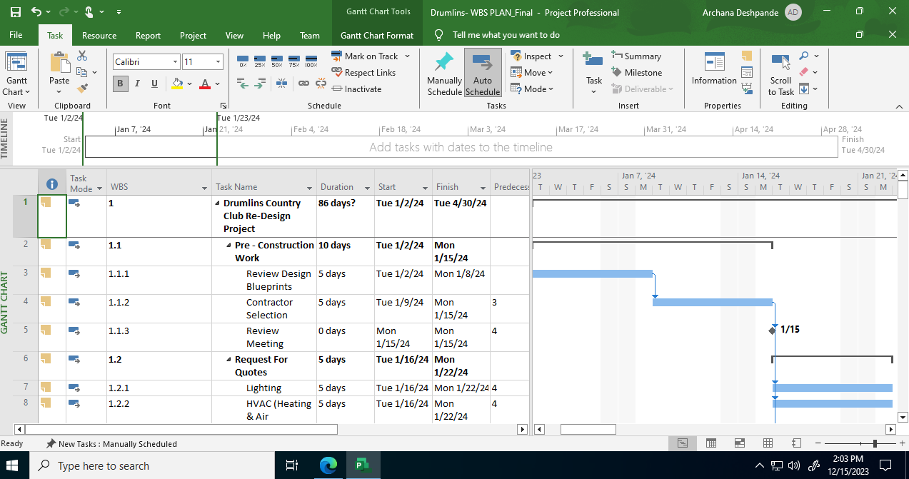

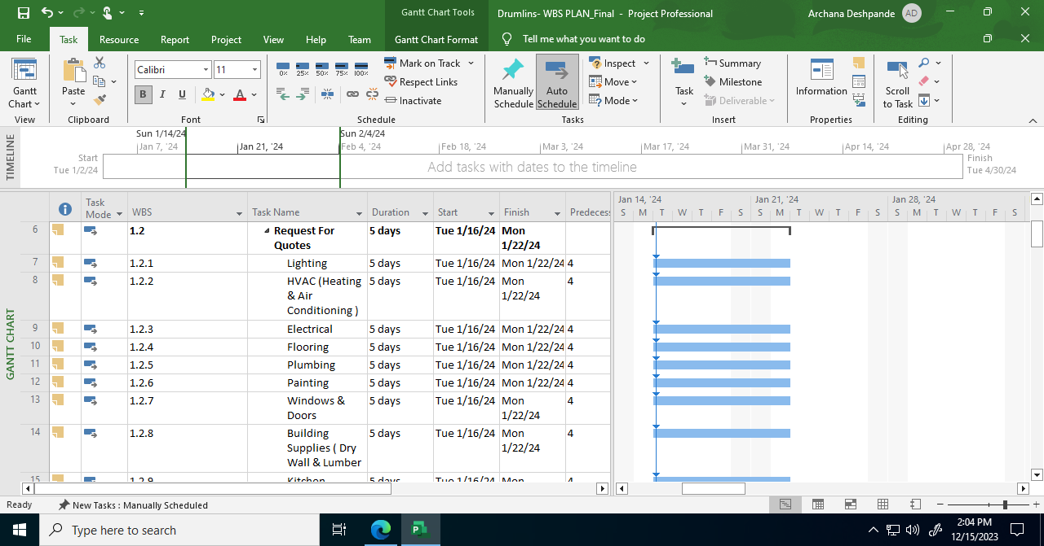

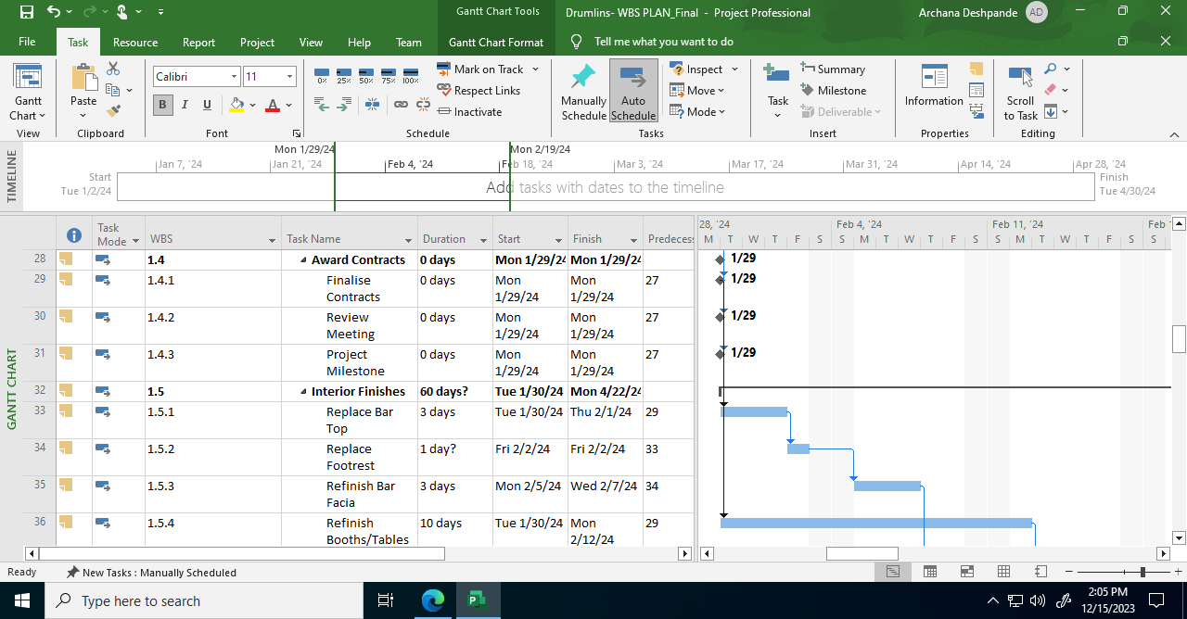

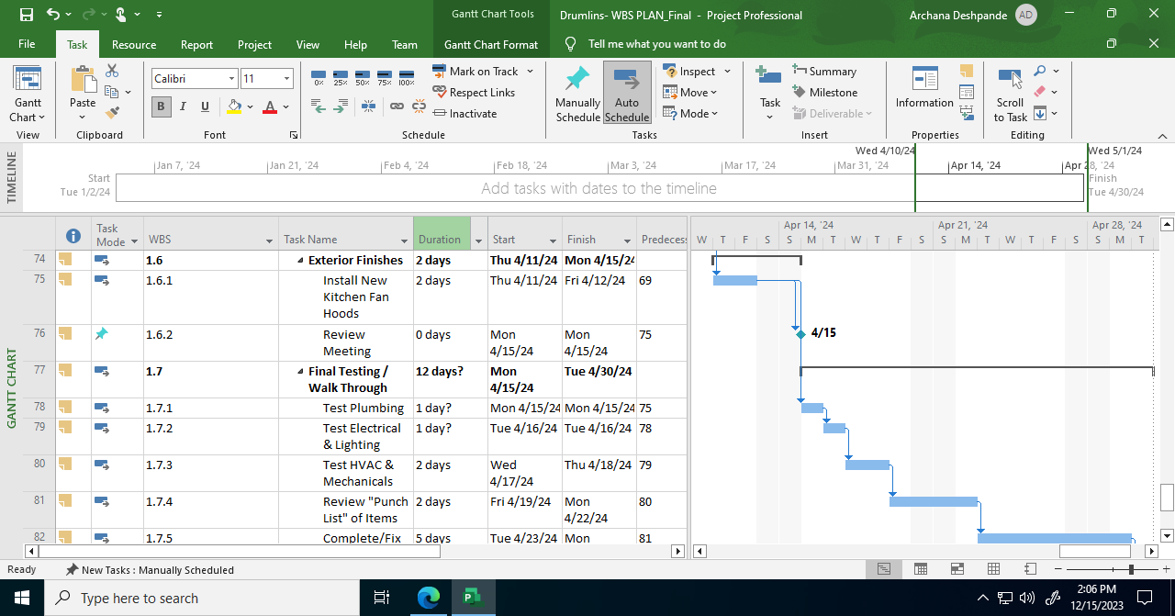

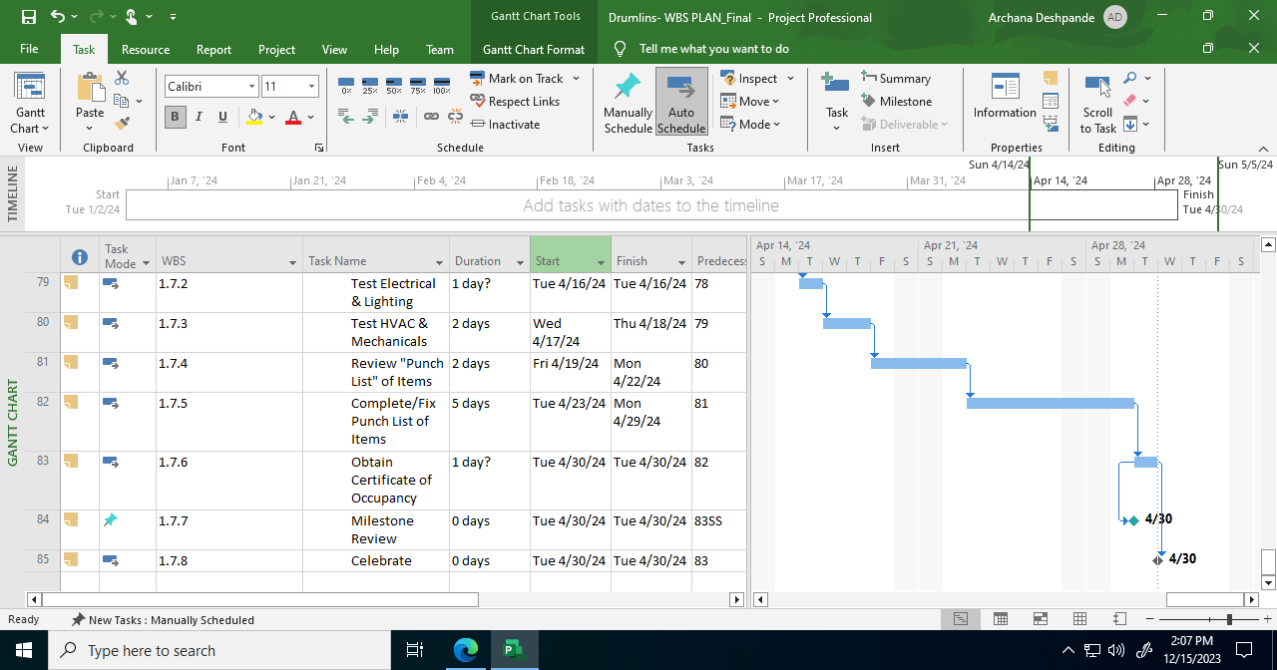

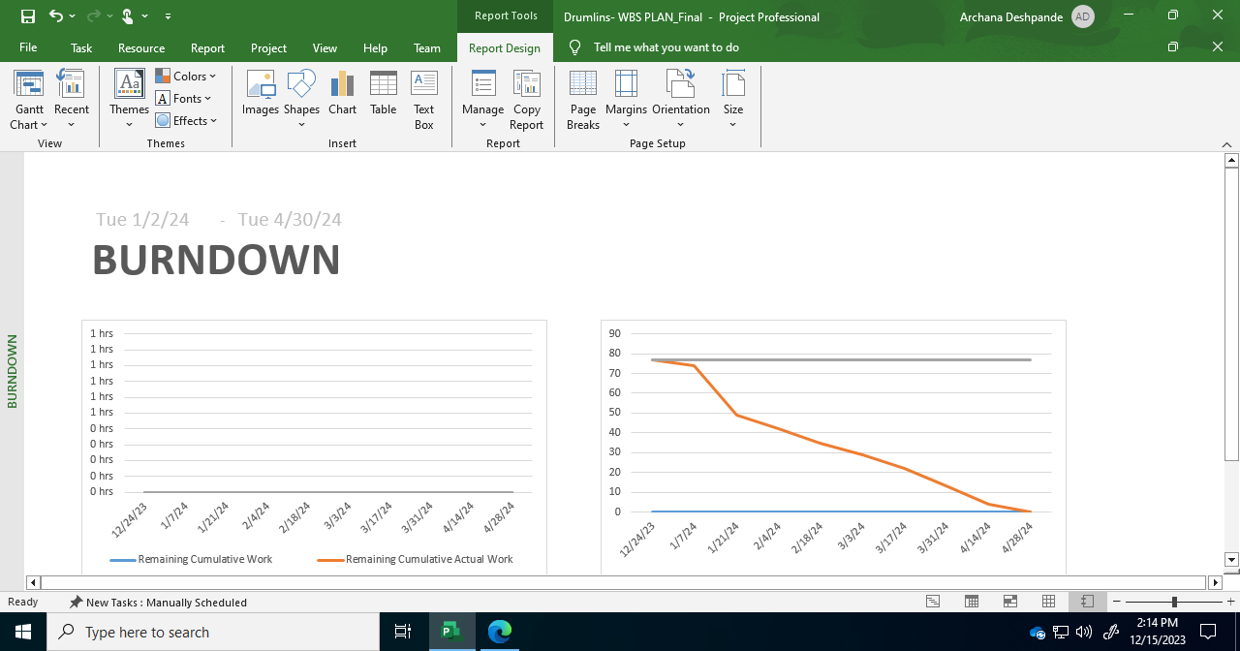

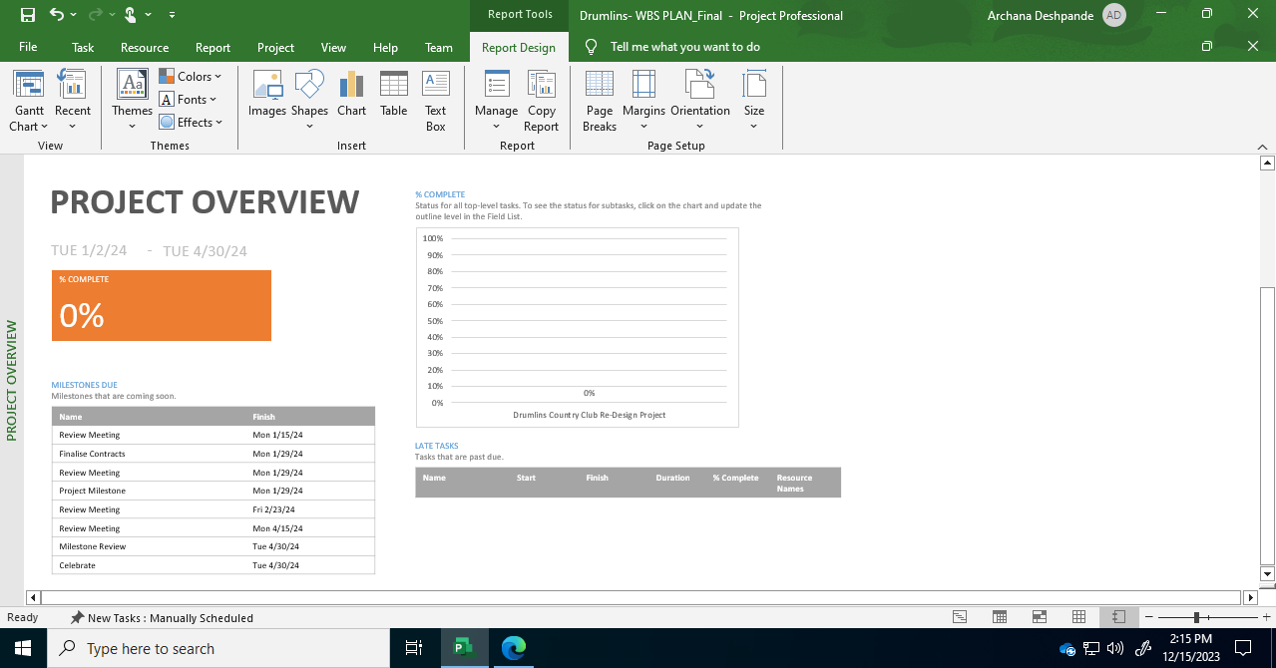

**For more clear view, please refer the MS Project file.**

**BUDGET MANAGEMENT**

For the Drumlins Country Club Renovation Project, cost management involves meticulous tracking against a baseline budget, which represents the initial estimated total cost of the project. Approved changes impacting the budget are carefully accounted for, with adjustments made through contingency funds, management reserves, or additional funding requests as needed. This is meticulously tracked in an owner's budget spreadsheet, which details all expenditures and aligns with the project scope. Change orders are systematically recorded, highlighting any deviations from the baseline budget. These financial updates are regularly cross-referenced with the Project Management Plan (PMP), ensuring that any revisions impacting the project scope, schedule, or resources are accurately reflected. For this capital project, the budget planning also includes listing the planned fiscal years for funding, taking into account any constraints or specific timelines for fund availability, which ensures financial readiness and alignment with organizational fiscal policies. This comprehensive approach to budget management ensures financial transparency, accountability, and effective resource allocation throughout the project lifecycle. The initial project cost was estimated to be $250k.

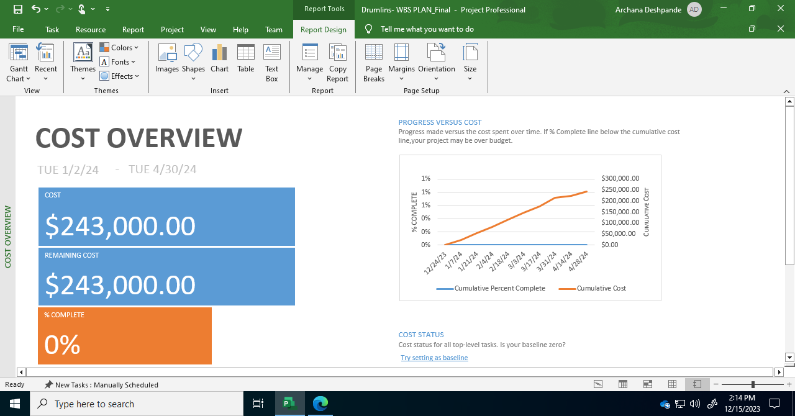

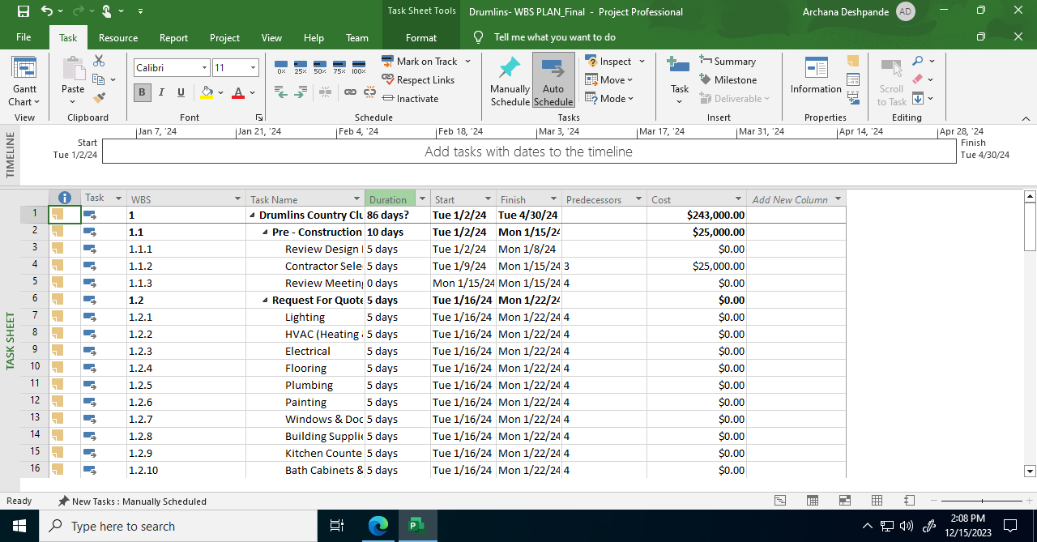

**QUALITY CONTROL PLAN**

A quality control plan is a comprehensive document that outlines the processes and standards for ensuring the quality of a project's deliverables. It defines quality objectives, roles and responsibilities, quality control measures, and methods for continuous improvement, all aimed at meeting or exceeding customer expectations and project requirements.

|  |  |  |  |  |  |
| --- | --- | --- | --- | --- | --- |
| **Task** | **Allocated Workers** | **Objective** | **Highest Quality** | **Better Quality** | **Basic Quality** |
| **Design Review Process** | CPDC Staff, Architects, Engineers | Align design with project objectives and aesthetics | Multi-stage review with comprehensive feedback | Initial and final reviews only | Basic design compliance check |
| **Document Distribution and Approvals** | Project Manager, Architects, Engineering Leads | Ensure access to and approval of design documents | Structured distribution with formal approvals | Efficient document distribution | Standard distribution |
| **Special Inspectors and Commissioning** | Accredited Inspectors and Commissioning Agents | Oversee critical construction aspects | Intensive inspection and commissioning | Regular inspections | Basic inspection |
| **Adherence to Standards and Codes** | Project Team | Comply with building codes and best practices | Strict and updated adherence to codes | General compliance with codes | Basic code compliance |
| **Construction Administration Services** | CA Service Providers | Ensure construction adheres to design and quality | Comprehensive administration and communication | Efficient project oversight | Basic construction oversight |
| **Submittal Review Process** | Contractors, Project Managers | Ensure materials and systems meet requirements | Rigorous review and approval process | Detailed review and approval | Basic review and approval |
| **Collaboration with CPDC and Services** | CPDC Staff, Facilities Services, Orange Automation | Align project with institutional standards and practices | Regular, collaborative review meetings | Scheduled review meetings | Basic coordination meetings |
| **Continuous Monitoring and Reporting** | Project Management Team | Ensure compliance with the quality plan | Continuous on-site monitoring | Regular quality control reporting | Basic compliance checks |
| **Feedback and Improvement** | All Team Members | Enhance quality control practices | Continuous improvement based on detailed feedback | Implementation of feedback for improvement | Basic feedback consideration |

**RESOURCE PLAN**

For the Drumlins Country Club Renovation Project, an effective Resource Plan is essential to ensure that all necessary resources are identified, allocated, and managed efficiently. Here's a suggested Resource Plan:

**1. Consultant Architectural and Engineering (AE) Services:**

* Responsibilities: Provide expert design services, including architectural, structural, and MEP (Mechanical, Electrical, Plumbing) engineering.
* Resource Allocation: Selection of experienced and reputable consultant AE firms through a competitive bidding process.
* Stakeholder Involvement: The CPDC staff to oversee the selection and management of the AE consultant services.

**2. In-House Architectural and Engineering Services:**

* Responsibilities: Support the consultant AE in design development, ensure compliance with university standards, and provide local knowledge and expertise.
* Resource Allocation: Assign in-house architects and engineers based on their expertise in relevant areas.
* Stakeholder Involvement: Facilities Services to provide necessary support and coordination.

**3. Physical Plant/General Contractor/Construction Manager (GC/CM):**

* Responsibilities: Oversee all construction activities, manage subcontractors, ensure project is on schedule, and maintain safety on site.
* Resource Allocation: Selection of a qualified GC/CM through a bidding process, considering experience in similar projects.
* Stakeholder Involvement: CPDC staff to monitor the performance of the GC/CM, ensuring adherence to project specifications.

**4. Material:**

* Responsibilities: Procurement of all necessary materials as per the project specifications and design.
* Resource Allocation: The GC/CM, in coordination with the AE team, to manage the procurement and delivery of materials, ensuring quality and timeliness.
* Stakeholder Involvement: Regular updates to CPDC staff and the project manager on material procurement status.

**5. Equipment:**

* Responsibilities: Provide all necessary equipment for construction, including heavy machinery, tools, and safety equipment.
* Resource Allocation: The GC/CM to arrange for the rental or purchase of equipment, ensuring availability and operational condition.
* Stakeholder Involvement: Facilities Services to assist in coordinating access and logistics for equipment delivery and usage on site.

**6. Stakeholder Responsibilities and Limitations:**

* Syracuse University, through its CPDC, is responsible for providing overall funding for the project
* Regular financial and progress reporting to stakeholders to ensure transparency and accountability.
* Limitations such as budget constraints, resource availability, and institutional policies should be clearly communicated and managed.

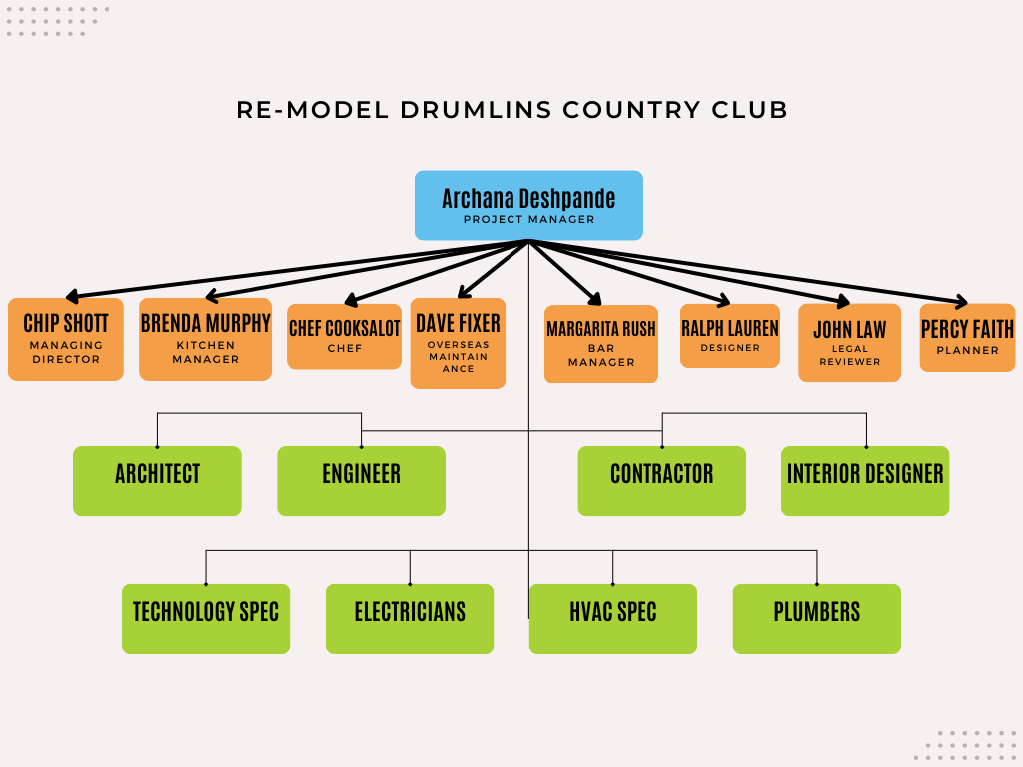

**FLOWCHART OF THE TEAM MEMBERS/STAKEHOLDERS**

**RACI CHART:**

A RACI chart, often referred to as a Responsibility Assignment Matrix, is a visual tool used in project management and organizational planning. It serves to clarify roles and responsibilities within a project or a business process.

In our RACI chart for the Drumlins Country Club renovation project, we can say that:

**R (Responsible):** Individuals or roles assigned as "R" are the ones accountable for completing specific tasks or activities. This is represented by color **blue** in our chart.

**A (Accountable):** The "A" designates the individual who is ultimately answerable for the successful completion of the task or activity. This is represented by color **purple** in our chart.

**C (Consulted):** Those marked as "C" are the people who provide input, advice, or expertise regarding the task but do not bear direct responsibility for its execution. This is represented by color **green** in our chart.

**I (Informed):** "I" indicates individuals or roles that need to be kept in the loop and informed about the task's progress or completion. This is represented by color **red** in our chart.

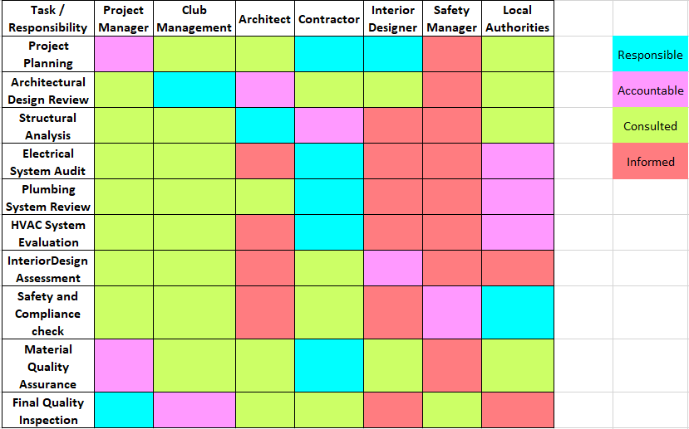

**COMMUNICATION PLAN**

A communication plan is a structured strategy outlining how information is shared within an organization or project. It defines key stakeholders, channels, messages, and timing, ensuring effective, clear, and timely communication. By fostering transparency and alignment, it enhances collaboration and supports the achievement of project goals and objectives.

|  |  |  |
| --- | --- | --- |
| **Stake Holders** | **Communication Method** | **Purpose** |
| **Project Manager** | Face to Face | Overall Project Coordination |
| **Club Management** | Zoom Video Call | Strategic Decisions, Approvals |
| **Architectural Firm** | Email | Design Feedback, Updates |
| **General Contractor** | Face to Face | Operational Updates, Issue Resolution |
| **Club Members** | Email | Progress Updates, Feedback |
| **Local Regulatory Bodies** | Email or Call | Compliance, Permits |
| **Suppliers** | Call | Order Management, Logistics |
| **Interior Designer** | Zoom Video Call | Design Discussions |
| **Neighboring Residents** | Community Meeting | Impact Communication, Feedback |
| **Construction Workers** | Face to Face | Daily Briefings, Safety |
| **Financial Stakeholders** | Email | Budget Reports, Financial Updates |
| **Safety Inspectors** | Face to Face | Compliance Checks, Reports |
| **Legal Advisors** | Call | Legal Consultations, Risk Management |
| **Marketing Team** | Email | Marketing Strategies, Member Communications |
| **IT Support Team** | Email or Call | Technology Integration, Support |

**RISK MANAGEMENT PLAN**

A risk management plan is a strategic document that identifies, evaluates, and mitigates potential risks in a project or business operation. It outlines processes for risk assessment, response strategies, and monitoring to minimize the impact of adverse events, ensuring that the project or business remains on track and achieves its objectives.

The risk management strategy has identified the following dangers:

|  |  |  |  |  |
| --- | --- | --- | --- | --- |
| **Risk Identified** | **Likelihood** | **Impact** | **Mitigation Plan** | **Contingency Plan** |
| Asbestos removal complications | High | Severe | Engage certified abatement professionals, conduct regular air quality tests | Set up an alternative work plan to continue project in other areas |
| Electrical system non-compliance | Medium | High | Pre-inspection by a licensed electrician, upgrade plans to meet codes | Have backup electricians and additional budget for unexpected work |
| Plumbing failures during renovation | Medium | Moderate | Schedule inspections, ensure contingency in the budget for unexpected issues | Arrange for alternate plumbing contractors |
| Delays due to permit acquisition | High | High | Early application, hire a permit expediter, keep open communication with authorities | Utilize other project areas while waiting for permits |
| Budget overruns | Medium | Severe | Implement strict financial controls, regular budget reviews | Secure additional funding sources or scale back project scope |
| Historical preservation restrictions | Low | High | Consult with historical societies, plan for compliance from the start | Alternate design plans that comply with historical standards |
| Environmental regulations breach | Low | Severe | Conduct an environmental impact assessment, follow best practices for sustainability | Engage environmental consultants for immediate remediation |
| Insufficient staffing | High | Moderate | Develop a robust hiring plan, include clauses in contracts for timely hiring | Partner with staffing agencies for quick hires |
| Schedule delays | High | High | Develop a detailed project schedule with buffers, closely monitor progress | Implement accelerated work schedules or shift project focus |

**PROCUREMENT PLAN**

A procurement plan is a strategic document outlining the approach and methods for acquiring goods, services, or resources necessary for a project or organization. It encompasses the entire procurement process, from defining needs and identifying suppliers to evaluating proposals, negotiating contracts, and monitoring performance. The plan details procurement objectives, budgets, and schedules, as well as risk assessments and legal considerations. It ensures efficient resource allocation, cost control, and compliance with regulations. A well-structured procurement plan is essential for minimizing risks, optimizing vendor selection, and ultimately, achieving project or organizational goals while maintaining transparency and accountability in the procurement process.

A Procurement Plan is a strategic tool used to determine the necessary resource acquisitions based on documents such as Requests for Proposal (RFP), Requests for Quote (RFQ), or Requests for Information (RFI).

It outlines the specific resources and materials required for the successful execution of the project.

|  |  |  |  |  |
| --- | --- | --- | --- | --- |
| **Procurement Aspect** | **Method** | **Items or Services to Procure** | **Contracts** | **Preferred Procurement Control Method** |
| Electrical Systems | Requests for Proposal (RFP) | Wiring, Panels, Outlets | Fixed-Price | Milestone Reviews |
| Plumbing Services | Requests for Quote (RFQ) | Pipes, Fixtures | Time & Materials | Performance Monitoring |
| Construction Materials | Requests for Information (RFI) | Lumber, Concrete, Paint | Cost-Reimbursable | Budget Control |
| Interior Design Services | Requests for Proposal (RFP) | Design Consultation, Furnishings | Fixed-Price | Quality Assurance |
| Architectural Services | Requests for Quote (RFQ) | Blueprint Development, Consulting | Fixed-Price | Scope Verification |
| Landscaping Services | Requests for Information (RFI) | Plants, Landscape Design | Cost-Reimbursable | Environmental Compliance |
| HVAC System Installation | Requests for Proposal (RFP) | Heating, Ventilation, AC Units | Fixed-Price | Energy Efficiency Standards |
| Technology Installations | Requests for Quote (RFQ) | Security Systems, Networking | Time & Materials | Technical Specifications |
| Furniture and Decor | Requests for Information (RFI) | Tables, Chairs, Decorative Elements | Cost-Reimbursable | Aesthetic Consistency |

**MONITOR & CONTROL PHASE**

In the Monitor and Control phase of the Drumlins Country Club Renovation Project, various activities and functions are performed to ensure the project stays on track, adheres to its planned scope, schedule, and budget, and maintains quality standards. Here's an outline of how progress would be monitored and controlled:

**Monitoring Activities:**

1. **Regular Status Meetings:**
   * Conduct weekly or bi-weekly status meetings with the project team to review progress, discuss issues, and update tasks.
   * Monthly meetings with key stakeholders to present high-level progress and receive feedback.
2. **Performance Tracking:**
   * Use project management tools to track task completion, milestones, and deliverable statuses against the project plan.
3. **Budget Monitoring:**
   * Regularly review expenditures against the budget.
   * Identify and analyse variances and take corrective actions if necessary.
4. **Quality Checks:**
   * Conduct ongoing quality inspections of the work completed.
   * Ensure compliance with project specifications and standards.
5. **Risk Management:**
   * Continuously identify and assess new risks.
   * Monitor the effectiveness of risk response strategies and adjust as needed.

**Reporting Functions:**

1. **Status Reports:**
   * Create weekly or bi-weekly status reports detailing completed tasks, upcoming tasks, issues, and risks.
   * Include visual aids like Gantt charts or dashboards for a quick overview of project progress.
2. **Variance Reports:**
   * Prepare monthly variance reports comparing actual progress and expenditures against the project plan and budget.
   * Highlight any significant variances in schedule or cost, along with reasons and proposed corrective actions.
3. **Quality Reports:**
   * Issue quality reports post each major inspection or milestone, documenting the results of quality checks and any non-compliance issues.
4. **Risk Reports:**
   * Update the risk register and provide regular reports on the status of risks, including any new risks identified and the effectiveness of mitigation strategies.
5. **Stakeholder-Specific Reports:**
   * Tailor reports for different stakeholder groups to provide relevant information. For instance, financial reports for budgetary stakeholders and detailed progress reports for the project team.

**Tools and Techniques:**

* **Project Management Software:** Utilize software like MS Project or similar for tracking tasks, timelines, and resources.
* **Dashboard Tools:** Implement dashboard tools for real-time monitoring of project metrics.
* **Document Management System:** Use a system to store, manage, and easily retrieve project documents and reports.

The Monitor and Control phase is critical for the successful delivery of the project as it ensures that any deviations from the plan are identified early and addressed promptly to keep the project on course.

**CLOSEOUT PLAN**

The Close Out Phase of the Drumlins Country Club Renovation Project involves finalizing all project activities, ensuring all objectives have been met, and formally concluding the project. A detailed Closeout Plan is essential for a smooth transition from the project execution phase to the operation of the renovated facilities. Here's an outline for the Closeout Plan:

1. **Project Completion Confirmation:**
   * Conduct a thorough final inspection of all renovation areas to confirm that all work has been completed as per the project scope and quality standards.
   * Obtain necessary approvals and sign-offs from relevant authorities, including building inspectors and Syracuse University representatives.
2. **Financial Closure:**
   * Finalize all accounts, ensuring all invoices have been processed and paid.
   * Review the final budget, comparing actual expenses against the planned budget and documenting any variances.
3. **Contract Closure:**
   * Complete all contractual obligations with contractors, suppliers, and consultants.
   * Secure warranties and guarantees for work completed and materials used.
4. **Documentation and Record Keeping:**
   * Compile a project documentation package, including design drawings, contracts, change orders, inspection reports, and approvals.
   * Archive all project documents in a centralized document management system for future reference.
5. **Lessons Learned and Knowledge Transfer:**
   * Conduct a lesson learned session with the project team to document what went well and what could be improved for future projects.
   * Prepare a project closure report summarizing the project’s performance, including successes, challenges, and key learnings.
6. **Stakeholder Communication:**
   * Communicate the completion of the project to all stakeholders, including club management, Syracuse University, and club members.
   * Provide a final project report summarizing the outcomes and benefits of the renovation.
7. **Asset Handover:**
   * Officially hand over the renovated areas to the Drumlins Country Club management for regular operation.
   * Transfer all relevant documentation and manuals related to new installations and upgrades.
8. **Post-Project Review:**
   * Conduct a post-project review meeting with key stakeholders to evaluate the overall success of the project against its objectives.
9. **Release of Project Resources:**
   * Release project resources, including disbanding the project team and returning any rented equipment or facilities.
10. **Celebration and Acknowledgment:**
    * Organize an event to celebrate the successful completion of the project and acknowledge the contributions of the team, contractors, and stakeholders.

**Specific Documents to Include:**

* Final Inspection Reports
* Final Budget and Financial Closure Report
* Project Closure Report
* Lessons Learned Document
* Warranty and Guarantee Documents
* Asset Handover and Acceptance Forms

This Closeout Plan ensures that the Drumlins Country Club Renovation Project is concluded systematically, with all aspects properly documented and communicated, setting a strong foundation for the club's successful operation post-renovation.