**HBASE- HIVE CONNECT Assignment:**

1. Data set

🡺Sales_order_data.csv

1. Create Hbase table:

create 'order_sales','order','sales','product','address','contact'

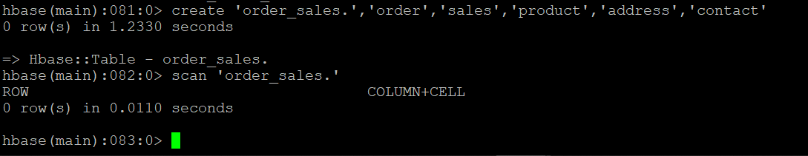

1. Create Hive table:

CREATE EXTERNAL TABLE IF not exists hive_order_sales

(

key int,QUANTITYORDERED int,

PRICEEACH int,

ORDERLINENUMBER int,

SALES int,

STATUS string,

QTR_ID int,

MONTH_ID int,

YEAR_ID int,

PRODUCTLINE string,

MSRP int,

PRODUCTCODE string,

PHONE string,

CITY string,

STATE string,

POSTALCODE int,

COUNTRY string,

TERRITORY string,

CONTACTLASTNAME string,

CONTACTFIRSTNAME string,

DEALSIZE string

)

ROW FORMAT DELIMITED

FIELDS TERMINATED BY ','

STORED BY 'org.apache.hadoop.hive.hbase.HBaseStorageHandler'

WITH SERDEPROPERTIES

("hbase.columns.mapping"=":key,order:QUANTITYORDERED,order:PRICEEACH,order:ORDERLINENUMBER,sales:SALES,sales:status,sales:qtr_id,sales:month_id,sales:year_id,product:PRODUCTLINE,product:MSRP,product:PRODUCTCODE,address:phone,address:CITY,address:STATE,address:POSTALCODE,address:COUNTRY,address:TERRITORY,contact:CONTACTLASTNAME,contact:CONTACTFIRSTNAME,contact:DEALSIZE")

TBLPROPERTIES("hbase.table.name"="order_sales");

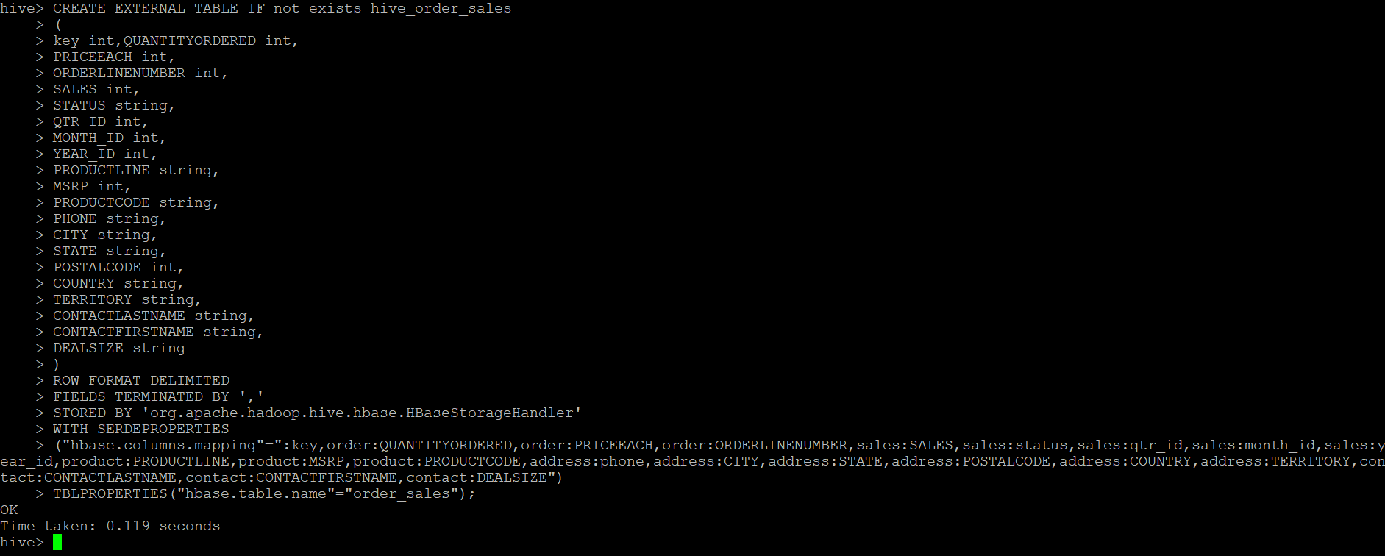

1. Create Hive stage table

CREATE EXTERNAL TABLE IF not exists hive_Stg_order_sales(

key int,

QUANTITYORDERED int,

PRICEEACH int,

ORDERLINENUMBER int,

SALES int,

STATUS string,

QTR_ID int,

MONTH_ID int,

YEAR_ID int,

PRODUCTLINE string,

MSRP int,

PRODUCTCODE string,

PHONE string,

CITY string,

STATE string,

POSTALCODE int,

COUNTRY string,

TERRITORY string,

CONTACTLASTNAME string,

CONTACTFIRSTNAME string,

DEALSIZE string

)

ROW FORMAT DELIMITED

FIELDS TERMINATED BY ','

tblproperties("skip.header.line.count" = "1");

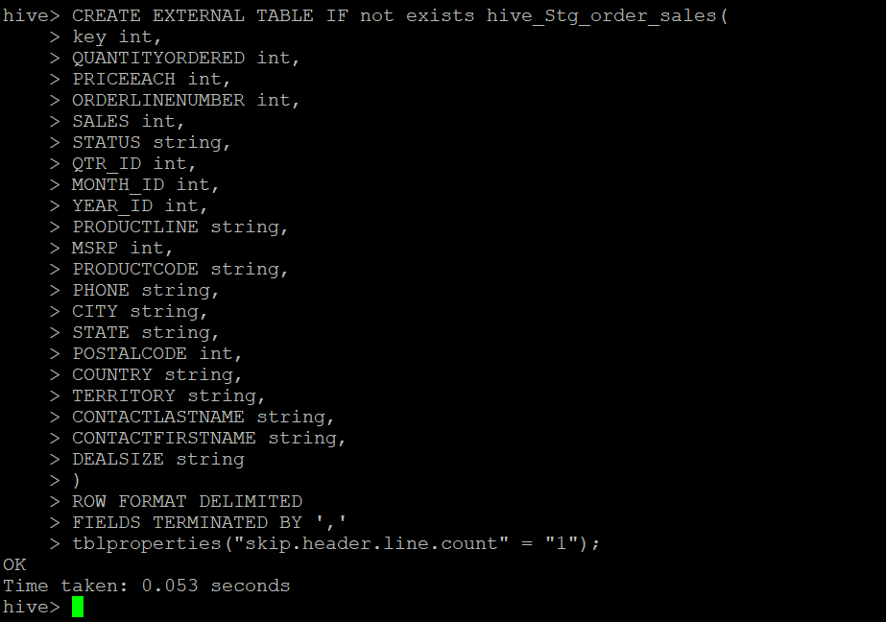

1. Loading the data into a stage table.

Load data local inpath '/home/cloudera/sales_order_data.csv' into table hive_Stg_order_sales;

select * from hive_Stg_order_sales limit 1;

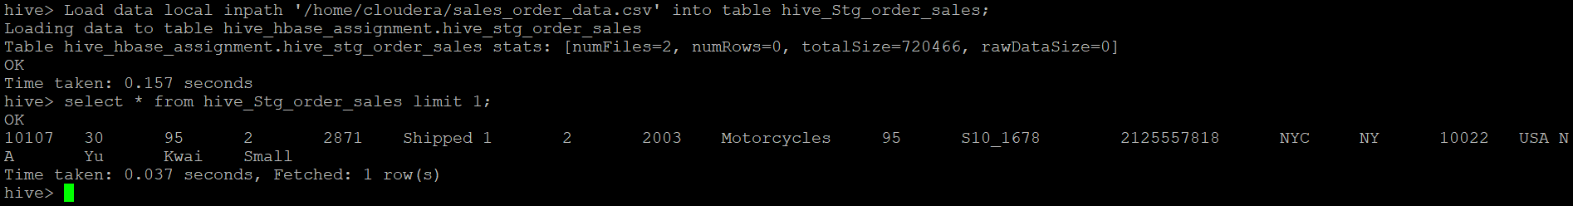

1. Insert the data from stage table to main hive table

insert into table hive_order_sales select * from hive_Stg_order_sales;

Select * from hive_order_sales limit 1;

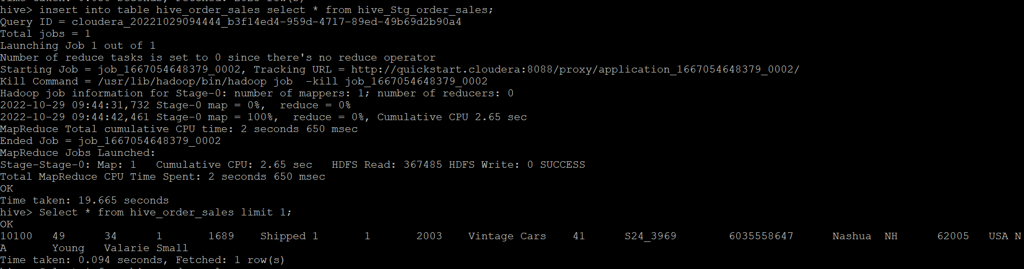

1. Put the data into the hbase table.

put 'order_sales' , '1', 'order:QUANTITYORDERED', '10'

put 'order_sales' , '1', 'order:PRICEEACH', '1000'

put 'order_sales' , '1', 'order:ORDERLINENUMBER', '7'

put 'order_sales' , '1', 'sales:SALES', '1434'

put 'order_sales' , '1', 'sales:STATUS', 'In Process'

put 'order_sales' , '1', 'sales:QTR_ID', '4'

put 'order_sales' , '1', 'sales:MONTH_ID', '6'

put 'order_sales' , '1', 'sales:YEAR_ID', '2008'

put 'order_sales' , '1', 'product:PRODUCTLINE','Trucks'

put 'order_sales' , '1', 'product:MSRP','200'

put 'order_sales' , '1', 'product:PRODUCTCODE','S50_1392'

put 'order_sales' , '1', 'address:phone','40.67.8555'

put 'order_sales' , '1', 'address:CITY','mainpuri'

put 'order_sales' , '1', 'address:STATE','UP'

put 'order_sales' , '1', 'address:POSTALCODE','201551'

put 'order_sales' , '1', 'address:COUNTRY','FRANCE'

put 'order_sales' , '1', 'address:TERRITORY','EMEA'

put 'order_sales' , '1', 'contact:CONTACTLASTNAME','Labrune'

put 'order_sales' , '1', 'contact:CONTACTFIRSTNAME','Janine'

put 'order_sales' , '1', 'contact:DEALSIZE','Small'

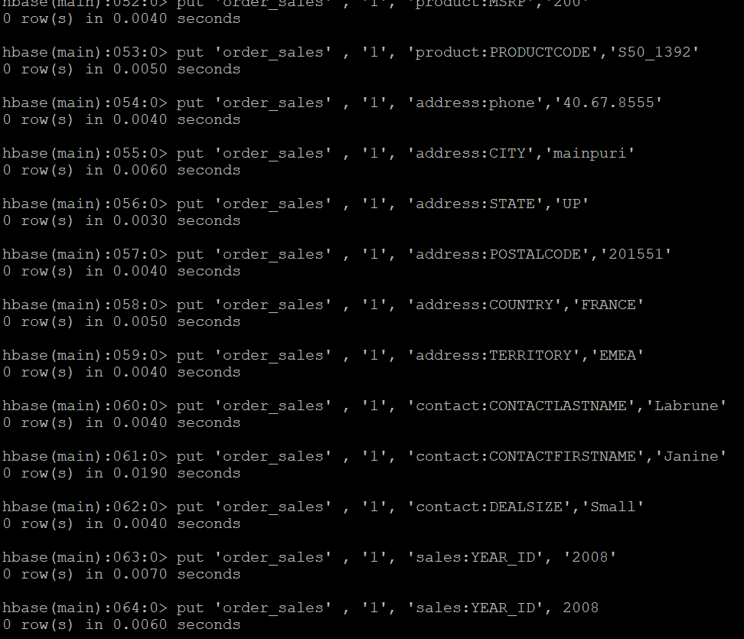

🡺Data in HBASE table after PUT

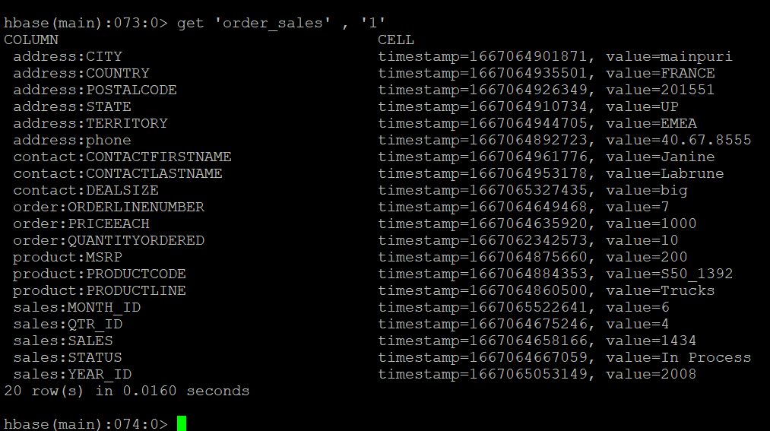

🡺Data in HIVE table after putting the data in HBASE table

