**HIVE MINI PROJECT : 3**

**Description:**

This is a project which is created in hive. The project was to create and maintain a database for candidate enrollment where they provide training for various courses .

In this project we have created five tables. We have performed various operations in this project like table join , partitioning, Clustering, insertion etc. We have also performed queries in in tables where we extracted the data from it.

**🡺Create a Table Enquiry**

create table enquiry_txts(id int,name string,mail STRING,mob BIGINT,course STRING,fee INT,discount INT,dte STRING,status STRING,status_final STRING)

row format delimited

fields terminated by ','

stored as textfile;

**🡺Create ORC table with partitioning and clustering**

create table enquiry

(

id INT,

name STRING,

mail STRING,

mob BIGINT,

course STRING,

fee INT,

discount INT,

dte STRING,

status STRING

)Partitioned by (status_final string)

clustered by (id) sorted by (id) into 2 buckets

ROW FORMAT DELIMITED

FIELDS TERMINATED BY ','

stored as orc;

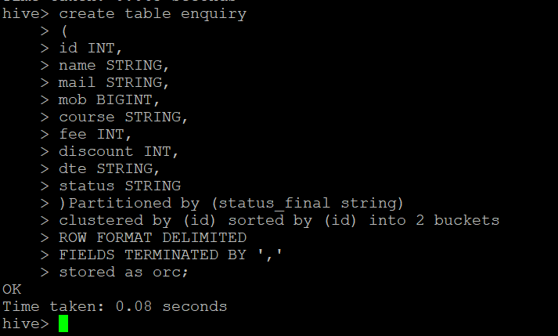

**🡺Load tha Data into tables:**

load data local inpath '/home/cloudera/hive_assignment3/Enquiry.csv' into table enquiry_txt;

set hive.exec.dynamic.partition.mode=nonstrict;

insert into table enquiry partition(status_final) select id,name,mail,mob,course,fee,discount,dte,status,status_ﬁnal from enquiry_txt;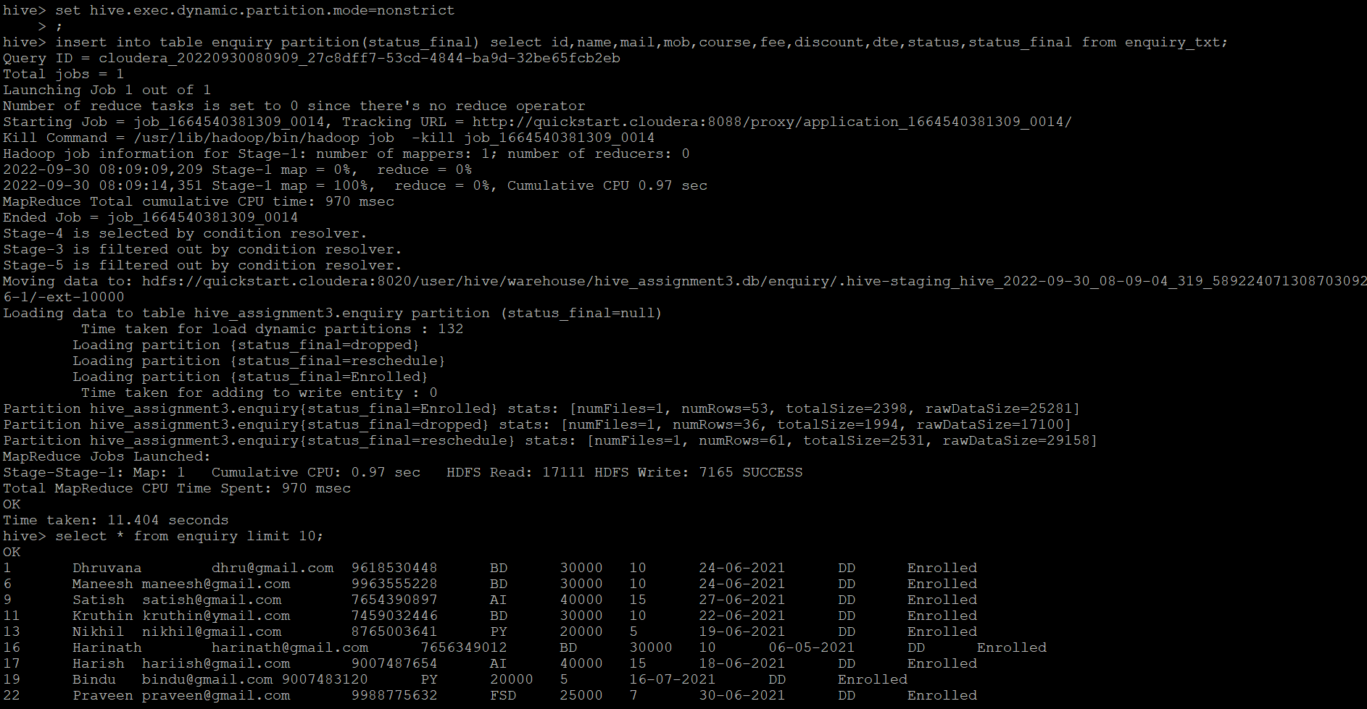

**🡺DEMO_SCHECULE Table**

create table demo_schedule(id INT,name STRING,mail STRING,mob BIGINT,course STRING,demoday STRING,day STRING,dte string,time STRING)

row format delimited

fields terminated by ','

stored as textfile;

**🡺Load the Data in table:**

LOAD DATA LOCAL INPATH '/home/cloudera/hive_assignment3/Demo_Schedule.csv' INTO TABLE demo_schedule;

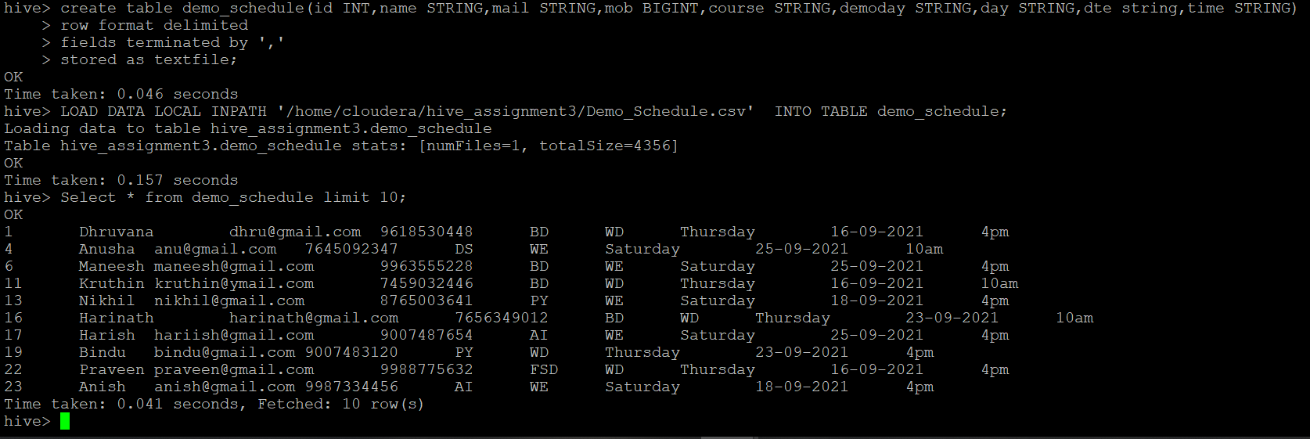

**🡺DEMO MISSED Table:**

create table demo_missed(id int,name string,mail string,mob bigint,course string,reschedule_date string,time string)

row format delimited

fields terminated by ','

lines terminated by '\n'

stored as textfile;

**🡺Load Data into Table**

LOAD DATA LOCAL INPATH '/home/cloudera/hive_assignment3/demo_missed.csv' INTO TABLE demo_missed;

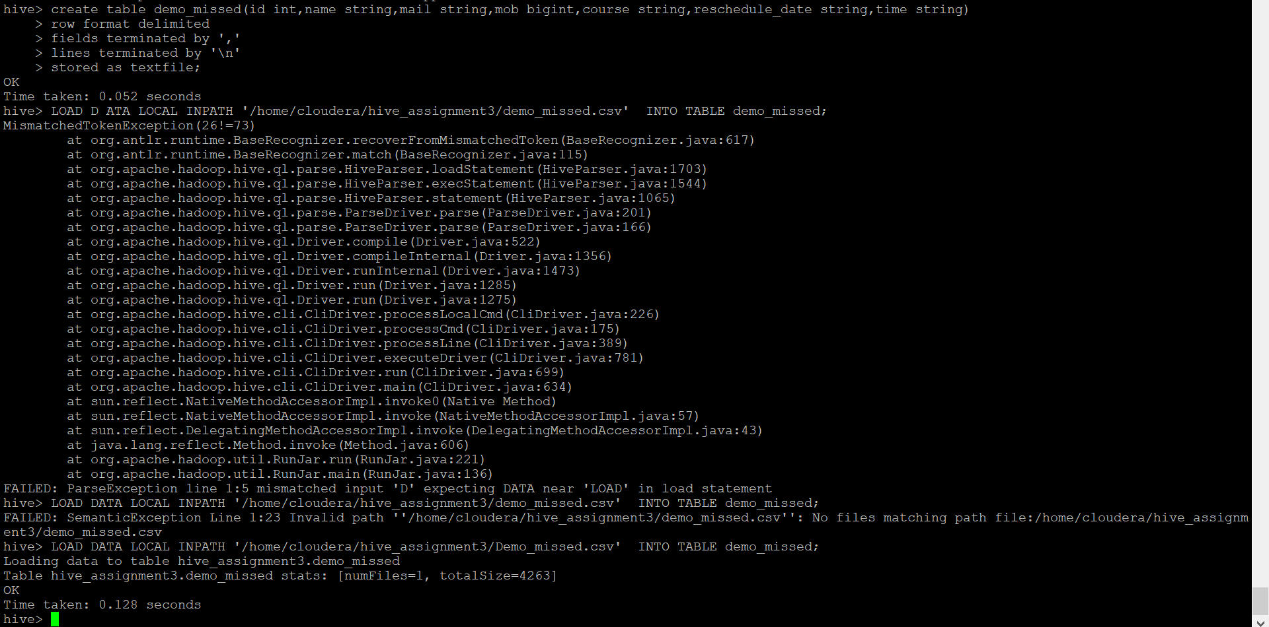

**🡺ENROLL Table:**

create table enroll (id int,name string,mail string,mob bigint,course string,status string,payment_mode string,total_installment int,installment_paid int,Next_installment_date string,payment_status string,installment_left int,final_fee int)

row format delimited

fields terminated by ','

stored as textfile;

**🡺Load data into table:**

LOAD DATA LOCAL INPATH ‘/home/cloudera/hive_assignment3/Enroll.csv' INTO TABLE enroll;

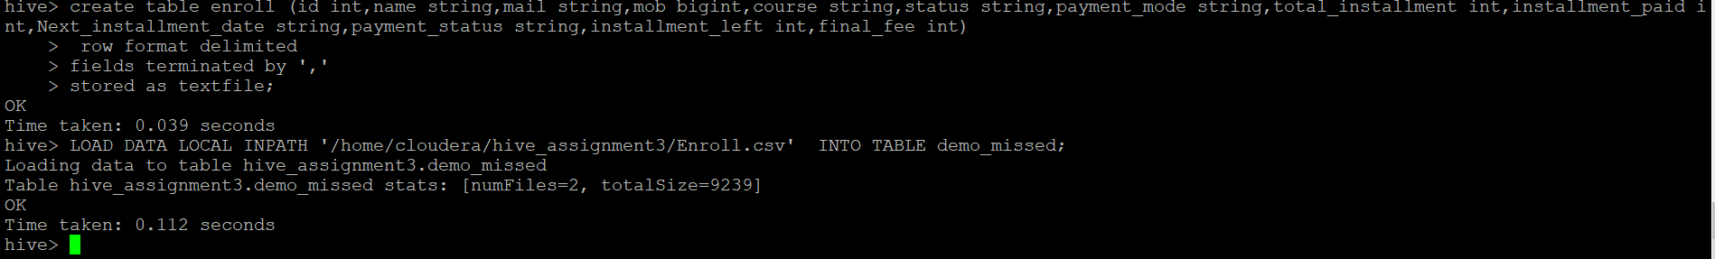

**🡺BATCH DISTRIBUTION table:**

create table batch_distribution(id int,name string,mail string,mob bigint,course string,joining_date string,week_day string,day string ,time string)

row format delimited

fields terminated by ','

stored as textfile;

**🡺Load data into table:**

LOAD DATA LOCAL INPATH '/home/cloudera/hive_assignment3/batch_distribution.csv' INTO TABLEbatch_distribution;

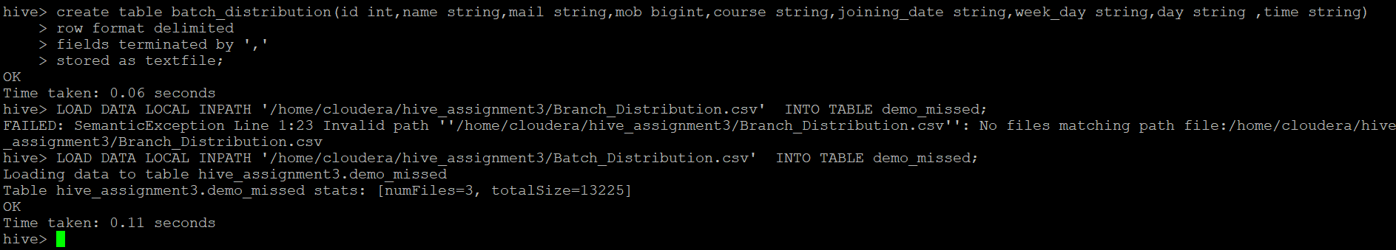

**Questions:**

**🡺Join on enquiry and demo_schedule table:**

SELECT c.id,c.name,c.mail,c.mob,c.course,c.status,o.demoday,o.day,o.time FROM enquiry c JOIN demo_schedule o ON (c.id= o.id);

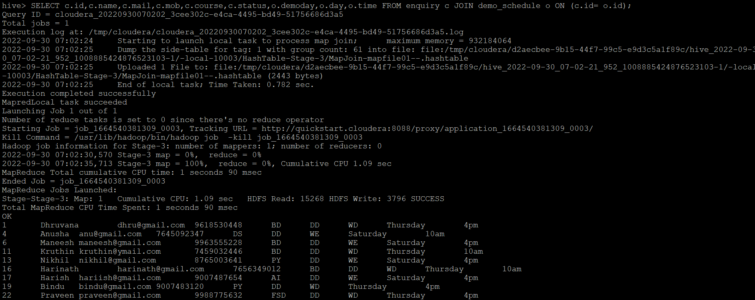

🡺 **Join on enquiry_txt and demo_missed:**

SELECT c.id,c.name,c.mail,c.mob,c.course,c.status,o.reschedule_date,o.time FROM enquiry_txt c JOIN demo_missed o ON (c.id = o.id);

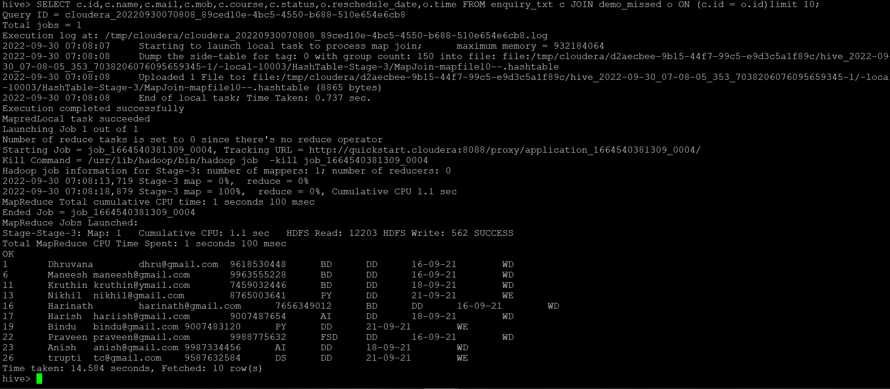

**🡺** **enroll and batch(which student enroll for which batch)**

SELECT e.id,e.name,e.mail,e.mob,e.course,b.joining_date,b.week_day,b.day,b.time FROM enroll e JOIN batch_distribution b ON(e.id=b.id)limit 10;

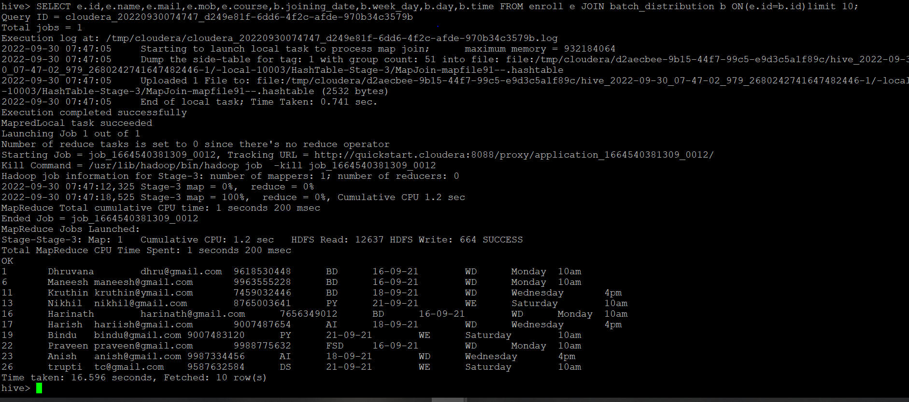

**🡺** **students who enrolled for weekend batch**

SELECT e.id,e.name,e.mail,e.mob,e.course,b.joining_date,b.week_day,b.day,b.time FROM enroll e JOIN batch_distribution b ON(e.id=b.id) where b.day='Saturday';

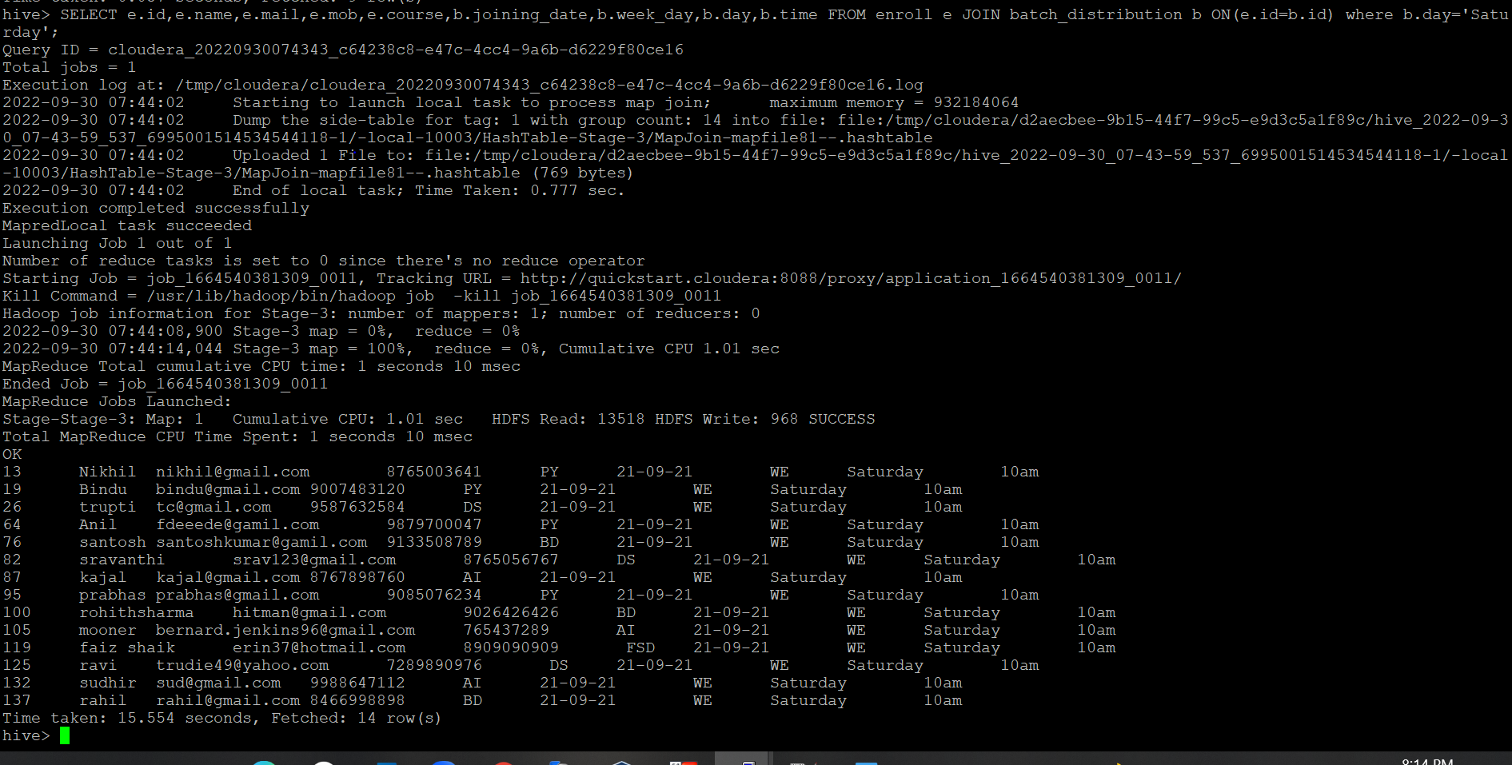

**🡺Details of student whoes fees pending**

SELECT id,name,mail,mob,course,payment_status FROM enroll where payment_status='Pending';

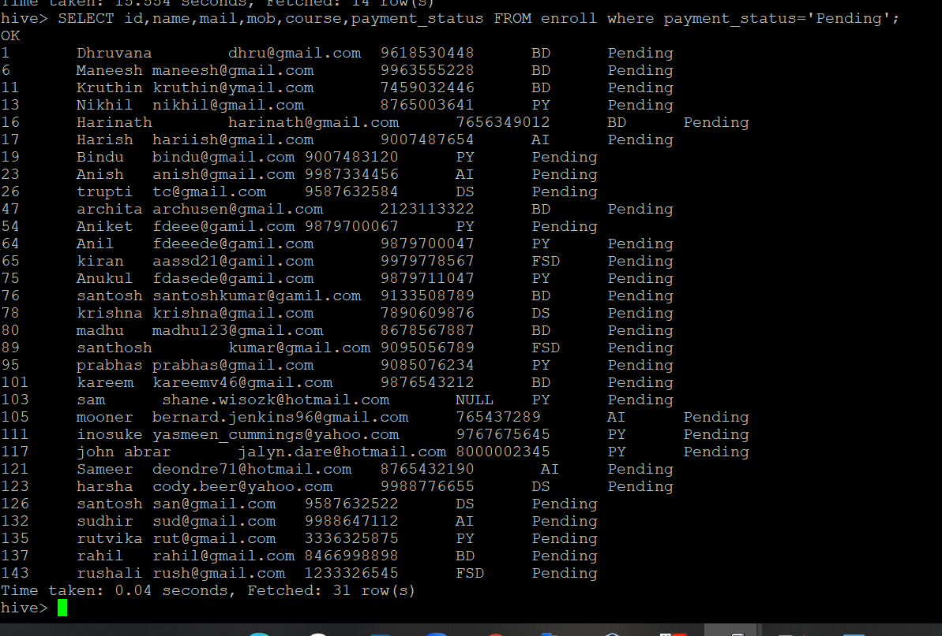

**🡺Details of student whose 1 installment pending**

Select id,name,mail,mob,course,total_installment,installment_paid,Next_installment_date,

payment_status,installment_left,ﬁnal_fee FROM enroll where installment_left=1;

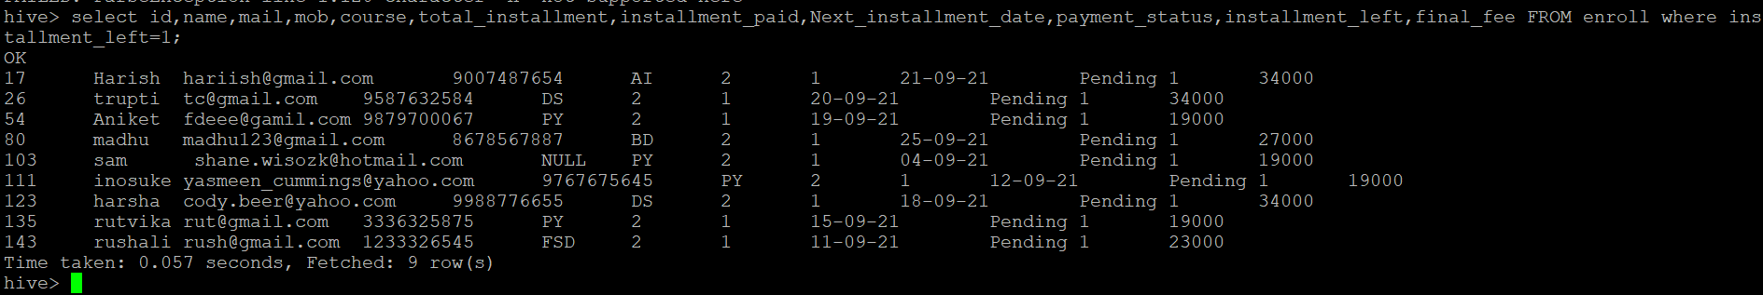

**🡺All details of student who enrolled for python batch**

SELECT * FROM enroll e JOIN batch_distribution b ON(e.id=b.id) where e.course=‘PY’

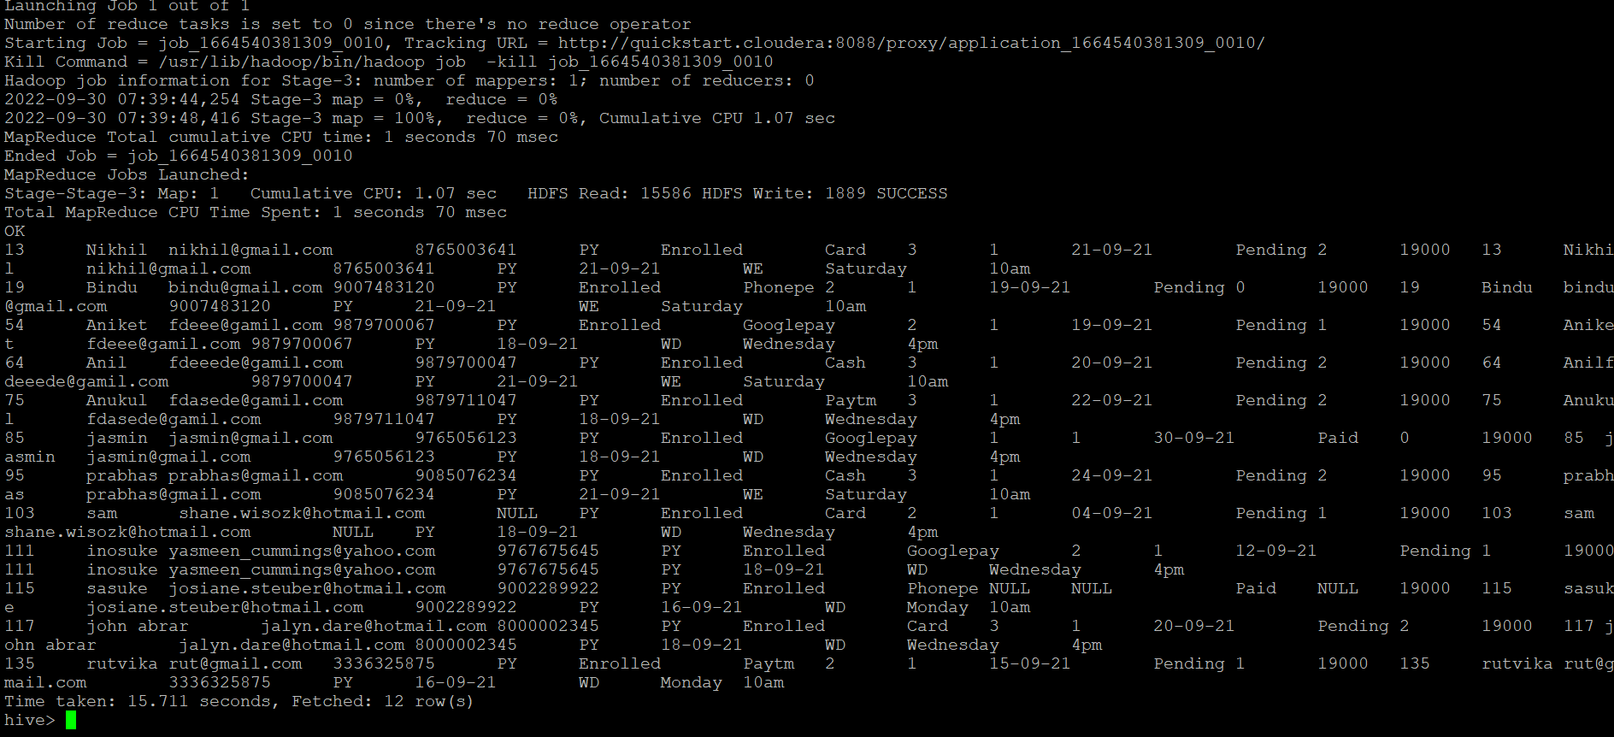

**🡺Insert into table Enquiry:**

INSERT INTO enquiry PARTITION(status_final='Enrolled') VALUES (159,'mar','mar@gmail.com',9988998899,'BD',30000,10,'16-09-21','DD');

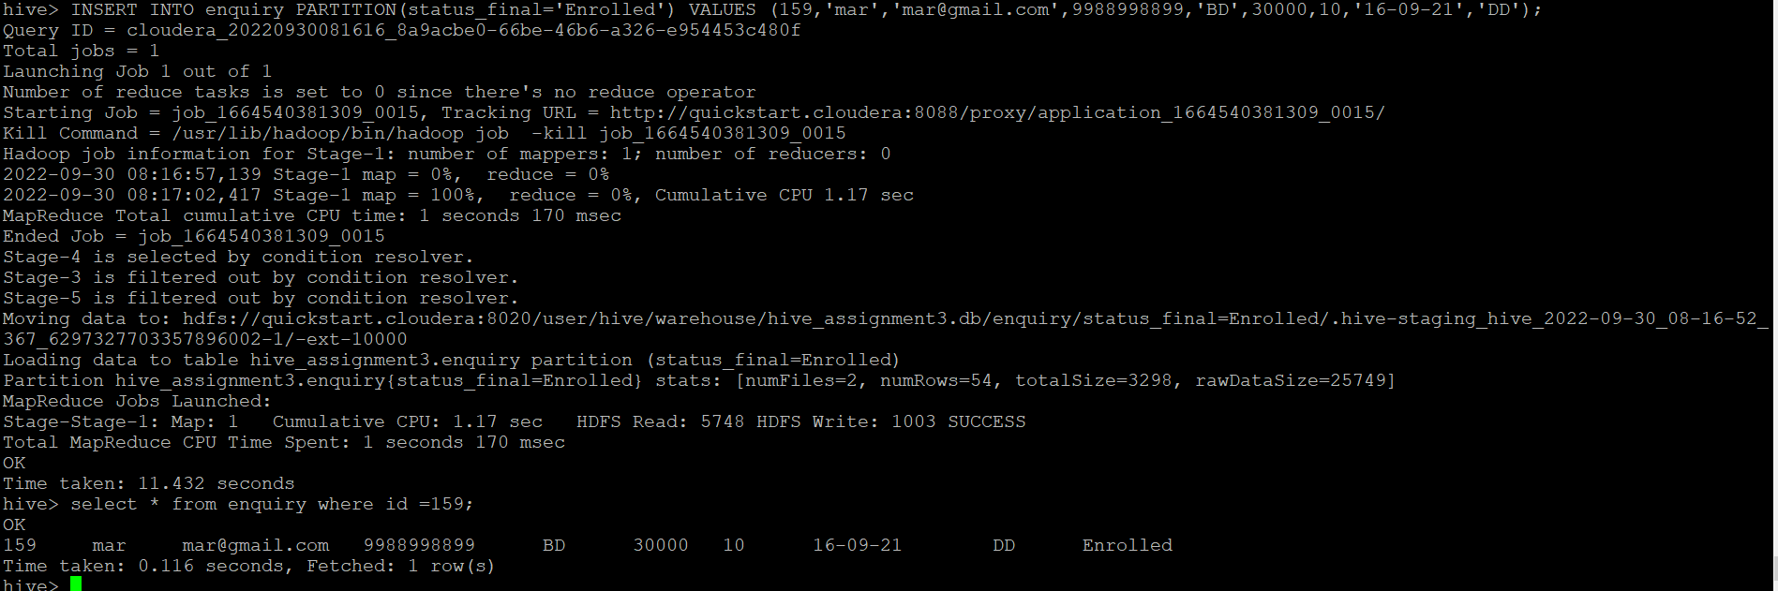

**🡺List the student whose demo scheduled at 4pm.**

Select * from demo_schedule where day= ‘25-09-2021’ and time = ‘4pm’;

