**1. Create a schema based on the given dataset**

**2.** **Dump the data inside the hdfs in the given schema location.**

create table agent_logging_report (

sl_no int,

Agent string,

Date date,

login_time string,

logout_time string,

duration string)

row format delimited

fields terminated by ','

tblproperties ("skip.header.line.count" = "1");

);

create table agent_performance(

sl_no int,

Date date,

Agent_name string,

total_chats int,

average_response_time string,

average_resolution string,

average_rating float,

total_feedback int

)

row format delimited

fields terminated by ','

tblproperties ("skip.header.line.count" = "1");

);

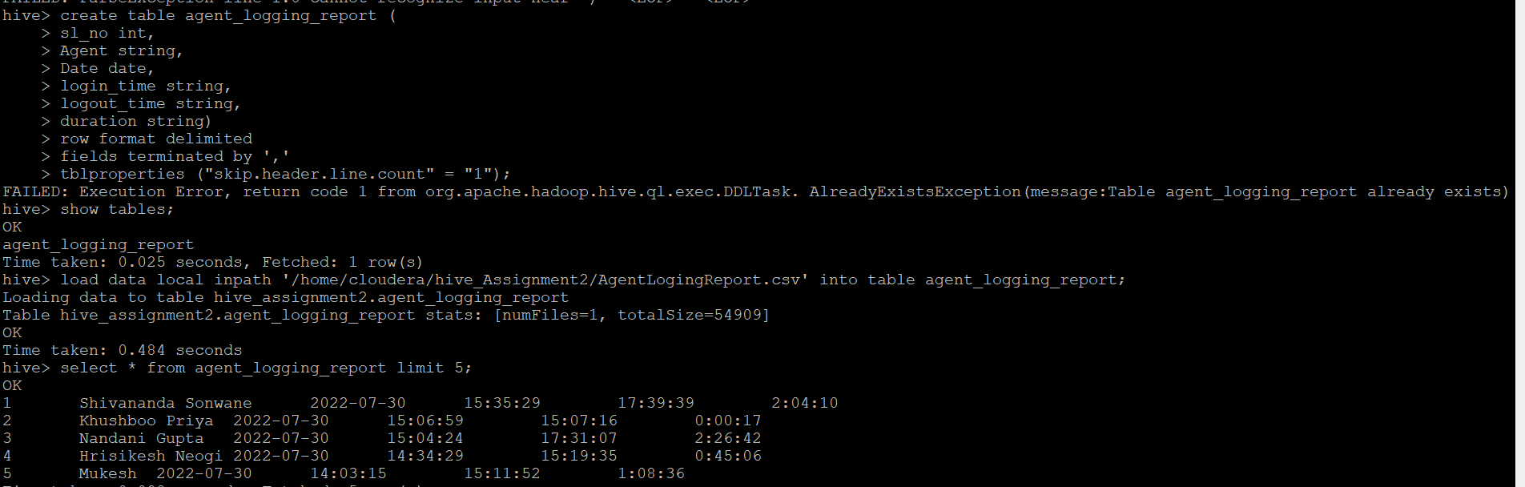

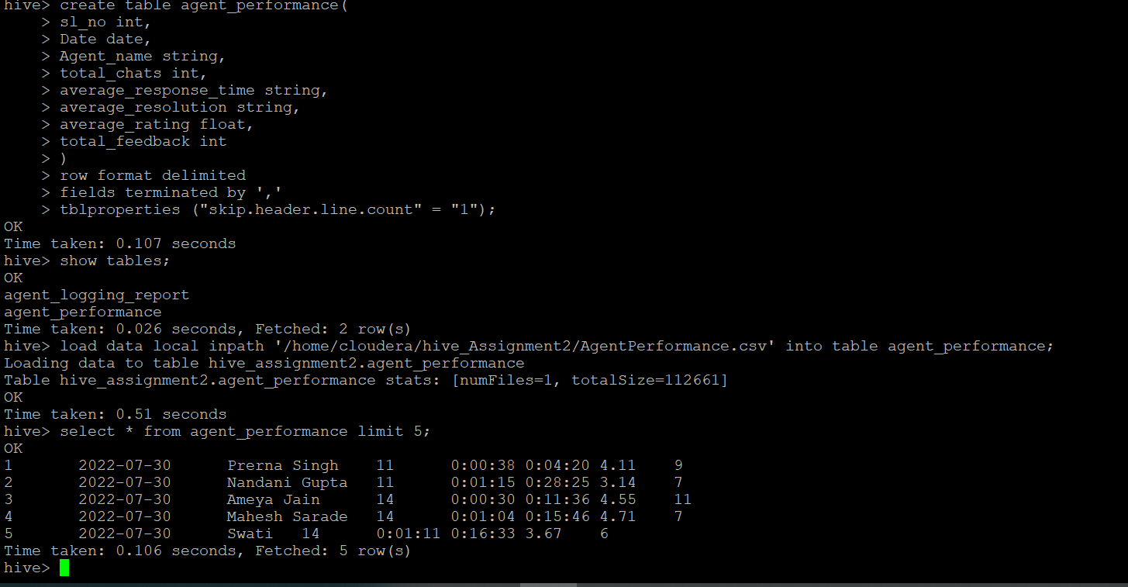

**3. List of all agents' names.**

select distinct agent from agent_logging_report ;

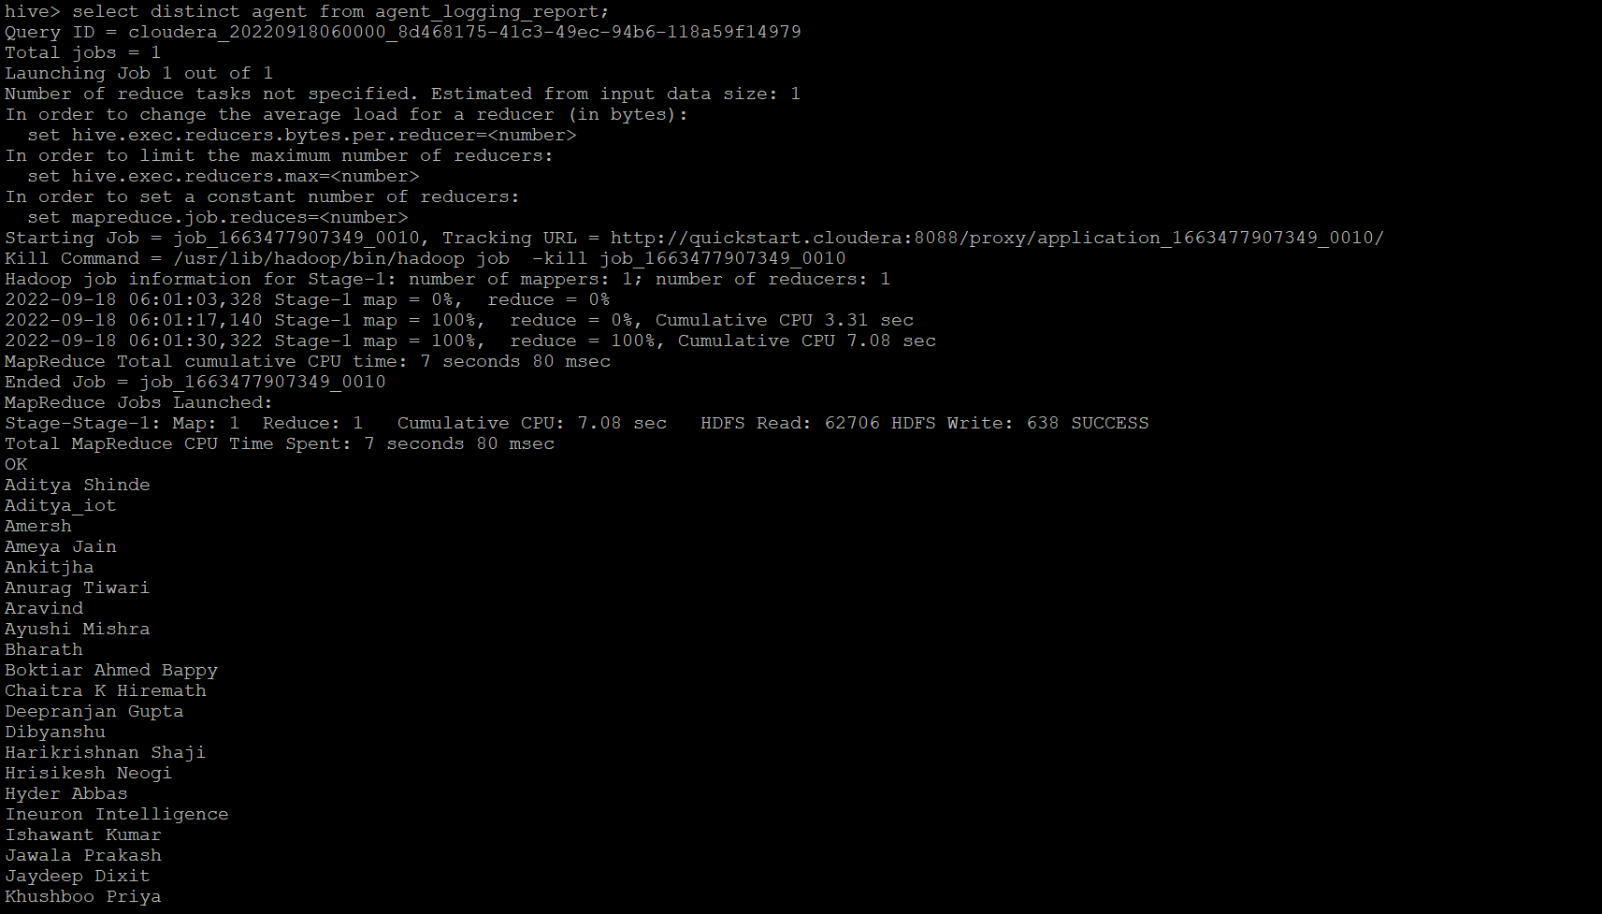

**4. Find out agent average rating.**

select avg(average_rating),agent_name from agent_performance group by agent_name limit 5;

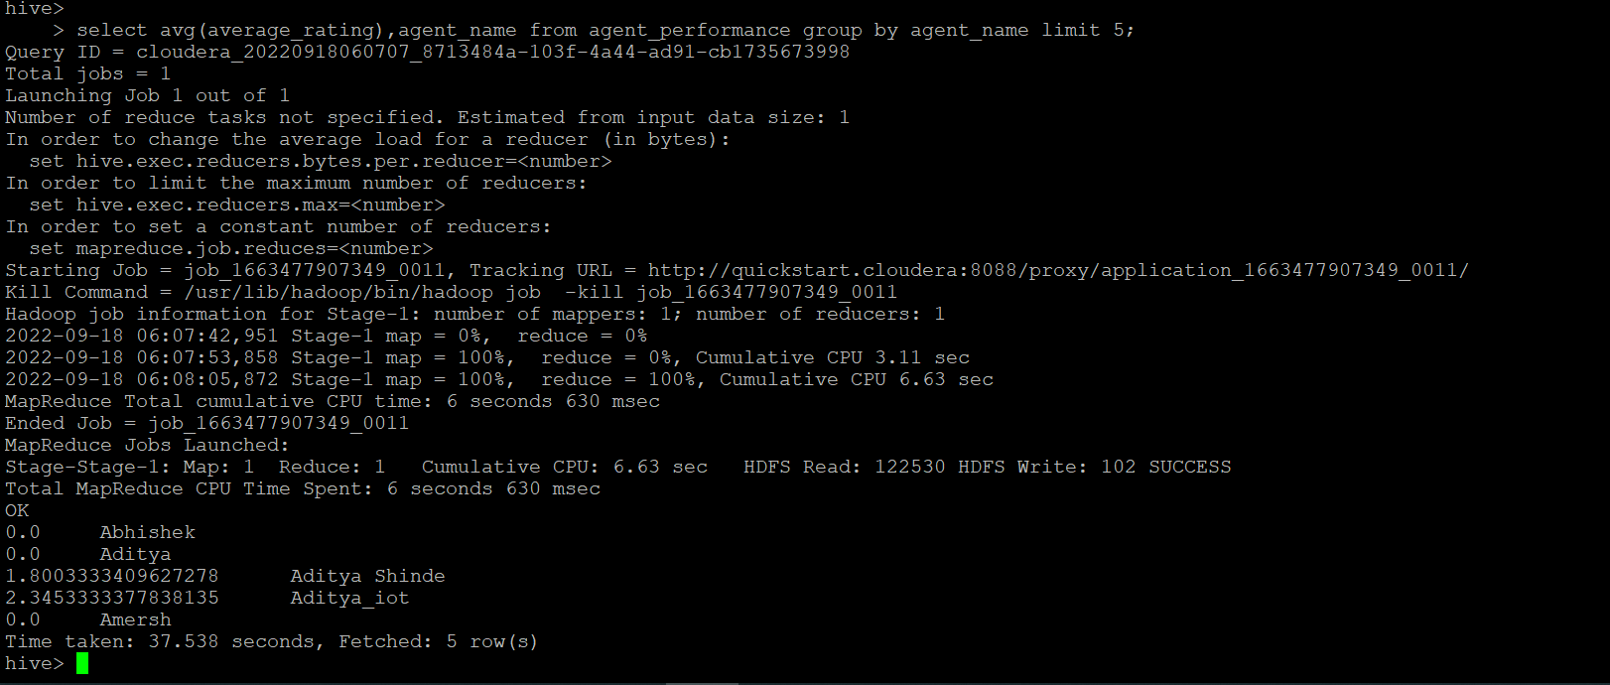

**5. Total working days for each agents**

select count(date),agent from agent_logging_report group by agent limit 5;

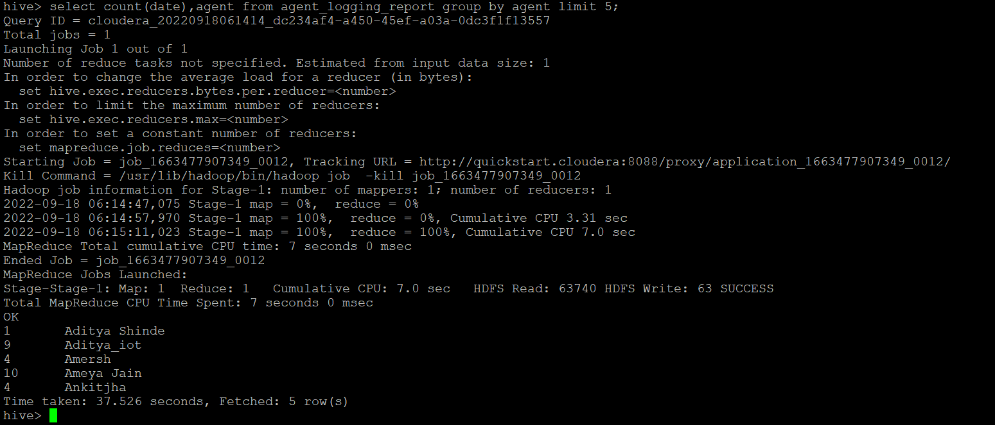

**6. Total query that each agent have taken**

select sum(total_chats),agent_name from agent_performance group by agent_name limit 5;

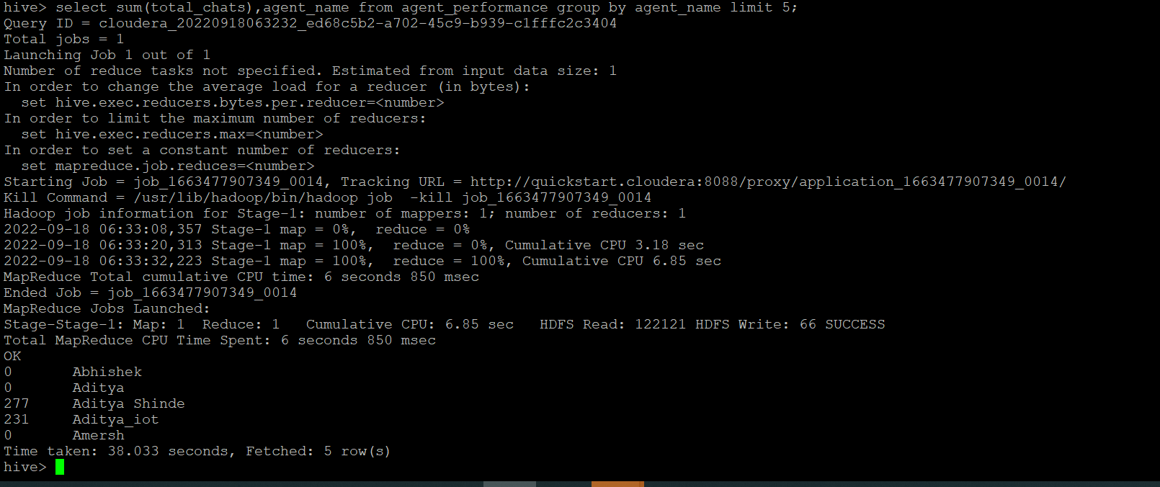

**7. Total Feedback that each agent have received**

select sum(total_feedback),agent_name from agent_performance group by agent_name limit 5;

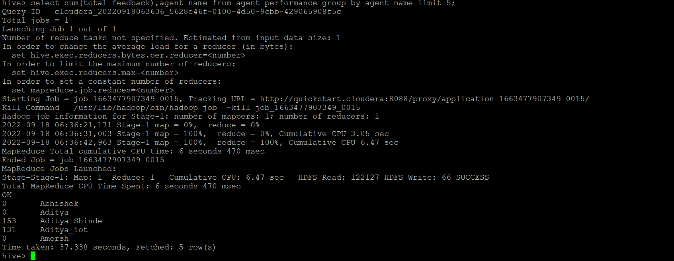

**8. Agent name who have average rating between 3.5 to 4**

Select agent_name from agent_performance where average_rating BETWEEN 3.5 AND 4 limit 5;

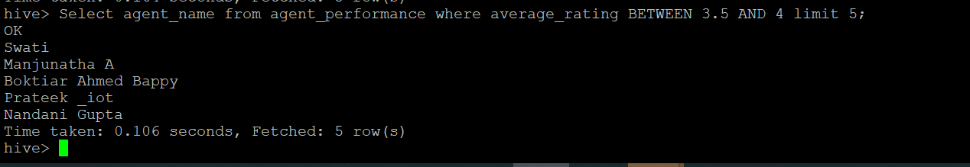

**9. Agent name who have rating less than 3.5**

Select agent_name from agent_performance where average_rating < 3.5 limit 5;

**10. Agent name who have rating more than 4.5**

Select agent_name from agent_performance where average_rating > 4.5 limit 5;

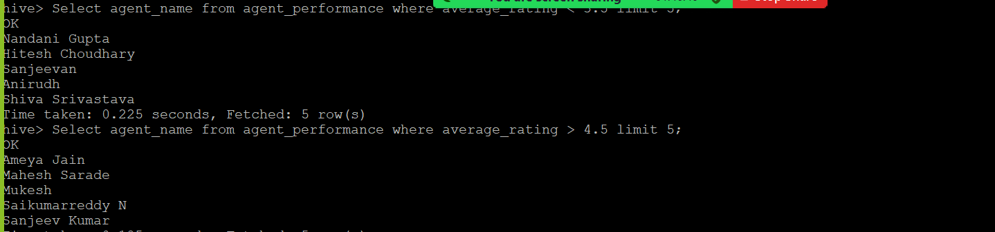

**11. How many feedback agents have received more than 4.5 average**

select avg(total_feedback), agent_name from agent_performance group by agent_name having avg(total_feedback)>4.5;

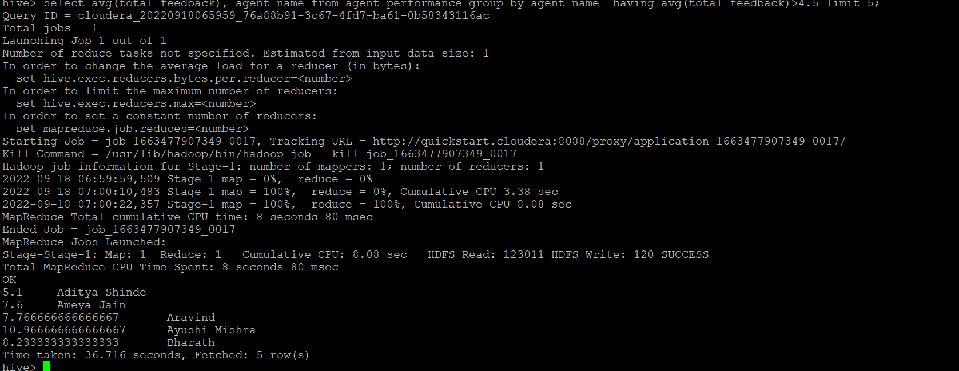

**12. average weekly response time for each agent**

select s.agent_name,avg(col1[0]*3600+col1[1]*60+col1[2])/3600 from(

select agent_name,split(average_response_time,':') as col1 from agent_performance)s group by s.agent_name;

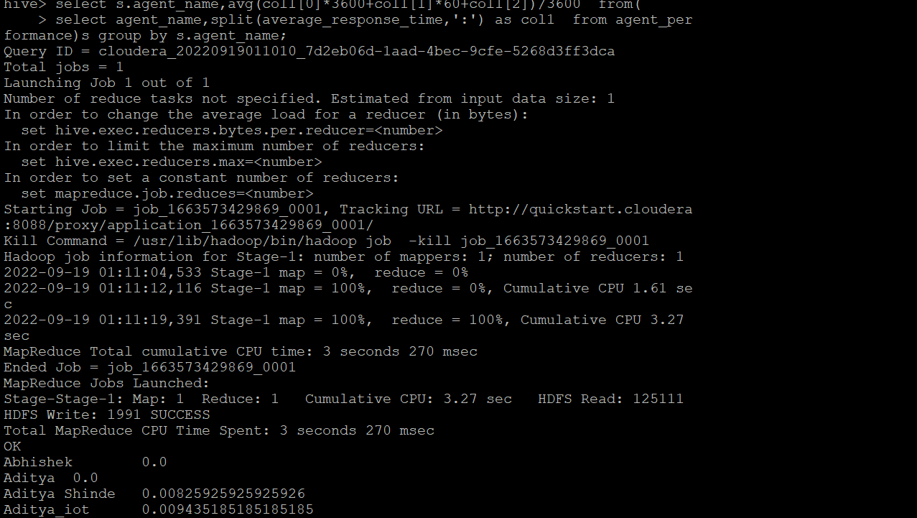

**13. average weekly resolution time for each agents**

select s.agent_name,avg(col1[0]*3600+col1[1]*60+col1[2])/3600 from(

select agent_name,split(average_resolution,':') as col1 from agent_performance)s group by s.agent_name;

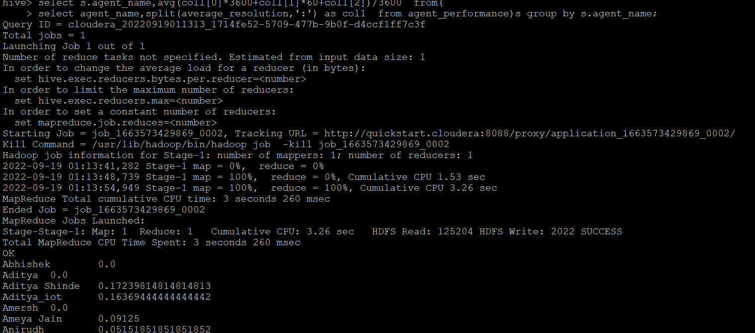

**14. Find the number of chat on which they have received a feedback**

Select agent_name,sum(total_chats),total_feedback from agent_performance where total_feedback>0 group by agent_name,total_feedback;

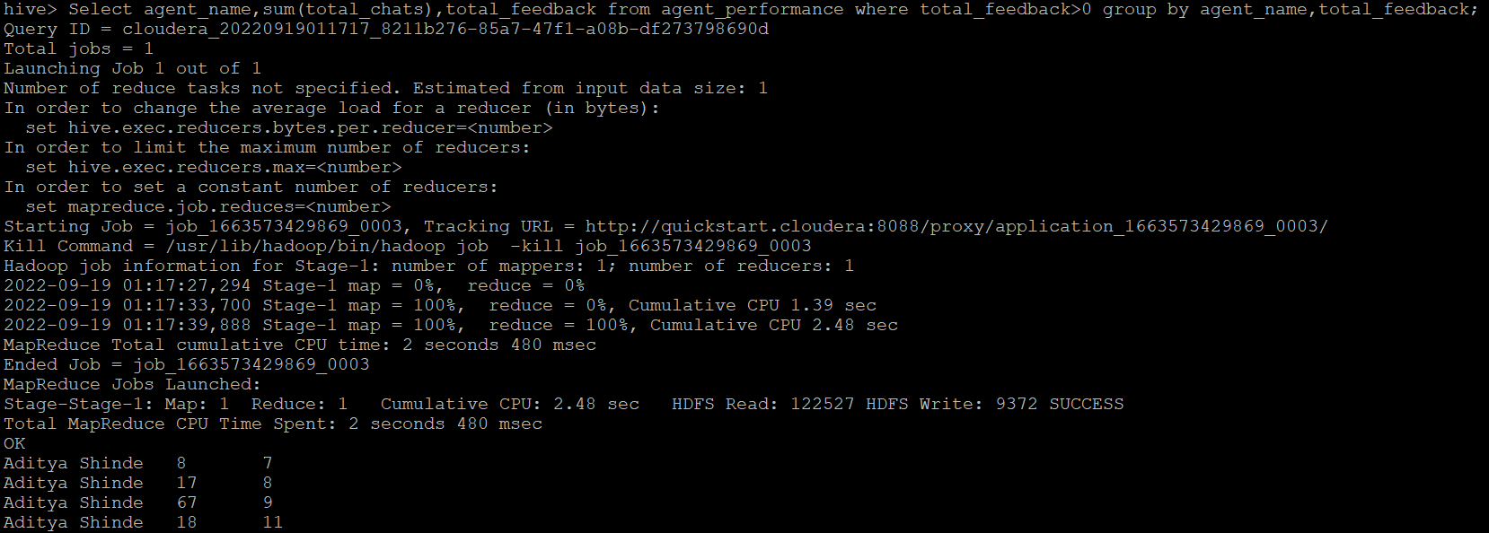

**15. Total contribution hour for each and every agents weekly basis**

select s.agent,sum(col1[0]*3600+col1[1]*60+col1[2])/3600,s.weekly from(

select agent,split(duration,':') as col1 ,weekofyear(Date) as weekly from agent_logging_report)s group by s.agent,s.weekly limit 2;

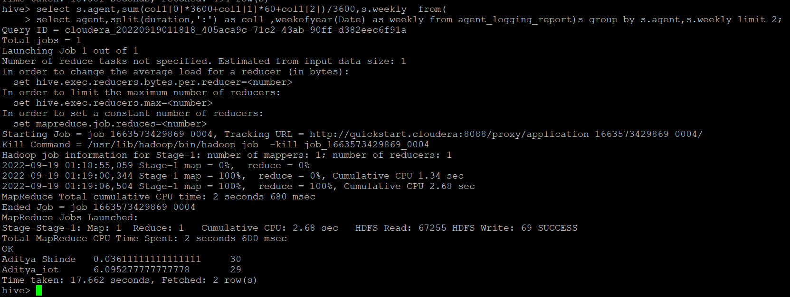

**16. Perform inner join, left join and right join based on the agent column and after joining the table export that data into your local system.**

**INNER JOIN:**

Select alr.agent,alr.date,ap.total_chats,ap.total_feedback from hive_assignment2.agent_logging_report alr join hive_assignment2.agent_performance ap on alr.agent = ap.agent_name limit 5;

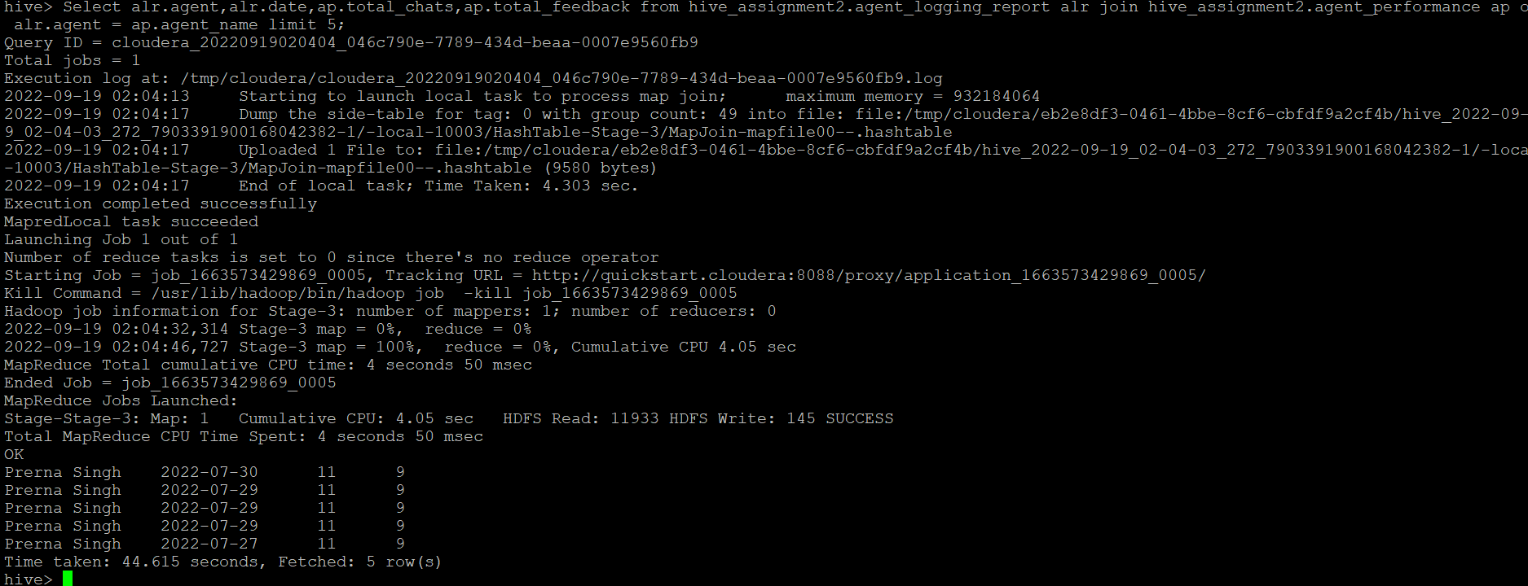

**LEFT JOIN:**

Select alr.agent,alr.date,ap.total_chats,ap.total_feedback from hive_assignment2.agent_logging_report alr left join hive_assignment2.agent_performance ap on alr.agent = ap.agent_name limit 5;

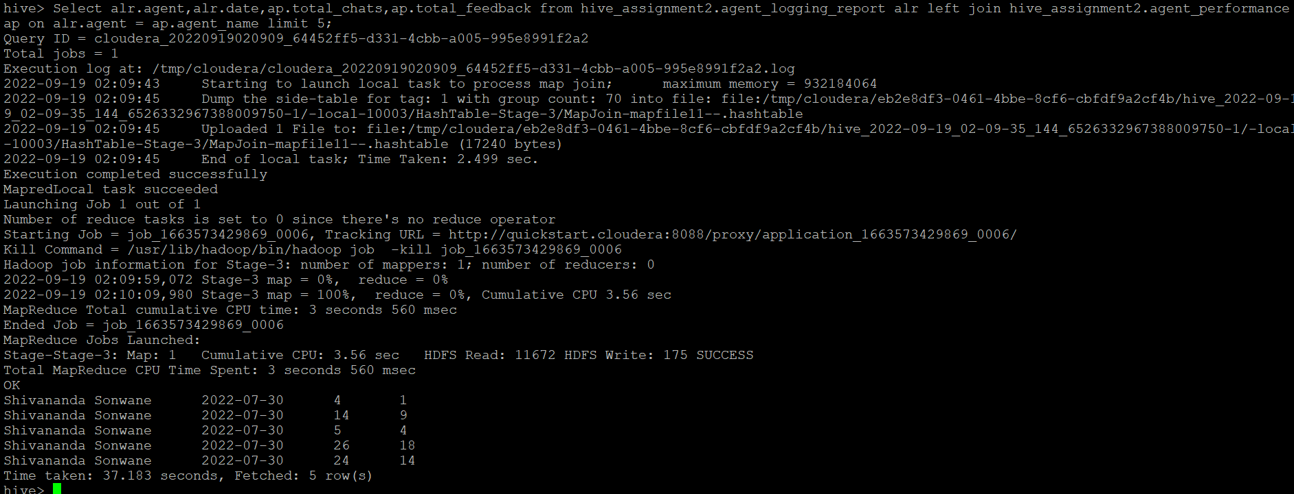

**RIGHT JOIN:**

Select alr.agent,alr.date,ap.total_chats,ap.total_feedback from hive_assignment2.agent_logging_report alr right join hive_assignment2.agent_performance ap on alr.agent = ap.agent_name limit 5;

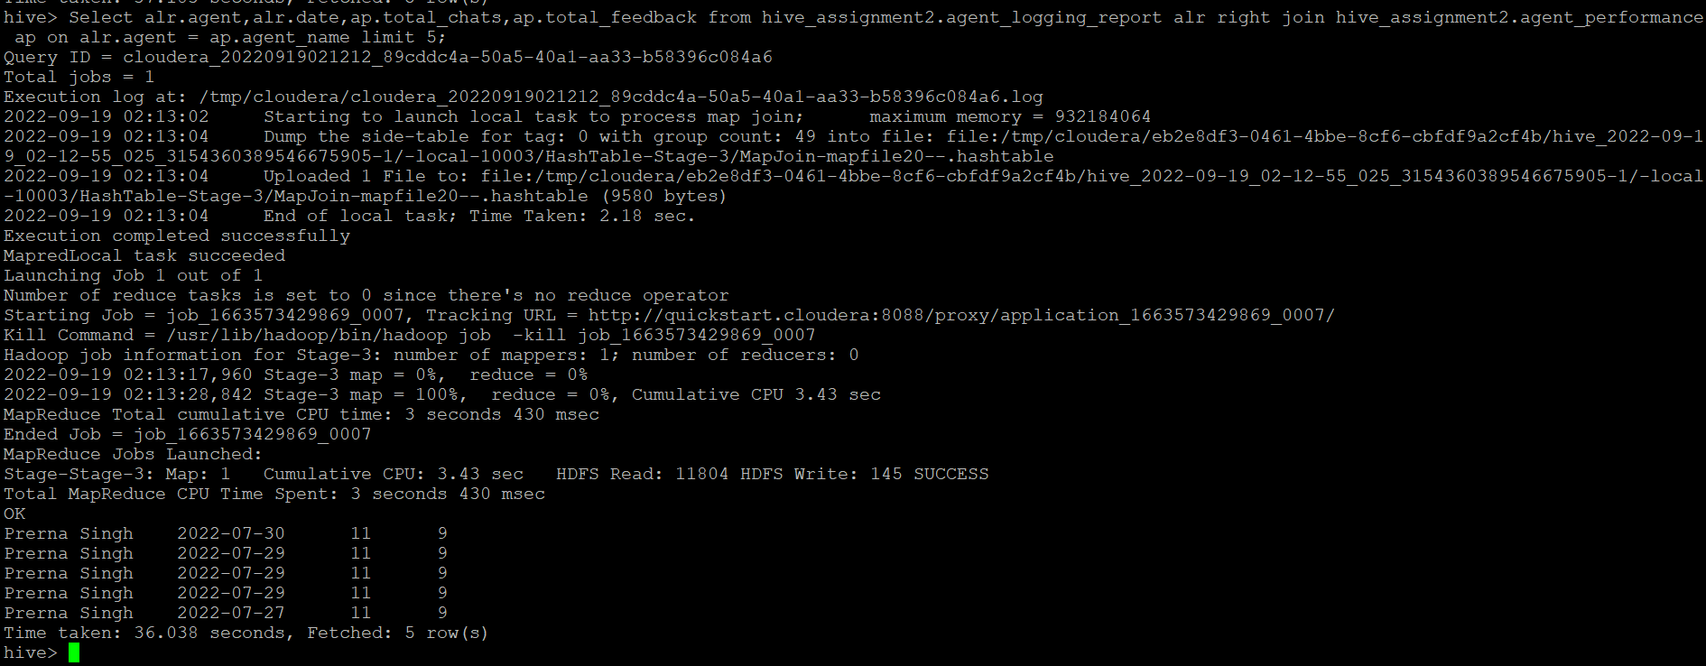

$ hive -e 'Select alr.agent,alr.date,ap.total_chats,ap.total_feedback from hive_assignment2.agent_logging_report alr join hive_assignment2.agent_performance ap on alr.agent = ap.agent_name limit 5' > /home/cloudera/hive_Assignment2/inner.join.csv;

$ hive -e 'Select alr.agent,alr.date,ap.total_chats,ap.total_feedback from hive_assignment2.agent_logging_report alr left join hive_assignment2.agent_performance ap on alr.agent = ap.agent_name limit 5' > /home/cloudera/hive_Assignment2/left.join.csv;

$ hive -e 'Select alr.agent,alr.date,ap.total_chats,ap.total_feedback from hive_assignment2.agent_logging_report alr right join hive_assignment2.agent_performance ap on alr.agent = ap.agent_name limit 5' > /home/cloudera/hive_Assignment2/right.join.csv;

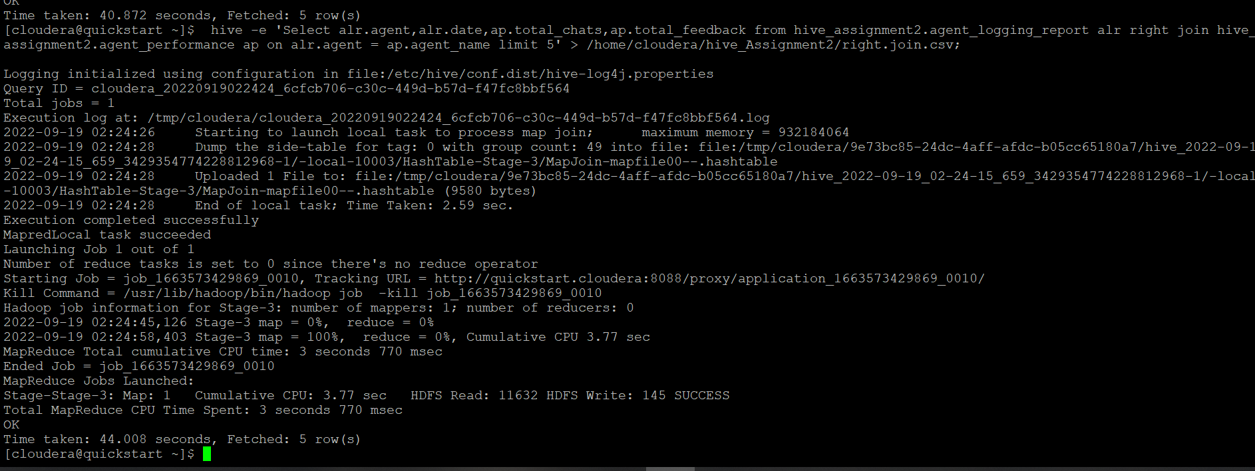

**17. Perform partitioning on top of the agent column and then on top of that perform bucketing for each partitioning.**

Create table ALR_partition_Bucket

(

sr_no int,

Date date,

Login_time string,

Logout_time string,

Duration string

)partitioned by (Agent string)

CLUSTERED BY (Date) sorted by (Date) INTO 4 BUCKETS

ROW FORMAT DELIMITED

FIELDS TERMINATED BY ',';

set hive.exec.dynamic.partition=true;

set hive.exec.dynamic.partition.mode=nonstrict;

hive> insert into table ALR_partition_Bucket partition(Agent) select sl_no,Date,Login_time,Logout_time,Duration,Agent from agent_logging_report;

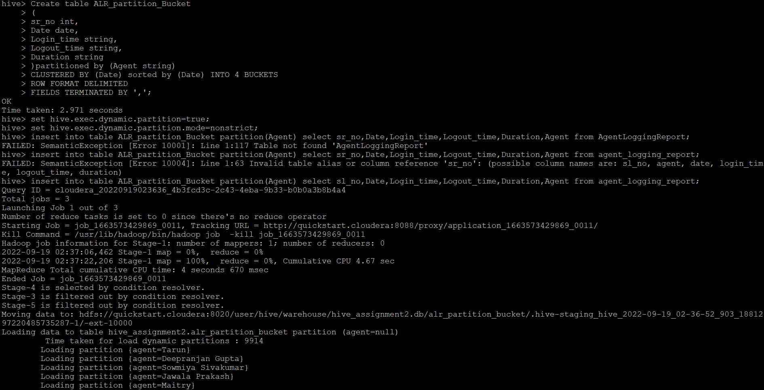

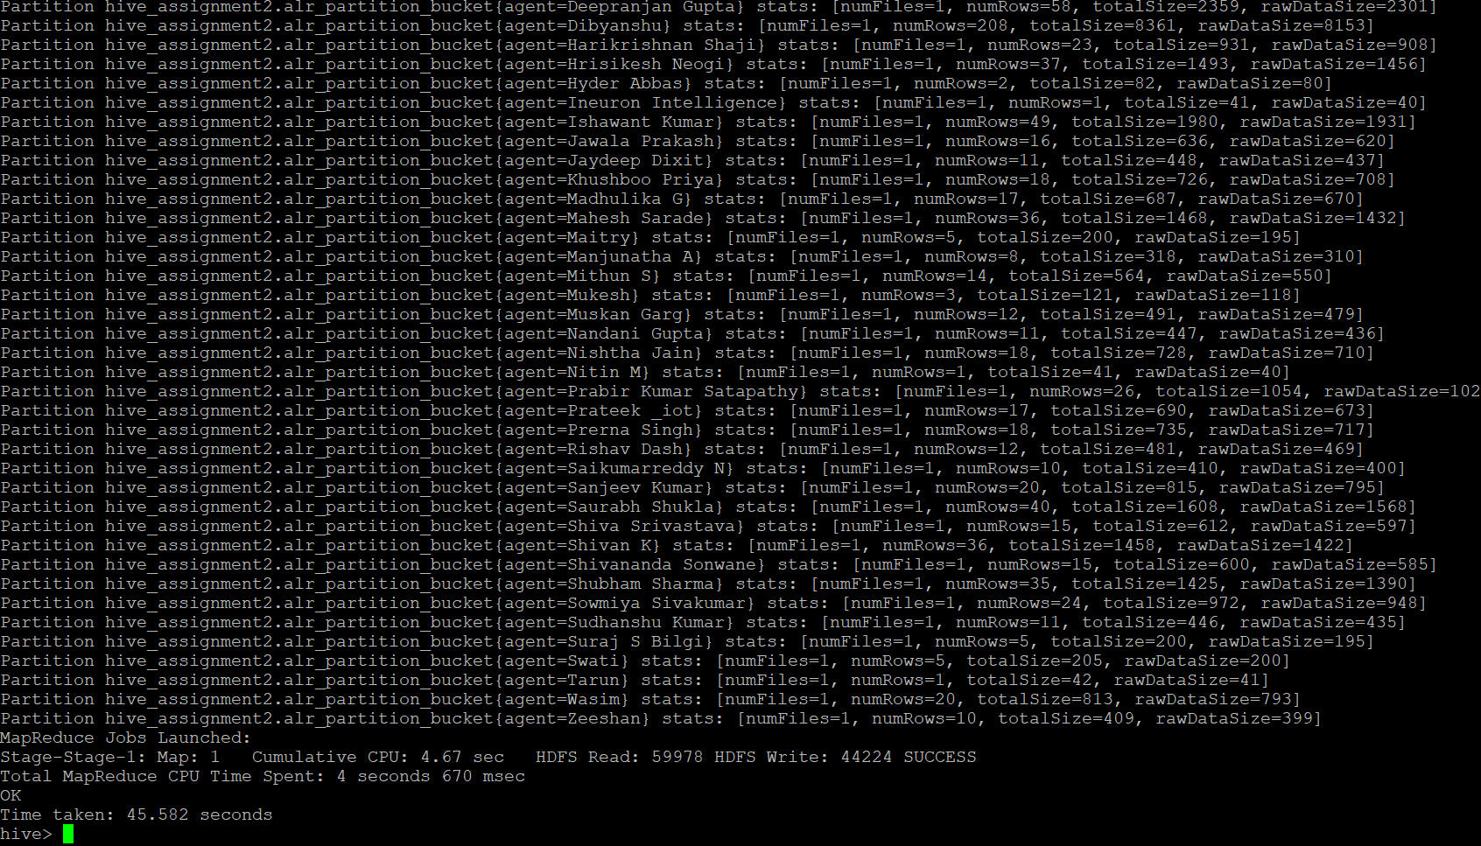

Create table AP_partition_Bucket

(

sr_no int,

Date date,

Total_chat string,

Average_Response_Time string,

Average_Resolution_Time string,

Average_Rating float,

Total_Feedback int

)partitioned by (agent_name string)

CLUSTERED BY (Date) sorted by (Date) INTO 8 BUCKETS

ROW FORMAT DELIMITED

FIELDS TERMINATED BY ',';

insert into table AP_partition_Bucket partition(agent_name) select sl_no,Date,Total_chats, Average_Response_Time, Average_Resolution,Average_Rating,Total_Feedback,Agent_name from Agent_performance;

