**Task-1 Assignment:**

1. Download vechile sales data -> <https://github.com/shashank-mishra219/Hive-Class/blob/main/sales_order_data.csv>
2. Store raw data into hdfs location

**hadoop fs -mkdir hiveAssignment1**

**hadoop fs -put /home/cloudera/hive_Assignment1/sales_order_da ta.csv /hive_Assignment1**

**hadoop fs -ls /hive_Assignment1/**

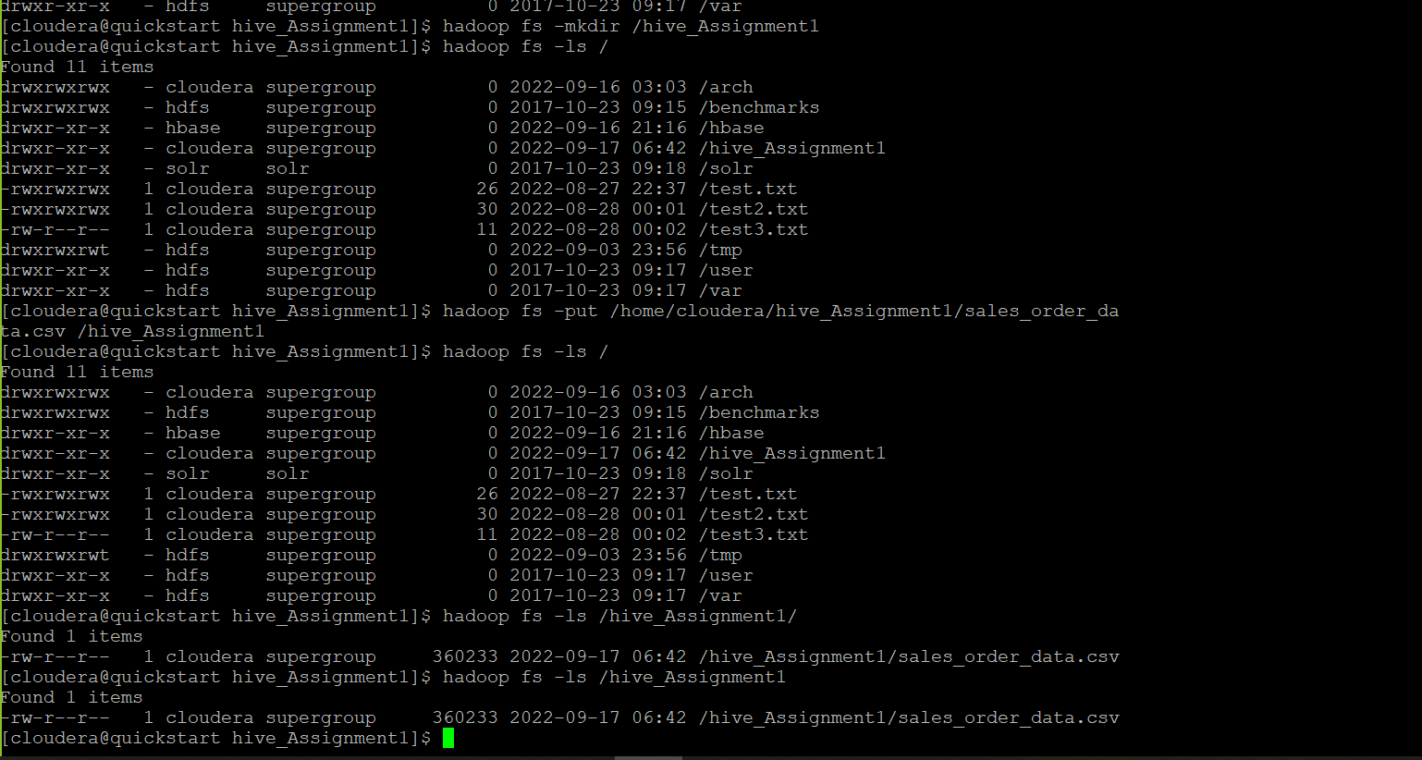

1. Create a internal hive table "sales_order_csv" which will store csv data sales_order_csv make sure to skip header row while creating table.

**hive> create database hive_Assignment1;**

**hive> show databases;**

**hive> use hive_assignment1;**

**hive> show tables;**

**hive> create table sales_order_csv(**

**ORDERNUMBER int,**

**QUANTITYORDERED int,**

**PRICEEACH int,**

**ORDERLINENUMBER int,**

**SALES int,**

**STATUS string,**

**QTR_ID int,**

**MONTH_ID int,**

**YEAR_ID int,**

**PRODUCTLINE string,**

**MSRP int,**

**PRODUCTCODE string,**

**PHONE string,**

**CITY string,**

**STATE string,**

**POSTALCODE int,**

**COUNTRY string,**

**TERRITORY string,**

**CONTACTLASTNAME string,**

**CONTACTFIRSTNAME string,**

**DEALSIZE string**

**)**

**row format delimited**

**fields terminated by ','**

**tblproperties ("skip.header.line.count" = "1");**

1. Load data from hdfs path into "sales_order_csv"

**hive> load data inpath '/hive_Assignment1/sales_order_data.csv' into table sales_order_csv;**

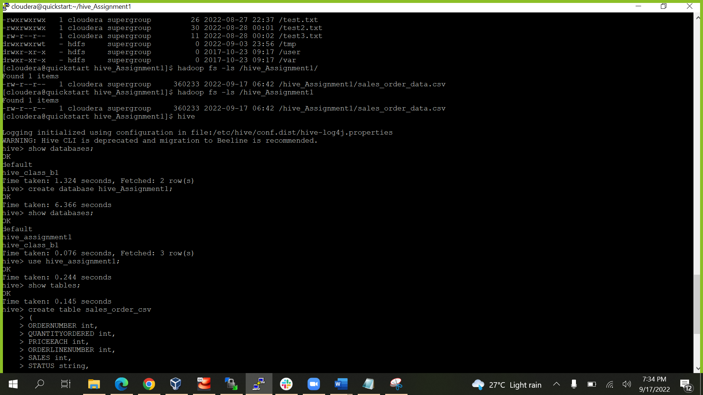

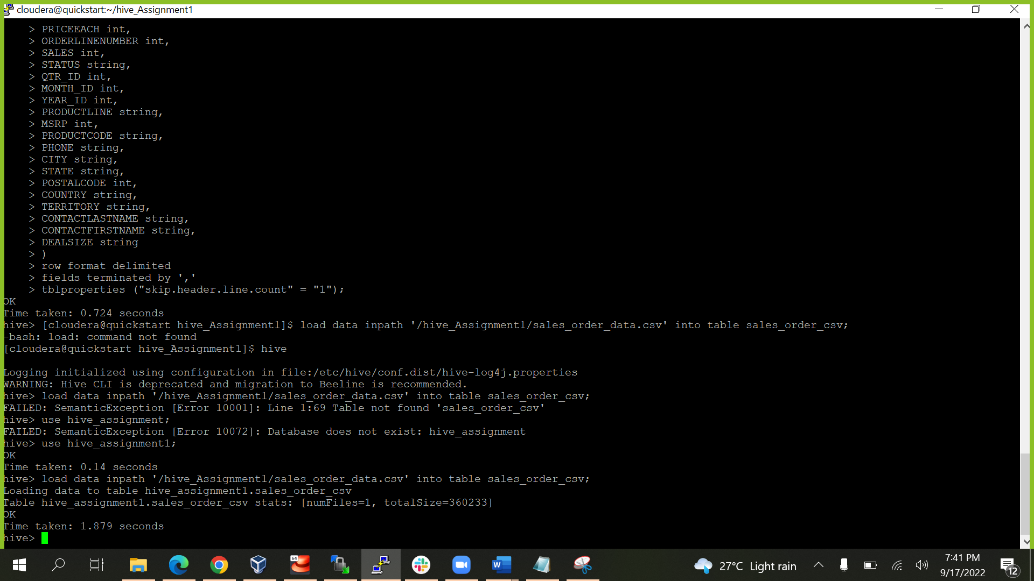

1. Create an internal hive table which will store data in ORC format "sales_order_orc".

**create table sales_order_orc**

**(**

**ORDERNUMBER int,**

**QUANTITYORDERED int,**

**PRICEEACH int,**

**ORDERLINENUMBER int,**

**SALES int,**

**STATUS string,**

**QTR_ID int,**

**MONTH_ID int,**

**YEAR_ID int,**

**PRODUCTLINE string,**

**MSRP int,**

**PRODUCTCODE string,**

**PHONE string,**

**CITY string,**

**STATE string,**

**POSTALCODE int,**

**COUNTRY string,**

**TERRITORY string,**

**CONTACTLASTNAME string,**

**CONTACTFIRSTNAME string,**

**DEALSIZE string**

**)**

**stored as ORC;**

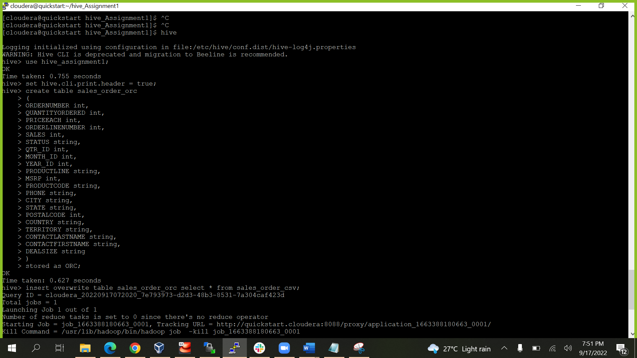

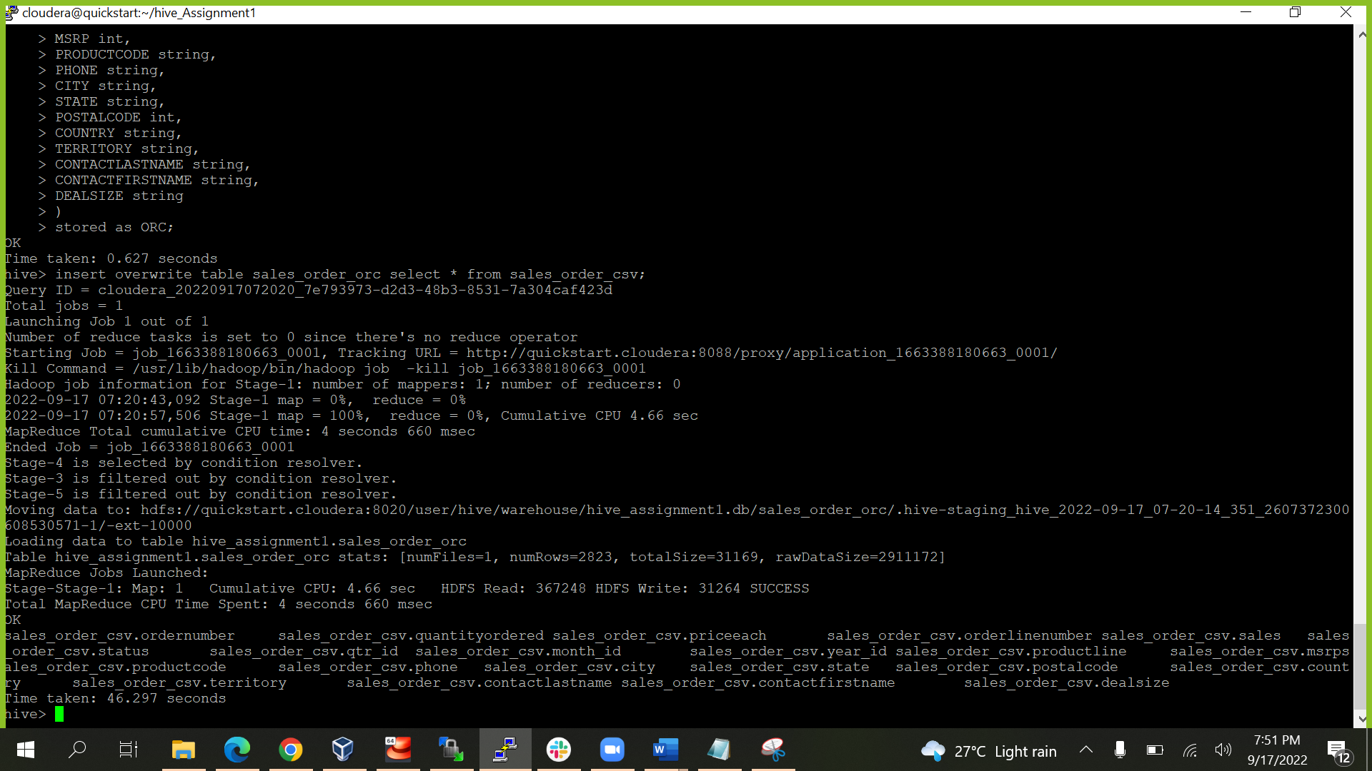

6. Load data from "sales_order_csv" into "sales_order_orc".

**hive> from sales_order_csv insert overwrite table sales_order_orc select *;**

**or**

**hive> insert overwrite table sales_order_orc select * from sales_order_csv;**

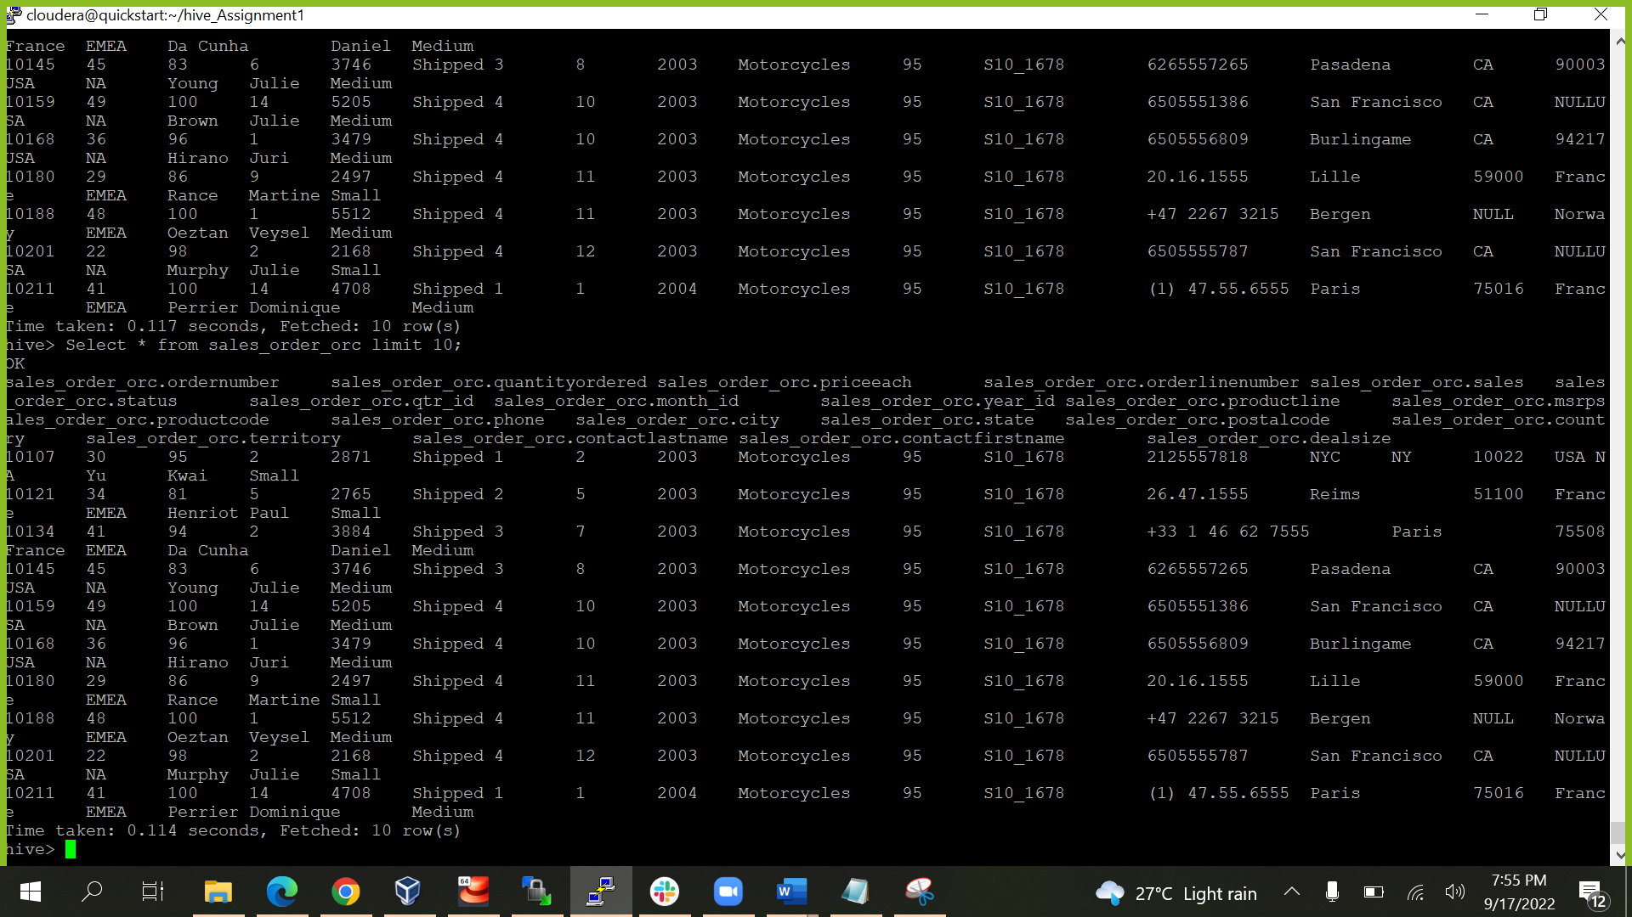

Perform below mentioned queries on "sales_order_orc" table :

1. Calculate total sales per year.

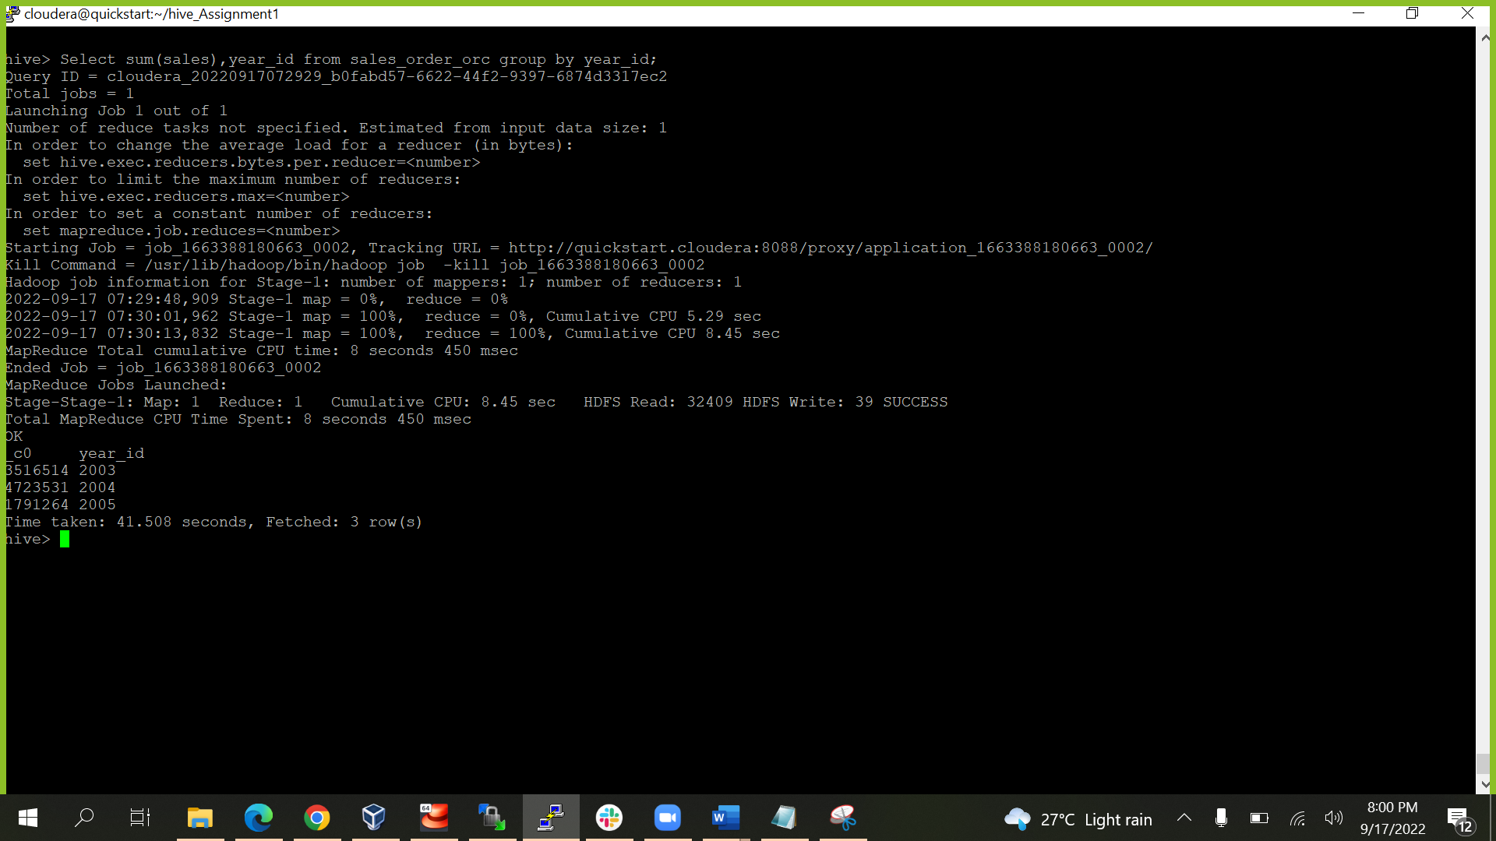

**Select sum(sales),year_id from sales_order_orc group by year_id;**

1. Find a product for which maximum orders were placed.

**Select A.productline from (Select sum(quantityordered) as maxorder,productline from sales_order_orc group by productline order by maxorder desc limit 1)A;**

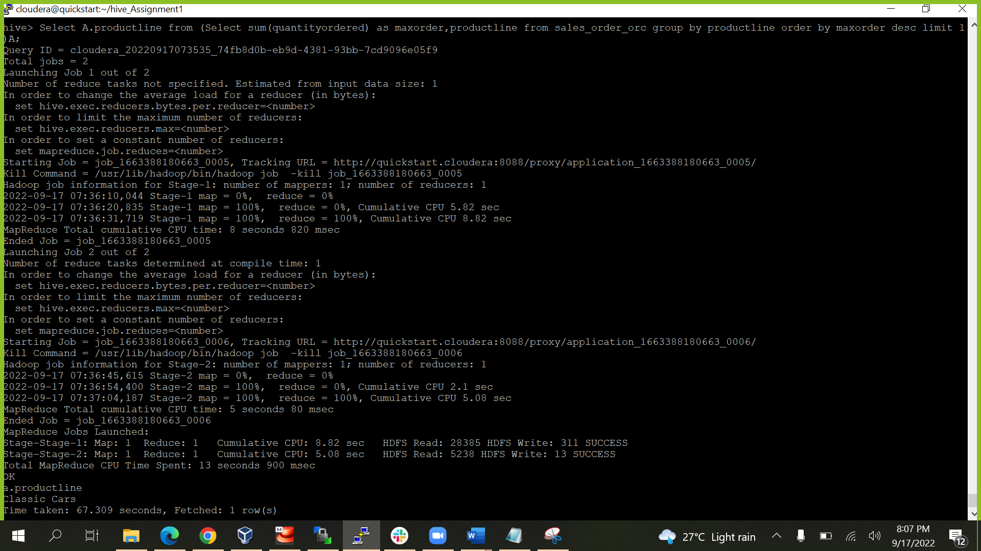

c. Calculate the total sales for each quarter

**Select sum(sales),qtr_id from sales_order_orc group by qtr_id;**

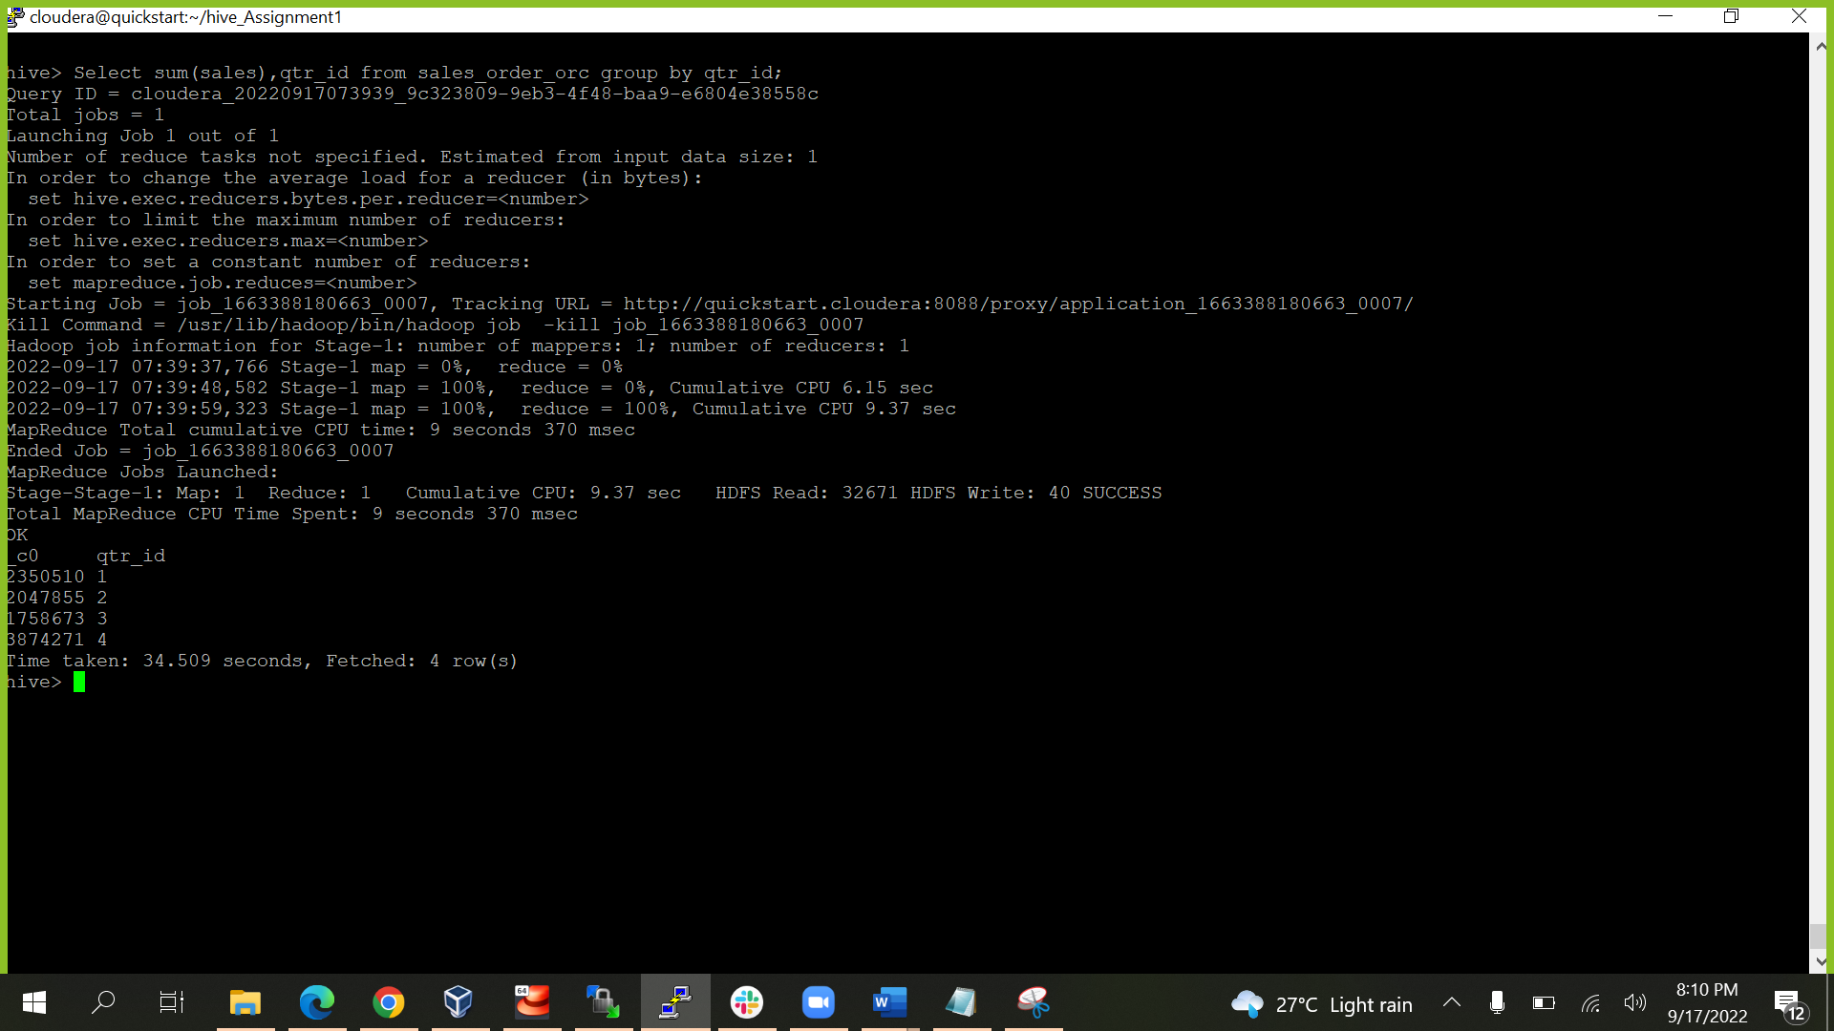

d. In which quarter sales was minimum?

**select sum(sales) as salesorder, qtr_id from sales_order_orc group by qtr_id order by salesorder limit 1;**

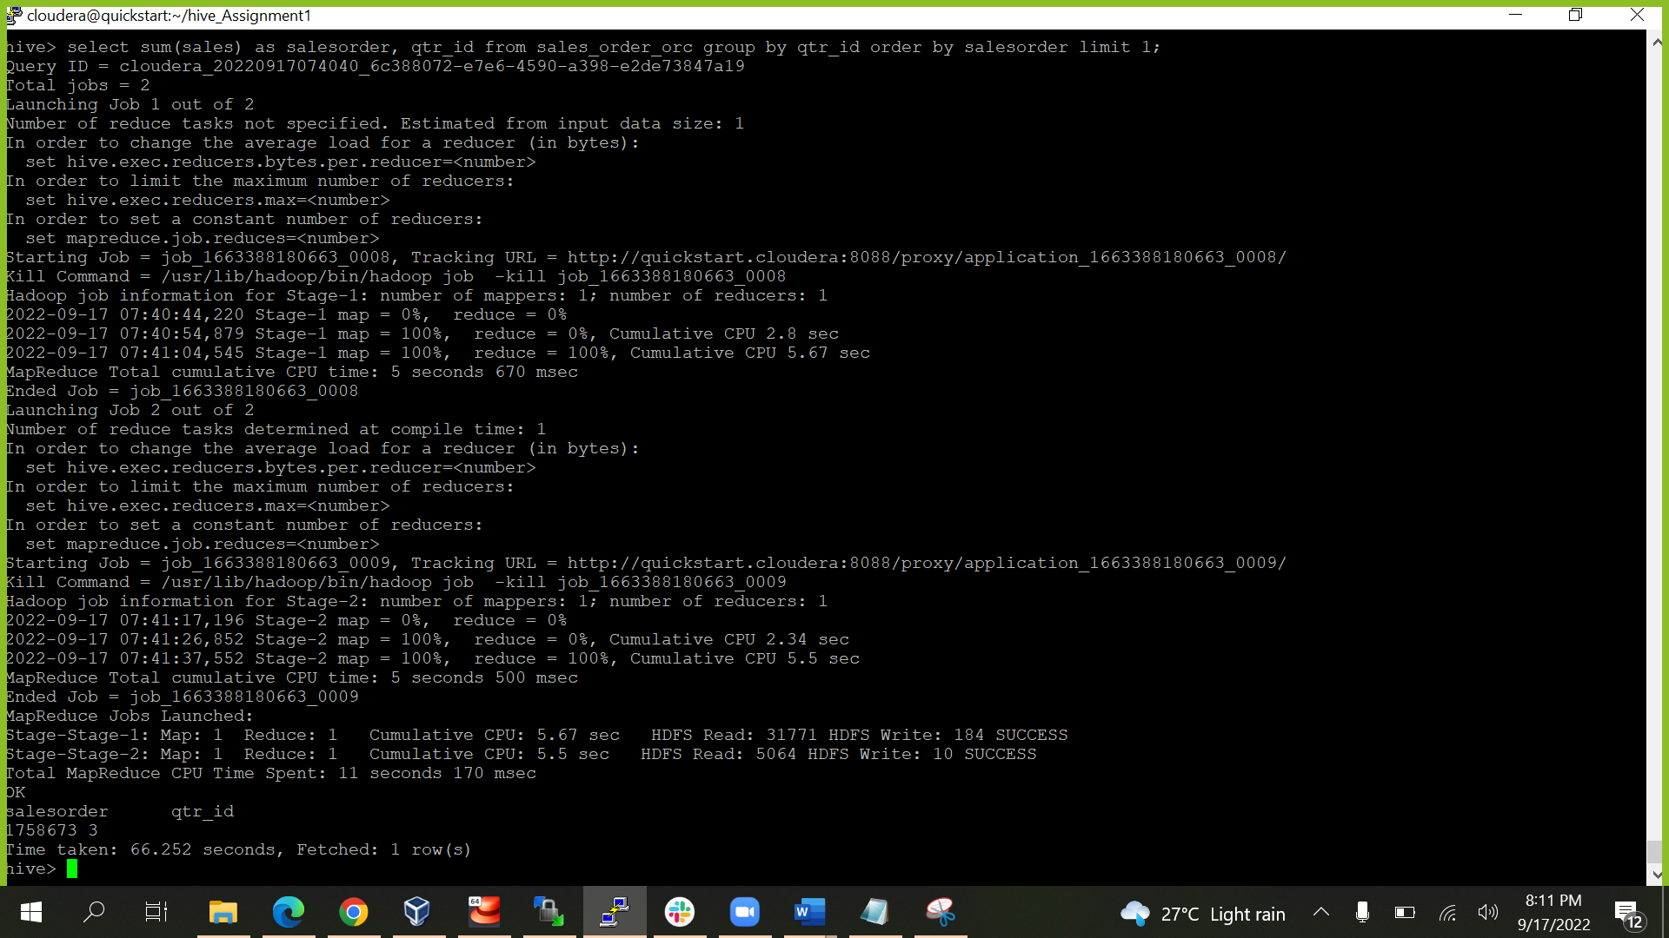

e. In which country sales was maximum and in which country sales was minimum.

**SELECT A.country, A.sales FROM(SELECT country,Sales,RANK() OVER (ORDER BY sales) rnk_min,RANK() OVER (ORDER BY Sales DESC) rnk_max FROM sales_order_orc)A WHERE rnk_min = 1 OR rnk_max = 1 ORDER BY Sales;**

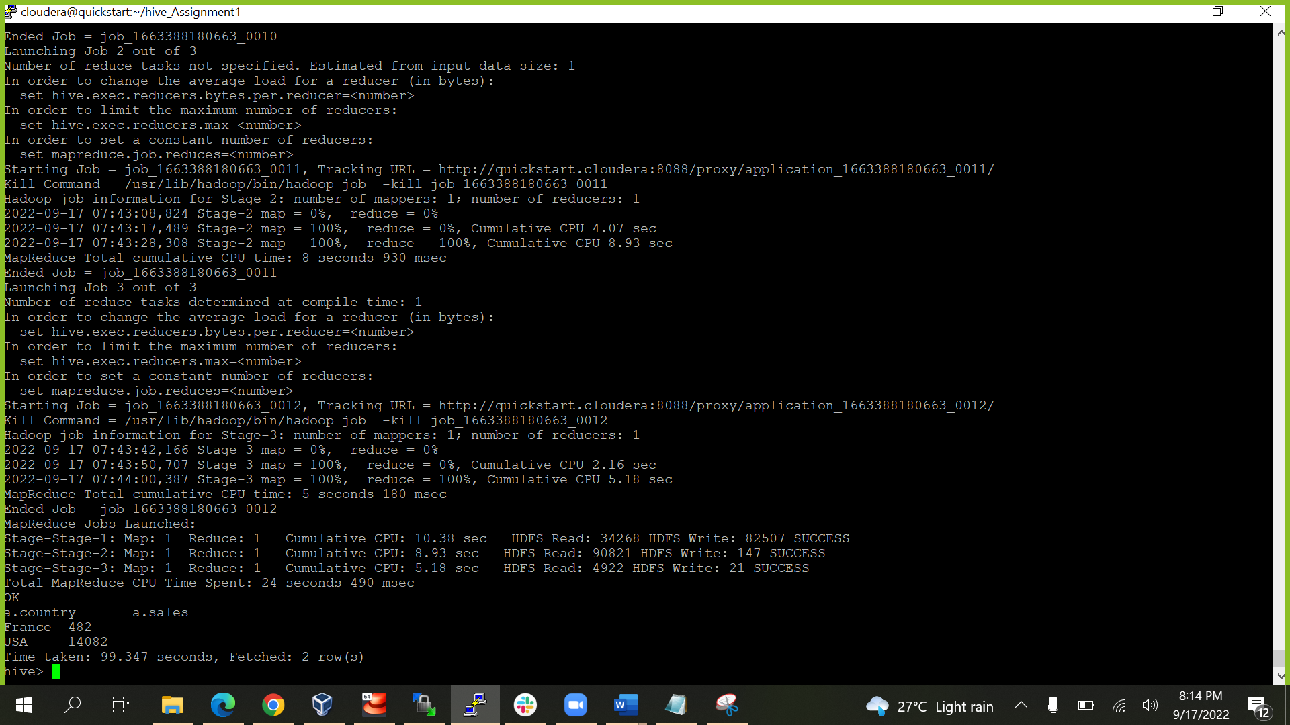

f. Calculate quartelry sales for each city.

**Select sum(sales) as Quarter_sales, qtr_id, city from sales_order_orc group by qtr_id, city;**

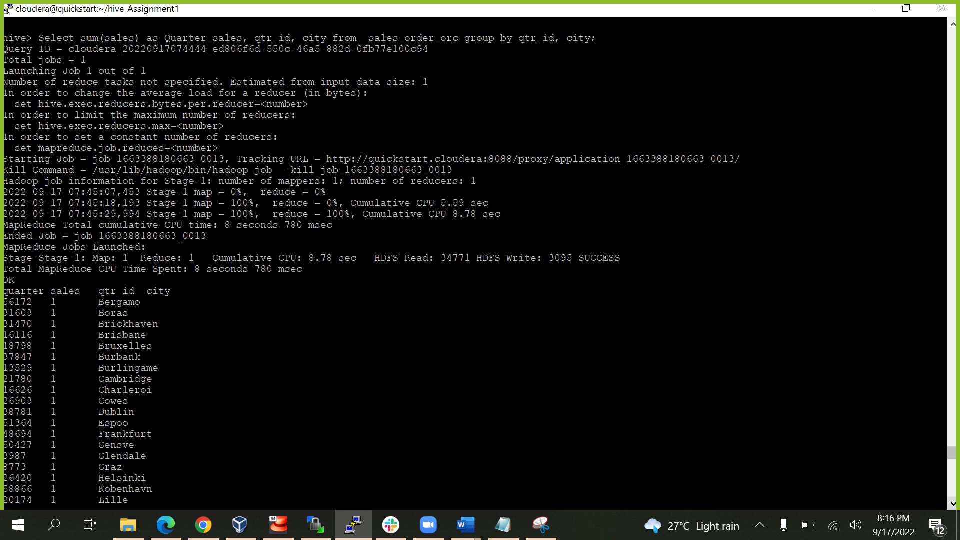

h. Find a month for each year in which maximum number of quantities were sold

**select month_id,year_id,QUANTITYORDERED from (select month_id,year_id,QUANTITYORDERED ,dense_rank() over(partition by year_id order by QUANTITYORDERED desc) as rnk from sales_order_csv)a where a.rnk =1;**

