Assignment(1)

Archana Gadicharla

2024-02-02

## R Markdown

netflix_india <- read.csv("C:\\Users\\archa\\Downloads\\archive (2)\\netflix_india_shows_seasons.csv")  
View(netflix_india)

This file has been imported from <https://www.kaggle.com/datasets/jhajalaj/netflix-india-shows-and-movies>

mode(netflix_india$episode_count)

## [1] "numeric"

median(netflix_india$episode_count)

## [1] 10

mean(netflix_india$episode_count)

## [1] 11.99176

max(netflix_india$episode_count)

## [1] 188

sd(netflix_india$episode_count)

## [1] 10.13416

These values represent descriptive statistics for a selection of quantitave variables. The above values shows mode, median, maximum,and standard deviation for the quantitave variables.

str(netflix_india$name)

## chr [1:4368] "Friends" "Friends" "Friends" "Friends" "Friends" "Friends" ...

These values represent categorical descriptive analysis of variables.

netflix_india_transformed <-(netflix_india$episode_count - mean(netflix_india$episode_count)/median(netflix_india$episode_count))  
head(netflix_india_transformed)

## [1] 22.80082 22.80082 23.80082 22.80082 22.80082 23.80082

Transformation of variables has been done above.

hist(netflix_india$release_year)

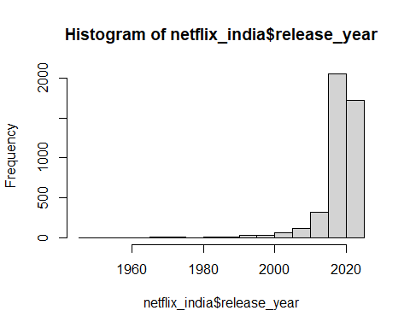 The above graphical representation is a histogram.

x <-netflix_india$release_year  
y <-netflix_india$episode_count  
plot(x,y, main="Scatterplot", xlab = "release_year", ylab = "episode_count" )

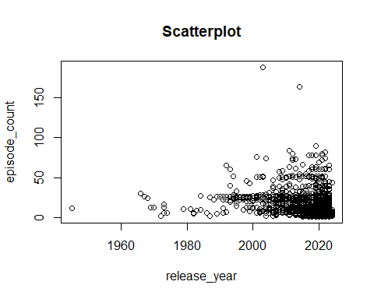 The above graphical representation is a scatterplot. The selected variables are episode_count and release_year.