Create a Repository:

right corner-> click on + sign-> create repository

https://github.com/ArchanaHassan/gitDemoRepo.git

=======================================

How to generate SSH key for gitHub

$ ssh-keygen -t rsa -b 4096 -C "archanakl.05@gmail.com"

Note : Error : when you are copying the command line check $ symbol if it copied twice then it will through command not found error

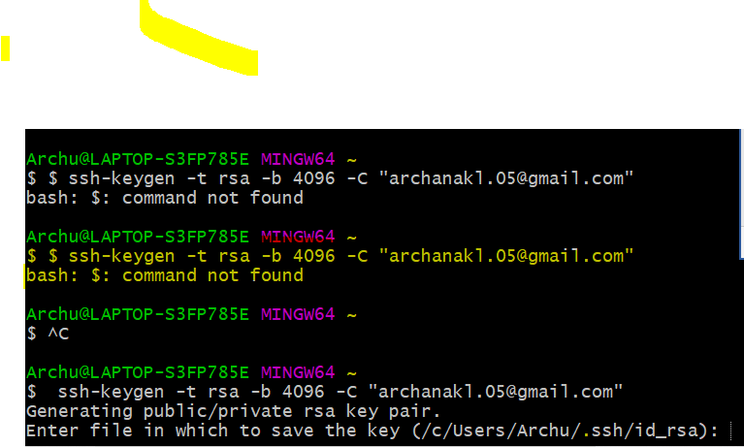

Why SSH key ?

When we are working with git hub repository we need to identify yourself to github using user name and password .:

Using SSH key does not require to enter username and password every time

It comes in pairs public and private key

* Pub key -shared with gib hub
* Private key stored on your computer if it match, 9we can access

Git Init command:

$ dir -AH => it will show hidden directories

Note : Error:

$ git commit -m "initial commit"

\*\*\* Please tell me who you are.

Run

git config --global user.email "you@example.com"

git config --global user.name "Your Name"

to set your account's default identity.

Omit --global to set the identity only in this repository.

fatal: unable to auto-detect email address (got 'Archu@LAPTOP-S3FP785E.(none)')

Solution: its pretty simple but tricky at the first time.  
For example:  
If my email is [mrsuicidesheep@gmail.com](mailto:mrsuicidesheep@gmail.com)  
type:  
git config --global user.email [mrsuicidesheep@gmail.com](mailto:mrsuicidesheep@gmail.com)  
OR  
If my username is mrsuicidesheep  
type:  
git config user.name mrsuicidesheep