

EDS 6397 – Natural Language Processing

Abstractive News Summarization using BART and MISTRAL

Submitted by

ARCHANA LAKSHMINARASIMMAN - 2409599
SAI TANMAI BURELA - 2360570

Under the guidance of Dr. Nima Ekhtari, Ph.D. Cullen College of Engineering
University of Houston -Main Campus

Table of Contents
- Introduction 3-4
  - Problem Statement 3
  - Literature Review 4
- Dataset(s) Used 4-5
  - Description of Datasets 4
  - Preprocessing Steps 5
- Methodology 5-8
  - Model Architecture 5
  - BART Model: Pretrained and LoRA Fine-Tuned 6
  - Mistral Model: Pretrained and LoRA Fine-Tuned 7
- Results 8-10
  - Evaluation Metrics (ROUGE, BERTScore) 8
  - BART vs Mistral: Pretrained and Fine-Tuned Comparison 9
  - Visual Analysis 10
  - Demo Interface Implementation
- Discussion 11
  - Challenges 11
  - Recommendations for Future Work 11
- Conclusion 12
- References 12

Introduction:
  - Problem Statement:

There are thousands of articles published in digital platforms such as news websites, apps every day. People often struggle to read and understand the entire context of the news due to its abundance source of information. Extractive summarization methods effectively select and concatenate the sentences. They lack coherence between the sentences and nuanced understanding given by human-generated summaries. In contrast, abstractive summarization models provide more coherent, human-like summaries by generating new sentences and it also captures the underlying semantic relationship.

Recent development of transformer-based models such as BART (Bidirectional and Auto-Regressive Transformers), has shown strong performance in abstractive news summarization due to its blend of encoder-decoder style architecture. Newer Large Language Model such as Mistral also has potential for handling complex tasks such as summarization by using enhanced contextual understanding and generative fluency. However, there are practical challenges to implement these models: accuracy of generated summaries, relevance of summaries while comparing human written and generated summaries and computational efficiency.

Thus, this project aims to comparatively evaluate and enhance abstractive summarization performance using BART and Mistral models on news article dataset. The goal is to achieve concise, coherent and consistent summaries. Metrics such as ROUGE (Recall-Oriented Understudy for Gisting Evaluation) and BERT Scores are used to analyze and compare the effectiveness of the models in real-world news article summarization tasks.

  - Literature Review:

Automatic text summarization has been extensively studied to reduce lengthy documents into concise and coherent summaries [1]. The methods have been categorized into two approaches: extractive and abstractive summarization. Traditional models relied on extractive methods, utilizing statical, lexical and positional features to identify important sentences. Recent trends indicate significant shift towards abstractive approaches due to advancement in deep learning and natural language generation techniques that helps in achieving more readability and fluency.

The introduction of neural network-based architectures, such as sequence-to-sequence (seq2seq) models with attention mechanism significantly advanced abstractive summarization [2]. Notable architectures include recurrent neural networks (RNNs) with attention and convolution neural networks (CNNs). However, early approaches faced issues such as repetition, hallucination and factual inaccuracies due to limited contextual understanding [3].

BART combines the strength of BERT’s bidirectional encoder and GPT’s autoregressive decoder, making it particularly suited for abstractive summarization tasks [4]. As demonstrated in [4], BART archives superior performance on benchmarks like CNN/DailyMail and XSum by effectively capturing semantic contexts and generating coherent summaries with fewer hallucinations compared to other models.

Recently Large Language Models (LLMs) such as GPT-4, LLaMA and Mistral have shown remarkable generative capabilities due to their massive scale, improved training strategies and enhanced architecture innovations. Mistral demonstrates excellent generalization and contextual understanding in complex generative tasks [5].

Parameter-efficient fine-tuning approach such as LoRA (Low rank Adaptation) has emerged recently to reduce the computational overhead by injecting low-rank trainable matrices to existing transformer layers without altering the original model weights [6]. Unlike traditional full model fine-tuning, LoRA fine-tunes a minimal subset of parameters, which helps in quicker adaptation and reduced memory consumption.

Despite the promising results from LoRA based fine-tuning, comparative studies explicitly evaluating the performance of BART and Mistral leave much room for further development. Thus, this project addresses the identified research gap by systematically evaluating and comparing LoRA-based fine-tuning strategies using ROUGE and BERT scores across these two prominent transformer models for the task of abstractive news summarization.

Datasets Used:

  - Description of Datasets:

CNN-DailyMail Dataset: [7]

The CNN/DailyMail dataset is a large dataset designed for training and evaluating abstractive summarization systems. It includes around 300K original news articles sourced from CNN and DailyMail websites, each accompanied by a concise, human-written abstractive summary (highlights). In this project, a subset of 3000 records was utilized, partitioned into 80% for training and 20% for testing purposes due to computational complexity. Each dataset entry consists of three primary fields:
- Article: The full text of the original news article, capturing detailed narrative and context.
- Highlights: Concise abstractive summaries crafted by human annotators, capturing key points from the article.
- ID: A unique identifier associated with each article-summary pair for tracking and reproducibility.
This structured dataset enables effective training, evaluation, and benchmarking of summarization models, particularly transformer-based models like BART and Mistral.

  - Preprocessing Steps:
The primary preprocessing tasks performed before model training and evaluation include:
- Feature Selection:
Selected relevant features such as the article text, human-written highlights, and discarded the unique identifier (ID) which was irrelevant to summarization task.
- Normalization:
Applied Unicode normalization (unicodedata.normalize) to standardize text data and ensure consistency, addressing potential encoding discrepancies.
- HTML Tag Removal:
Removed HTML tags from text content using regular expressions (regex), ensuring clean and structured textual input.
- Whitespace and Punctuation Trimming:
Eliminated redundant whitespaces and punctuation to enhance text uniformity, readability, and subsequent model tokenization efficiency.
- Dataset Conversion:
Converted the cleaned data frame into a Hugging Face Dataset format, enabling integration with BART and Mistral models.

Methodology:
  - Model Architecture:
The project structure is geared to compare and test the performance of two of the most popular transformer-based language models in abstractive news summarization: Mistral, which is a decoder-only model, and BART, an encoder-decoder model. The overall pipeline is intended to compare the performance of the two models in two different settings: pretrained (zero-shot) and LoRA fine-tuned over a shared dataset.
We start with a dataset of 3,000 records, long-form news articles and their human-generated summaries, from the CNN/DailyMail dataset. A constant random seed (42) was used in sampling this data to create uniformity and fairness between both model pipelines. The data was cleaned and formatted into a default structure with basic preprocessing.
Following preprocessing, the architecture diverges into two similar but parallel pipelines: one for Mistral and one for BART.
- Articles are fed through the facebook/bart-large-cnn tokenizer in the BART pipeline, which tokenizes the text into token IDs using Byte Pair Encoding (BPE). To produce summaries, these are fed into the pretrained BART model. We fine-tune with LoRA (Low-Rank Adaptation), which introduces trainable parameters to the encoder and decoder's attention layers. Because the other weights are frozen, the training is effective, and the model's performance remains enhanced. New summaries are then produced for comparison according to this enhanced model.
- Each article is resized to an instruction-type prompt for Mistral's decoder-only, instruction-finely-tuned model in the pipeline, e.g., "Summarize this article: [article]". Tokenization is performed by an AutoTokenizer, and inputs are fed into the Mistral-7B-Instruct-v0.2 model. We generate outputs from base pretrained and fine-tuned via LoRA wrapped versions, like BART configuration. LoRA is applied solely to the self-attention head of the decoder in this instance.
- To make inferences efficient and accurate, the two models both employ a generation strategy specifically designed for summarization with beam search, max length truncation, and early stopping.
- Standardized metrics like ROUGE-1, ROUGE-2, ROUGE-L, ROUGE-Lsum, and BERTScore (F1) are then used to quantify and compare the output of the four configurations: Pretrained BART, Fine-Tuned BART, Pretrained Mistral, and Fine-Tuned Mistral. We could reasonably test the advantages of both model architecture and fine-tuning under the same input conditions because of our modular, side-by-side design.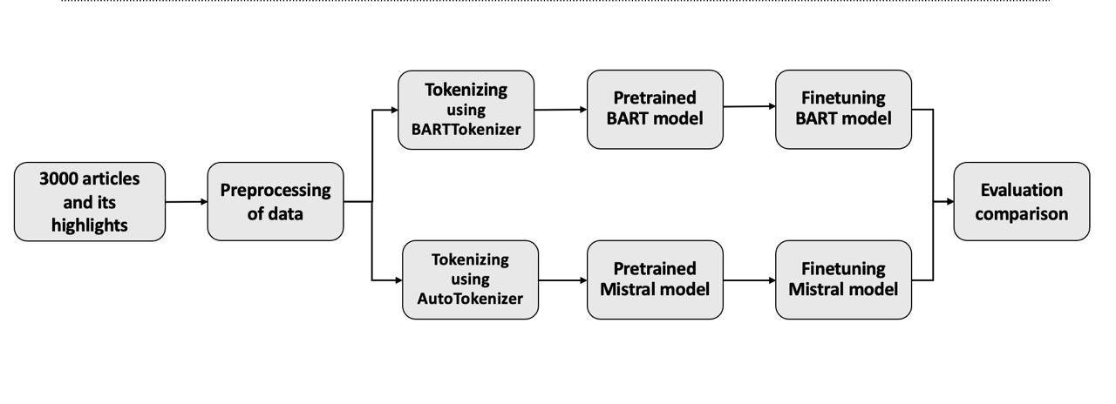

  - Pretrained BART:

For this task, the facebook/bart-large-cnn model of Hugging Face Transformers was utilized, which is a pre-trained encoder-decoder model specifically structured for abstractive summarization. The pipeline starts with the passage of the raw news article to BART's tokenizer, which uses Byte Pair Encoding (BPE) to tokenize text into sub word units to process rare or compound words efficiently. The tokenized input is then fed into the model's encoder-decoder layers.

The sequence of input is encoded by the encoder using feedforward layers and self-attention layers to give a contextualized representation of the article. This representation is provided to the decoder, where the decoder produces the summary stepwise without looking at future tokens during generating with the help of masked self-attention.

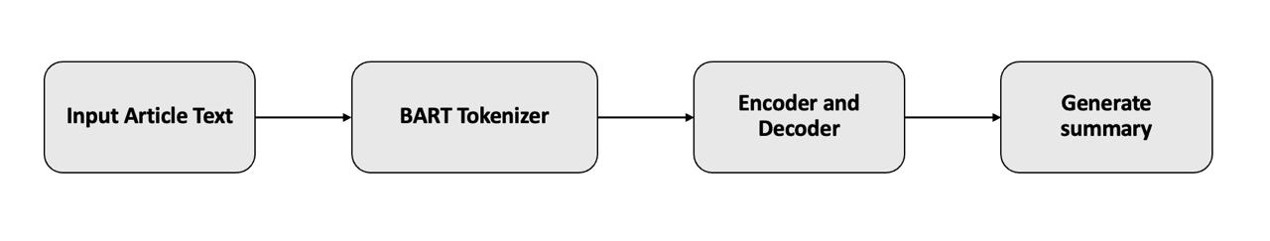
Most of the news articles in the dataset can be captured under the 1024 tokens window that is set for the model. Beam search with four beams was activated to guarantee high-quality summaries, permitting the decoder to consider a few probable sequences and choose the most likely one. To prevent having too lengthy outputs, early stopping was enabled, and the maximum generated summary length was set at 150 tokens. Given this setting's excellent summarization quality out of the box, BART can be used as a good baseline against which the fine-tuned models will be compared.

Hyperparameter | Value
Model | facebook/bart-large-cnn
Context Window | 1024
Max Length | 150
Early Stopping | True
Number of Beams | 4
Learning Rate Scheduler | Linear
Metric for Best Model | F1

  - Finetuned BART:

To help the pretrained Facebook/Bart-large-cnn model work better for the dataset, Low-Rank Adaptation (LoRA), a simple fine-tuning method was used. As such, it was suitable to add trainable weights to certain BART components without having to change the entire parameter space.

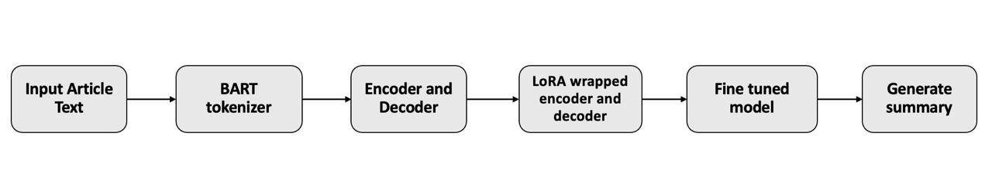
Having fed the same tokenized input article text through the encoder-decoder architecture of BART, fine-tuning pipeline began. The two important components to which trainable parameters were added after wrapping the model with LoRA are the self-attention layers of the encoder and decoder. To drastically cut down memory and computation overhead, the remaining model weights were frozen to a constant value. In our configuration:

- To specify the size of the low-rank matrices, the LoRA rank was set to 8.
- To determine the scale utilized on these matrices while training, alpha was set to 16.
- Since BART is a typical encoder-decoder model, the model was trained using the Seq2Seq objective (teacher forcing); dropout 0.1 was included to attempt to avoid overfitting.
- After each of the three training epochs, evaluations were made.
- Adam optimizer was used with a learning rate of 1e-4.

Hyperparameter | Value
Task Type | Seq2Seq
Rank | 8
Alpha | 16
Dropout | 0.1
Eval Strategy | Epoch
Epochs | 3
Learning Rate | 1e-4
Optimizer | Adam

This configuration made it a very effective fine-tuning strategy because training was performed on only 0.28% of the total model parameters (1,179,648 out of 407 million). With the same inference strategy as in the pretrained setup, the fine-tuned BART model was employed to produce summaries on the test set after training.

  - Pretrained Mistral:

The decoder-only model baseline was Hugging Face's Mistral-7B-Instruct-v0.2 model, which is an instruction-tuned large language model that has general text generation capabilities. Mistral was conditioned to this task by translating each input article into an instruction-following prompt format as it's not necessarily a model meant for summarization.

Token IDs were generated from the string in this question by passing it through an Auto Tokenizer. To make it compatible with the model's maximum token limit, the input was truncated to a context window of 1024 tokens. The default decoder-only causal language modeling approach, which enables the model to produce text left to right token by token, was used to produce the output summary.

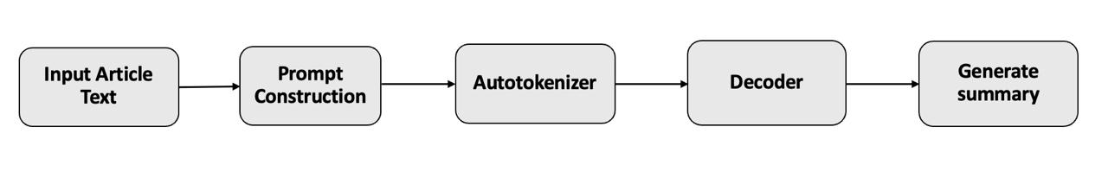

To prevent too lengthy summaries, early stopping was used on generation and the output was set to a maximum of 150 tokens. The 4-bit quantization was also implemented, which allowed the model to successfully run on a GPU with limited memory and greatly reduced the memory used while inferring.

Hyperparameter | Value
Model | Mistral-7B-Instruct-v0.2
4-bit quantization | True
Context | 1024
Max Length | 150
Early Stopping | True
Weight Decay | 0.01
Beam Width | 5

This step was included to test Mistral as a general-purpose language model first and then test it against its fine-tuned version, despite not being pre-trained specifically for summarization.

  - Finetuned Mistral:

The LoRA method was used for effectively fine-tuning the pretrained Mistral-7B model with significant reduced computational overhead. Each news article was converted into structured prompts explicitly instructing the model to generate summaries. Articles were tokenized using Huggingface Autotokenizer designed specifically for Mistral-7B model with strategic padding and truncation applied to standardize the input lengths. These tokens are fed into LoRA-wrapped decoder module, wherein low rank adapters were injected into key and value projection sublayers (q_proj, vproj) to capture task specific adaptations without altering pre-trained parameters.
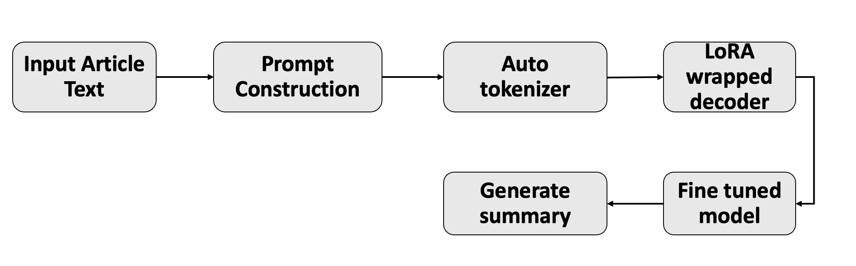

Rank-8 decomposition with alpha scaling factor of 32 was used which controls the influence of trainable weight matrix. Training proceeded for 3 epochs with model evaluation conducted at the end of each epoch to monitor summarization quality and to select best checkpoints. The adam optiomizer was used at learning rate of 5e-5, striking a balance between convergence speed and stability. Dropout rate of 0.1 was used to prevent overfitting. By freezing the original decoder weights and updating only LoRA adapters, it reduced computational efficiency and leveraged the robustness of pre-trained model.

Hyperparameter | Value
Task Type | Causal_LM
Target Modules | q_proj, v_proj
Rank | 8
Alpha | 32
Dropout | 0.1
Eval Strategy | Epoch
Epochs | 3
Learning Rate | 5e-5
Optimizer | Adam

The fine‐tuned model generated summaries by decoding the LoRA‐adapted representations through the original language modeling head. Preliminary evaluations on standard news summarization metrics demonstrated that the adapter‐based fine‐tuning yields competitive ROUGE scores compared to full‐model tuning. In total, the full model comprises 3,755,479,040 parameters, of which only 3,407,872 (≈0.09 %) are trainable adapter parameters, thereby underscoring the efficiency of the method.

- Results:

This section presents the performance of all four model variants evaluated on the test split of 3,000 CNN/DailyMail news articles. We compare pretrained and fine-tuned versions of BART and Mistral, using ROUGE and BERTScore as our evaluation metrics.

Evaluation Metrics Used

To assess the quality of the generated summaries, we implemented the following measures:

ROUGE-1: Measures the number of unigrams (single words) shared between the reference and generated summaries.

ROUGE-2: Finds overlap between word pairs, or bigrams.

ROUGE-L and ROUGE-Lsum: While finding the longest subsequence of tokens, ROUGE-L and ROUGE-Lsum provide structure and fluency insight.

BERTScore (F1): Evaluates the semantic similarity of the generated and reference summaries based on contextual embeddings from BERT.

4.2 Metric Scores
The table below summarizes the evaluation scores for each of the four models:
Metric | Pretrained BART | Fine-Tuned BART | Pretrained Mistral | Fine-Tuned Mistral
ROUGE-1 | 0.39 | 0.40 | 0.12 | 0.17
ROUGE-2 | 0.18 | 0.19 | 0.07 | 0.08
ROUGE-L | 0.27 | 0.29 | 0.09 | 0.12
ROUGE-Lsum | 0.27 | 0.29 | 0.09 | 0.15
BERTScore (F1) | 0.85 | 0.87 | 0.82 | 0.83

4.3 Analysis: BART vs Mistral

- On all BARTScore and ROUGE metrics, BART outperformed Mistral, both the pre-trained and the fine-tuned version. This is expected as BART was pre-trained on the same data (CNN/DailyMail) and is optimized for summarization tasks.
- With no extra training, pretrained BART already proved the effectiveness of pretraining for tasks by functioning well.
- There was a tiny but persistent improvement of ROUGE and BERTScore following LoRA's fine-tuning of BART by just 0.28% of its parameters.
- This tiny consistent gain is in fact affirmative evidence of the value of LoRA in assisting successful fine-tuning.

4.4 Analysis: Effect of Fine-Tuning
- Mistral gave lower performance when used in its original form because it is an encoder-general model.
- Its ROUGE-1 and ROUGE-Lsum metrics, however, showed significant improvement after they had already been fine-tuned using LoRA.
- Although their baseline performance lags behind summarization-tailored models like BART, fine-tuned and improved Mistral demonstrates that even the general-purpose models might be transferable to summarizing.

4.5 Visual Comparison
Below is a bar chart comparing the ROUGE and BERTScore scores across all four models, clearly showing the improvement due to fine-tuning and the overall advantage of BART:

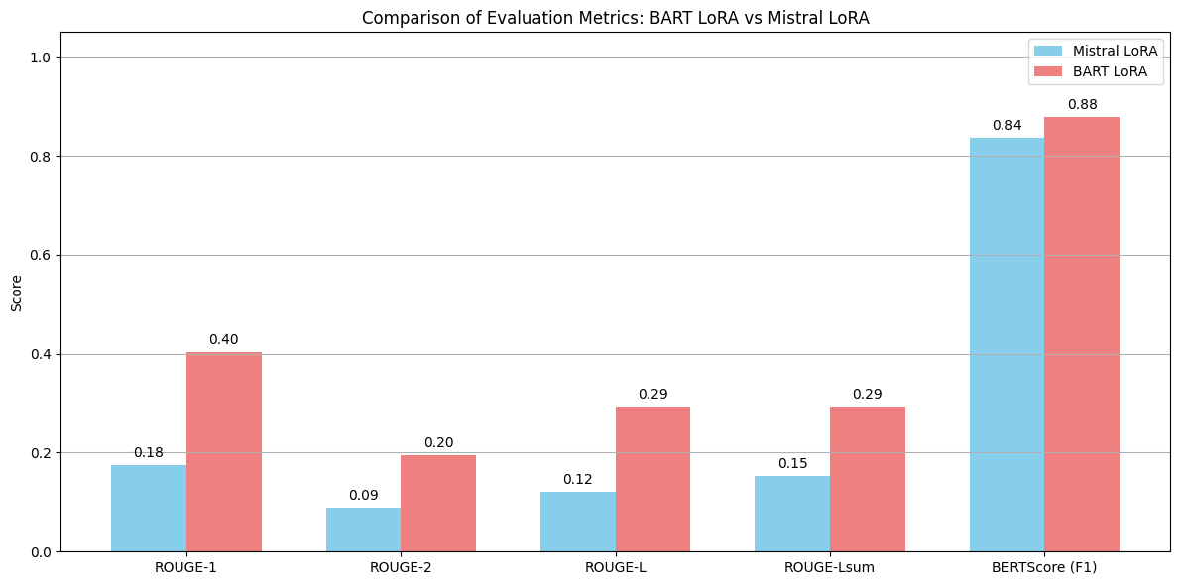

4.6 Summary of Observations
- Mistral improved with fine-tuning but was still short of BART on all measures.
- BART produced the best overall performance, particularly after LoRA fine-tuning.
- Task-specific training and model architecture do affect the summarization performance, as the test demonstrates.
- LoRA augmented both models with low compute cost, which was beneficial for memory-limited situations.

Discussion
  - Challenges and limitations:
Despite the reality that fine-tuned and pretrained models of abstractive summarization were successfully utilized, our research was confronted by various practical and technological constraints that reduced the testing and evaluation scope.
- Varying Quality of Data
While intensively utilized, the CNN/DailyMail dataset occasionally has diverse writing styles, duplicated sentences, or unusual formatting. While the data were largely clean, the integrity of the evaluation and training efficiency might have been damaged by sporadic noise in the article text or highlights. Additionally, though useful, the utilization of a set 3,000-record subset would have prevented the model from being exposed to a larger variety of linguistic structures.
- Hardware and Memory Constraints
It took a lot of GPU memory to train massive models like Mistral-7B and BART-large. CUDA Out of Memory (OOM) error was common in training in Google Colab Pro, especially in trying long input sequences or full fine-tuning. This forced us to:
Limit training in one epoch for Mistral.
Use LoRA and 4-bit quantization to lower the memory requirement.
Employ small batch sizes (two, for instance) to accommodate hardware constraints.
These choices, although necessary, might have limited our models' highest capacity.
- Complexity Fine-Tuning
Compared to BART's encoder-decoder architecture, modifying LoRA fine-tuning to decoder-only models like Mistral was quite complex. More testing and debugging were necessary due to the hurried construction and cautious handling of causal attention, particularly for preventing training errors and input-label mismatch.
- Sensitivity to Hyperparameters
We were unable to perform thorough hyperparameter optimization due to time and resource limitations. Defaults or minimal grid search were used to choose parameters such as learning rate, dropout, LoRA rank, and beam size. Particularly in the Mistral pipeline, where changes were more sensitive, this would have resulted in suboptimal training.
- Limitations of the Evaluation
Although we used traditional evaluation metrics like ROUGE and BERTScore, they have limited capability in evaluating grammatical fluency, factual consistency, and coherence of summaries. Although human evaluation was not possible within the project timescale, it may give more revealing information. Furthermore, a larger evaluation set would have given more trustworthy results as we only used a 20% test split.
  - Recommendations for Future Work:
By training the Mistral model over many epochs, we hope to expand the LoRA fine-tuning of the model in the future, which may further enhance the summarization quality. Furthermore, we intend to provide a comprehensive interactive demonstration for the refined Mistral model, akin to the one we executed for BART. This would provide a more useful illustration of our findings by enabling users to enter articles and compare summaries produced by both methods in real-time.

Conclusion

Using a part of the CNN/DailyMail dataset, we evaluated the pretrained and LoRA-fine-tuned versions of the BART and Mistral models that we used to implement abstractive news summarization in this research. In terms of ROUGE and BERT Score measures, BART, an encoder-decoder model tailored for summarization, performed better than Mistral. Mistral's performance was much enhanced by fine-tuning with LoRA, demonstrating that even general-purpose models may adjust to summarizing tasks with little training overhead. Despite obstacles like limited training epochs and hardware constraints, our work showed that parameter-efficient fine-tuning techniques like LoRA are very successful. All things considered, our study demonstrates the importance of model architecture, fine-tuning, and resource optimization in creating summarization systems and lays the groundwork for further advancements using larger datasets and longer training periods.

References

- A. Nenkova and K. McKeown, "Automatic summarization," Foundations and Trends in Information Retrieval, vol. 5, no. 2–3, pp. 103–233, 2011.
- A. M. Rush, S. Chopra, and J. Weston, "A neural attention model for abstractive sentence summarization," in Proc. 2015 Conf. Empirical Methods in Natural Language Processing (EMNLP), Lisbon, Portugal, 2015, pp. 379–389. C. S. a. R. Mihalcea, "Learning to Identify Emotions in Text," Learning to Identify Emotions in Text, vol. 15, no. 4, pp. 1-15, 2014.
- A. Vaswani, N. Shazeer, N. Parmar, J. Uszkoreit, L. Jones, A. N. Gomez, Ł. Kaiser, and I. Polosukhin, "Attention is all you need," in Advances in Neural Information Processing Systems (NeurIPS), vol. 30, 2017.
- M. Lewis, Y. Liu, N. Goyal, M. Ghazvininejad, A. Mohamed, O. Levy, V. Stoyanov, and L. Zettlemoyer, "BART: Denoising sequence-to-sequence pre-training for natural language generation, translation, and comprehension," in Proc. 58th Annu. Meeting Assoc. Comput. Linguistics (ACL), 2020, pp. 7871–7880.

- A. Q. Jiang, T. Scialom, A. Fan, E. Pajarskas, G. Ghosh, A. Guha, and A. Synnaeve, "Mistral 7B," arXiv preprint arXiv:2310.06825, Oct. 2023.

- E. J. Hu, Y. Shen, P. Wallis, Z. Allen-Zhu, Y. Li, S. Wang, and W. Chen, "LoRA: Low-rank adaptation of large language models," in Proc. Int. Conf. Learn. Representations (ICLR), 2022.

- G. Sankar, "Newspaper Text Summarization: CNN-DailyMail," Kaggle, 2024. [Online]. Available: https://www.kaggle.com/datasets/gowrishankarp/newspaper-text-summarization-cnn-dailymail

