./

Report – CASE STUDY

Course Code: <CODE>



Version Number:

Team Members :

Team No:

Module: Model Based System Engineering

|  |  |  |  |  |  |
| --- | --- | --- | --- | --- | --- |
| **Ver. Rel. No.** | **Release Date** | **Prepared. By** | **Reviewed By** | **Approved By** | **Remarks/Revision Details** |
| 1 | 16/09/2021 | MEESALA ARCHANA |  |  |  |

**Document History**

# 

## **CASESTUDY**

## **Introduction :**

This is the case study of seat heat monitoring system . In this seat heat monitoring system the sensor will sense the presence of person in the seat and changes the temperature accordingly. If the person is seated and node/ switch has been pressed then only temperature for the seat can be updated ,else if either the person has not been seated or the switch has not been pressed then the temperature cannot be updated for seat.

The system design consists of a main board controller and an heating element, which represents the resistive heating component in automotive seat heaters, which control the temperature of each seat as well as provide robust and protection .

**Design :**

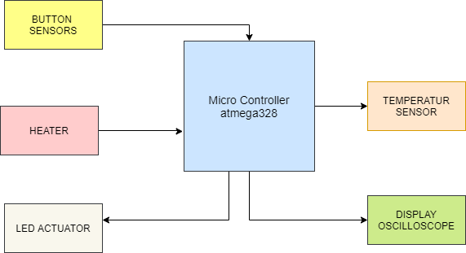

**Fig.1.0 Block Diagram**

**Features :**

* The system design is simple
* Monitors Actively
* It has Resistive Load Heating Element.
* light-emitting diode (LED) driver provides status indication
* Potentiometer is used for temperature modification.
* As per the person request, the temperature of seat is adjusted.
* Robust system.

## **Activity 1**

1. To check whether the seat is occupied by person or not.

2. To check the status of heater.

3. Indicating the seat occupied and status of heater using LED actuator.

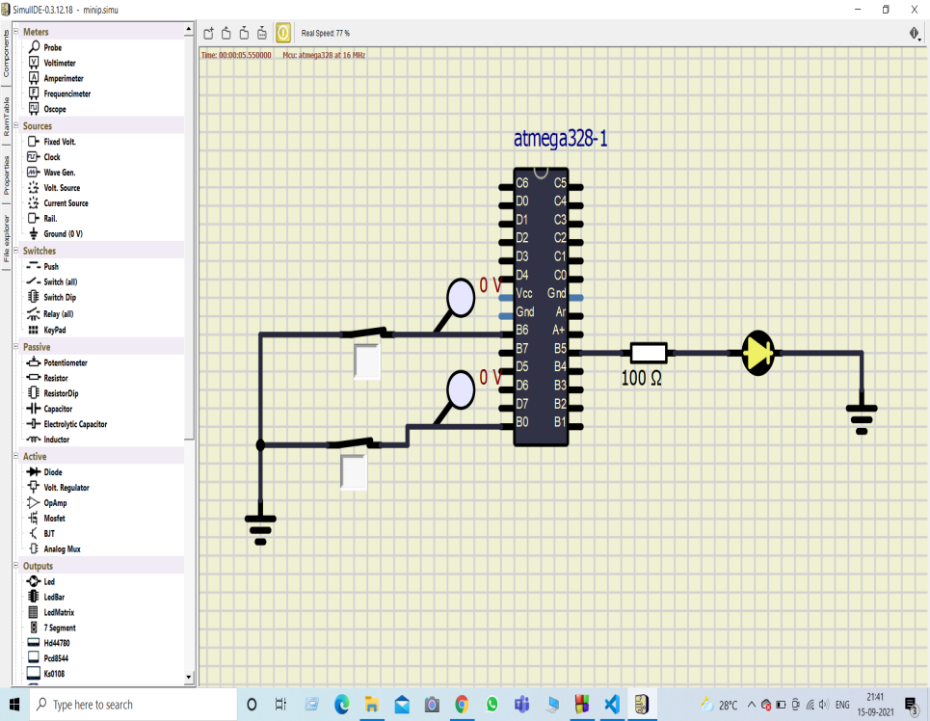

Fig.1.1 Activity1

## **Activity 2**

1. To interface temperature sensor with microcontroller.

2. To read the temperature value set by the user.

3. To convert the Analog value of temperature to digital value.

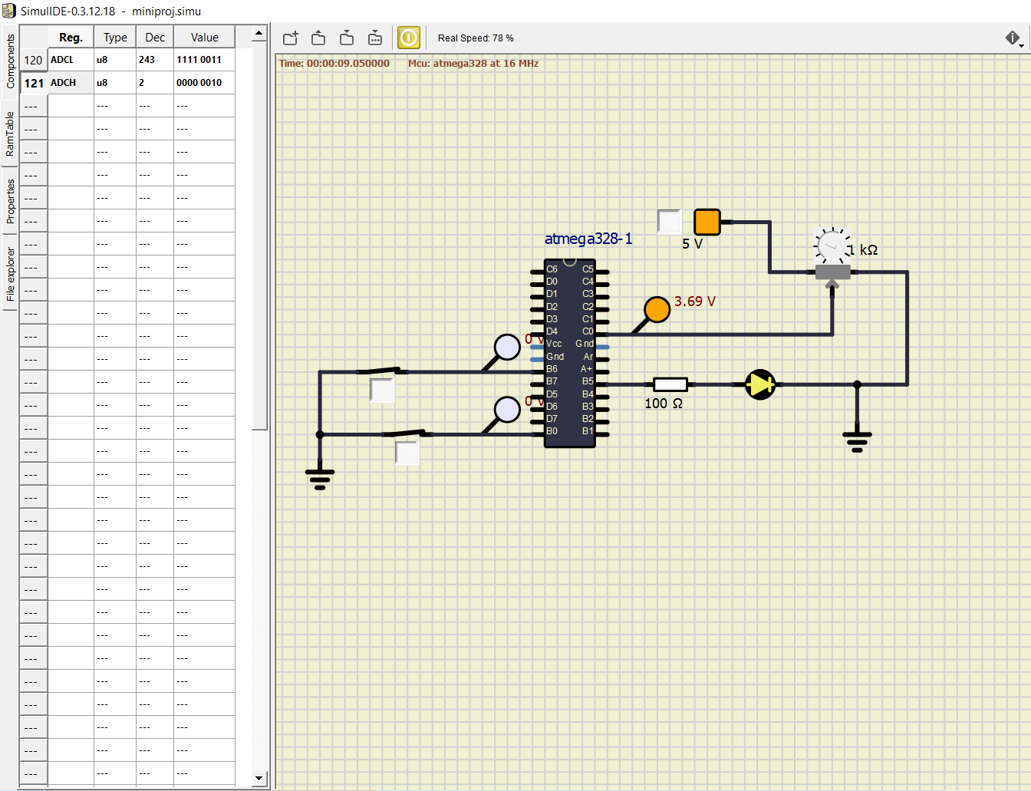

Fig.1.2 Activity2

## **Activity 3**

1. To generate PWM pulse with varying duty cycle based on the temperature value set by the user.

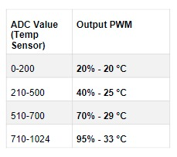

Fig. 1.3 Activity3

The below fig.1.4 shows the circuit diagram of displaying pwm output when the button sensors both are pressed .

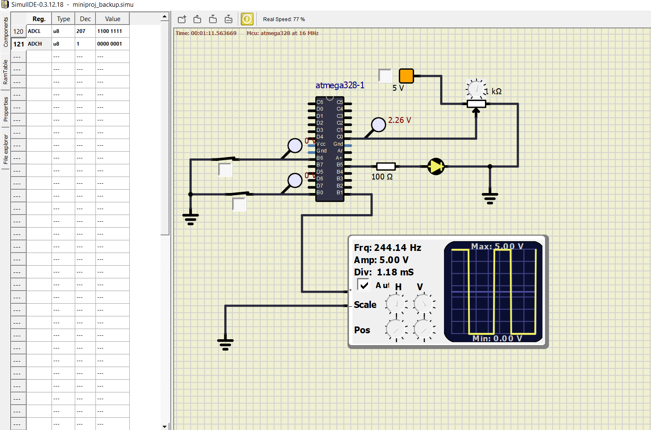

Fig.1.4 Activity3