KillTheZombie Game Analysis:

* KillTheZombie Game was released in July 2019.
* The analysis was carried out using pandas.
* The game data has been taken from firebase. The data was in “.json” format.
* The data was then converted into a pandas DataFrame and was sort on the basis of high-scores in descending order.
* The counts per level line and bar plots are shown below:

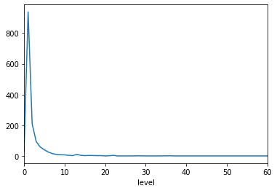

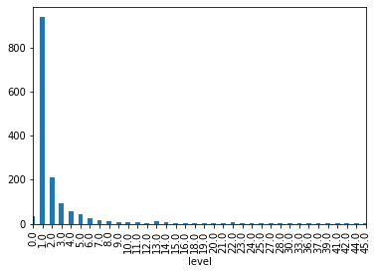

* By observing these plots, it is found that most of the users are at level 1. The count of the number of users is decreasing with the level.
* The plot for the count of number of attempts at level 1 is shown below:

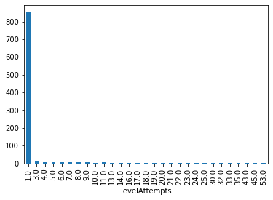

* By observing this plot, it is found that most of the users have attempted level 1 only once.
* There may be two causes for this:

1. The difficulty in passing the level 1 by the users.
2. The low interest of users in the game.