# **CLOUD APPLICATION DEVELOPMENT**

**Team member: M.Archanaa(410621104014)**

## **GROUP-1 Project 4: Image Recognition with IBM Cloud Visual Recognition**

## **Phase 2: INNOVATION**

**Consider incorporating sentiment analysis to generate captions that capture the emotions and mood of the images in IBM cloud visual recognition.**

**Explain in detail the complete steps that will be taken by you to put your design that you thought of in previous phase into transformation.**

To implement sentiment analysis for generating captions based on image emotions using IBM Cloud Visual Recognition, we’ll need to go through several steps. Here’s a detailed breakdown:

**1.Access IBM Cloud Services:**

- Create an IBM Cloud account if you haven’t already.

- Log in to your IBM Cloud account.

**2.Set Up IBM Visual Recognition:**

- Navigate to the IBM Cloud Catalog.

- Search for and select the “Visual Recognition” service.

- Create a new instance of the service. This will give you the necessary credentials (API key, URL, etc.) to interact with the Visual Recognition API.

**3.Integrate Image Processing:**

- Develop a module in your application to handle image uploading or linking. This can be a web interface or an API endpoint, depending on your application’s architecture.

**4.Invoke IBM Visual Recognition API:**

- Use the credentials provided by IBM to make API calls to the Visual Recognition service. This involves sending the image data to the service for processing.

**5.Retrieve Image Tags:**

- Parse the response from the Visual Recognition API to extract relevant tags and classifications for the image. These tags will provide information about the objects, scenes, and other elements present in the image.

**6.Incorporate Sentiment Analysis**

- Integrate a sentiment analysis API or library (such as IBM Watson Tone Analyzer) into your application. Use the same API key or credentials approach as with Visual Recognition.

**7.Feed Image Tags into Sentiment Analysis:**

- Send the tags obtained from Visual Recognition to the sentiment analysis component. This will generate a sentiment score or label representing the emotional tone conveyed by the image.

**8.Generate Captions:**

- Based on the sentiment score and the tags from the Visual Recognition, create a logic to generate captions. This might involve mapping specific sentiments to corresponding text templates or using a natural language generation model to create unique captions.

**9.Display Captions:**

- Integrate the generated captions with your application’s interface, making sure they are appropriately associated with the respective images.

**10.Testing and Fine-Tuning:**

- Thoroughly test the system with various types of images to ensure accurate sentiment analysis and caption generation.

- Monitor the results and consider adjustments to improve accuracy if needed. This could involve tweaking the sentiment analysis model or adjusting the caption generation logic.

**11.Deployment:**

- Deploy your application with the integrated sentiment analysis and image captioning features.

**12.Scale and Optimize:**

- Consider optimizations for performance, such as caching frequently used results and implementing rate limiting or other strategies to manage API usage.

**13.Architecture Diagram:**

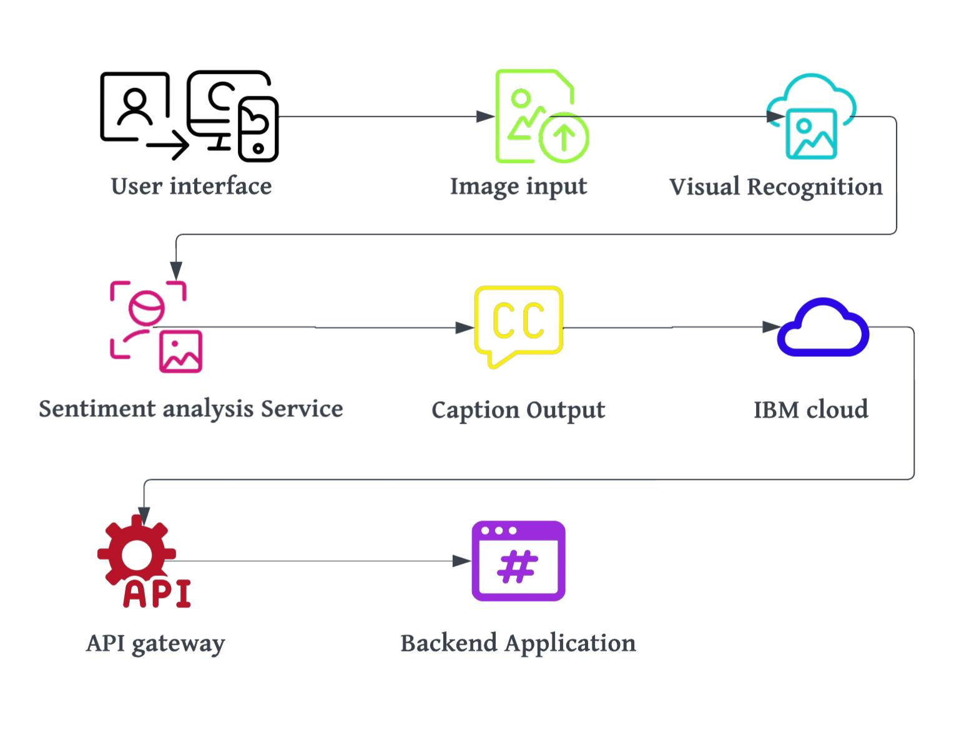**Conclusion:**

This architecture is a high-level representation and can be more detailed based on specific technologies, frameworks, and tools you choose to use.

Once you’ve implemented and deployed this architecture, users will be able to upload images, and the system will generate captions reflecting the detected emotions.