Trello is Task Management website..
It consist of boards which can be created for each of the projects or user purpose that we do… Like board for project a
Each board consists of list that will contain info like today this week later etc…each with different status of the current project
Each list consists of cards that contains the actual task…
Cards can be moved from one list to another
The following are the features of the board:
- Create a board
- Add user access
- Add board description
- Can contain multiple list
- 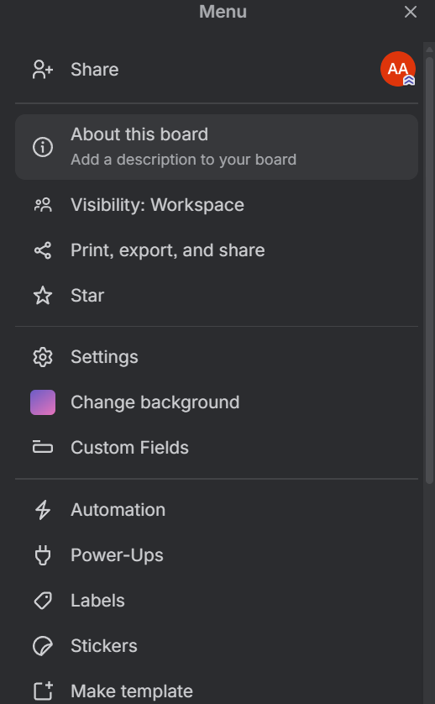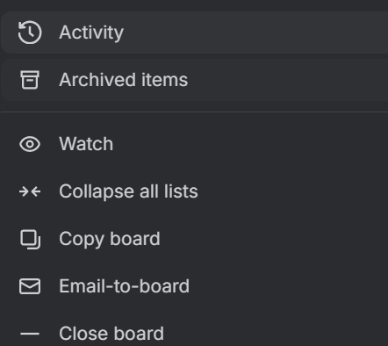
The following are the features of the list:
- Contains name of list
- Include board name of the list as tag or something…. Same name also in diff boards but ensure card is same
- Can copy list, move list or add card to list
- Automation of the list(will implement it at last)
- Change the status of list – live, archive ,done something
- 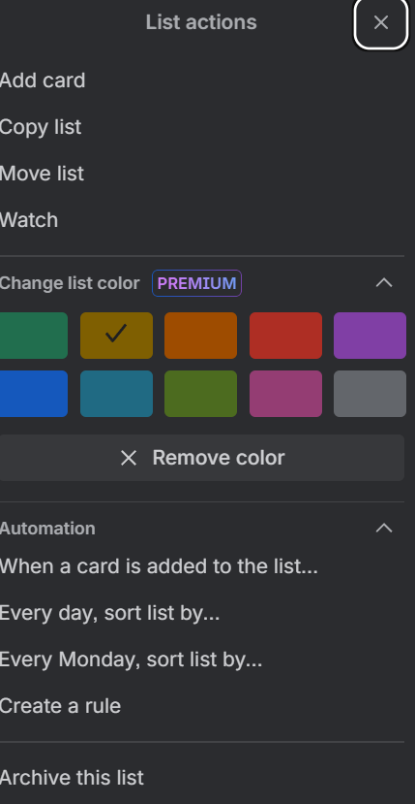
The following are the features of the card:
- Enter title or paste a link
- Create multiple cards for the list
- Change tags based on the list names
- Can add labels like colors or something for priority or based on the task
- Add dates – start, end date, recurrence , reminder date/time,
- Can add checklist within the card -> let’s say we buy groceries…so each grocery can be inside the checklist of the day’s list.
- 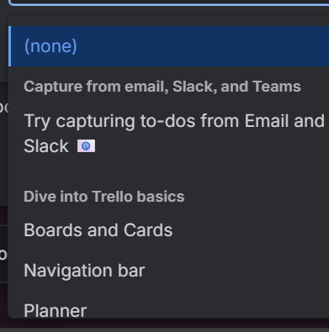
- 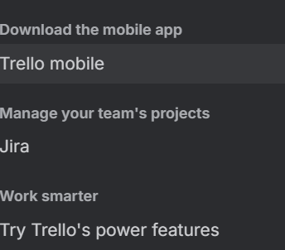
- Can add description to the card, comments and activity(at last) too
- Can add some person to the card, copy or move it to the other list
- For ui can use colors or include cover image

- 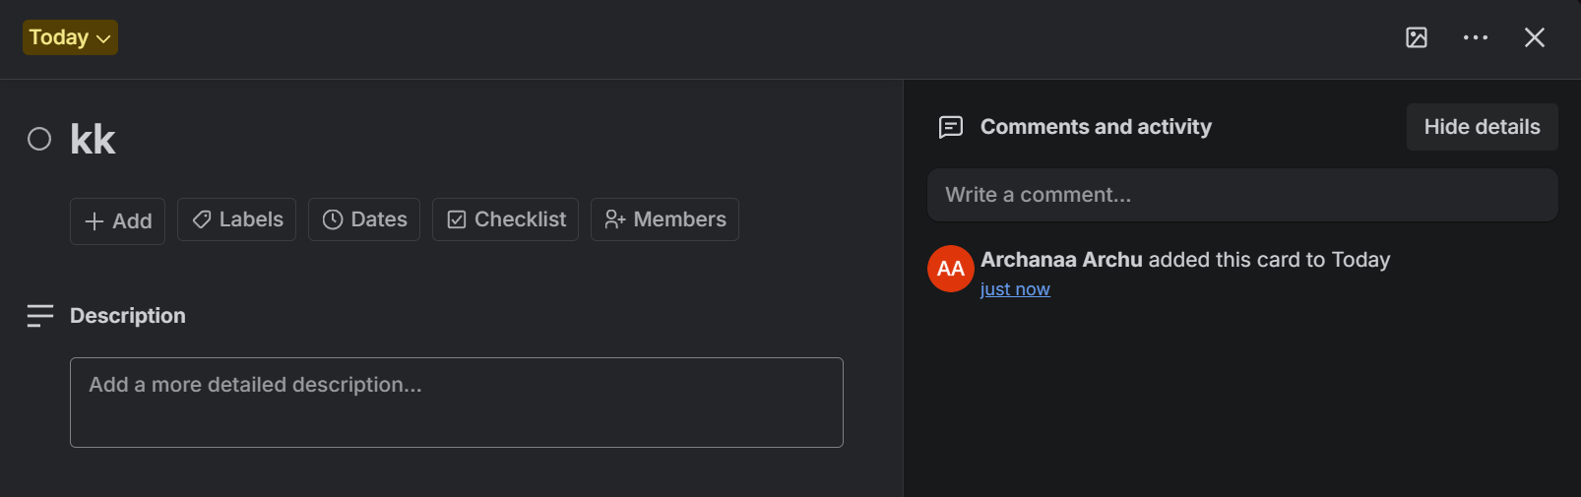
- 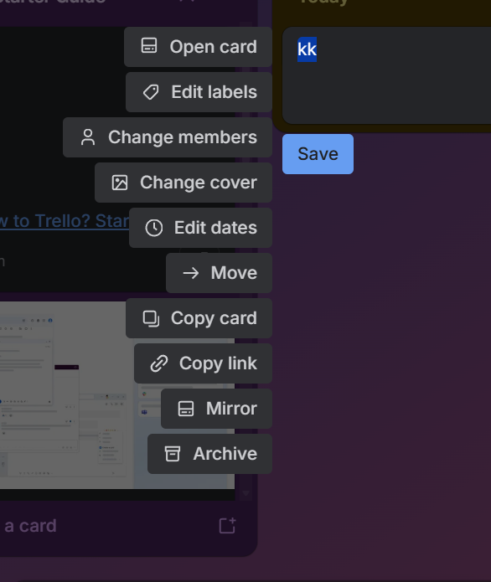
Let’s now focus on the backend schema entity that must be present in this….
User – name, mail, password(login), boards(as list)
Boards – board name, (idk how to map each user different access and how to display it too), list names(tag)

