**WEEK -1 ASSIGNMENT (DIGITAL-NURTURE-4.0)**  
NAME: ARCHANA J  
SUPERSET ID: 6396032

**Exercise 1: Implementing the Singleton Pattern**

Logger.java

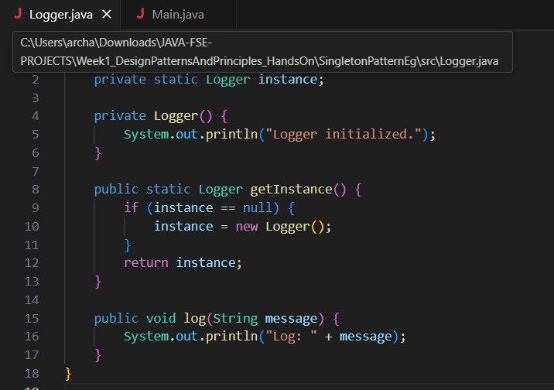

Main.java

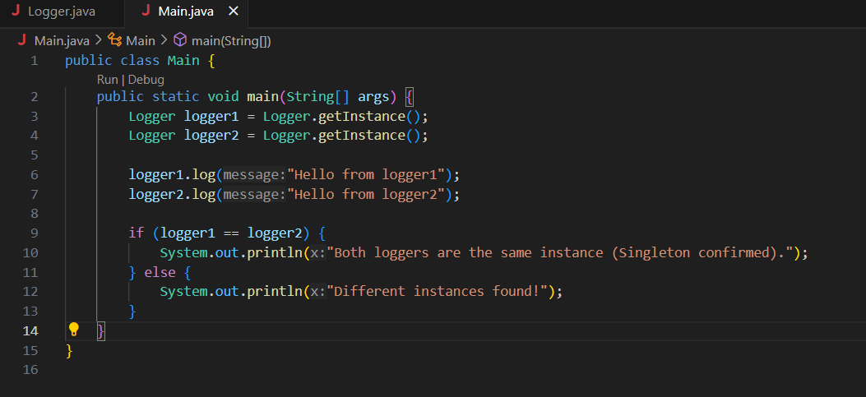

Output:

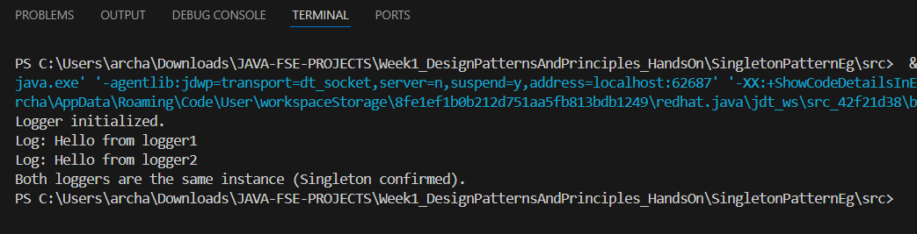

**Exercise 2: Implementing the Factory Method Pattern**

1.Document.java (interface)

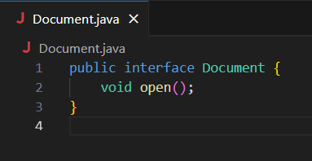

2. WordDocument.java

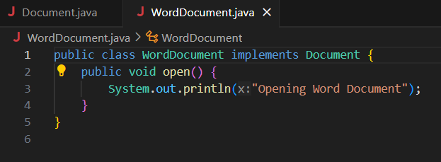

3. PdfDocument.java

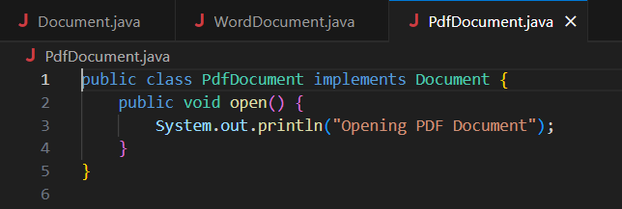

4. ExcelDocument.java

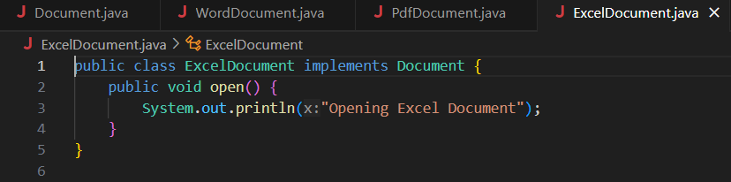

5. DocumentFactory.java (abstract class)

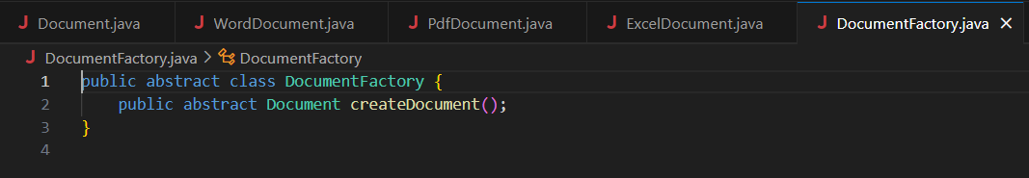

6. WordDocumentFactory.java

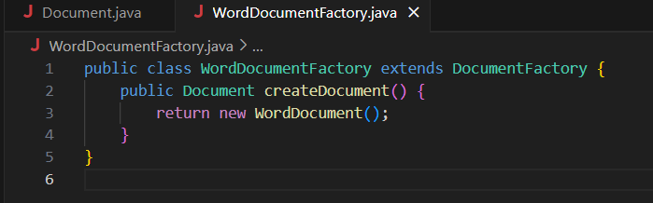

7. PdfDocumentFactory.java

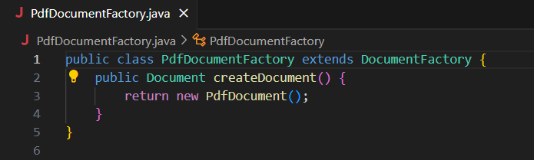

8. ExcelDocumentFactory.java

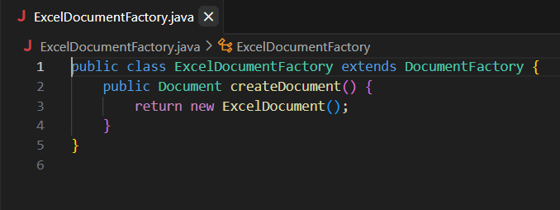

9. Main.java (Test class)

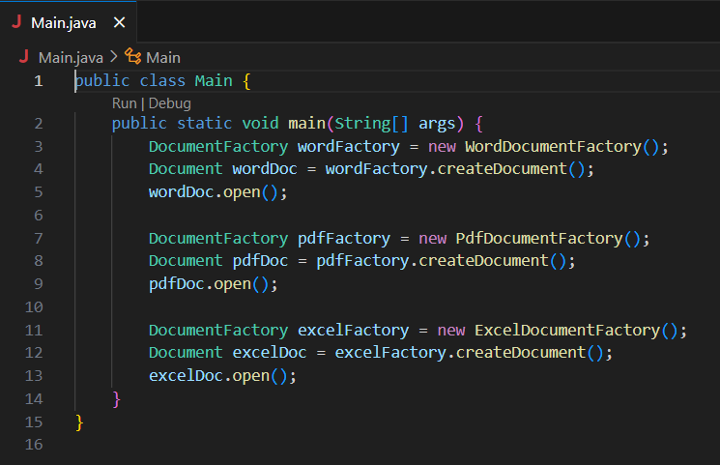

Output:

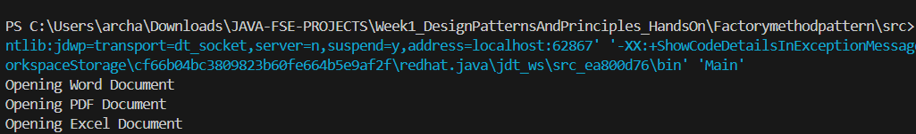

**Exercise 3: E-commerce Platform Search Function**

Product.java

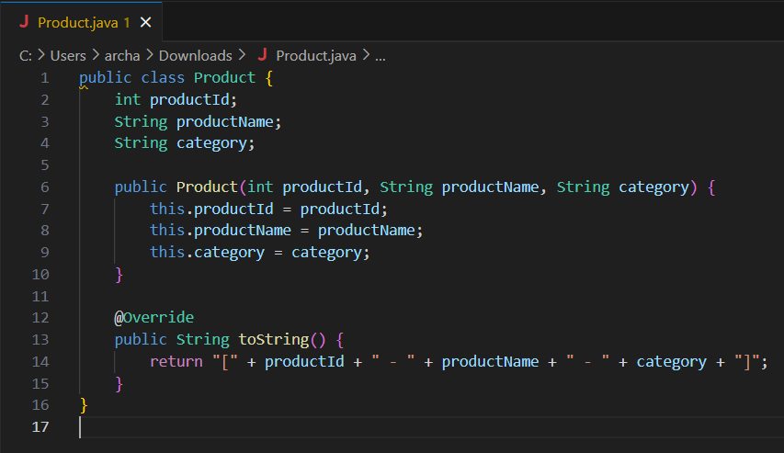

SearchDemo.java

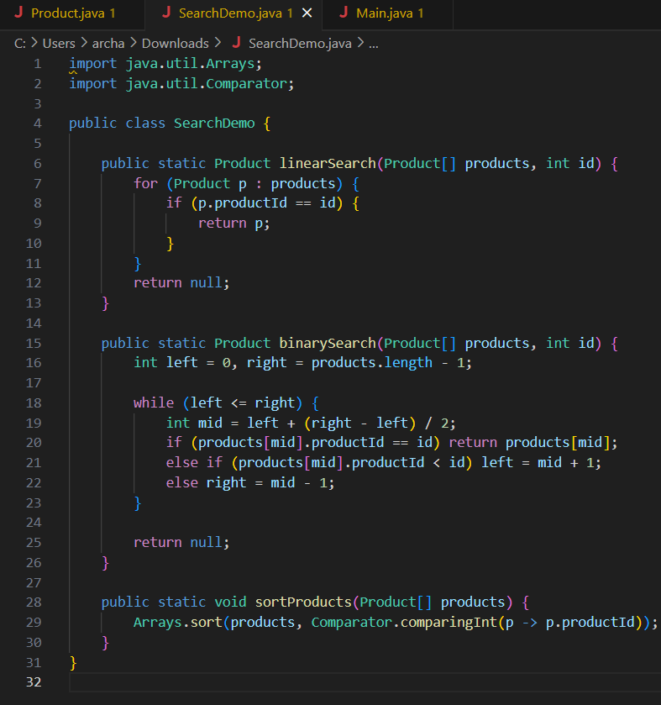

Main.java

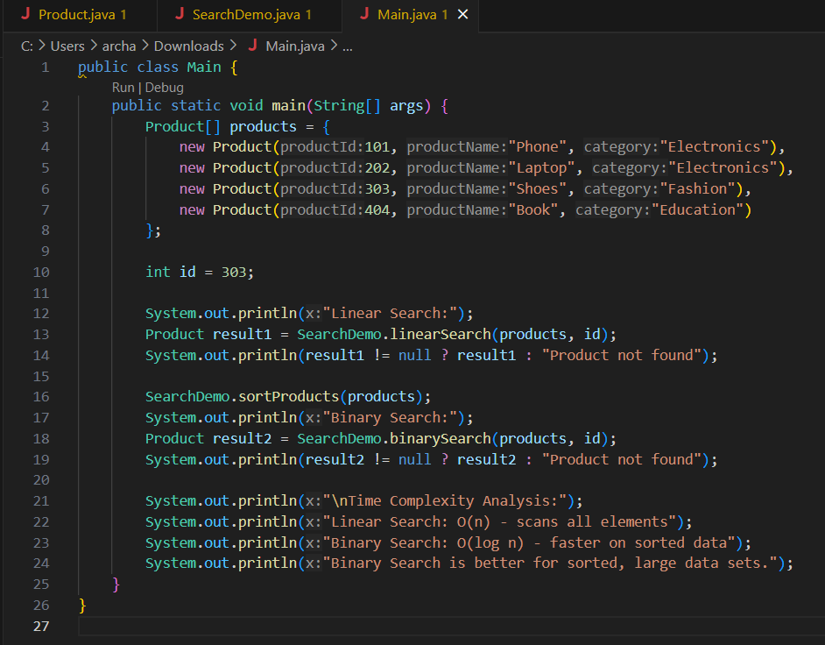

Output:

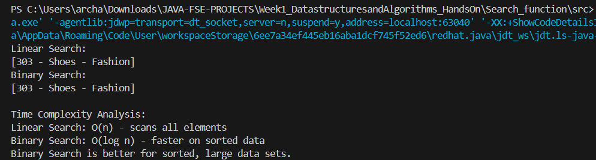

**Exercise 7: Financial Forecasting**Forecaster.java

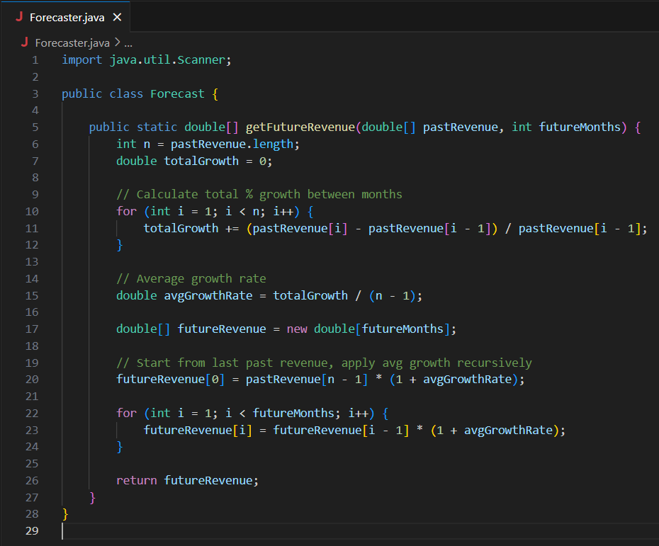

Main.java

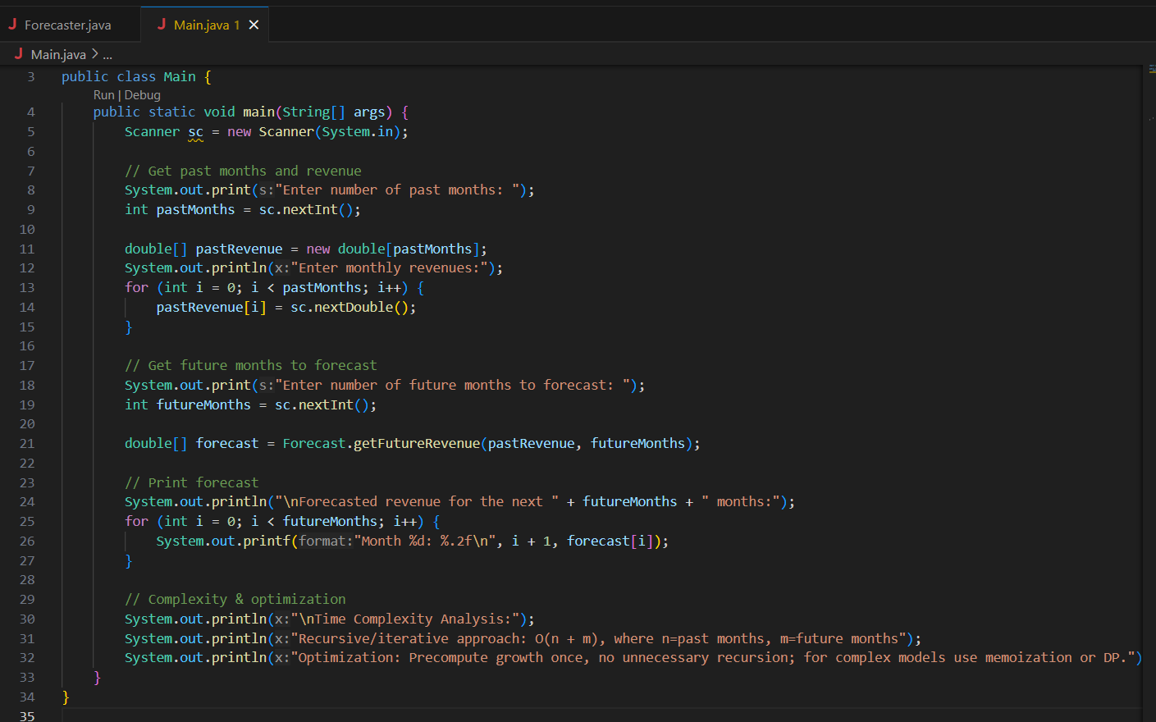

Output:

