Abstract— In this project, a multi-agent simulation is built using SIRV (susceptible, infected, recovered, vaccination) for epidemic disease. An evolutionary game model is used for infectious disease vaccination strategies. The two strategies include vaccination and non-vaccination. This model considers factors such as vaccination cost, vaccination effectiveness, and treatment cost after illness. In a network, agents are nodes and are connected by edges. Each individual agent updates its game strategy according to the benefit relationship with the adjacent nodes with the help of policy update rule (Femi rule). The results shows that the cost of vaccine effects the percentage of infection and percentage of vaccination. When the vaccination effectiveness is about 0.6, it is a better value for the evolution of vaccination strategy.
Multi-agent simulation for epidemic disease using SIRV model and Game-theory strategy (May 2021)
Archana Dasharath Marol | DSCI-6051 Capstone Project | Under the guidance of Prof. Vahid Behzadan

INTRODUCTION
C
urrently, due to the devastating COVID-19 pandemic, the infectious disease has become a public health threat. Millions of people are forced by national governments to stay in self-isolation and in difficult conditions as the disease has spread fast in many countries around the world. Hence social distancing, self-quarantine and wearing a face mask have been emerged as the most widely used strategy for the mitigation and control of the pandemic.
Many scientific communities, across numerous disciplines including medical and pharmacy are currently focused on developing safe, quick, and effective methods to help government in preventing the spread of virus. Moreover, in the field of statistics and artificial intelligence, mathematical models are being used to estimate disease transmission, recovery, and deaths. In the fight against COVID-19, a vaccine becomes a critical part of addressing the global health crisis. Recently, in 2020, Pfizer and BioNTech has made COVID-19 vaccine available to the public. Governments around the world, when making decisions regarding which measures to enact at which times, often rely on epidemiological models that predict and project the course of the pandemic. The idea of this project is to create a simulation and applying mathematical models to help the government in decision-making problem.
In this report, results can be seen for the analysis of the influence of factors such as the ways to get vaccinated, vaccination costs, and disease treatment costs by proposing an evolutionary game SIRV model of infectious disease vaccination strategy. The evolutionary game to make everyone in the network get two strategies, including vaccination and non-vaccination. At the same time, in each propagation process, each individual updates its game strategy according to the profit relationship with the adjacent nodes based on the policy update rule (PUR).

Review of Literature

Reinforcement Learning for Optimization of COVID-19 Mitigation Policies
(https://arxiv.org/abs/2010.10560)
Epidemiological models provide insight into the spread of these types of diseases and predict the effects of possible intervention policies. However, to date, the even the most data-driven intervention policies rely on heuristics. In this research paper, a study on how reinforcement learning (RL) can be used to optimize mitigation policies that minimize the economic impact without overwhelming the hospital capacity is shown. The main contributions are (1) a novel agent based pandemic simulator which, unlike traditional models, is able to model fine-grained interactions among people at specific locations in a community; and (2) an RL-based methodology for optimizing fine-grained mitigation policies within this simulator.
To begin with the PandemicSimulator contain functional blocks that includes; 1) locations, with properties that define how people interact within them.2) people, who travel from one location to another according to individual daily schedules. 3) an infection model that updates the infection state of each person. 4) an optional testing strategy that imperfectly exposes the infection state of the population. 5) an optional contact tracing strategy that identifies an infected person’s recent contacts. 6) a government that makes policy decisions. Next, the government is the learning agent. Its goal is to maximize its reward over the horizon of the pandemic. Its action set is constrained to a pool of escalating stages (from stage 0 to stage 4) which it can either increase, decrease, or keep the same when it takes an action. To encourage the agent to keep the number of persons in critical condition and below the hospital’s capacity keeping the economy as unrestricted as possible.

The results validate both the overall simulator behavior and the learned policies under realistic conditions. The paper the implementation is shown for an open-source agent-based simulator, where pandemics can be generated as the result of the contacts and interactions between individual agents in a community. Results are shown for 4 different analysis. First, a single run of the simulator with no government restrictions, showing the true global infection summary, the perceived infection state, and the number of people in critical condition over time. Second, Simulator dynamics at different regulation stages. The plots are generated based on 30 different randomly seeded runs of the simulator. Third, simulator dynamics under different hand constructed and reference government policies. Fourth, results of the learned policy evaluated at different action frequencies and in a larger population environment.

Modeling social response to disease spread using spatial game theory by Marzieh Soltanolkottabi
In this paper, a modeling approach based on spatial game theory using public goods game is proposed, a prominent approach for capturing the behavior of individuals in response to local stimuli. The settings of public goods game enable this method to model the dilemma of not vaccinating and not paying the related costs of vaccination or vaccinating to provide a healthy living environment for the individual and other members of the community. This is the first time that a public goods game payoff function is used in modeling and capturing the behavior of populations in response to epidemics. In this dissertation, two variants of the proposed model are introduced. The first captures the behavior of individuals in response to an epidemic, in which decision making is on whether to vaccinate or not. The second model aims to capture the behavior of interacting populations to an epidemic, and the decision is on how much to change the level of vaccination in each population. Also, the impact of considering the time-delay between infection and emergence of symptoms of the disease is studied. These models demonstrate that the adoption of public goods game-based payoff function in the modeling of epidemics can capture the vaccination behavior of individuals and can lead to a better control of the epidemic spread in the population level. Moreover, this dissertation proposes two new strategy updating methods in spatial evolutionary games, which are shown to be capable of modeling the dynamics of decision making under different sensitivities to vaccination and fear of infection.
In the context of preventive strategies, cost-benefit calculation commonly involves agents comparing the utility of adopting protective behavior with their perceived payoff of not taking any action and remaining susceptible to infection. Thus, in the simplest form, considering λ as the probability of becoming infected, the agents decide to vaccinate if 𝐶𝑉<𝜆𝐶𝐼 where 𝐶𝑉 is the cost of prevention technique or vaccination and 𝐶𝐼 is the cost of infection. Game theory-based models are an integral part of this category.
The cost of vaccination can be in the form of the expense of vaccine administration and the potential risk of vaccine side-effects, and the cost of disease infection can include disease complications, expenses for treatment, or absence from work. Bhattacharyya and Bauch considered that individuals take vaccination behavior based on their perceived cost where the total number of vaccinated (herd immunity) in the society can inversely affect their perceived cost. They showed that this behavior will result in free riding in society. Perisic et al considered the payoff of each agent to be the probability of being infected at each time and then individuals choose whether to vaccinate at any step according to perceived payoff of vaccination and infection.
On the other hand, in the rule-based models, the social or peer influence in decision making is incorporated. In these models, it is assumed that agents compare their behavior with behavior of other individuals in the society and through this comparison they can learn whether their behavior is optimal or not. Evolutionary game theory-based models are an integral part of this category. Thus, agents typically sample other agents from the population and adopt either the most prevalent strategy or rely on adopting the strategy implemented by a randomly selected agent. Some studies have investigated behavior imitation using Fermi function, in which each individual 𝑖 randomly chooses another individual 𝑗 as role model and imitates the behavior of j with the following probability where 𝑃𝑖 and 𝑃𝑗 are respectively the payoff of individual 𝑖 and 𝑗, and 𝛽 shows the strength or sensitivity of selection.
Thus, the larger the beneficial payoff difference and the larger the sensitivity of individuals to change their strategy, the larger the probability of changing the behavior. In these models, if the sensitivity of agents is very low, there is still a probability for the agents to adopt the behavior of an agent with a lower payoff.

Methodology

SIRV Model
The SIR model is a 3-state model i.e. it divides the population into 3 populations. S is the susceptible individuals where individuals are not infected and have no immunity. I is infected state where individuals are in the infected as they have exposed to the virus/infection. R is the recovered state where infected person is cured and had certain immunity. We assume that the susceptible people can have immunity through vaccine. So, the fourth state is introduced as vaccinators-state. So instead of classic SIR, we use SIRV model here. Moreover, a state called Immune state is also included. The people in the immune state are those whose vaccine has worked properly. If the vaccine has not worked on people, then they are same as the people who are not vaccinated so they will be in the susceptible state again. The people are transformed from one state to other based on the probability value for different states. The probability of infection due to contact with one infected person is called as beta (β). The probability that a vaccine is effective is determined by the value of effectiveness. Recover from illness according to the recovery probability gamma (γ). The strategy model for the different states is explained in the next part of this report.

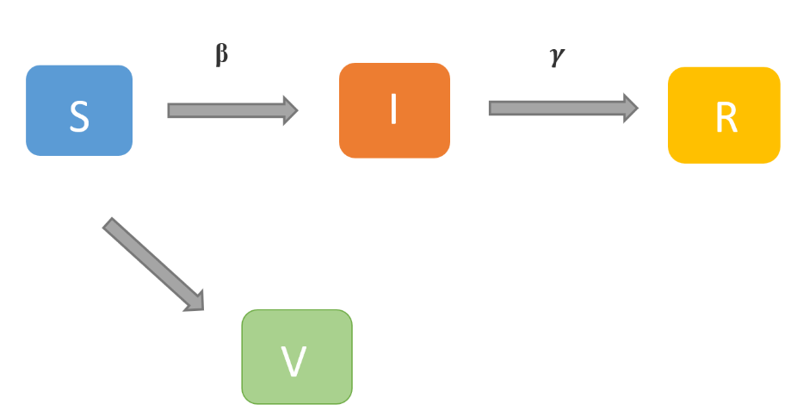
Fig1: SIRV Model

In this project, the agents are generated using networks library in python, where each nodes are the individual agents and edges are the contact of each agent to the other agent. The average degree for the contact is considered as 8 i.e an agent will come in contact with on an average of 8 other agents in the network. The network can be imagined something like the diagram shown below. Each node have one of the four states. A game-theory strategy is applied on these states to help in decision making for agents to decide whether to take vaccine or not.

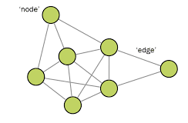
Fig2: Network of agents

Evolutionary game model of infectious disease vaccination strategies

Vaccination decision process
As of now, for most of the dangerous infectious disease like Covid-19, vaccine is the most effective solution. When the population of the vaccinated individuals increase to a certain number, there will be control in the spread of the disease. This indirectly controls the non-vaccinated individuals. But, as per the reports and past experiences, when new disease spreads among the people, they tend to predict the risks of the cost of vaccination, risk of disease. Also, their decisions are based on the decisions of their surrounding individuals. For example, a person gets vaccinated in an office and he behaves normally and doesn’t get infected for many days, there are high probability of the people around him getting vaccinated or if one person in a family decides to get vaccinated, everyone in the family does. Here comes the picture of game theory to apply on the model to deal with the individual’s decision about getting vaccinated. We consider the factors such as the effectiveness of the vaccine, the cost of vaccination, and the cost of disease treatment, and comprehensively analyze the SIRV model.
Mathematically, if node 𝑖 is a S individual, it checks if its adjacent node contains an infected I. If not, the state of node 𝑖 in the next transmission process will still be S. If there is an I individual in the adjacent nodes, node 𝑖 will be infected with a certain probability during the propagation process and becomes I state. If node 𝑖 is an I individual, it will be transformed into a R individual with a certain probability.
Before/ongoing epidemic of an infectious disease, each agent will choose whether to vaccinate. When there are agents vaccinated (V) in the network, before the next infectious disease cycle, each agent will update his own vaccination strategy. Each agent’s attitude toward vaccination will be affected by aspects like as personal preferences, the cost of treatment, the cost of the vaccine, and so on. In this project, the analysis is done assuming that vaccination has no side effects, but the vaccination is not completely effective i.e., the vaccination may fail. If the vaccine fails, the agent will be in susceptible state else they will be in Immune state (IM).
In any game theory, there are 3 components: Players, Strategy and Payoff. Here Players are the individuals are interacting with each other, strategies are based on the transmission model SIRV and the payoff of each agent is considered to be the probability of being infected at each time. The payoff of each individual is calculated along the way, which is important in the decision making of agent about getting the vaccine. An equation below is the payoff equation, where -Cv is the cost of the vaccine ranging from 0 and 1 if i is in vaccinated state. The payoff for individual in I state is -1. Here the negative value is considered because, its cost and mot a benefit. Zero for the individual in susceptible state.

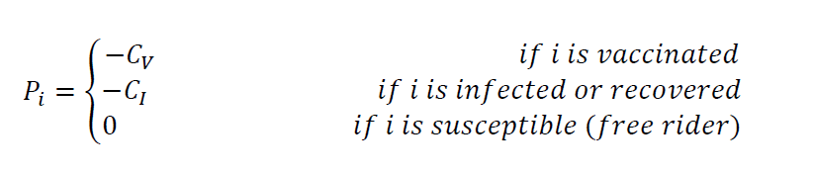
Fig3: Payoff function

Therefore, the proportion of vaccinated people and the proportion of infected people is calculated by the following steps: 1) Before the start of the first-time step (season), calculate infection dynamics by having half of all agents vaccinated. 2) Then when the infected person disappears, it is said as the time step (infectious season) has ended, and all the agents need to decide whether or not to vaccinate for the next time step. 3) Keeping the agents who decided to vaccinate in previous step as vaccinated individuals, the dynamics is recalculated. 4) This step is repeated until there is no change in the proportion of vaccinated people.

Policy update rules:

Considering that individuals can make certain mistakes with limited rationality when making strategy so here, Femi update rule allows irrational probabilistic imitation. To update its strategy, an individual 𝑖 randomly chooses its own neighbor 𝑗 to compare the return values. The probability that the individual 𝑖 will adopt the strategy of its neighbor 𝑗 in the next game is given by the below equation, where Pi and Pj are the payoff of individuals 𝑖 and 𝑗 in this game respectively.

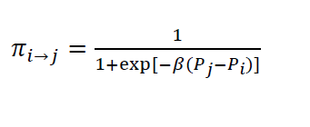
Fig4: Femi update rule

Results

The number of agents considered are 10,000 and the average degree of contact in the network is 8. The transmission probability is 0.4 for the adults between 18-45 and the recovery probability is 0.6, as the recovery for healthy adult for Covid-19 is high. The model is run for 1,000 time steps and for Cv values between 0 to 1. Below are the results obtained.

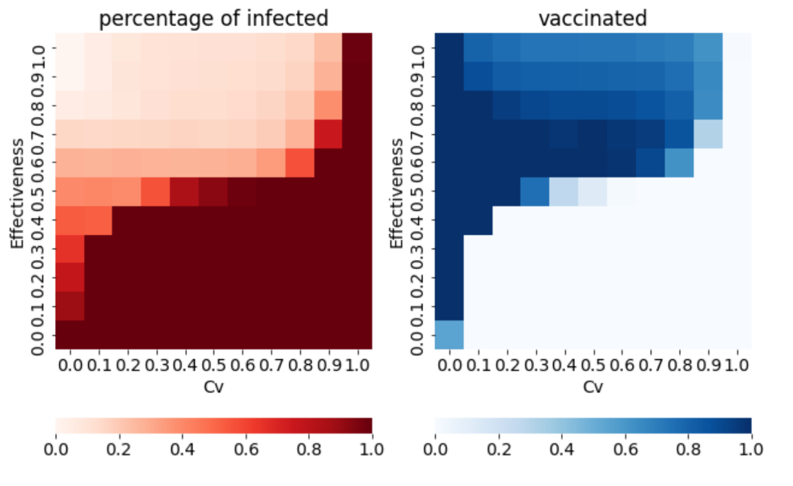
Fig5: Heat map

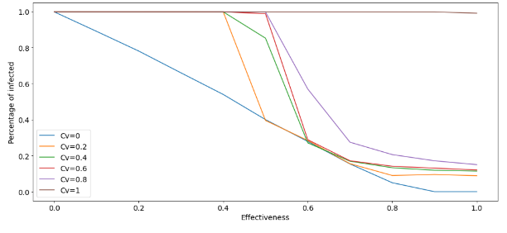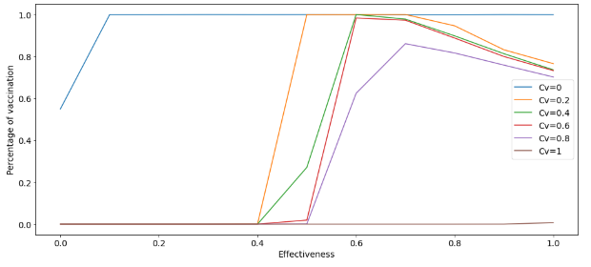
Fig6: plot of infected and vaccinated percentage

The proportion of infected individuals decreases as the effectiveness increases, and the proportion of vaccinated individuals increases. We can see that the effectiveness rate is 0.5-06, the proportion of infected persons is the lowest, and the proportion of individual vaccinated is the highest.

A plot o fraction of susceptible and immune individuals for different cost are also shown below.

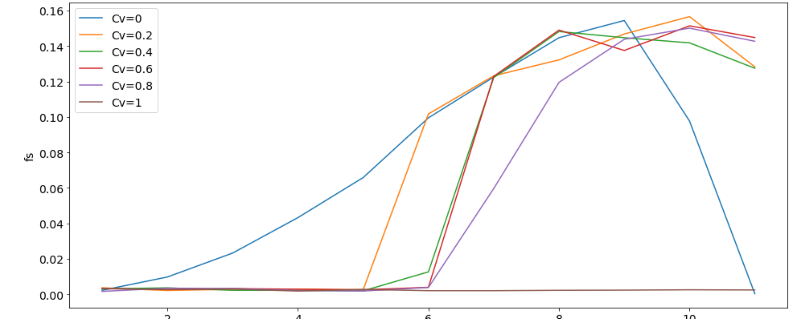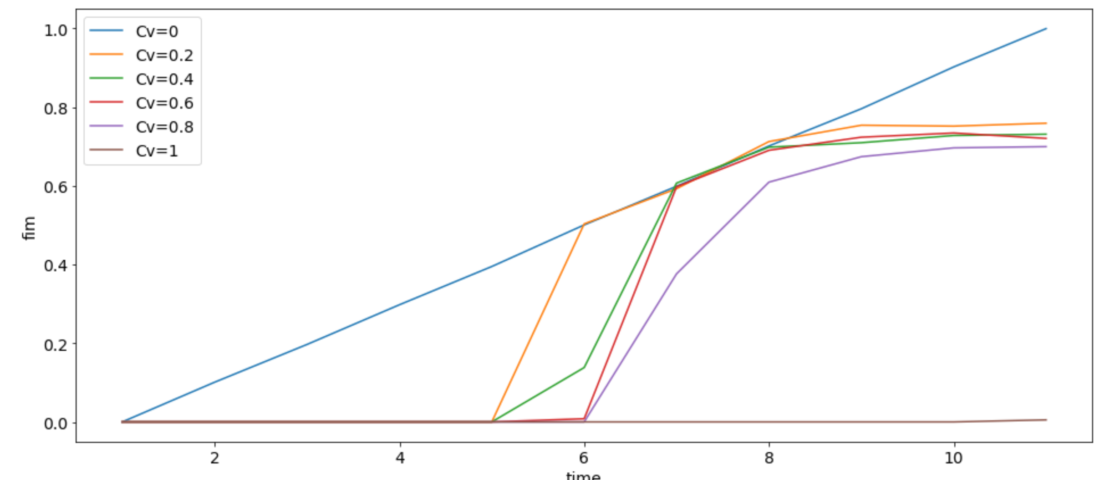
Fig7: Plots of fraction of susceptible and immune vs timesteps

CONCLUSION AND FUTURE SCOPE

In this project, a implementation was done for a multi-agent simulation with SIRV for covid infectious disease vaccination strategies. Factors considered were vaccination effectiveness, vaccine cost and treatment cost. In the propagation process, according to the policy update rule, each individual update its game strategy according to the profit relationship with adjacent node.
Based on the results obtained, we can recommend the government 1) keeping the cost of the vaccine low can increase the percentage of vaccinators 2) Increasing the initial number of vaccinators is important, this can be done by spreading the awareness among the communities and individuals imitate the behavior of their neighbors.3) As the recovery rate of the covid is high and very low for old adults and less immune individuals, the government can consider keeping discount for old adults population. This will help to control the spread. Once it is under control the government can decrease the cost of the vaccine for the healthy adults as well. This will help them to utilize their funds in the optimized way.
The project can be further extended by changing the population value as per the country/community and also by changing the transmission and recovery probability. Also, the weights can be given to the edges of the nodes that represents the contact rate of everyone.
References
- Aleta, A.; Mart´ın-Corral, D.; y Piontti, A. P.; Ajelli, M.; Litvinova, M.; Chinazzi, M.; Dean, N. E.; Halloran, M. E.; Longini Jr, I. M.; Merler, S.; et al. 2020. Modelling the impact of testing, contact tracing and household quarantine on second waves of COVID-19. Nature Human Behaviour 1–8.W.-K. Chen, Linear Networks and Systems (Book style). Belmont, CA: Wadsworth, 1993, pp. 123–135.
- Bansal, S.; Grenfell, B. T.; and Meyers, L. A. 2007. When individual behaviour matters: homogeneous and network models in epidemiology. Journal of the Royal Society Interface 4(16): 879–891.
- Brockman, G.; Cheung, V.; Pettersson, L.; Schneider, J.; Schulman, J.; Tang, J.; and Zaremba,W. 2016. Openai gym. arXiv preprint arXiv:1606.01540 .
- Cobey, S. 2020. Modeling infectious disease dynamics. Science
- Del Valle, S. Y.; Mniszewski, S. M.; and Hyman, J. M. 2013. Modeling the impact of behavior changes on the spread of pandemic influenza. In Modeling the interplay between human behavior and the spread of infectious diseases, 59–77.
- Barabási A and Albert R 1999 Emergence of scaling in random networks Science 286 509-12
- Holme P and Kim B J 2002 Growing scale-free networks with tunable clustering Physical Review E 65 026107
- Starnini M, Machens A, Cattuto C, Barrat A and Pastor-Satorras R 2013 Immunization strategies for epidemic processes in time-varying contact networks Journal of Theoretical Biology 337 89-100
- Chen L and Wang D 2015 An improved acquaintance immunization strategy for complex network Journal of Theoretical Biology 385 58-65

 

